“CINDERELLA”

As told by Moxy

Table of Contents:

Chapter I: The Stepfamily

Chapter II: The Royal Ball

Chapter III: The Fairy MoxMother

Chapter IV: The Princess

Chapter V: Midnight

Chapter VI: The Glass Cock Ring

*WARNING: Futa, ageplay, rape, incest*

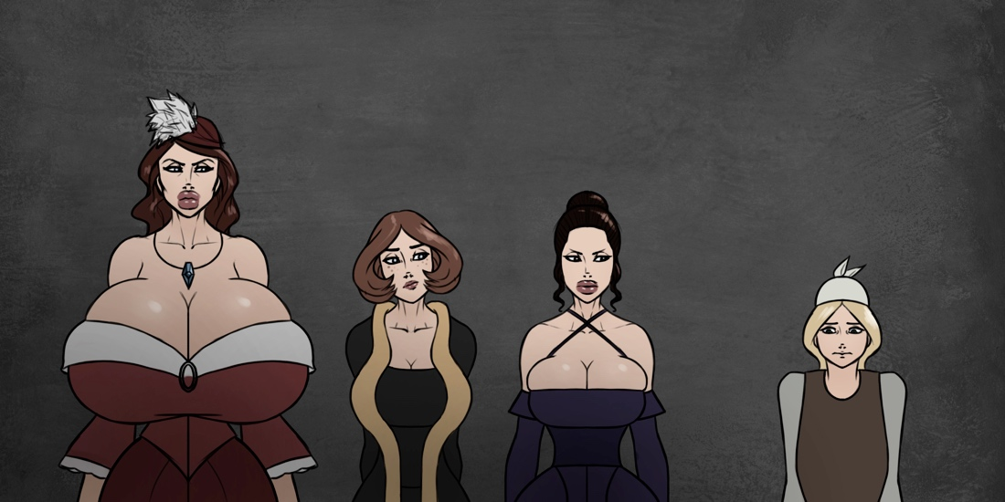

-I-

The Stepfamily

*It is a tale that everyone has heard. Mistreated girl gets magical karmic retribution against her oppressive stepmother and marries a prince.*

*The end.*

*Except the facts are all wrong, and it’s passed off as a fairy tale told to children. Let me tell you the truth. I was actually there, after all. And as I remember it, there was a lot more cock than the kid’s version. And it wasn’t a prince, it was a princess. Also the whole midnight thing… you know what? I’ll just tell you how it really happened.*

—————

Cinderella was set up for unhappiness the moment she was born. Her mother died during childbirth. She was a third wife, and the first one to bear a child to a husband who stuck his knob into any young lady who let him. He was rich.

And that was the long and short of his positive traits.

Months before Cinderella was born, he was involved in an affair with the Madame of a brothel. This brothel was known for its unique flavor of female: ones with cocks[1].

Madame Zara herself possessed an unsurpassed sixteen-inch shaft. Her long wine-red coiffure and piercing blue eyes gave her an air of sophistication that her plump lips, superior bust, and weighty derriere matched in eroticism. Cinderella’s father wasted no time marrying for a fourth time out of sheer lust only a week after Cinderella was born, and Madame Zara became Cinderella’s stepmother.

Less than a year later, a life of debauchery caught up to Cinderella’s father. During a particularly twisted lovemaking session involving a donkey, his heart gave out[2]. “Lady” Zara (as she now called herself) discovered that Cinderella’s lazy father had neglected to change his will. The entire fortune belonged to Cinderella by default.

Zara was now used to a certain lifestyle, and the only way for her to keep the means to that lifestyle was to be a mother to Cinderella. The law of the kingdom allowed a portion of a child’s inheritance to be used by the child’s guardian until adulthood. By her own twisted calculus Zara decided to perform the bare minimum of motherly duties while finding a way to get her hands on the rest of the inheritance.

Zara sold the brothel and spent the money satisfying her own base desires. She held lavish orgies, imported expensive food and drink, and doted on her two daughters, Renee and Monique. They were half-sisters, born from Zara’s seed and the wombs of two separate brothel girls. Zara loved them in in her own warped way.

Meanwhile, she punished Cinderella with chores on a whim. At first it was purely bored sadism, but eventually the money started to dry up. The tasks once performed by the hired hands on the estate were all forced onto Cinderella, who was given a small nook in the attic to sleep in. She was not allowed to be seen by guests, and was fed only when all the chores of the day were finished.

—————

Things took a turn when Cinderella was thirteen.

She was around the same age as her stepsisters. At the time, Zara was thirty-four. Unlike the three of them, Cinderella was completely female, but appeared more boyish than any of them. Renee and Monique were developing very quickly into sultry replicas of their mother.

Renee was a redhead, with a light spatter of freckles. Her thick strawberry locks curled around her cherubic face and pale shoulders. She shared her mother’s icy blue eyes. Her small smile belied the mischief within her.

Monique had straight dark brown hair that was always arranged in a tight bun on some sort. She inherited her mother’s large, pouty lips. Her eyes were almost pitch black, and she made no effort to hide the contempt on her face.

Both girls showed promise of reaching Zara’s incredibly voluptuous figure. Their bosoms were larger than most adult women and their hips and posteriors had gained substantial heft. Even without corsets the hourglass shapes were extremely pronounced.

On the other hand, Cinderella was a waifish blonde in servant’s rags.[3]

As for Madame Zara, she was still enjoying her physical peak. While her breasts had lost a bit of their former buoyancy, they still had enough volume to eclipse the average pumpkin[4] that grew in the estate’s garden. Almost mirroring her front orbs in mass were her buttocks, which bounced and swayed when she promenaded throughout the house.

Cinderella was used to constantly laundering sheets and undergarments from Zara that were soaked with a clumpy white goo. If she was fortunate, it hadn’t dried completely and she wouldn’t have to spend precious time prying crusty fabric apart to wash it. Recently, she had noticed the same issue with Renee and Monique’s things, though to a lesser extent.

One day, Cinderella was clearing the dining room table. Zara strode into the room.

“Don’t be so clumsy with the plates. And bring a ruler to the master bedroom,” Zara snapped. She turned to walk out, paused, and half-turned her head towards Cinderella. “Better make it a yardstick.” She smiled and sashayed out of the room.

—————

Cinderella trudged upstairs with yardstick in tow. Her fingers tightened around it thinking of all the times it had been used against her in the name of discipline. She was almost certain Zara was going to “punish” her for some trumped up transgression as usual.

As she approached the master bedroom door, she took a deep breath. Then, she gritted her teeth, stood up straight, and turned the handle.

Her eyes bulged.

Her stepsisters were standing in front of Zara completely nude. More shocking was their mother, gripping the girls’ turgid cocks in either hand. They all looked at Cinderella; Zara with a craven grin, the sisters with flushed, heavy-lidded glances.

“Well, don’t just stand there,” Zara growled. “Give that to me so I can measure their….” She eyed the throbbing meatpoles. “…magnificence.”

Cinderella had yet to blink.

“Mother!” whined Renee. “If you don’t let go, I’m going to–”

“No daughter of mine is going to have such pathetic sexual fortitude. I want you to be queens of cock.” Zara glared at Cinderella. “Bring. That. Here.”

Cinderella gradually stepped towards her stepmother. She only caught a glimpse of her stepsisters’ members. Renee’s was pale and pink towards the tip, and incredibly smooth, much like the tight orbs of seed attached to the base. Monique had a darker, thicker shaft lined with pronounced veins, but a smaller head than her sister’s. Two small egg shapes hung a substantial distance between her legs in contrast to Renee. Hastily averting her gaze, Cinderella held out the yardstick.

“Ashamed at the sight of real females, moppet?” Zara sneered as she took the ruler.

“Why are you doing this, mother?” Monique panted. “Isn’t this… wrong?”

“If I don’t teach you how to be a real woman, Moni, then who will? Now, both of you stand still.”

Zara knelt in front of her daughters. First was Renee. Zara placed the yardstick atop the throbbing cock, using her thumbs to press it flat against the ruler. Renee gave a small squeal as her mother handled her length.

“Ten and a half. That’s even better than I had hoped,” Zara said. She repeated the process with Monique. “Nine, but with very impressive girth. If you two weren’t my daughters….” Zara blinked once, then leered ravenously at the two ready organs. “What am I saying?”

With sickening speed, her lips had barely wrapped around Renee’s tip before plunging all the way to the base. Renee’s knees buckled and she let out a helpless moan. Zara released her and without taking a breath swallowed Monique’s entire length, eliciting the same reaction. Cinderella backed her way to the door once Zara crossed the line into incest.

“Stop right there, girl.” Zara’s mad gaze froze Cinderella in dread. Escape was no longer an option.

Zara licked her enormous lips in a broad, and practiced motion. She turned back to her daughters.

“You both taste wonderful, darlings,” she purred, undoing her dress. “And for that I will treat you both to the best mummy has to offer.” As the dress fell to the ground, all sixteen inches of proud, pulsating penis stretched into the open air, wider than Zara’s arm and jutting slightly upwards vindictively. A large glob of clear liquid formed at the tip and soon began crawled down the shaft, followed by many other drops that collected near the bottom apex of her large, egg-like testes, then stretching slowly to the floor. The three barely teenaged girls all watched in awe as a pool began to form on the floor as Zara shucked her undergarments, baring two voluminous breasts[5].

Somewhere in the back of Cinderella’s mind the thought of having to clean the floor later flitted by and was gone the next second.

“But first, an appetizer. Cinderella.”

“Yes?” Cinderella didn’t even know she had responded; it was a physical habit anytime her stepmother called her name. No response had always resulted in a swift beating.

“Come here.”

The mousey blonde moved towards her stepmother, more from a feeling of horrible inevitability than obedience. She caught a look in her stepsisters’ eyes; like two predator cubs watching their mother stalk prey. She turned back to Zara. The former Madame reached towards her and yanked Cinderella in close by the cheeks.

“You are certainly no specimen. Not like my daughters,” Zara hissed. Cinderella felt something push up against her stomach. It was warm at first, followed by wetness. Zara’s cockhead had leaked through the thin rags that served as Cinderella’s adornment. The aroma was subtle, but very heady, and Cinderella’s body trembled. Zara traced Cinderella’s thin, soft lips with a fingertip. “But even you have holes. You may not turn out so useless after all.”

“Please....” Cinderella struggled to form words with Zara’s nails digging into her face. “Don’t—”

*SLAP.*

“What have I told you about speaking out of turn?!” Zara’s expression softened as she faced her daughters. “Would you like to go first, Renee?”

Renee eagerly stepped forward. Seeing her mother’s enormous, fleshy rod made her own cock twitch giddily.

1. Told you there’d be cocks.
2. As a favor to everyone involved, I will not get into it.
3. I don’t need to go on. If you know the story, you get the gist.
4. I would say “basketball” but that wouldn’t be period-appropriate language. In any case, those things were huge.
5. I do not endorse hate-fucking. But if I did, Zara would be a prime candidate. She makes me horngry.