MILF HOUSE
COMMISSION STORY
BY CHALDEACHANGE


Things had been quiet the past few days.

Classes at Garreg Mach were on break due to a chain of Seiros related holiday anyways, but Byleth had stayed at the academy through a number of holidays by this point and she’d never been able to relax this much. Typically the Archbishop, Rhea, would bother her into completing this or that, maybe even sending her and the members of the Black Eagles on a mission of some sort.

In a similar vein, if not Rhea? The leader of the Black Eagles, Edelgard von Hresvelg might have approached her with some personal tasks. The professor knew that, as of late, she had been wracking her brain trying to figure out how to pull better results out of Bernadetta von Varley, too. But she hadn’t heard if any progress had been made on that front. “If you’re worried about it, you could go ask them you know? Stop moping around! It’s a holiday!”

A voice that only Byleth could hear resonated within her, spouting advice that was one part helpful, and one part pointedly criticizing. That was Sothis. The best way that the ex-mercenary could describe her was as ‘a goblin that suddenly appeared before her one day, and basically lived in her head’. Her existence wasn’t something she could tell anyone about since they would definitely think she was crazy, but their symbiotic relationship had given her a number of benefits.

“…I could.” The woman’s reply was curt as always, and she went to step out her dorm room to do just that. Since birth she had struggled with expressing her emotions, and incidentally her heart did not beat. So even if she thought this basic idea of Sothis’ was a good one, she did not endorse it as enthusiastically as she might have were she someone more ‘normal’. “But… Hm?” What was that? An unusual hint of emotion in her voice? Maybe it was none too surprising considering, Byleth?

She realized she was no longer standing in her assigned room.

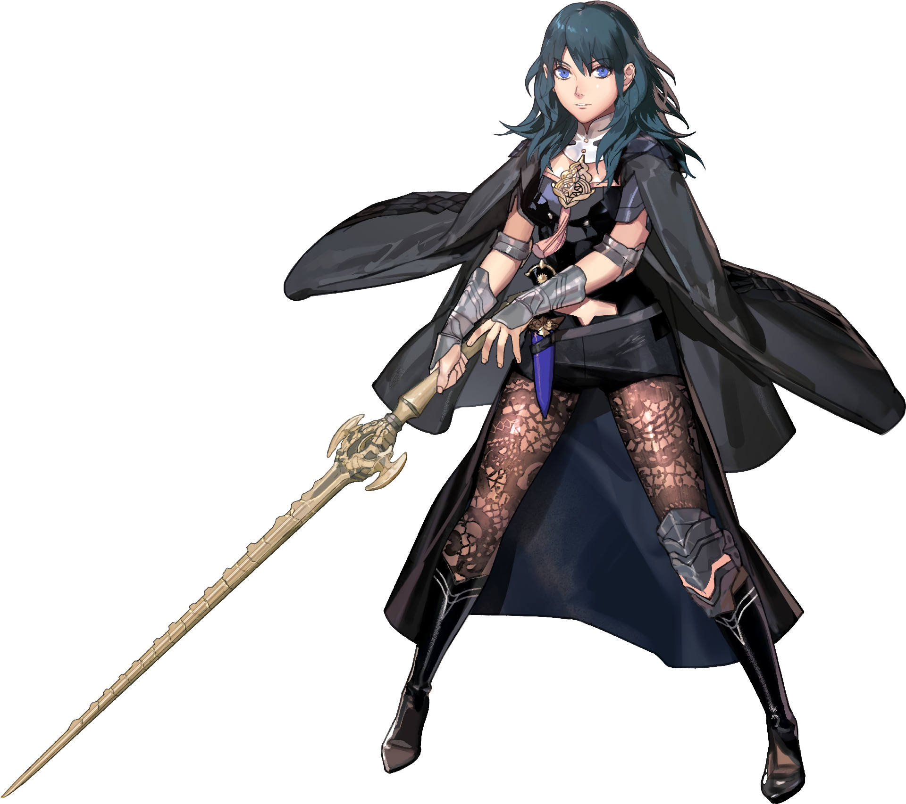
“Sothis? Where are we?” Byleth had stepped through her door, so she should have been outside the Garreg Mach dorm area. But she was still inside, and in an open room with a couch, a table, and a strange, flat black thing on a cabinet across from the couch. A modern living room, not that the woman that hailed from a medieval fantasy world knew what that was.

Her big, blue eyes blinked. There was no response from her brain goblin, and even after asking several related questions the results were the same. She had clearly been teleported by some strange magic, but had Sothis not made the jump with her somehow? “…I need to find a way to get back.” She didn’t like this one bit. There was too much uncertainty, and her chest kept thumping. Was something broken inside of her? No, wait… Wasn’t this…?

A heartbeat?

“Ara ara!?” For some reason the young woman’s first reaction to this realization was to make an unusual, repetitive noise with her mouth. One that was expressed without the absence of energy that was so typical of her unemotive self. It took her by surprise. “What’s… happening here?” What was happening to her? She’d changed locations, but it also seemed that her presence in this place seemed to be having some sort of effect on her body, and maybe even her personality as well.

The phenomenon had actually taken root in more places than Byleth had initially realized. Several irregularities plagued her body in quick succession, seeing to it that the color palette that she was known by to her students was irreversibly shifted. Her skin was included among the things that were changed early, as the melanin levels in her skin were elevated and pushed her skin tone into a deeper, natural tan – before this color was left only as bikini lines as the skin everywhere else darkened further to a tan that had been enhanced through a tanning booth.

Whatever had prompted this browning of her skin, evidently, was not satisfied with her skin alone, however. Within the woman’s shorts her pubic hairs were robbed of their blue, becoming a dark brown in its stead. And before long? The same was true of her brows, any other hair on her body, as well as the hair atop her head. But this hair didn’t just seem darker in color though. The quality of it appeared aged and worn, something that became more obvious as it shortened without hesitation until it was only a messy, butchered bob that didn’t even cover her entire neck, bangs tossed and showing off much of her forehead.

“My, what was I getting all up in a tizzy about!? No, wait… something is really wrong here, right? Why am I writing it off…?” Watching Byleth attempt to reason with herself was certainly an ordeal, because she seemed to flip between a peppier, more carefree personality and her quieter, more critically thinking self on a dime. “Not to mention I feel so tired… But at my age, after a long day of work…!” At her age? Why had she said that? What did it mean?

Her transformation, evidently, seemed to exist to appease the invasive thoughts that left the woman staggered between two different personas. If she believed she was older then, well… That was what was going to happen! This was made plenty evident by the look of the professor’s face alone at first. Crow’s feet etched themselves plainly in the corners of her eyes as the thickness of her face appeared to swell, giving her rounder cheeks that did not hold any of the tightness in their skin that was typical of someone youthful.

And yet in tandem? That face quickly lost any trace of resemblance to Byleth’s previous self. Her lips swelled several inches thicker and her nose became shorter and rounder. Yet it was her eyes that took the brunt of the change here. Her irises shrunk several inches in size yet also developed a golden yellow color, leaving more of her sclera visible between widened eyelids that pinched in at the corners with longer lashes. Back home Byleth wouldn’t have known this term, but now she did. She was a Japanese woman, and the language she was thinking and speaking in had changed to match this.

“Hm? Why am I wearing this? It isn’t comfortable at all!” Looking down at herself, Byleth was conflicted. A voice in the back of her mind knew that this was her usual outfit, and yet what she had commented on, provoked by a sudden discomfort throughout, implied she had never put it on before in her life. In fact she had started to wonder if it was some sort of cosplay. Did I put it on to surprise my daughter? No, she isn’t into that sort of thing…

Daughter?

“Fantasy isn’t real, and my daughter certainly doesn’t like shows like that!”

Regardless of why she was wearing it, the cause of her discomfort was certainly observable. Her tights had begun to fray around her thighs after all, with tanned flash poking through the holes in a newer, more greatly swollen form. In fact her thighs soon doubled in their girth, shredding through the thin fabric entirely and seemingly forcing her hips to rear into a childbearing width, prompting the front and back of her shorts to tear while tanned skin exposed itself. This was especially true in the back, for the cheeks of a swollen ass pushed past the waistband of those shorts and spilled over the top, the cleavage of this full rear made evident.

Not that Byleth herself batted an eyelash at any of this. She was much too far gone, cast wholly into the new role that she had been assigned mentally. So not even her tummy pushing forward into a notably rounded shape that was more a product of age than eating habits, peeking out through her tummy cutout and showing off subtle stretchmarks that had lingered from a pregnancy, did not really prompt a reaction. Something deep down told her that this comfort she felt would come to pass shortly. She just didn’t know how nor why.

But before this correction came, there was still one area left untouched that needed to fill in, so to speak. While her body had softened overall, muscles absent and scars and callouses erased upon her complexion, the plating around her chest that was meant to serve as armor struggled to contain what was bloating beneath it. Byleth had already possessed a notable bust, but the same ample fat that had blessed her thighs and ass filled each tit with the vengeance.

Browned nipples had inflated themselves, areola practically tripled in width after only a few moments. But they were quickly crushed against the underside of the woman’s armor plate as fatty tissue built and built, tanned skin stretching beyond capacity as her breasts grew larger and larger. Without thinking much about it, she bit her lower lip sensually from the pressure. But all at once, suddenly? All of her discomfort went away, and G-cup tits, perkiness absent thanks to her new age, bounced free into the cups of a pink tank top that showed off all of her cleavage. Along with some very short, blue shorts that highlighted her thighs and ass.

“Hmhmhm~! Rumi-chan said that she would be over soon, right? I can’t let my hot date wait for too long!” Gone was the calm, emotionless, and young professor that had existed prior. Rather? A boisterous and carefree woman dressed down to highlight her tanned, bombastic figure had begun to bounce around her living room, picking up this and that to shove into her purse.

Benika Hashimoto was, in many ways, your typical Japanese mom. She had her day job as a teacher and was fairly well known by the local children. Even the teens and those starting college knew her – she had been in the business for just that long, and as a result the teenaged girls in the building she rented her apartment in even called her sensei to this day. But Benika was also something of a wild animal at night.

She was a single mother, having divorced about ten years prior when her daughter had been born. It was tough, especially when her daughter was such a rascal, but she had been seeing people recently. Mostly studs, sometimes a beautiful woman. Much like her past self, she wasn’t all that picky when it came to sex.

“Ara ara… What if she wants love advice again?” Things had gotten a little spicy lately when it came to her favorite babysitter, and ex-student, Rumi. She was a girl obsessed with goth fashion, and she was extremely pretty. Benika had wondered when she would finally fall in love, and it seemed like there was a girl that had caught her attention. Not that she had been told who, but..

She felt like she had an idea.

Sothis’ eyes blinked one, five, ten, twenty times before she was finally able to process her change in surroundings. Having been bound to Byleth since ‘awakening’ once more, she had been able to see through the mercenary’s eyes and manifest as a specter that only she could see here and there. But things were different now. Somehow? “I have a physical body? How in the world?” Her youthful body wasn’t translucent but solid, and she could interact with her surroundings?


So astounded by this, there was a delayed reaction regarding those surroundings. “Wait, where am I? Where is Byleth!?” Had they been pulled apart? Truthfully, the professor was nearer than she though, just out the closed door and down the hall to the living room. In the meantime, her surroundings were quite… stunning. It was clearly a bedroom designed for a child, with small furniture and baby blue walls. Toys and clothes were scattered about. It made Sothis uncomfortable, because while she was a woman of small stature, she was not actually a child.

…Yet.

“Everything from my bed to my clothes… Huh!? Why am I saying they’re mine!? They are! N-No, they are!” The goddess had noticed very early on that something was awry upon her mental plane, because try as she might to think otherwise, she had begun to view her surroundings in a possessive sense. Almost like she had spent much of her life in this room despite never having set foot in it in her life. And yet as she struggled with this verifiable inconsistency, the green of her eyes was stolen away until they were a golden yellow. The very same golden yellow that Benika’s eyes possessed.

That wasn’t even the only thing that she ultimately inherited from Byleth’s transformation, which was transpiring downstairs in the very same house. When it came to her eyes alone, it wasn’t even just the color. Their shapes irreversibly shifted towards something more noticeably Japanese in shape – coinciding with a shift when it came to her known language. “I don’t get it! What’s wrong…?” Not only was she speaking in fluent Japanese, but her voice sounded higher now; even more childish.

And her vernacular even seemed a little simpler.

The exact reason for this wasn’t initially evident, but only because her body was changing in other ways at first. Her change in color scheme had not stopped with her eye color change, and splotches of a tan that was similar to Benika’s natural skin color had splashed across her pink flesh. These splotches grew both in number and in size, and it didn’t take long at all for the color to have spread completely across her skin. This would have included the points of her long ears, but unfortunately? Those points no longer existed, with ears having regressed into the short, round shapes that you might find on any human.

Even her impossibly long, evergreen hair wasn’t spared from this world’s influence. It darkened suddenly and promptly, the bloom of green dying in favor of a dark brown that was arguably much more normal – at least in this world. But this miscolored hair thinned as well, shortening in tandem so that long and fluffy locked were ultimately rendered in a short bob that fell only just past her shoulders. It all felt so normal, so unlike what was average in the fantasy realm that she hailed from. And certainly not at all like a goddess.

“I… Why am I here? I’m forgetting something, aren’t I? Kaa-san would know…!” Kaa-san? Her mother? But she didn’t have a mother, did she? Yet why could she picture her? Kaa-san always knows what’s best! Or so her thoughts ultimately rationalized. She couldn’t exactly remember her past life very well, and instead of dwelling on it, she fixated on something else. Was I always this tall?

Evidently she wasn’t supposed to be, because Sothis’ frame soon collapsed in stature. She had always looked young, but in the sense that she was around fourteen or so. Her collapse down to 4’3” was a dramatic one even despite the fact that she had already been short, and with her dress hanging loosely off of her, it was clear that it hadn’t just been a height loss.

She was notably younger. Reduced to the form of an actual child, she looked to be about ten years old. She was at an age where puberty had not struck yet, and so any traces of a womanly figure had been taken – though there were promises of what might be one day. Her hands were small, her face round and cute, and her intellect? Well, it had taken quite the dive. She only understood concepts that would have been taught to a Japanese schoolgirl of her age. Because that was exactly what she was.

Sothis didn’t really get to wonder about her big, fancy dress for long either, because it shifted promptly. She was left wearing a yellow tank top and a pleated, blue skirt with pink crocs on her feet. A tiny bit of her hair was even held up by a hair decoration, giving her a small, childish side ponytail that was flicked to the left. And all of this? It felt completely normal to her.

The ten year old Suzuka Hashimoto was fidgeting with her outfit in the mirror now, a little confused. Had something been wrong with her tank top and skirt a moment ago? But she always wore these! Maybe she was misremembering? Hadn’t she just gotten changed out of her school uniform and into these clothes? “D-Done!?”, she ultimately chimed, still uncertain. But her doubts were quickly dispelled when she remembered something.

“Oh, right! Rumi-san is coming over tonight! Yay!” Tiny hands were clapped together several times, the child recalling just why she had wanted to wear her favorite casual outfit in the first place. Rumi was her favorite babysitter! Of course Suzuka was close with her mom, but there was something about Rumi that felt warm and familiar too! It was just a hard feeling for her to place!

…Probably because they had been mother and child in another life.

But Rumi was bringing over friends this time too! A gyaru friend and a… What was that word? “Hikikokikikkokokomori— Ouch!” She bit her tongue trying to say it! Not that she had even been saying it correctly in the first place! But Suzuka loved meeting new people, and if they were Rumi’s friends then they would have been fun people, right? She was excited to play all sorts of games with them!

She couldn’t wait!

But what of Fodlan? Hadn’t a power vacuum been left in its political landscape? Not only had the Archbishop gone missing, but the princess of the Adrestian Empire, the woman who would lead a faction to war, the goddess that lived in her head, and… Well, just Bernadetta. Fortunately what was altered by Edelgard’s spell, now that it had reached its conclusion, was corrected. Not by bringing the women that it had spirited away back, but through a stranger means.

Copies of the originals had been created to fill the shoes of those missing persons, and with time? Fodlan would continue on its destined track. For better or for worse with a war looming on the horizon, of course.

