FATE / DOWNGRADE
CHAPTER 3: PIPE UP
BY CHALDEACHANGE
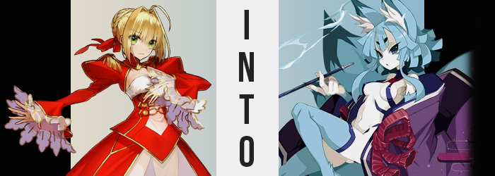

While our examples of Servants within Chaldea’s new ownership had demonstrated good eggs that did as they were told thus far, there were still those that were less than pleased with their current circumstances. Some that did not agree with being put into lockdown, much less being kept so separated from their Master. It was these Servants that were, for the most part, sealed away for the time being. But even then sealing process took time, so until it was their turn they were kept in specialized cells beneath the building.

One such Servant was Nero Claudius. Already a rambunctious soul that loathed being spoken down to, the introduction of an element that seemingly existed to do just that had amounted to a number of outbursts on her part. She would not listen to any invaders! She would only listen to her Master, Ritsuka! Even among the group of Servants that did not enjoy the Clock Tower’s presence, she was an exceptional case.

“I command you to LET ME OUT!” Trapped within one of the cells meant to hold disobedient Servants, Nero lashed out at a Chaldea staff member that had brought her food and water. While Servants were constructs of magic and didn’t exactly need to eat, they had to do so to keep their mana levels at an appropriate point. The staffer did feel guilty about it, but she was under strict orders to ignore the Servants she brought food and water to unless she wished to lose her job.

This left the Saber to huff alone as she paced about her tiny cell, arms crossed beneath a bosom that was quite impressive for a young lady of her height. “How dare they confine ME down here! When all I want to do is aid my Master with their woes! Just what are you doing to them, you bastards!?” She knew full well by now that no amount of effort would break what bound her in this place. The walls of this cell rejected the very fabric of her being, the magic properties that physically bound her put into disarray just by touching the pale red walls that surrounded her. Not even entering spirit form could bypass it.
Angrily, she sipped at the glass of water she had been given. She found it helped with the migraines she suffered to have liquids, and since she was so emotional said migraines had plagued her from the very moment she had entered the cell. Naturally she, nor the woman who had served it to her, knew anything about this water being polluted. And perhaps that was for the best in the end.

“Umu? That’s strange. My migraine disappeared? Just like that?” Not that the tiny emperor was complaining, but it certain had struck her as a little unusual. She couldn’t have possibly fathomed that the migraine had disappeared because the skill that forced it upon her had been lifted from her though. As had every skill.

Nero hardly minded, though. Being free of that accursed migraine was the greatest gift she could ever ask for! Well, maybe if she’d also been sent some beautiful women to fuss over then that would have been a better gift, but she would take what she could get! Mind you, having her head cleared of her greatest nemesis had not come without a cost, and said cost could be seen against the woman’s skin.

Or rather, her skin was the cost. Its healthy pink glow was escaping her, and in its place there was an almost sickly white what spread throughout her complexion. Whether it was her face, her breasts, her tummy, or her limbs, they all took on this ghastly pale. Where she didn’t receive it, of all places, were her nipples and clit, which instead took on a dark blue that didn’t look much like a healthy color whatsoever.

“Hey! Just because my migraine is gone doesn’t mean I’m not mad though!” So caught up in the first positive emotion she’d had since she had been thrown in the cell, she was quick to correct her scowl. Nero bared her teeth, unbeknownst to her that she was instead baring fangs a little more literally than normal. Because her canine teeth were much longer and sharper than normal, looking more like they belonged to a beast than an emperor.

Thing really were trending in that direction – one that gave off the impression that Nero’s humanity was in peril – but more had to be taken from her before that picture truly became apparent. Such as the beautiful blonde locks that the woman was notorious for. The hairs themselves didn’t disappear, but the gold was contended by a color that was rather strange. An icy blue that weaved through it all, ultimately replacing each and every strand upon not only her head, but within her leotard as well.

Strangely her brows turned black, and more than that they became little more than two round spots above her eyes. Even her (now blue) hair shifted in style, the braided bun in the back coming undone as the cuts of her hair took on blockier shapes. The length of it all wasn’t exactly compromised for the most part, but her ahoge did flatted while the hair that framed her face alone dangled longer, right past her chest.

Blue came awash against the emerald of her shining eyes next, but satisfied little with only leaving a change of color, their design soon changed as well. Eyelids narrowed passively, pinching in closer at the corners so that much of her eyes appeared to be rather veiled even when open as wide as she could muster passively. The end result was an aesthetic that was much more Eastern than was true of Nero’s heritage, in fact making her look Japanese. Were she in her right mind to realize just what was transpiring, she might have cursed the fact that she was looking more akin to the fox whom she loathed so much. But the extent of those similarities in general would worsen much more dramatically.

“My, I feel a little strange. Subdued? Where did all of my energy go?” It was a puzzling affair. For how boisterous Nero had been up to just moments ago, she now felt unusually calm and couldn’t find that spark within that made her go BRRRRRRRR. Instead, she was dancing around her cell with grace, without a single wasted movement whatsoever.

This fresh elegance became complimented by a face that spoke to a more mature demeanor, with narrowed feature and more pronounced lips that not only spoke to her being Japanese, but created the impression that she was a proper adult despite her height remaining unchanged. In fact, shorts of what was a slight loss in the size of the woman’s breasts, her figure more or less remained consistent with her usual proportions.

Her fingers twitched not because they were changing but because the Saber felt something. An urge? A craving. She was not one to smoke, but her body was going through withdrawals as if it needed one. But even though this addiction was the cause of her fingers twitching, that didn’t mean that nothing was happening regarding them. Quite the contrary, in fact.

Her fingers were swelling. For a time it was almost reminiscent of an allergic reaction, what with how they became longer and thicker. Yet as her nails were pulled longer and sharper, and the skin around them began to appear rather fuzzy, it was evident enough that this wasn’t the case. In fact that white fuzz was a soft fur that coated her hands in their entirety. When it reached her wrists? The thicker fur that spread was the same blue as her hair, and crept all of the way to the bases of her shoulders.

Similar blue hairs erupted across her legs from the peaks of Nero’s thighs right down to the tips of the woman’s toes. Unlike her hands, her feet did not swell, but the fur at the very tippy-tops of her tootsies was undeniably of a darker blue than the rest. “…Where is my pipe!? Eh…? Did I have a pipe!?” Rather than address her new fuzziness, the woman herself was far too fixated on her smoke addiction, which culminated in an outburst demanding an item she couldn’t quite recall owning. Or could she? Her head felt so fuzzy…

Much like the pair of fuzzy delights that were reaching up from the base of her head. Not from nowhere, mind you. Her once-human ears had slowly been crawling up the sides of her head, growing longer in the process. They reached up towards the roof of her cell, blue fur coating them until they peaked with darker points. Evidently the ears of a fox, there were ample tufts of white fur lurking within them.

“Hm?” Rather than dissipate before her transformation had completed, her clothing chose that moment to dissipate into a plethora of golden sparkles that floated around the room of her imprisonment. She perceived them but didn’t think much of them, nor of the immense pressure that predated what amounted to an explosion of fluff behind her.

Because not one, not two, not even three new appendages erupted from the base of her spine… but nine. Nine vulpine tails, each one as big as her body and enveloped in fluffy, ice blue fur with darkened tips. Each one swished about according to Nero’s full control, and she felt right at home controlling them. With tails like these, there were no shortages of individuals that would desire to lay with her. Which was something that now sounded quite appealing. It was clear why her clothes had dissipated first though, as there was no way they would have survived a fuwa explosion of that degree.

And so the particles returned to her body, but the outfit she was gifted could be hardly seen as an outfit. It was largely composed of a network of skintight, blue bindings that wrapped around her nipples and crotch like a net designed to obscure only the naughtiest of bits, while a purple kimono was draped about her shoulders. It was very reminiscent of the outfit of a certain oni in Chaldea. Perhaps a little too reminiscent.

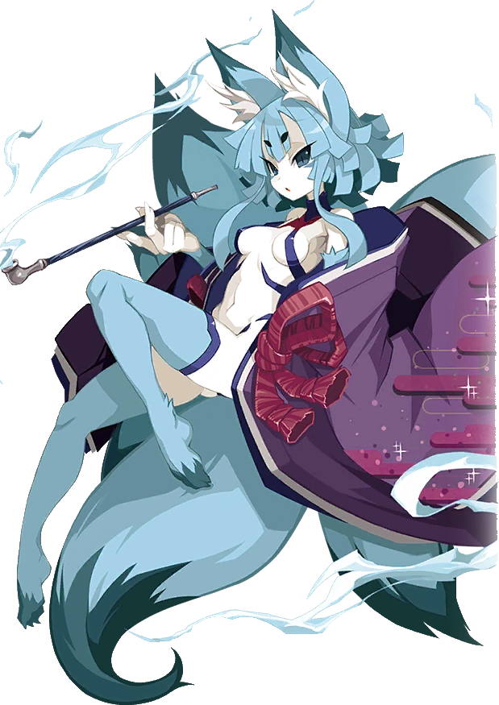
A pipe in hand, the vulpine woman exhaled a circle of smoke from her vague snout after first taking a meaningful inhalation. Furred feet took several steps towards what had once acted as a barrier, but as her body was once again regular flesh and blood, the Nine-Tail demon was more than capable of passing through. “My, my? Did they hope to contain a beast with such a lackluster showing? Well, I suppose it wasn’t meant for me. Not as I am now.”

The fox woman, now going by the name Nemu, had a vague memory of the life she had once led. And yet at the same time there were memories of the life she had now. By human standards she was little more than a monster, a creature that posed a threat to humanity. Yet she was much, much weaker than a Servant and was permitted to aide Chaldea as something of a guide whenever their missions turned them towards Japan.

She was also something of a courtesan to those that desired her body, albeit one who spent most of her time with Shuten-Douji. That oni was surprisingly frisky considering her size, and couldn’t get enough of Nemu’s fur. “On that note, I suppose I should pay her a visit. There’s no doubt it’s been long enough since our last encounter.”

