**Nanami and the Mask of Izanami**

**Tokyo 05.08.2021**

It was a normal Day in Tokyo and Nanami decided to go into the Shopping District in Shibuya and go to Buy some Clothes and maybe two or three sweets which she can send to her big Sister Akira. After some hours of shopping she finally found a cute new Outfit. It was a whine red top in combination with white shorts and a belt. The new Outfit showed her Body quite well and Nanami loved this because she always wanted to show off her Female Curves more. With her new Clothes in her Bag Nanami walked some streets deeper into Shibuya and she came across an old looking store with antiques and she thought: **“Huh? I never noticed this Store before. Must be a new one lets have a look what they have to offer.”**

Nanami entered the Store and the Clerk welcomed her then Nanami walked around the store and she see many interesting things like some old Katanas and some other antique looking things.

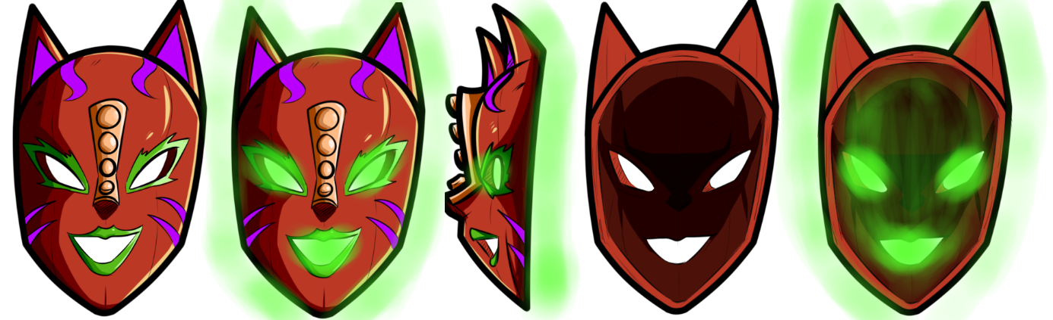Shortly after that Nanami found a Wall with old looking Masks there were mostly old Hanya Masks and only a Few Kitsune Masks but one Masks looked interesting to Nanami and she decided to take it from the Wall to look at the Price. The Mask was an old looking wooden Kitsune Mask but with unusual colors and made of Japanese Cherrywood. **“Oh! This one looks cool.”** Nanami thought to herself.

But sadly, there was no Price Tag on it so she asked the store Clerk how much it costs. The store Clerk said **“Ah yes! A good choice this is the so-called Mask of Izanami. It is rumored that this Mask was created by the Goddess Izanami herself and has some magical power. But to me it looks just like a Special Kitsune Mask. It will cost 2500 Yen if that’s ok for you?”**

**“Yes, that’s fine. I take it. It will be a nice Decorative Mask for my Room.”** answered Nanami.

Nanami handed the 2500 Yen over and takes the bag with the Mask.

**“Thank you very much please come again.”** said the store clerk.

**“Thank you for your help too.”** said Nanami.

**“Ok, now its time to find some nice sweets that I can send to Akira”** said Nanami to herself.

After some shopping later Nanami has also a Bag with all Kinds of Japanese sweets and she headed back to her Home.

**Later at the Miyasaki House**

Nanami sat in her room on her Desk and she wrote a Letter for Akira.

**“Dear big sis,**

**I hope you have a great time in Fringe City I have you long time not seen and I hope you’re healthy and having success with your modeling career. Today I walked through Shibuya and found a cool looking old wooden Kitsune Mask I will use it for Decoration. Also, I have bought some Japanese sweets for you and I hope you like them. Maybe someday I can visit you in Fringe City.**

**Bye your little sister Nanami.”**

**“Perfect this should made Akira happy. ^^”** said Nanami to herself.

Then she grabbed the Bag with the Mask and take the Mask in her Hands to inspect it a little further. As she already knows the Mask is Made out of Japanese Cherrywood and after some more inspection the Details of the Mask were amazing. Also, she noticed that the plate for the Nose was made out of Pure gold but it was not polished. Then Nanami polished the gold a little bit and now it was really shiny. Suddenly as Nanami looked at the inside of the Mask she see a green glow and she suddenly have the urge to bring the Mask Closer to her Face but just before the Mask reached her Face she snapped out of the trance and said “I will inspect you later first I must get the Package for Akira Ready.” And she put the Mask on her desk.

Some minutes later the Package was ready and she sat on her bed to play some Nintendo Switch suddenly she heard a Voice **“Hey sweetie don’t you want to be a Famous Model like your Sister too?”**

**“Huh? Who said this?”** asked Nanami confused

The Nanami picked up the Mask from her Desk and said **“No, it can’t be. Masks can’t talk.”**  
  
**“Are you sure sweetheart?”** the voice said.

**“What? You can speak? But how?”** said Nanami.

**“Oh, silly you. I’m Magical. But don’t you want to become a Famous Model like your big Sister?”** said the Voice.

**“Y-yes. This would be amazing.”** said Nanami.

**“Then let us form a Contract! I can grant you anything you want you just need to wear me. Also, I grant you some special Powers. But sometimes I take over control to have some Fun myself. How’s that sound for you sweetie?”** said the Voice.

**“You can really help me?”** asked Nanami.

**“Of course, I can! Buy the way I’m Inari the spirit of this Mask”** answered the Voice.

**“Guess then we have a Deal Inari-chan”** said Nanami.

The she Put the Mask closer to her Face and suddenly the Mask Jumped on her Face and starts to spread around her head quickly Nanami started too feel pure pleasure. **“Oh Yes! You’re perfect Honey. Now its time for Fun!”** said the Voice.

**“W-what’s Happening!”** said Nanami with a mix of pleasure and shock.

Then Nanami’s breasts and Ass started to become bigger and much firmer. Also, her hair color shifts from Brown to light Blue with Red tips and she gets two cat ears and and her teeth gets two cute cat Fangs.

**“Ahhhh <3 T-this feels Great! M-m-meow <3”** said Nanami in pure pleasure.

**“Oh, just wait Honey I’m not done yet.”** said Inari.

Shortly after that Nanami’s Legs are becoming longer and more defined also her Abs are firmed up and she gets a Sexy Six pack. But that was not all behind Nanami grow two Cat tails and then two fox Tails right above her now bigger and sexier Ass. Then Nanami can’t hold back anymore and she said in pure pleasure **“Ahhhh! I can’t hold back Anymore! More! Meeeow <3”**

Nanami came multiple times then she was engulfed by a Red and Green Twister and started to spin around her room.

Some seconds later the Twister stopped and a Completely new Nanami stands in the Room.

Nanami has now Two Cat ears and two Cat Tails and two fox Tails. The two fox Tails are light Blue with Red Tips just like her Hair and the Cat tails were light Blue with white Tips. Her legs are now longer and much sexier, her hips are a little bit wider, her ass is now big and perfectly firm. Nanami’s waist is now a little bit slimmer and her belly is perfectly defined, she has a well-trained sexy six-pack and Nanami’s C-Cup breasts are now a massive and firm F-Cup.

Her Outfit changed into a sport Outfit which hugged her now massive Curves perfectly but that was not all her feels now rubbery and is light red in color also she wears a Sexy Make-Up with dark purple lipstick and light blue eyeshadow.

Then the new Nanami strikes a sexy Pose and said: **“Wow! That was Amazing! Meow <3 Time to Turn the City Upside down.”**

**The End**

**Credits:  
Thanks to Megalinx for the great Artwork of my Mask**

**Also thanks to all my Patreon Supporters**