**Tension Force Problems**

**Worksheet**

9 Practice Questions

Organic Chemistry Tutor

1. A rope is used to lift a 50 kg box with an upward acceleration of 2.3 m/s2. (a) What is the tension in the rope? (b) What would be the tension in the rope if the box descended slowly with a downward acceleration of 0.75 m/s2 ?

2. What is the tension in the two ropes in the picture shown below?

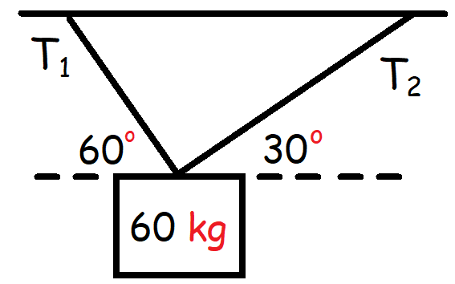

3. Calculate the tension in the two ropes shown below.

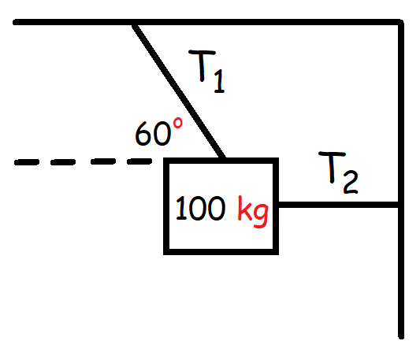

4. Calculate the tension force in the rope connecting the two blocks as shown below:

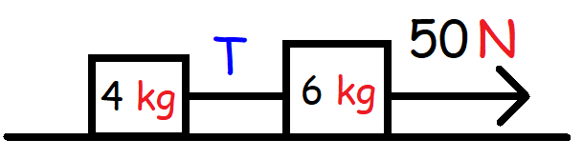

5. Calculate the tension force in the rope between the two blocks shown below. The coefficient of kinetic friction between the blocks and the horizontal surface is 0.25.

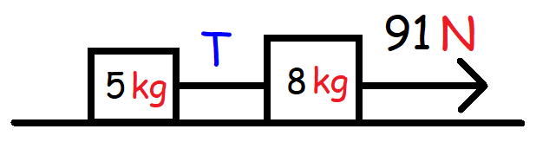

6. Calculate the tension force in each rope that connects two blocks as shown below. There is no friction across the horizontal surface.

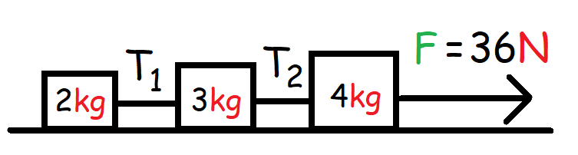

7. What is the magnitude of the tension force in each rope shown below?

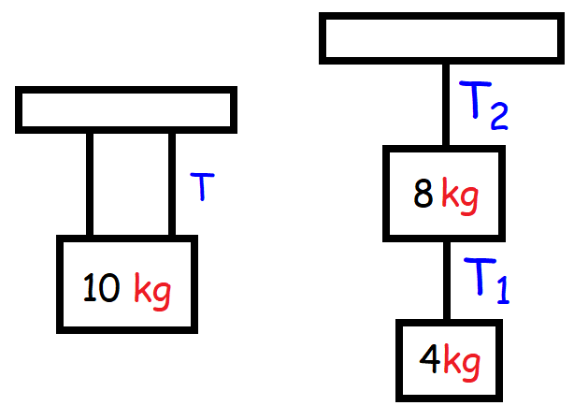

8. A 10 kg block is pulled to the right by a tension force on a surface with a coefficient of kinetic friction of 0.20. (a) What tension force is needed to pull the block to the right at constant speed?

(b) What tension force is needed to pull the block to the right with a constant acceleration of 2 m/s2 ?

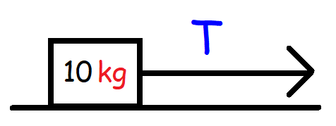

9. A 15 kg block is pulled to the right by a tension force directed 300 above the horizontal as shown below. The coefficient of kinetic friction between the block and the surface is 0.25. What tension force is needed to pull the block to the right with a constant acceleration of 3 m/s2?

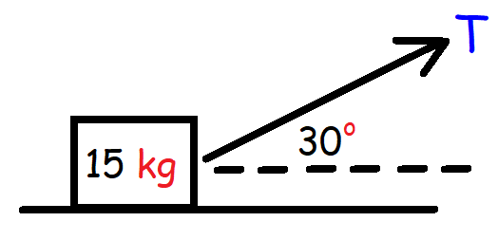

**Answers:**

1a. 605 N

1b. 452.5 N

2. T1 = 509 N, T2 = 294 N

3. T1 = 1132 N, T2 = 565.8 N

4. 20 N

5. 35 N

6. T1 = 8 N, T2 = 20 N

7. T = 49 N, T1 = 39.2 N, T2 = 117.6 N

8a. 19.6 N

8b. 39.6 N

9. 82.5 N