**Organic Chemistry Exam 2**

**Worksheet**

Organic Chemistry Tutor

1. Which of the following represents the name of the compound shown below?

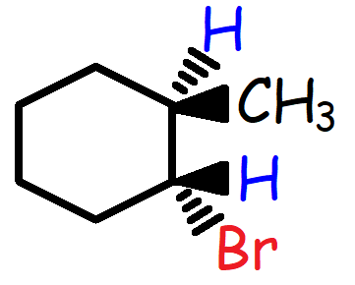

A. (1R, 2R)-1-bromo-2-methylcyclohexane

B. (1R, 2S) -1-bromo-2-methylcyclohexane

C. (1S, 2R) -1-bromo-2-methylcyclohexane

D. (1S, 2S) -1-bromo-2-methylcyclohexane

2. Which of the following alkyl halides would you expect to undergo a SN2 reaction most rapidly?

A. 1-Bromobutane

B. 2-Bromobutane

C. 2-Bromo-2-methylbutane

D. 2-Bromo-3-methylbutane

3. Which of the following solvents will work best in a SN1 reaction?

A. Hexane

B. Ethanol

C. Acetone

D. DMF

E. H2O

4. What is the major product of the following reaction?

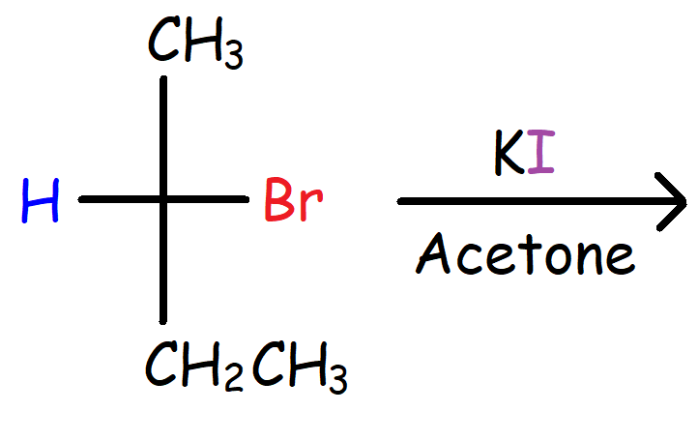

A. (R)-2-Iodobutane

B. (S)-2-Iodobutane

C. A racemic mixture of A and B

D. None of the above

5. What is the major product that will be formed when 1-Butene reacts with HBr?

A. 1-Bromobutane

B. (R)-2-bromobutane

C. (S)-2-bromobutane

D. A racemic mixture of B and C

6. Which of the following reagents will convert 3-Methyl-1-butene to 3-Methyl-2-butanol?

(A) 1. BH3/THF 2. H2O2, OH-, H2O

(B) 1. Hg(OAc)2, H2O 2. NaBH4

(C) H2O/H2SO4

(D) 1. MCPBA 2. H3O+

(E) 1. OsO4 2. NaHSO3, H2O

7. What is the relationship between the two compounds shown below?

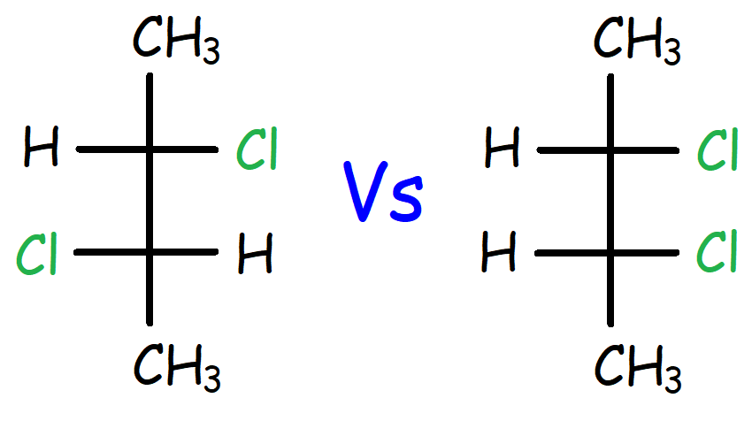

A. Enantiomers

B. Diastereomers

C. Constitutional Isomers

D. Meso Compounds

8. Which of the following reagents will produce a meso compound after reacting with Cyclohexene?

A. Br2 / CCl4

B. 1. MCPBA 2. H3O+

C. H2O / H2SO4

D. CH3OH / H2SO4

E. 1. OsO4 2. NaHSO3, H2O

9. Which of the following is the major product that is formed in the reaction of Propyne with Sodium Amide followed by Ethyl Bromide?

A. 1-Pentyne

B. 2-Pentyne

C. 1-Pentene

D. 2-Pentene

10. 3g of a chiral stereoisomer was dissolved in 20 mL of solution. The observed rotation measured by a polarimeter was found to be -90 at 250 C using a wavelength of 589 nm. The sample tube of the polarimeter is 20 cm long. What is the specific rotation of the stereoisomer?

11. How many possible stereoisomers exist for 3-Ethoxy-4-methylcyclohexanol?

12. What is the major product that will be formed when 3,3-Dimethylcyclohexane reacts with Hydrobromic Acid?

13. What is the major substitution product of the reaction shown below?

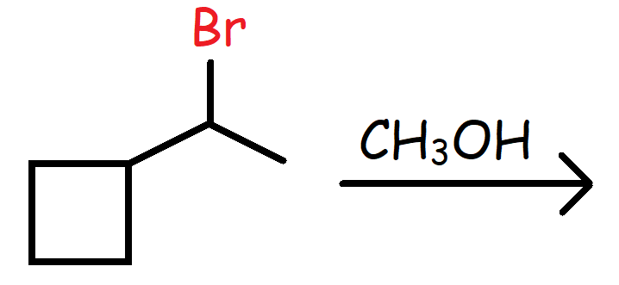

14. Which of the following reagents will convert 2-Butyne into Cis-2-butene?

A. H2 / Pt

B. H2 with Pd/C

C. Na(s) / NH3(l)

D. H2 / Lindlar’s catalyst

15. Which of the following compounds will be produced when 2,3-Dimethyl-2-butene reacts with Ozone followed by Dimethyl Sulfide?

A. Ethanal

B. Propanal

C. Acetone

D. 2-Butanone

16. What is the relationship between the two compounds shown below?

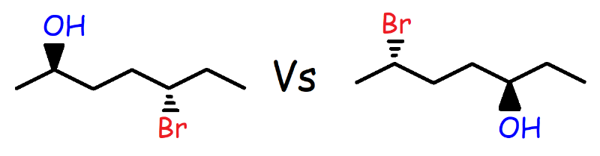

A. Diastereomers

B. Enantiomers

C. Constitutional Isomers

D. Meso Compounds

17. Calculate the % enantiomeric excess for a solution that contains 16g of (R)-2-bromobutane and 4g of (S)-2-bromobutane.

18. Which of the following alkenes is most stable?

A. 1-Hexene

B. Trans-2-hexene

C. Cis-2-hexene

D. 2-Methyl-2-pentene

E. 2,3-Dimethyl-2-butene

19. Which of the following alkyl halides will react most readily in a SN2 reaction?

A. CH3CH2-F

B. CH3CH2-Cl

C. CH3CH2-Br

D. CH3CH2-I

20. Which of the following represents the correct rate law expression for a SN1 reaction?

A. Rate = k[Substrate][Nucleophile]

B. Rate = k[Substrate]

C. Rate = k[Substrate][Base]

D. Rate = k[Base]

E. Rate = k[Nucleophile]

21. Which of the following statements is not true?

A. The rate of a SN2 reaction will double if the concentration of the nucleophile doubles.

B. The rate of an E1 reaction will triple if the concentration of the alkyl halide triples.

C. The rate of an E2 reaction will increase by a factor of 6 if the concentration of the alkyl halide doubles and the concentration of the base triples.

D. The rate of a SN1 reaction will quadruple if the concentration of the nucleophile quadruples.

22. Which of the following reagents can be used to convert 1-Methylcyclohexene to 1-Bromo-2-methylcyclohexane.

A. Br2 / CCl4

B. Br2 / H2O

C. Br2 / CH3OH

D. HBr

E. HBr / ROOR

23. Which of the following reagents can be used to accomplish the transformation shown below?

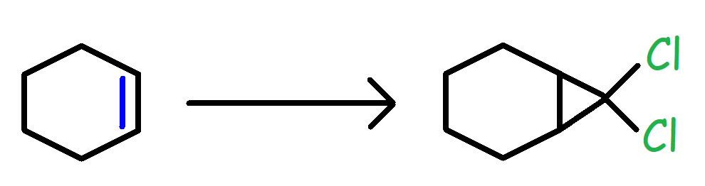

A. CH2N2 / heat

B. Zn(Cu) / CH2I2

C. CHBr3 / KOH

D. CHCl3 / KOH

E. Cl2 / CCl4

24. Which of the following nucleophiles will yield the fastest SN2 reaction in a polar aprotic solvent such as DMSO?

A. F-

B. Cl-

C. Br-

D. I-

25. Which of the following alkyl halides will have the greatest reactivity in a SN1 reaction?

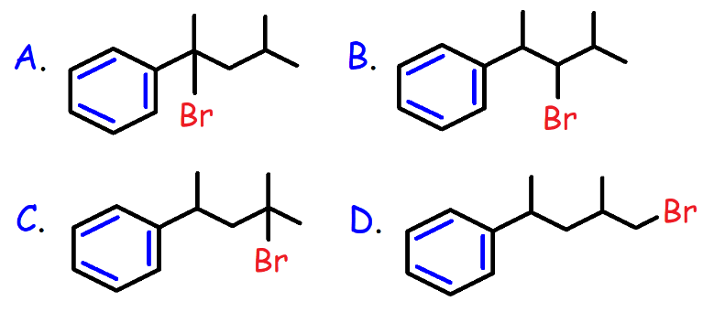

26. Which of the following molecules is optically inactive?

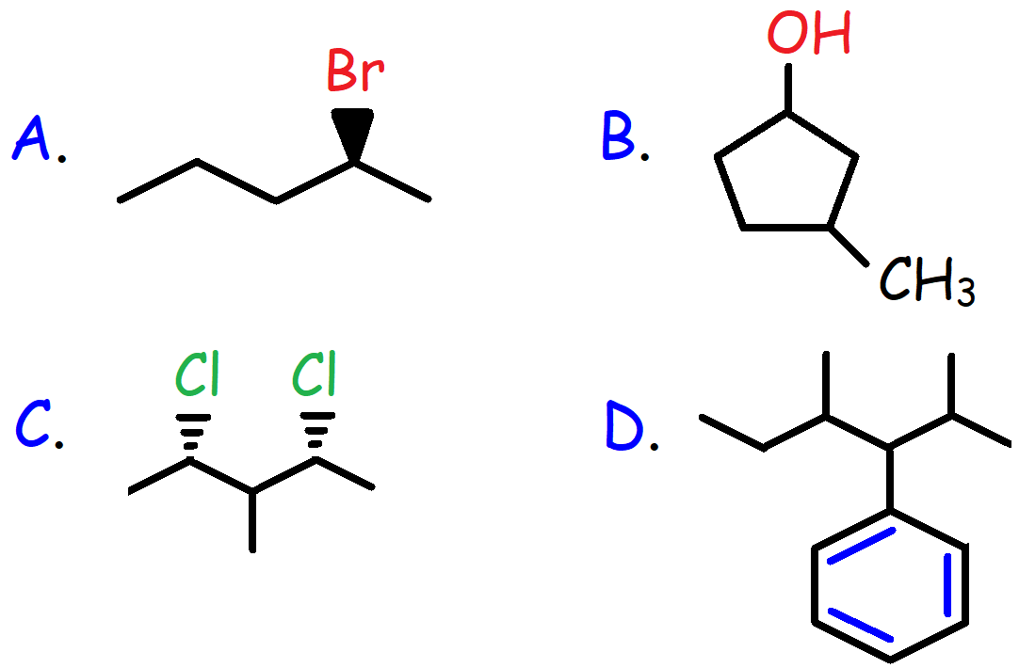

27. Which of the following solvent mixtures will yield the fastest reaction between Tert-butyl Bromide and Potassium Iodide?

A. 25% H2O / 75% CH3OH

B. 50% H2O / 50% EtOH

C. 50% H2O / 50% MeOH

D. 100% CH3CH2OH

28. Which of the following nucleophiles will work best in a SN2 reaction with a polar protic solvent such as EtOH?

A. OH-

B. CH3S-

C. CH3SH

D. -SCOCH3

E. C6H5O-

29. What is the major product of the reaction shown below?

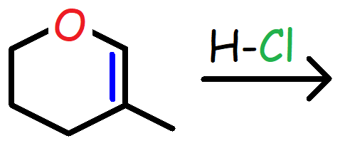

30. Which of the following reagents will proceed with anti-addition upon reacting with

1-Methylcyclohexene?

A. H2 / Pt

B. KMnO4, Cold / OH-, Dilute

C. 1. BH3 / THF 2. H2O2, OH-

D. Br2 / CH3OH

31. What is the major product of the reaction shown below?

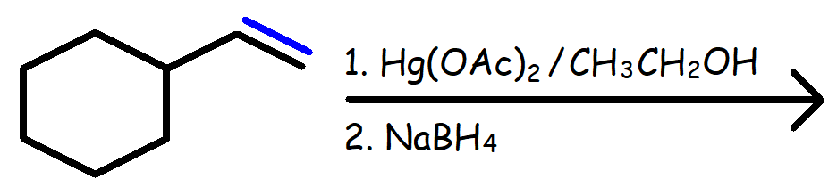

32. Which of the following compounds could be a major product of the reaction shown below?

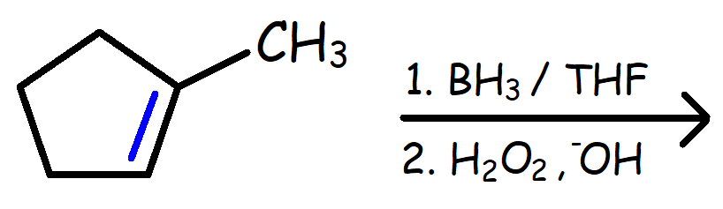

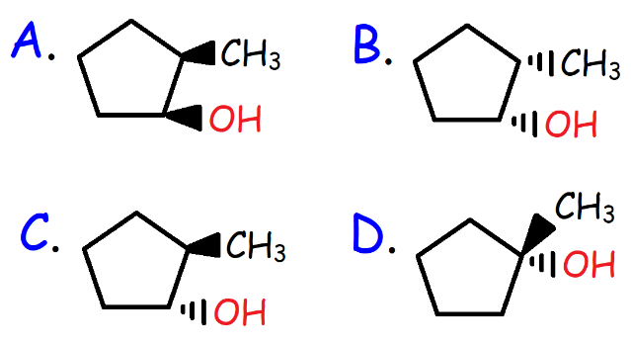

33. How many possible products can be produced from the reaction of 2-Pentene with HBr?

34. Which of the following reagents will convert

1-Butyne to 2-Butanone?

(A) H2 / Pd

(B) Li(s) / CH3NH2(l) @ -500 C

(C) 1. R2BH 2. H2O2, NaOH

(D) HgSO4, H2SO4, and H2O

35. What is the major product that will be produced when 1 mole of Br2 reacts with 1 mole of 2-Methylpropene and 2 moles of NaCl?

36. What is the major product that will be produced when 3-Methylcyclohexene reacts with BrCl?

37. Which of the following statements is not true?

A. The SN2 mechanism is a concerted reaction where all bond breaking and bond formation processes occur simultaneously.

B. The SN2 reaction proceeds with inversion of configuration.

C. The SN1 reaction produces an unequal racemic mixture of products due to the presence of an intimate ion pair.

D. The SN2 reaction is enhanced by a polar aprotic solvent because it solvates the cation but not the nucleophilic anion.

E. The SN2 reaction generates carbocation intermediates and is subject to carbocation rearrangements.

38. Which of the following compounds will undergo solvolysis in aqueous Methanol most rapidly?

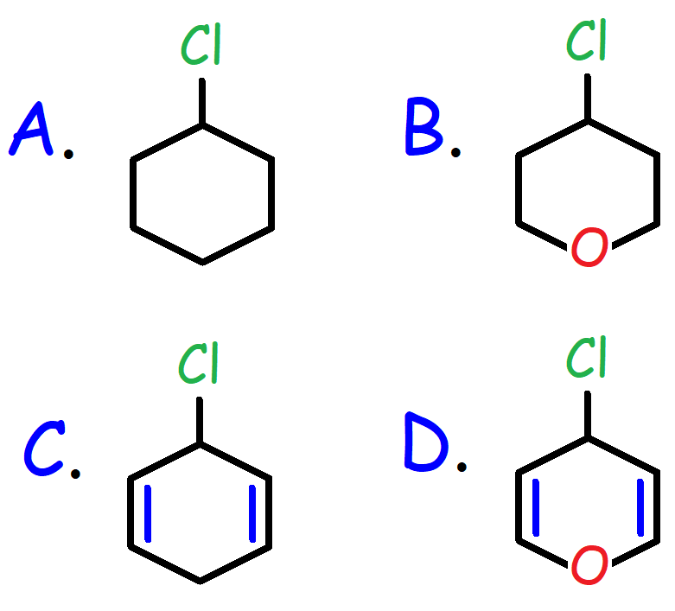

39. What is the major product produced from the reaction of 1-Bromopentane with Methanol?

A. 1-Methoxypentane

B. 1-Pentene

C. 2-Pentene

D. (R)-2-Methoxypentane + (S)-2-Methoxypentane

40. How many intermediates are present in the potential energy diagram for the reaction shown below?

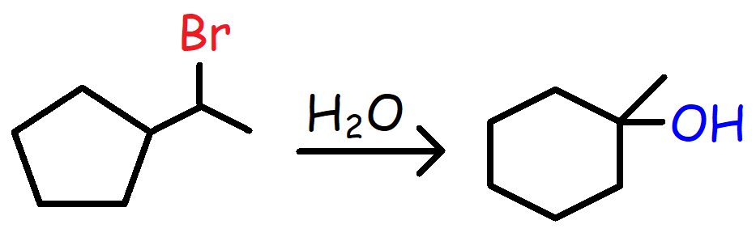

A. 2

B. 3

C. 4

D. 5

41. What is the major product of the reaction between 5-Bromo-2-methyl-1-pentanol with Sodium Hydride?

42. What is the major product of the reaction between Cyclohexene with Br2 in H2O followed by NaH?

43. What is the major product of the reaction shown below?

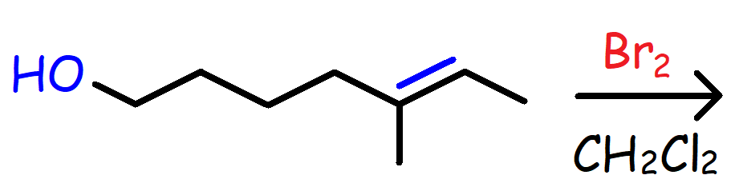

44. Which of the following is the major product of the reaction between 2-Bromopentane and Sodium Ethoxide in Ethanol?

A. 1-Pentene

B. Cis-2-pentene

C. Trans-2-pentene

D. 3-Pentene

45. How many possible elimination products can be produced in the reaction of 2,2-Dimethylcyclohexanol with concentrated Sulfuric Acid and heat?

46. What is the major product of the reaction when 2-Bromo-2-methylpentane reacts with Sodium Methoxide in Methanol?

47. What is the major product of the reaction when 2-Bromo-2-methylpentane reacts with Potassium Tert-butoxide in Tert-butanol?

48. What is the major product of the reaction when 2-Fluoropentane reacts with Sodium Methoxide in Methanol?

49. What is the name of the major elimination product of the reaction when 2-Bromo-3,4-dimethylhexane reacts with Methanol at 950 C?

50. Which of the following bases will convert

1-Bromobutane to 1-Butene with the greatest yield?

A. KOH

B. NaOCH3

C. NaOCH2CH3

D. KOC(CH3)3

E. KOC(CH2CH3)3

51. What is the major product of the following reaction?

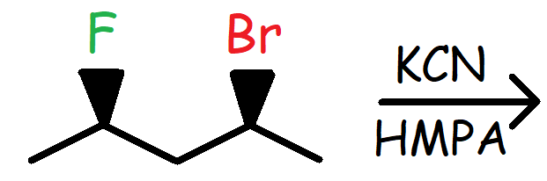

52. What is the major product of this reaction?

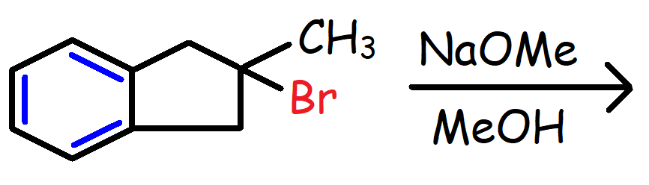

53. What is the major product of this reaction?

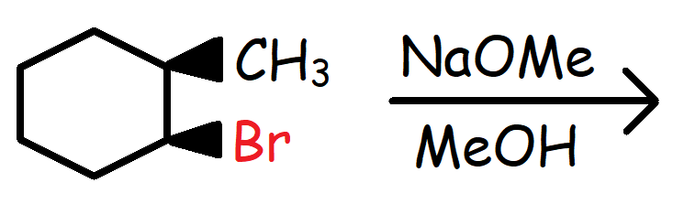

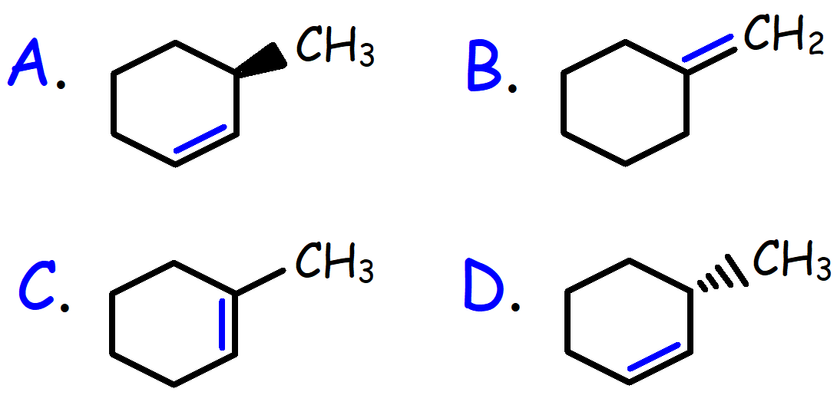

54. What is the major product of this reaction?

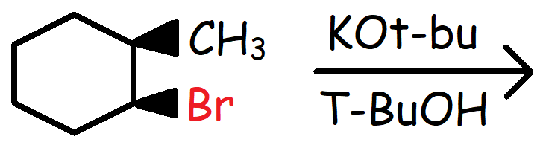

55. What is the major product of this reaction?

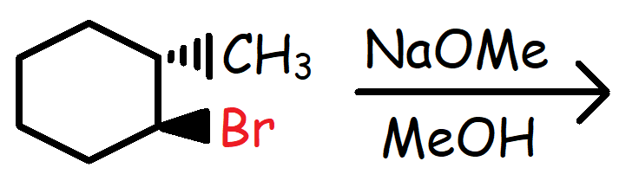

56. Which of the following compounds will have the fastest reactivity in a SN2 reaction?

A. Phenyl Bromide

B. 1-Bromo-1-butene

C. 1-Chloro-2-butene

D. 3-Iodo-1-Butene

57. Which of the following bases will convert 1-Bromopentane to 1-Pentene with the greatest yield?

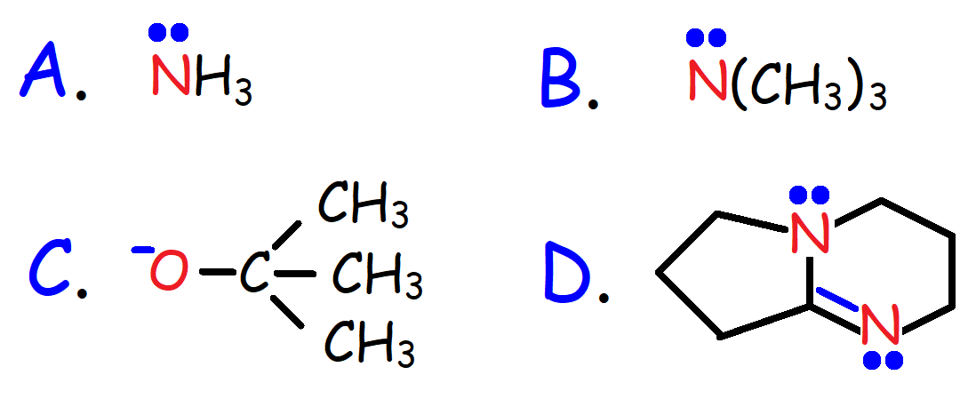

58. What is the major product?

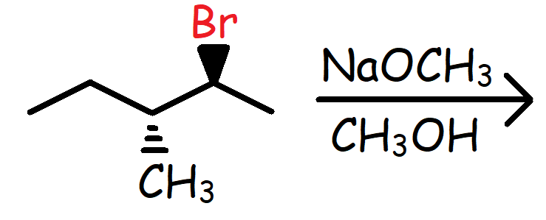

59. Which of the following statements is not true?

A. Good leaving groups are weak bases and bad leaving groups are strong bases.

B. The SN2 reaction works well with methyl and primary alkyl halides due to steric factors.

C. The SN1 and E1 mechanism works very well with tertiary alkyl halides due to carbocation stability.

D. Vinyl and aryl halides work very well with SN1 and SN2 reactions due to alkene stability.

E. The E2 reaction works well with tertiary alkyl halides because the transition state resembles a more stable alkene.

60. Which of the following molecules is chiral?

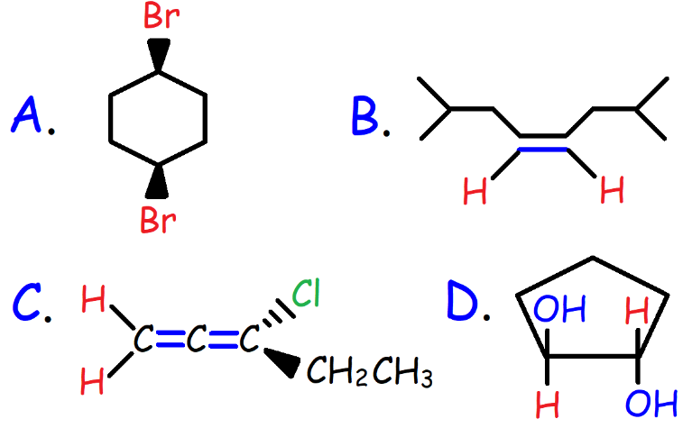

61. What is the major product of the reaction shown below?

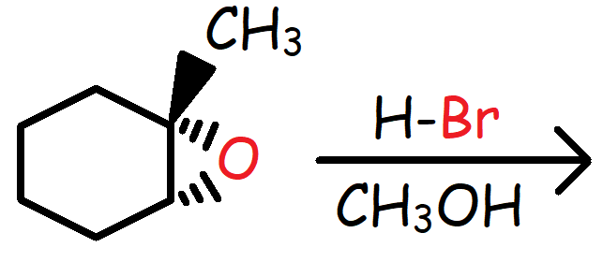

62. Which of the following statements is not true?

A. Diastereomers have different melting points.

B. Enantiomers have the same density but different optical properties.

C. Meso compounds are optically inactive.

D. Enantiomers can be separated by distillation.

E. A racemic mixture of enantiomers will not rotate plane polarized light.

63. A solution has an enantiomeric excess of 60%. (R > S) How many grams of the R and S stereoisomers are present in the solution if a 50g sample of the chiral compound was dissolved in the original solution?

64. Draw the structure of the alkene that will produce Cyclopentanone and Acetone upon reacting with Ozone at -780 C followed by Zinc in Acetic Acid.

65. Which of the following is not an intermediate in the Ozonolysis reaction of Cis-3-hexene followed by DMS?

A. Propanal

B. Molozonide

C. Carbonyl Oxide

D. Ozonide

E. Propanone

66. Which of the following reactions will generate a meso compound?

A. Cis-2-butene and Br2/CH2Cl2

B. Cis-2-pentene + OsO4 followed by NaHSO3/H2O

C. Trans-2-butene with D2 and Wilkinson’s catalyst

D. Trans-3-hexene with RCO3H followed by H3O+

67. What is the major product of the reaction shown below?

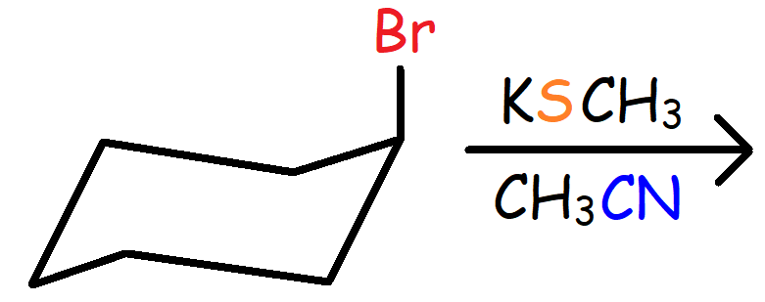

68. Which of the following reagents will reacts with 2-Methylpropene to produce Carbon Dioxide?

(A) Ozone followed by (CH3)2S

(B) KMnO4, OH-, Cold, and Dilute

(C) 1. OsO4 2. NaHSO3/H2O 3. HIO4

(D) KMnO4, H3O+, Warm, and Concentrated.

69. Which of the following reagents will convert 1-Butyne to 2-Bromobutane?

A. 1 eq. HBr in CH2Cl2

B. 2 eq. Br2 in CH2Cl2

C. H2 + Pd/BaSO4/Quinoline followed by HBr/ROOR

D. 1 eq. HBr/ROOR

E. Na(s)/NH3(l) followed by HBr in CH2Cl2

70. Which of the following reactions will generate the highest yield of Acetic Acid?

A. 2-Butyne with O3 followed by H2O

B. Propyne with KMnO4 and H3O+

C. 2-Pentene with O3 followed by Zn/CH3COOH

D. 2-Methyl-2-butene with O3 followed by H2O2

71. What is the major product of the reaction shown below?

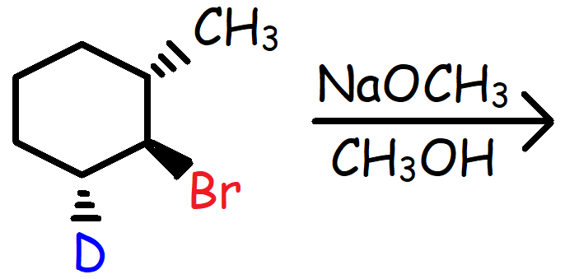

72. Which of the following compounds will be most effective in completing the reaction shown below?

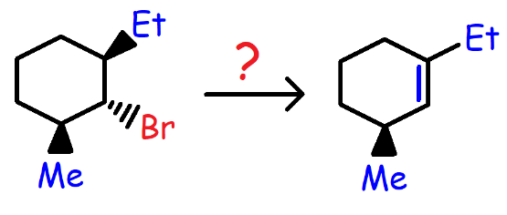

A. NaOCH3

B. CH3OH

C. KOC(CH3)3

D. KI

E. NaSH

73. Which of the following reactions will produce Methyl Tert-butyl Ether with the greatest yield?

A. (CH3)3C-I + CH3OH @ 200 C

B. (CH3)3C-Br + NaOCH3 in CH3OH

C. CH3-I + KOC(CH3)3 in (CH3)3COH

D. CH3-F + KOC(CH3)3 in (CH3)3COH

74. What is the major product of this reaction?

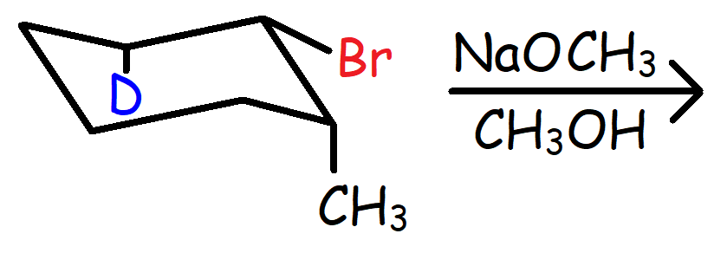

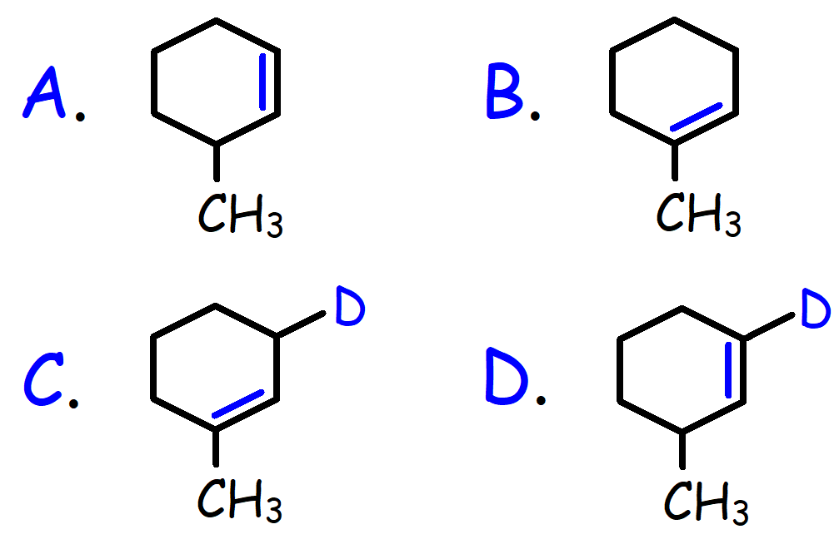

75. Which of the following reactions will not produce an alkene?

A. Trans-1,2-dibromocyclohexane + KI in Acetone

B. Tert-butanol with H2SO4 and heat

C. 1-Methylcyclohexanol with H3PO4 and heat

D. Cyclopentyl Bromide with NaN3 in THF

76. Which of the following alcohols will react most rapidly with H2SO4?

A. 1-Pentanol C. 3- Methyl-4-hexen-3-ol

B. 2-Pentanol D. 2-Phenyl-2-propanol

77. Which of the following reagents will convert 1-Methylcyclohexene to 6-Oxoheptanoic Acid?

A. Ozone followed by DMS

B. KMnO4, Cold, OH-, and Dilute

C. KMnO4, Conc., OH-, and heat. followed by H3O+

D. MCPBA followed by H3O+

78. What is the major product of the reaction?

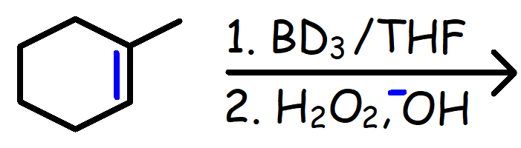

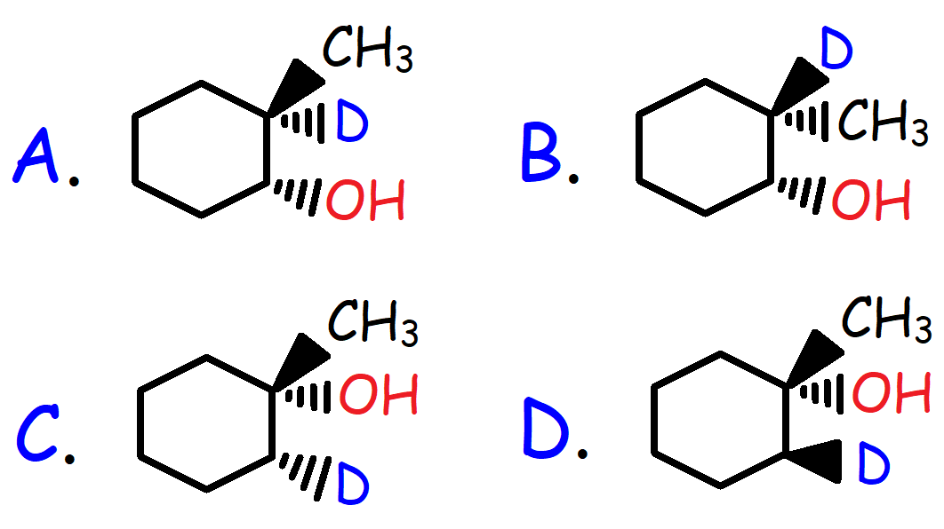

79. What is the major product of the reaction?

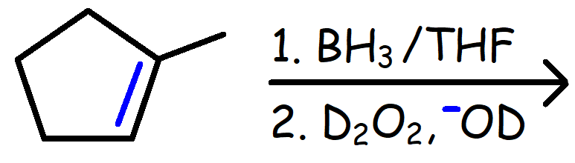

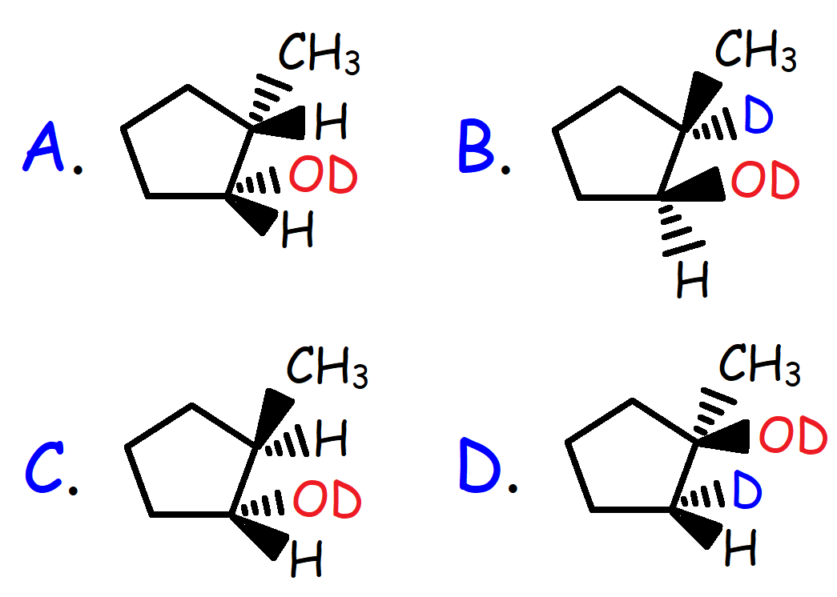

80. Which of the following alkyl halides will produce 2-Ethyl-1-pentene upon reacting with KOC(CH3)3 in (CH3)3COH?

A. 1-Bromo-4-methylhexane

B. 2-Bromo-4-methylhexane

C. 3-Bromo-3-methylhexane

D. 2-Bromo-3-methylhexane

81. What is the major product of the reaction shown below?

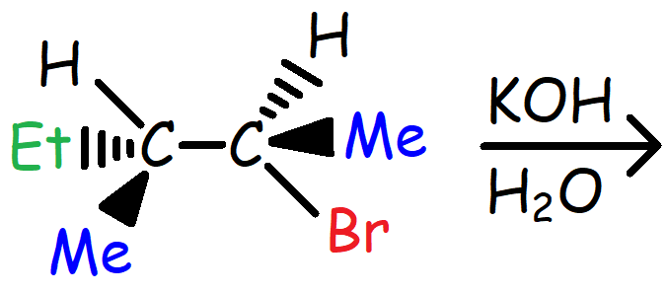

82. What is the major product?

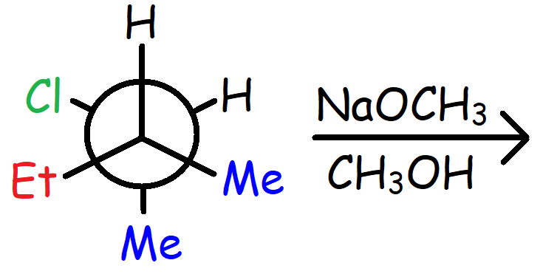

83. What is the major product that will form when (R)-2-Bromopentane is treated with KI in Acetone followed by NaCN in Acetonitrile?

84. What is the IUPAC nomenclature of the molecule shown below?

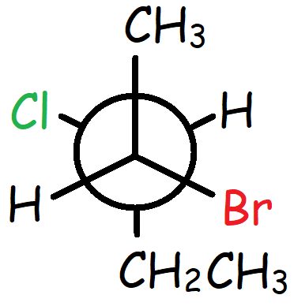

A. (2S, 3R)-2-Bromo-3-chloropentane

B. (2S, 3S)-2-Bromo-3-chloropentane

C. (2R, 3R)-2-Bromo-3-chloropentane

D. (2R, 3S)-2-Bromo-3-chloropentane

85. What products will form from the reaction of 2-Pentyne with H2/Lindlar’s catalyst followed by OsO4 and NaHSO3/H2O?

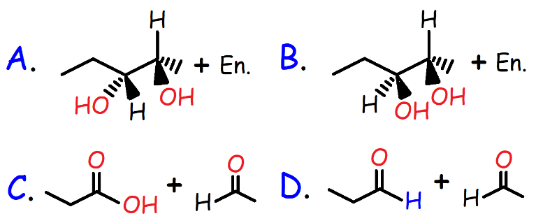

**Answers:**

1. A

2. A

3. E

4. A

5. D

6. B

7. B

8. E

9. B

10. -300

11. 8

12. 1-Bromo-1,2-dimethylcyclohexane

13. 1-Methoxy-1-methylcyclopentane

14. D

15. C

16. C

17. 60%

18. E

19. D

20. B

21. D

22. E

23. D

24. A

25. A

26. C

27. C

28. B

29.

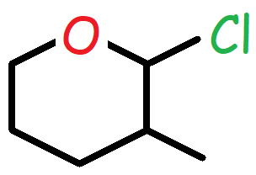

30. D

31.

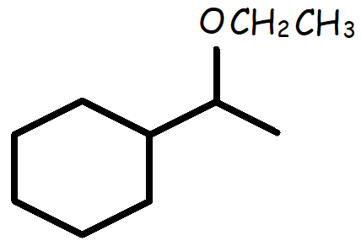

32. C

33. 3 Products (3-Bromopentane, (R)-2-Bromopentane, and (S)-2-Bromopentane)

34. D

35. 1-Bromo-2-chloro-2-methylpropane

36. 3-Bromo-1-chloro-1-methylcyclohexane

37. E

38. D

39. A

40. C

41.

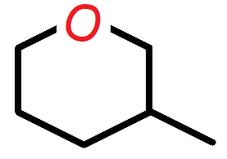

42.

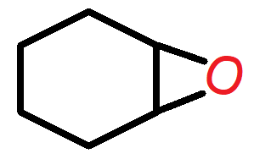

43.

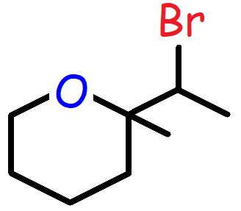

44. C

45. 4

46. 2-Methyl-2-Pentene

47. 2-Methyl-1-Pentene

48. 1-Pentene

49. (E)-3,4-dimethyl-3-hexene

50. E

51.

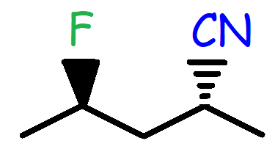

52.

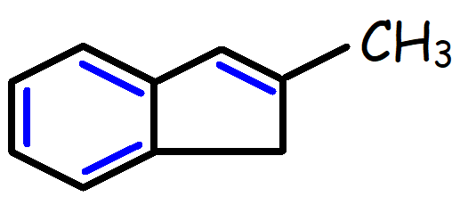

53. C

54. A

55. D

56. C

57. D (DBN)

58. (Z)-3-methyl-2-pentene

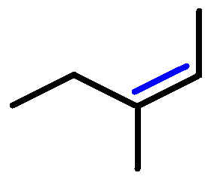

59. D

60. D

61.

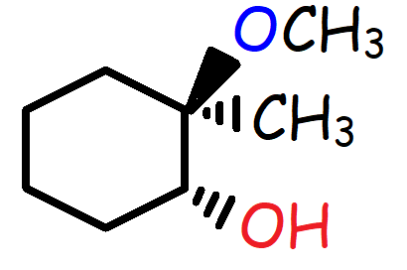

62. D

63. 40g of the R-Isomer, 10g of the S-isomer

64.

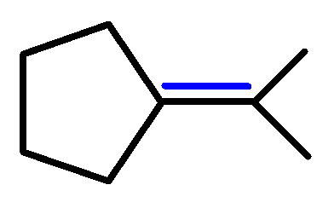

65. E

66. D

67.

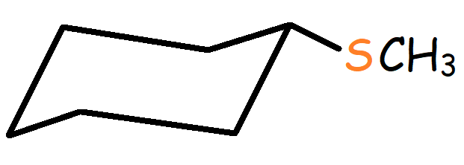

68. D

69. E

70. A

71.

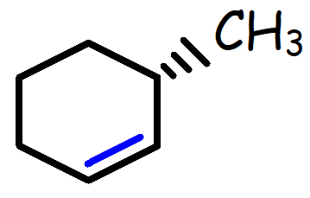

72. B

73. C

74. C

75. D

76. D

77. C

78. A

79. C

80. C

81.

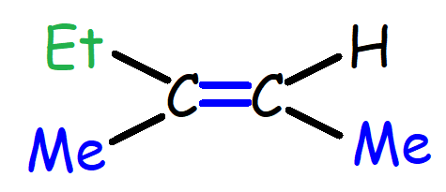

82.

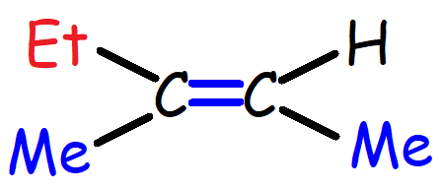

83.

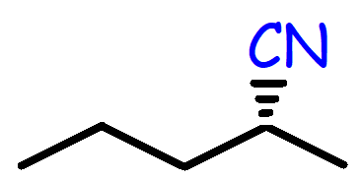

84. A

85. A