PSYCH-OPS
A Short Story
By Maryanne Peters

Twelve originally volunteered, and six were selected, including myself.

You might ask: Why would I volunteer to be a human guinea pig for a test that was too secret even for the participants to know about? The truth is I had just come off some bad sessions of repetitive fatigues for nothing offences. I was being victimized by my superior and I wanted out. This detail had special allowances and took me off the base. Just across town to another Defence Department property which housed Psychological Warfare Unit 5.

I suppose we all figured that we would be in for some stress testing – flashing lights, sleep deprivation, being shouted at, stuff like that. For me that was no different from what I had been having for months. I leapt at the chance to get away from where I was. And there was extended furlough waiting at the end.

The other guys were all small guys (I noticed that the selection process had weeded out the big guys) – two were preppy types, one in line for officer training, both taking the detail for exposure to a new experience. One was an older guy who looked like he was taking the time to dry out, and the other two much the same as me – scrawny misfits in the army: Larry and Dave. The three of us bonded instantly.

At the outset there was the usual briefing about how valuable the work would be, how we had to follow instructions to the letter, that kind of stuff. The only odd thing was some vague reference to the effect on our bodies, but as it was accompanied by the reassurance that our health would not be adversely affected, but I hardly took any notice. The armed forces are bad for anyone’s health. Something had to be expected on this kind of detail. They would look after us as best they could. That is what you expect for serving your country.

The only thing that we learned at the briefing was that we would be exposed to a weapon that would not injure us but would render us useless for armed combat. That sounded pretty cool to me, Larry and Dave. We were not looking forward to armed combat anyway. In fact, the weapon was a drug that was introduced to our water supply. We knew nothing about it. In the course of a training exercise we refilled from a jerry can that contained this drug. We were later informed that we had already been “hit” (although not how, so that we continued to drink the water) and the exercise was to continue to assess how we would react to it in the field. There were two observers placed with our 6 man unit, under the command of prep boy Johnny Dewes as acting sergeant.

I suppose it was 24 hours before we started to notice anything different. It was Larry. He fell over into a pile of mud and he just started crying, saying that he felt filthy and the mud was in his hair, stuff like that. Rob, the older guy just hugged him. It was really weird, and it seemed strange at the time, but somehow acceptable. It seemed like we were getting close as a unit, without inhibitions. It did not occur to us then that this was the effect of the new wonder weapon.

There were a couple of mock attacks on us. Looking back at it, some of the silly squealing noises that we made and the giggling afterwards, was unusual, but the truth is that I did not know these guys in my unit, and I had little to judge them by. We fired blanks back, and the observers took notes.

Later that day we were offered the option of continuing the exercise and taking a two day pass, or going back to barracks for a hot bubble bath right then and there. Curiously, we all chose the bath. We could take the pass later and we just wanted out of the dirt. And somehow the idea of a bubble bath instead of the usual shower just seemed like something we could not refuse.

When we got back, we discovered that a building that adjoined or quarters had been opened up. It was not the usual ablution block but contained three separate bathrooms and are large dressing areas containing 3 three dressing tables with chairs and mirrors. Instead of lockers there was a large wardrobe along the whole of the far wall, locked for now. Three warm baths had already been drawn, with fragrant suds.

I remember while I was lying in the bath I had a curious thought that my body was covered in unsightly hair and that I should take the razor on the shelf beside the bath and shave my arms and legs. I had the presence of mind to suppress this thought, but it was clear that I was not alone in my thinking. When I got out I discovered that Larry had shaved his body from head to toe. As he toweled off, I heard Johnny remark on what nice legs he had. There was no suggestion by anybody that this unusual, but it obviously was. The observer made notes.

So, when Johnny, Rob and Dave came out they were shaved too. Brad and I felt sort of out of place. We both shaved our legs in the shower the next day.

The observers ran some checks on us. In particular they used calipers to check body fat, and oddly they measured the size of our nipples and the length of our hair. That in itself was odd, because we had all gone from number 2 buzz cut to over an inch of hair all over in about three days. Brad and Rob even seemed to be growing hair on parts of their scalp where they had been nothing a week ago.

While waiting for the other three to have their baths I remember sitting at the dressing table and spending some time smoothing an eyebrow. It may seem like nothing much, but afterwards I felt a little worried that my head had so empty while I was doing this. I was just concerned with the shape of my eyebrows. It was weird.

We were all issued with clean standard underwear and new fatigues. That did not seem right either. I remember when I put the clothes on, I felt … just ugly – or at least I just did not look as nice as I should.

That night we talked about what was our favorite color, and our favorite flower – stuff like that. It was just fun to talk about something really nice rather than talking about sport, or drinking, or screwing around. Even after lights out we chatted on, just talking nonsense. It was as if we were bonding in a way completely unlike anything before.

We still had no idea that any of this had anything to do with this secret weapon they had been talking about. We were still waiting for that to happen.

When we got up the following day there was real competition for the mirrors at the dressing tables. I went to shave but found that I didn’t need to. There was not a whisker on my chin that called for attention. But when I got the chance I remained at the mirror inspecting my face, neck and shoulders, looking for any blemish. Maybe I was looking for some rash that might be associated with a chemical weapon, but there was nothing except clear, clean, hairless skin.

After just a little breakfast (none of seemed to have too much of an appetite) we had a series of mental tests, or at least we had to answer questions both in written papers and private interview. I remember being surprised at some of the answers that I gave.

There things like cleanliness, avoiding conflict and receiving compliments where my responses seemed out of whack with my thinking only a few weeks before. I followed the directions and just wrote down what I thought. Then I was left wondering: Do I really think that?

In addition to the quiz we were given tests on mathematics, navigation and abstract structures. Tests that I would have passed a month ago I now flunked. It was as if I was turning stupid in some areas but smarter in others. I could now guess what other people were thinking, whereas before … well I didn’t really care before.

What was sure was that none of us liked the clothes we were wearing. We all thought it was a good idea to add a little color. So, the observers brought in some colored bandanas. There was a bit of a fight over the pink ones but then we all settled with what we liked, one around the neck, or in the hair, or tied around a wrist. Sometimes matching sometimes contrasting.

We did some drill the day after that. Then we did some indoor exercises on problem solving. There seemed to be a new pattern to the way we worked. Nobody took command and set out a plan. We did not split into teams competing against one another. We just all worked co-operatively and it got done. We did lots of exercises like this in basic, but we had never resolved them that way.

The observers seemed very happy. Anyway, they decided to give a full 24 hour on base furlough starting at 1600 hours. It would include a barbeque and access to the Cannon Bar, which was a drinking spot on the base which had been the old sergeant’s mess. To be honest given that we were in the middle of a secret trial on-base, no leave was expected, so it was a plus to have some food laid on and a full bar even inside the gate.

The observers even said that they could lay on a stripper if we wanted, or put the cost of the stripper on the bar for cocktails. Suddenly nobody wanted to watch a stripper. It seemed as if there was something seriously wrong with us.

Being on base we could wear fatigues but we were told that there were civilian clothes in the wardrobe in the dressing area of our dorm. So, we raced in to wash up and open up the big wall unit which was now unlocked.

Well, imagine our surprise when we saw that it was full of women’s clothes. Not just women’s clothes. We had a choice. So why did we all choose to wear women’s stuff. I mean, some of us went for the yoga pants or the jeggings that a guy might wear, but with a colorful top. But Larry put on a dress. Like with a brightly colored pattern and a full skirt that flared when he spun about. It was gorgeous. I took off my yoga pants and found something even more fabulous. It ended up with us all changing into something else, more than once. We started strutting about like a fashion show.

And then we found the shoes. If you are going to pretend that you are on the catwalk then you have to wear the right shoes. Even if you have some trouble staying upright at the beginning, with a bit of practice you can do the whole thing. You know, one foot in front of the other, swing the hips, twirl and the end, strike a pose, pout. We were just thrilled all of us. Little fast hand claps, and squeals of delight. It was a whole room full of happiness.

Was this the weapon we had been attacked with – happiness?

Just for fun, we all chose girl names for ourselves. Larry became Laura, Dave became Debbie and then there was Annabelle, Rosita and Katy. I have actually forgotten what their original names were now. And I became Desiree, not because it was anything like my boy name, but just because it sounded like who I wanted to be: Exotic, alluring, feminine and desired.

We all decided to go to the Cannon Club dressed as women, with the clothes and wearing makeup too. There were bags of cosmetics in the wardrobe too, and we had been playing around with them for the fashion show afternoon, but as the time came for us to step out into the hard light of day, we needed to be more deliberate in our technique. We had time for some trial and error, but we all had a good laugh at some bad results. Finally, by helping one another, we were totally happy with our various looks.

We turned up and the Cannon Club was not nearly as busy as we expected. The observers were there, and as it was their shout we raised our cocktails and gave them a cheer. It was more giggly than throaty.

We told them to put their clipboards away. We just danced around them, showing off our outfits. It sounds like we might have been doing some kind of drag routine, but it was not like that at all. We were just having fun.

But it was not just the observers there. There were 6 other guys. All big guys, and not from the group we had trained with – maybe even not from our base. After the bar tab ran out, they were buying us drinks from a single tab kept at the bar. They were dancing with us, and telling us that we looked like girls, not boys. That was a hard thing to deny. We were all using the ladies room at the Club, maybe because it has a mirror, but there was no urinal so we did the sit down thing. It never occurred to any of us that you can just stand and piss in the bowl.

It seemed like these guys were all set to pair off with us. But I was more interested in talking to one of the observers. He seemed to me to be a really nice guy, and he was kind of good-looking to, although I should not be the judge of that. But he was standoffish – professional he called it.

But it was not long before I saw Debbie, Annabelle and Katy kissing the guys they were dancing with. I mean, don’t be deceived by the names – these were guys from my unit kissing other guys. It should have shocked me. Well, it did, but somehow not too much.

Despite all of these thoughts and actions, I am not sure that any of us really knew what was going on. I guess that this is how the weapon is supposed to work – weakening you without you even realizing it.

I think that it only started to hit home for me when we all started to grow breasts. It was like, up until then the changes had been all in our minds, but now we could see that the breasts were growing just by taking selfies. The day after the night at the Cannon Club I got up and saw what was on my chest. Not big tits, but tits for sure.

Some of the unit gathered around, and we all started to take a look at our chests. Some were checking their bottoms too. Some had got into some kind of trouble the night before and were sore down there, but not me. Still nobody seemed unhappy about any of it – not the sore buttholes, or the little protuberances on our chests, or the total confusion we were in. Nothing seemed to phase us.

It seemed to me that this was the weapon. We had been given some kind of narcotic to make us feel happy and to not give a shit about anything.

We had a day off that day, just playing around, but the following day, the observers said that things were going to get serious.

It turns out that we had a real battle coming up. The six guys that we had met at the cannon Club were going to be lined up against us in a battle scenario, but no bang bang – play dead wargame. This was going to be ambush and hand to hand. We were going to get hurt. They had been told that we would not be declared out of combat until we were unconscious or a bone was broken. We were told the same.

Things had got real, and we needing to start thinking. None of us felt like fighting. Somehow that just did not sit right with any of us, including those who might have been considered aggressive before this trial even began. We knew that we had been the victims of the weapon by that point, but strangely we could not identify what was different about us, even though it was staring at us in the mirror.

For some reason we all looked to Katy for some ideas, but she was just crying. It turned out that she had really hit it off with one of the guys at the Cannon Club and they had spent the night together – like they had gone to bed together. She was just upset that he might now be trying to hurt her. But we all agreed that we were not just going to take it. If you are backed into a corner you have to fight.

And we worked out that the best way to defend ourselves was to attack. Everybody seemed to think that we were pussies, just because we now liked pretty things, including ourselves. Well we were about to prove them wrong.

Katy told us where they were quartered, as she had shared a bed there - We got there before dawn. The exercise was to scheduled to start at 6:00am camp reveille but we got pretty Annabelle to delay the bugler so Rosita and Laura could sneak into the dorm and knock as many out using a well-known soporific. They got three before somebody rose.

Rosita and Laura came running out squealing, but we had laid a trap at the door. One whack with an iron bar from me and we all heard the crack. He was on the ground, out of combat. That left six against two, and we were not carrying rifle with blanks. We had machetes. We were in fatigues with our warpaint on – not camo grease, but mascara and eyeshadow, with edges drawn so we all looked like amazons.

One of them was Katy’s “boyfriend” who seemed only too willing to discuss surrender on the condition that she surrender her rosebud to him against. She said that surrender would need to be unconditional, but when he agreed she went right up and kissed him to seal the deal.

Victory for the best-looking unit in the army.

A success for the unit, but not for the trial as it turned out. Somehow they were hoping that the weapon would reduce our effectiveness as soldiers, rob us of courage and initiative. It turns out that assumption was wrong.

Men! We could have told them that at the start. They are always underestimating we women.

The End

Epilog: The Unit is still together

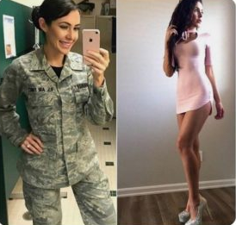  Laura | 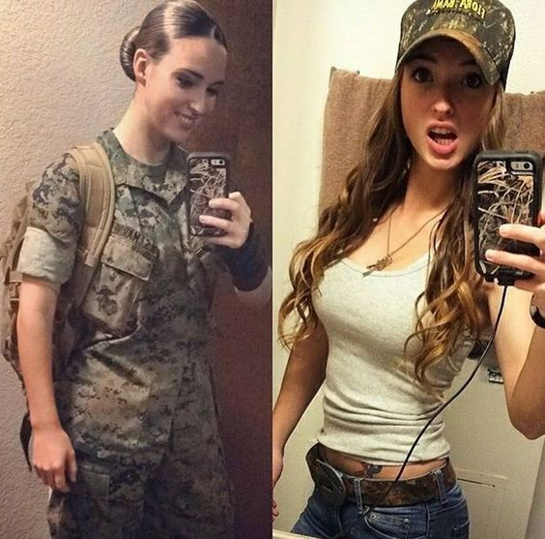  Debbie
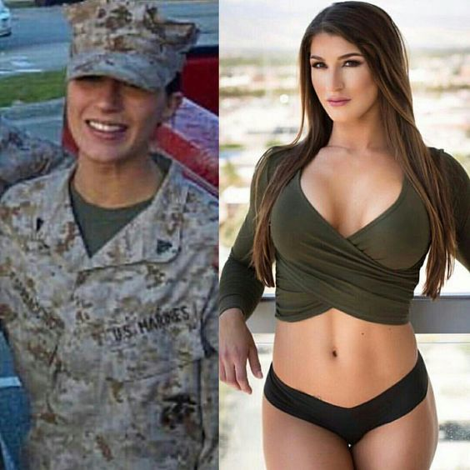  Katy | 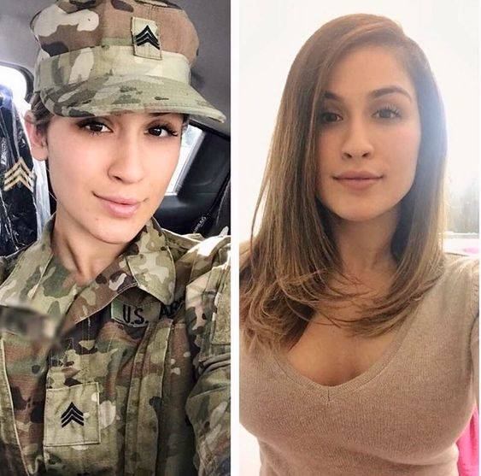  Annabelle
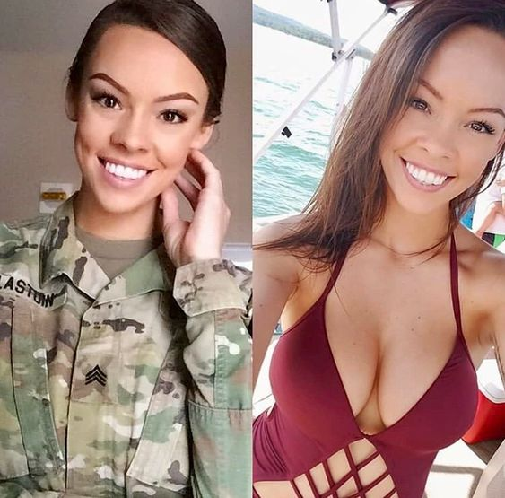  Rosita | 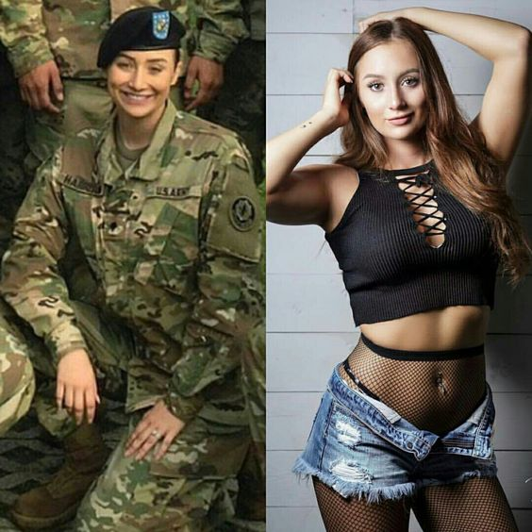  Me, Desiree

