LITTLE DEMON ACADEMIA
CHAPTER 1: OUTER EVIL
BY CHALDEACHANGE
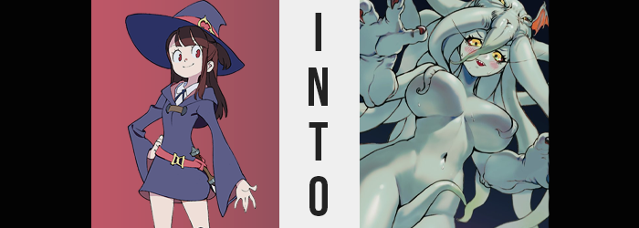

“They said the spell was harmless, but it probably doesn’t even work.”

Akko, or Atsuko Kagari, was in a bit of a huff as she drew a menacing looking chalk circle on the floor of the cellar beneath Luna Nova Academy. The occult, dark magic – these topics were typically off-topic for most of the school’s students, and for witches in general. Yet Akko? She had been coaxed into trying out a spell that she really shouldn’t have. Some upperclassmen had challenged her, having seen the Japanese witch make so many improvements over the past few months.

They’d thought it would be a funny joke! Give the girl a fake spell to ‘summon a demon’. It wouldn’t work because it was fake, of course. But they coaxed her into trying it nonetheless by both poking fun at her and talking her up. It was a two-layered assault upon her ego, and the girl fell for it almost a little too wonderfully.

“Okay! The circle is done, and I’ve put down the box of octopus tentacles… Yuck, those were gross to find!” She gave the box a light tap with her foot from a safe distance, almost like she was expecting them to wriggle out on their own. They didn’t, of course. “And then I just recite the spell. What was it? Mettatona arioglianala seratoninioma?” It was accompanied by a wave of her wand, and on cue the magic circle lit up.

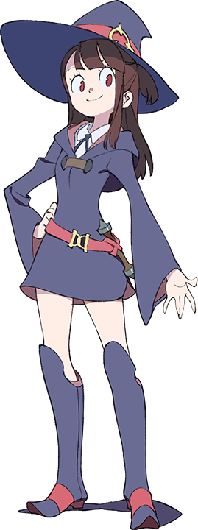
“I’ll just summon that cute little demon they told me about and then I can rub it waaaay into their faces! That’ll show them!” The pair had assured Akko that this would a) definitely work and b) not be dark magic of any sort. Both were lies on paper, but in truth? The magic had worked. Before the witch could say much else, the circle glowed so bright that her vision was entirely consumed, and then…

She was standing in… “SPACE!? AM I IN SPACE!?” Stars were all around her, and while she was standing on a surface it didn’t really look like she was standing on anything at all. An invisible platform? Either way, it was extremely jarring to perceive. But at the same time wasn’t space supposed to be like, cold? Wasn’t there supposed to be no air? So why was her temperature comfortable, and her breathing normal? “This can’t be happening! The spell must have been weird somehow…”

And then she heard it. A loud, inhuman bellow. Its words didn’t really make sense to her, but Akko could tell it was speaking – and at her, no less. “Huh!? Did you bring me here? What do you want with me!?” More monstrous noises called out from the depths of the galaxy. Once again, she couldn’t make heads or tails of them. “Weeeell. If it’s all the same to you, I have class in the morning, so I’d like to go home, please!”

If the sound and sight of a star exploding in the distance were any indication, it wasn’t all the same to them. And, in fact, in tandem with that explosion Akko’s entire Luna Nova uniform was blown off. “EEEEEEH!?”

Well… that wasn’t actually the truth. From the witch’s perspective the two events appeared to be intertwined, but the shockwave from that exploding star would take years upon years to reach where she was standing. What had actually happened was something that was difficult for Akko to really perceive without a sense of scale, something that had been denied by her vastly empty surroundings.

What had transpired was not her clothes suddenly being blown off, no. They’d all come to burst at the seams because she’d suddenly grown. And she’d suddenly grown a lot. We’re not talking a few inches, or even feet – the initial growth spurt had made her larger than a SMALL PLANET, and now she’d grown to the point that she was the largest physical existence in the entire galaxy. But it didn’t matter how big or small you were in space. The stars in the distance still looked like stars.

“I’m naked!? Well, I guess unless a spaceship flies by its not like anyone can see, but still!” Luna Nova uniforms costed money, and she didn’t want to have to replace hers! …Not that there weren’t much bigger fish to fry her. Her grotesque jump in size had only been the beginning, at least when it came to her growth. Of course, any changes in size now were wholly isolated to the girl’s build, and it didn’t take very long for that to show.

Her spine had actually stretched some, and proportionally she had grown a few inches taller than she had been at her age. This left her figure looking a little wacky for a time in the sense that it was far too vertical without the horizontal to fill it out. Whatever power was reshaping her had eventually been gracious enough to correct that, though.

“Oh!” Even Akko noticed this time, because it felt like something had gripped her body from either hip and shoulder and was giving it a dull tug out to the sides. She temporarily lost control of her limbs as the gait of her body widened with an emphasis on the width of her hips. This forced her tummy to stretch as well, but her waistline didn’t budge much in the process. “H-Hey, what’s going on here!? Who’s talking to me!?”

Atsuko was still hearing that voice, but what she didn’t really realize that she was only really hearing it within her own mind. The language was still foreign, but it was trying to pull her away from making heads or tails of what was happening to her body.

Her body was wider not, but it still needed to be filled in. And it was the girl’s breasts that were accommodated in that sense before anything else. Nipples swelled several inches in size (but in terms of her legitimate size now, each was bigger than a planet) while fat pooled beneath them to see her A-cups flourish in a way she never imagined that they would before.

Skin stretched uncomfortably around their swell, mounds blowing up like extremely firm balloons as the skin around them was pulled tight to the point that you could make out her veins. They bounced and jiggled while surging forward, so perky that despite their sizes they remained plump and firm without the slightest bit of sagging. They cast shadows that eclipsed the skin of her tummy, and yet these F-cups were comparatively bigger than some tiny galaxies each.

Not to be outdone in the thiccness department, the peaks of the girl’s thighs came to life similarly. Her widened hips had left a sizable gap between them with her pussy unshaved and bare evident in the center, but with those thighs growing more voluminous they eventually met in the middle.

Far too big for their own good, the excess mass from their growth soon fed into her ass, which blossomed with about as much vigor as your might expect considered her hefty tits and flourished thighs. Round as the cheeks of the freshest of peaches, the depths of her ass crack could likely house a galaxy all its own. Which really begged the question: what was turning her into this behemoth of a woman, and why?

The term ‘woman’ was used in the place of ‘girl’ because, well, with a bod like the one she had now, there was no point in continuing to assume she was still a girl in her teens. Even her facial features suggested she was a young adult now in their maturity.

A̵̢͇̮͓͈͓̺̺̩̾ͅÇ̸͖͚͕̭͖̭̰̜̅̆̆͗̒͋͛̓͆̃̐̇͌͊͜͝C̵̢̧̩̤͎͓͉̣̪͍̝͔̈̈́͛̈́̄͘ͅE̷̢̗̻̱̲̺̖͉̖͂͊P̶̡̢̲̗̺̙̻͕͎̥̩̈̄̋̍̈́͋̂̃̃̃̆̕̕͠͝T̶̡̨̛̫̳͇̜̻͌̄̆̒̈́̈̂͂̚ ̷̡̡̛̯̟͉̳͚́̾̑͋͑͒̈́̕̕͝M̶̡̢͚͔͔̳͚̬̝̓̾̇̌̎̇͒̾̄́͌͘͝È̵̢̞̹̬͈̘̈́̿͂̄͘

“Huh? Accept you!? I mean, I guess I can, but I don’t really know who you are…” For the first time since she’d initially heard it, Akko found herself able to make sense of the words spoken. Not because it was speaking a human language, but because her mind had been tweaked to speak it herself. Ever so slowly, knowledge she should have possessed was being inserted into her memory. A process that found itself hastened the moment she chose to ‘accept’ the voice.

That was around the time things began to take a turn for the strange. The woman’s eyes irises had begun to glow gold, her sclera had turned pitch black, and the lashes in the corners of her eyes pulled so long that that exceeded the distance of her face. “W-Wait! What is this… this POWER!?” It wasn’t magic, and in a way it struck her as inherently chaotic. But that chaos also felt good. Was that to her dismay? No, because no small part of her wanted to embrace it. Rather, she already was.

A second pair of eyes glowed not long after, this time from the top of her head. Brown hair wriggled about and hardened as a palish green color replaced strands that could hardly be referred to as such any longer, and the top of her head malformed itself into a growth that hosted this second pair of optics. “Ugh…! AAAAAAH!” Her voice distorted greatly as she screamed, incapable of stopping herself from doing so as all of the universe’s knowledge poured into her cranium.

Hands gripped the sides of her head, but given time it wasn’t hair that they rubbed up against. The locks of hair that hadn’t formed the octopus-like growth on her head’s very top had wriggled together to create a series of long and powerful, green tentacles – each one enough to destroy entire worlds if she so desired. Two framed the sides of her face and slapped against her nipples to obscure them though, while the longest one in the back slid down the crack of her ass and squeezed between her thick thighs to hide her pussy. The rest varied in length and were free to do whatever they wished, short of the shorter two acting as bangs in the middle of her face.

“AAAAAAAAAAAAAAH!”

She was too big to perceive it, but Akko’s scream obliterated a number of stars and planets that were in close proximity to her. Mouth wide, the fact that her teeth had become razor sharp teeth like a shark’s was clear. The hands holding her head’s sides were growing disfigured too, for not only did her pinky fingers remove themselves, but hands thickened, and fingers took on sharp, black claws – a trend that made its way to her feet to boot.

All of the skin that had not turned into tentacles took on the greenish hue that the octopus that was a part of her head now showed, the only pink remaining coming from Akko’s natural blush in her cheeks. That part of her didn’t wane at all. Her screams, on the other hand, eventually subsided. Nay, they changed. What was once a cry of overwhelmed agony turned into a roar of domination while clawed fingers dropped to her sides.

“RAAAAAAAAAWR!”

“AHAHA! HAHAHAHAHAAAA HAHAHAA!!!!”

Akko buckled, unable to contain a laughter that she didn’t really understand – all while a pair of wings sprouted from her tentacle head. She felt so strong and important, and above all else she really just wanted to be entertained! She was still herself and yet… She had been broken by the presence that had attached itself to her head. The source of the second pair of eyes. And the witch? She understood the nature of the alien creature she had become. She understood everything now.

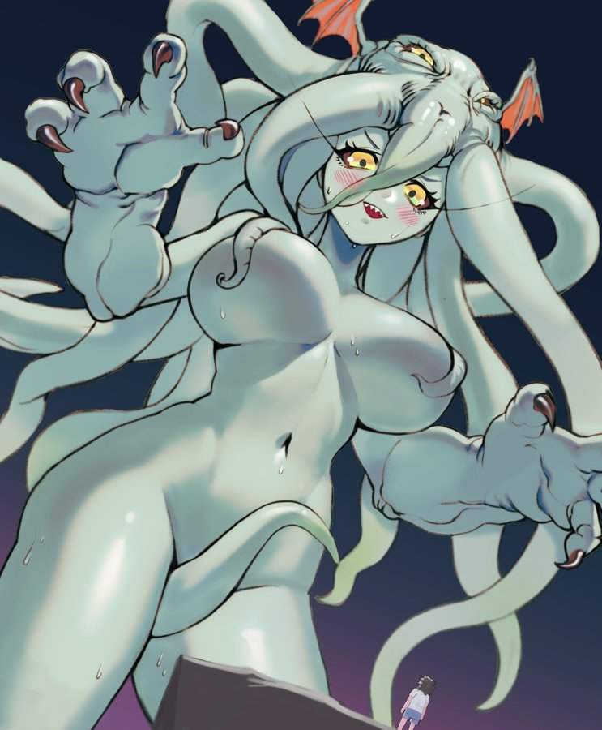
The vast universe looked so incredibly small now, but only because the monster’s hulking body was so huge that even the largest of planets looked like a tiny marble compared to her. How many stars and rocks had been destroyed during her growth spurt? Too many to count, and yet the weight of their destruction did not occur to Akko at all. Rather, tentacles whipping about, she crossed one thick thigh over the other in contemplation.

“So, I’m like this Cthulu thing!? That’s not a cute name though… What about Cthulu-chan!?” Her nature was both very different and exactly the same at the same time. She felt like she knew everything, and that knowledge granted her an insatiable desire for amusement. “It would be a shame to keep this gift to myself though, wouldn’t it? So what about all of my friends back at Luna Nova?”

Golden eyes closed, and she immediately felt displaced. She had both reappeared in the cellar of Luna Nova and hadn’t at the same time. While her giant monster body still existed in the far ends of the universe, a tiny gremlin variation now wandered Luna Nova’s campus, fully under Cthulu-chan’s control. “Heehee! This is going to be really fun!”

