**Work, Energy, and Power**

**Worksheet**

29 Practice Questions

Organic Chemistry Tutor

1. What is the kinetic energy of a 5 kg block sliding across a frictionless horizontal surface at 12 m/s?

2. What happens to an object’s kinetic energy if (a) the mass is doubled? (b) the speed is doubled? (c) the speed is tripled? (d) the mass is tripled, and the speed is quadrupled?

3. What is the gravitational potential energy of a 2.5 kg book that is 10 m above the ground?

4. A 10 kg ball falls from a height of 100 m. (a) Calculate the vertical speed of the ball each second for 4 seconds. (b) Calculate the height of the ball above the ground each second for 4 seconds. (Make a table) (c) Calculate the kinetic and potential energies of the ball for each second for 4 seconds. (d) Determine the total mechanical energy of the ball. (e) Is gravity a conservative force?

5. A 70.0 N force is applied horizontally in an eastward direction to a 10.0 kg block at rest for a displacement of 200. m across a frictionless surface. (a) How much work is done by the force? (b) What is the final kinetic energy? (c) How fast is the block moving? (d) What is the acceleration of the block in the horizontal direction? (e) Use kinematics to calculate the final speed of the block?

6. (a) How much work is required to accelerate a 1500 kg car from 15 m/s to 40 m/s? (b) What is the average net force acting on the car if it reaches a final speed of 40 m/s while traveling a distance of 275 m?

7. How much work is done by a constant 50 N force that acts over a displacement of 10 m?

(b) How much work is done by a varying force that increases at a constant rate from 40 N to 80 N over a displacement of 10 m?

8. How much work is done by the force represented in the graph shown below?

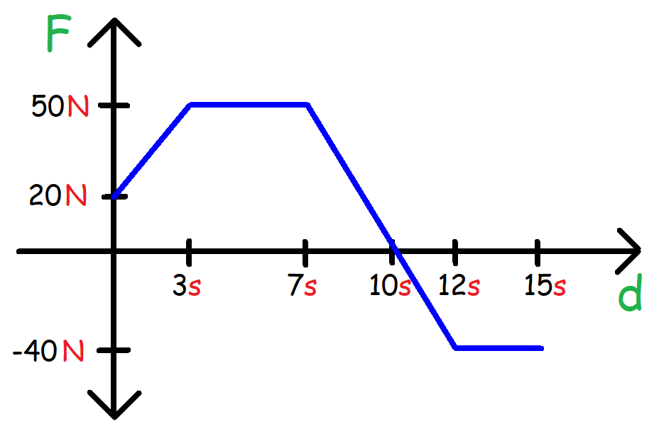

9. How much work is required to lift a 7 kg box 3 meters in the air? (b) How much work does gravity perform on the box during this process? (c) What is the net work done on the box?

10. How much work is required to lift a 500 N crate 15 m above the ground?

11. How much work is required to push a 50 kg box 200 m up a 30o frictionless incline? (b) What is the minimum force a person must exert along the incline to get the job done?

12. A 40 kg box is pulled 100 m by a tension force of 200 N at 30o above the horizontal to the right. A constant kinetic frictional force of 80 N impedes the motion of the box. (a) What is the work done by the tension force? (b) How much work is done by friction? (c) Calculate the net work done on the box?

13. A 5 kg box is moving east at 15 m/s. A frictional force of 50 N acts on it until the box comes to rest. (a) How much work does friction perform on the object? (b) How far does the object travel before coming to a complete stop?

14. A force of 100 N is applied to a 10 kg box resting on a horizontal surface with a coefficient of kinetic friction of 0.30. The box moves a distance of 20 m east. (a) Calculate the work done by all of the forces acting on the box. (b) Determine the net work performed on the box.

15. Determine the sign of the work done by gravity on the satellite shown below as it moves from position (a) A to B. (b) A to C. (c) A to D.

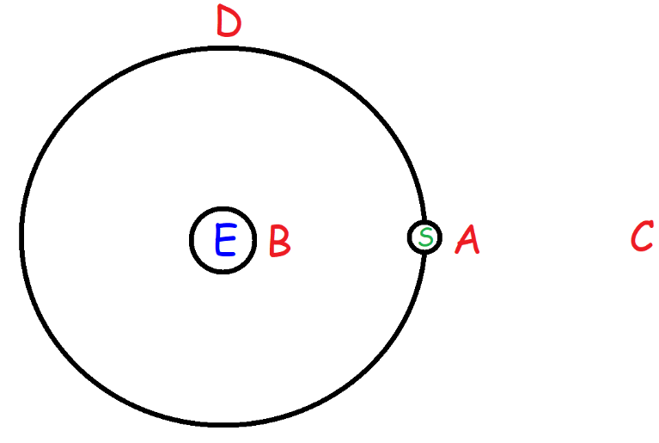

16. How much work is required for a 70 kg person to climb a mountain 800 m high? (b) How much power does he exert if it takes him 2 hours to make the climb?

17. A laptop uses 60 W of power. How much energy will the laptop expend if it’s used for 12 hours?

18. How much work can a 50 hp motor perform in 4 hours?

19. A lightbulb has a 60 W rating. If the price of electricity is $0.07 per kWh, how much will it cost to operate the light bulb continuously for 30 days?

20. How much work can a 25 hp motor do in 15 minutes? (b) How high can this motor lift up a 250 kg crate in 15 minutes?

21. The engine of a 1500 kg car exerts an average of 20 hp for 15 seconds to speed it up starting from rest. (b) What is the final speed of the car after 15 seconds?

22. A water pump can lift 450 kg of water per minute through a height of 150 m. (a) What is the power rating of this motor in watts and kW?

(b) What is the power rating in horsepower?

(c) How much work can this motor do in 4 hours?

23. How long will it take a 1500 W motor to lift a 1000 kg object 20 m high?

24. A 100 N force is required to keep a 30 kg block moving at a constant speed of 15 m/s. Calculate the average power exerted by this force.

25. A 5 kg block rest on a horizontal frictionless surface. A 30 N force is applied to accelerate the object from rest to a speed of 10 m/s. (a) What average power was required? (b) How long did it take the block to reach a speed of 10 m/s?

26. An unknown constant force was used to accelerate a 2 kg block from rest to a speed of 30 m/s in 5 seconds. (a) What average power was exerted by the force? (b) What is the magnitude of this force?

27. A 1200 kg car speeds up across a horizontal surface from a speed of 30 m/s to 60 m/s in 5 seconds. (a) What is the net force acting on the car? (b) What is the average power exerted by the engine of the car? (c) What is the maximum power exerted by the engine during the 5 seconds?

28. A 1500 kg car moves at a constant speed of 40 m/s across a horizontal surface. If the engines exert 60 kW of power to keep it moving at this speed, what is the retarding force that is exerted against the car?

29. A 1400 kg car moves up a 15o inclined plane with a retarding force of 1500 N working against it. (a) How much power must the engine exert to keep the car moving up the incline at a constant speed of 15 m/s? (b) What is the average power needed to accelerate the car up the incline from 15 m/s to 25 m/s?

**Answers:**

1. 360 J

2a. The kinetic energy doubles

2b. The kinetic energy increases by a factor of 4

2c. The kinetic energy increases by a factor of 9

2d. The kinetic energy increases by a factor of 48

3. 245 J

4.

|  |  |  |  |  |  |
| --- | --- | --- | --- | --- | --- |
| **time (s)** | **Vy (m/s)** | **h (m)** | **KE (J)** | **PE (J)** | **ME (J)** |
| 0 | 0 | 100 | 0 | 9800 | 9800 |
| 1 | 9.8 | 95.1 | 480.2 | 9319.8 | 9800 |
| 2 | 19.6 | 80.4 | 1920.8 | 7879.2 | 9800 |
| 3 | 29.4 | 55.9 | 4321.8 | 5478.2 | 9800 |
| 4 | 39.2 | 21.6 | 7683.2 | 2116.8 | 9800 |

4e. Gravity is a conservative force, it does not change the total mechanical energy of the system.

5a. 14,000 J

5b. 14,000 J

5c. 52.9 m/s

5d. 7 m/s2

5e. 52.9 m/s

6a. 1,031,250 J

6b. 3750 N

7a. 500 J

7b. 600 J

8. 220 J

9a. +205.8 J

9b. -205.8 J

9c. 0 J

10. 7500 J

11a. 49,000 J

11b. 245 N

12a. 17,320.5 J

12b. -8,000 J

12c. +9,320.5 J

13a. -562.5 J

13b. +11.25 m

14a. Work Done by Normal Force = 0 J

Work Done by Gravitational Force = 0 J

Work Done by Applied Force = +2,000 J

Work Done by Friction = -588 J

14b. Net Work Done on Box = +1,412 J

15a. W = +

15b. W = -

15c. W = 0

16a. 548,800 J

16b. 76.2 W

17. 2,592,000 J

18. 5.37 x 108 J

19. $3.02

20a. 1.68 x 107 J

20b. 6,851 m

21a. 223,800 J

21b. 17.3 m/s

22a. 11,025 W or 11.0 kW

22b. 14.8 hp

22c. 1.59 x 108 J or 158.8 MJ

23. 130.7 s or 2.178 min

24. 1500 W

25a. 150 W

25b. 1.67 s

26a. 180 W

26b. 12 N

27a. 7,200 N

27b. 324,000 W or 324 kW

27c. 432 kW

28. 1500 N

29a. 75.8 kW or 102 hp

29b. 157 kW or 210 hp