STERNRITTING
COMMISSION STORY
BY CHALDEACHANGE


Ichigo Kurosaki had plenty of reasons to be wary of technology sent to him from the Soul Society.

Especially in the wake of the incident with Yhwach and the Quincies. It felt like for the first time in a long time that some semblance of peace had finally washed over his life, even if he was still working as an aide for Soul Society after the fact. A few months had already passed and things were largely as ‘normal’ as he could have expected. Except for the constant messages from Soul Society to help with this and that and everything under the sink.

“Ugh, they sent Orihime one too? …and Rukia. Guess I can’t get away without trying it.” The last time they had sent him an experimental device had been a month prior. A portal to Soul Society hidden within a coffee machine? They really wanted to make it easier for him and his friends to visit, even though it was hardly all that difficult in the first place. In that case he had just said it hadn’t worked. How was he supposed to pass through a coffee machine anyways!?

Maybe they had caught on to Ichigo’s shenanigans though. Because in this case they had sent a letter with the invention claiming it was a ‘group test’ and that some of his friends had also received one. Rukia was in the human world right now, staying over at Orihime’s to talk about this and that. Ichigo wasn’t sure what, but it likely had to do with why things had been so awkward between Orihime and himself as of late.

There were just a lot of feelings flying around.

Ichigo squinted at the device in his hand. “Wait a sec, ain’t this Quincy tech!?” The item was like a little medallion of sorts, but it was clear that Quincy inspiration had been used with it. He knew that Soul Society had decided to repurpose a lot of their stuff at the end of the war, but to think they’d use it in this way. “They didn’t even give me instructions about how this is supposed to w-”

But in a flash of light, Ichigo disappeared from his bedroom.

Only to reappear at the gates into Soul Society… for a second.

There was yet another flash of light and Ichigo had found himself uprooted once more, this time spat out in the human world again… in what appeared to be a hotel room? “What the hell just happened!? This thing definitely ain’t working right!” He was assuming it wasn’t supposed to spit him back out in the human world in a completely different location. Thankfully he was in his spirit form and wasn’t shot out where people could see him, but…

He shot a glare down at the medallion, or at least he would have if it had still been there. It had disappeared! “Stupid piece of junk! Where the hell am I!?” Based on the view from the window he was very clearly in Japan. It definitely wasn’t Karakura Town though. The buildings were too high, the lights too bright. It almost looked more like… “Tokyo?” That was one hell of a bus ride home if that was the case!

…Not that he’d have much of a desire to leave shortly.

The first sign that something was awry was a feeling deep down, burning within Ichigo’s breast. He wasn’t horny or anything but there was a desire to be… satisfied? Even though he was still a virgin since he and Orihime hadn’t gone that far yet. His cheeks burned a little red. “What the hell am I thinking about right now!? It is not the tIME!?” Whoa! Voice crack!

Strange thoughts and a crackling voice were on surface level indicators that something was awry. The medallion wasn’t missing, it was inside Ichigo – or at least its energy was. And that energy had begun to wreak havoc according to the Quincy whose energy it had been structured with. The building desire within was part of their personality and the voice crack? Well, with how high Ichigo’s voice had gone… It didn’t look good for him.

There were already things happening that weren’t immediately apparent to him. His hair was a big one – or at least its color was at least. Orange strands that were so core to his identity had been darkening one by one, spikes slowly drooping while a permanent dark brown dyed them. In the end his hair all flattened against the top of his head but for the time being it didn’t grow longer. In fact, any excess body hair on his person was shaved away so that his skin was smooth.

…And a lot softer? Whether it was his face, his hands, or otherwise, all of his skin was plusher to the touch. Plusher and… off-pigment? Had Ichigo’s skin always been that pale? It seemed a touch more washed out than it normally did, affecting even the pink of his nipples. “I need to get… get… get someone to have some fun with! ...HAH!?” What had he just said? He needed to get out of this hotel, not bring someone into his room!

He'd also began to fantasize about it, not noticing that his face reflected an older appearance that put him around the age of twenty-three or so. But the fantasies were weird. They weren’t from the perspective of a man? And that too became reflected in his face. Features softened further, such as his lips bloating and his nose shrinking. Brown eyes likewise grew large with lengthened lashes and thinned brows on either side of a narrowed face. There was nothing masculine about his facial visage.

And that wasn’t exactly helped by Ichigo’s dark brown hair. He hadn’t noticed its color change initially, but now he was given little choice because it was dangling in his eyes. “Huh? What the—!? My beautiful hair! Wait, what’s weird about…? No! It’s weird!” Hands reached up to grab at his bangs, but it was all of his hair that was growing. It had already tickled his neck and fanned out behind him as far down as his hips. This hair was thick and glossy, a far cry in color and texture from… from what?

The young man couldn’t remember what his hair had looked like before to say it was wrong. So was it wrong? Even the shapes of his hands seemed bizarre to him. Had his fingers always been so small? His nails so long? While he couldn’t see them, similar changes had affected his feet. Since they were smaller he was having a little bit of difficulty maintaining his usual posture as well.

Or, well… “WHA—!?” Her voice squeaked at the sensation of a yank between her legs that stripped Ichigo of her sexual masculinity. A woman’s pussy was fashioned where a dick and balls had been. The sensation of this change unfolding had been sudden, but in its wake? The woman was confused more than anything. “My pussy? Why was I…?” Her voice had permanently shifted into the feminine now as well. She was confused because of all of those sexual acts she had been dreaming of before? They were all done from the point of view of a woman.

Which she was one.

Ichigo blinked. “Did the room get bigger? No, wait, my robes…?” Her reaction was a direct response to a loss of height. Limbs and torso shrunk quickly to peel ten inches off of her overall stature, down to 5’1” from 5’11”. Of course her Shinigami robes would become extremely loose with that much height loss, but she was alarmed by something else. “HAAAH!? Why am I wearing these shitty Shinigami robes? I’m not one of those losers!” She was a pureblooded Quincy!

As if responding to her outburst, the black robes began to tighten in size and lighten in color. But in the meantime? Her now feminine body became much more appropriately shaped. Such as? Well, her hips swung a touch wider so that meat could see her thighs grow plush and her ass perky. Just in time for a frilled, white skirt and a pair of tight, black, lace panties to hug her perky her ass.

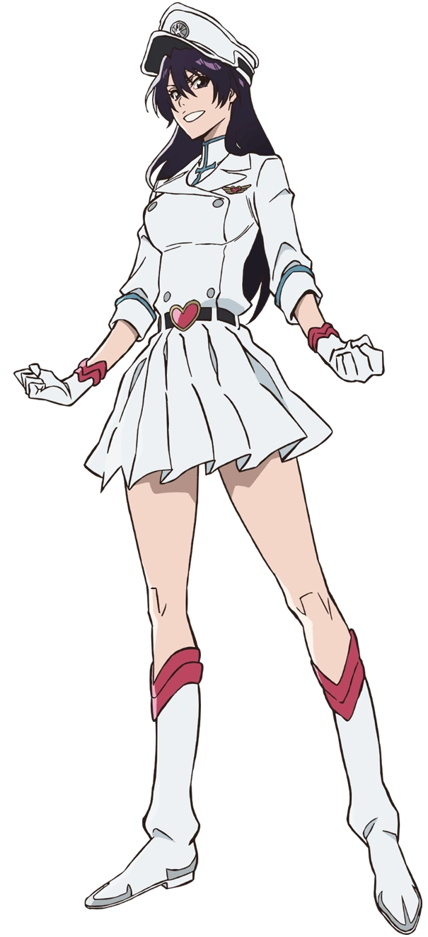
Her chest could be seen protruding as well once the top began a tight, white jacket with four buttons. Mass had accumulated beneath her nipples and swelled with a hefty bounce, giving her a sizable bust that was around a pair of DDs size wise. Her uniform was fashioned so she could show off her cleavage. It made it easier for Ichigo to give tit jobs when she was in the mood!

Beyond that, a familiar hat, boots, and gloves appeared. There was a belt with a pink heart clasp around her narrowed waist, while that same pink trim could be seen on the gloves and boots. It was all Quincy apparel.

“Humph! Karakura Town? Why would I wanna go back to that backwater town? There’s way more hot guys out here in the big city!” Massaging her own tits through the front of her Sternritter uniform, Bambietta Basterbine rejected not only the notion to return to Karakura but also the notion of her previous identity. But it would also be wrong to say that not a single scrap of Ichigo remained within her.

Bambietta’s personality had been dialed back a bit because of Ichigo acting as her new core. The woman herself could acknowledge who she had once been and didn’t care, but… When it came to her previous disregard for life and energy to kill, she had become much more subdued. What hadn’t become more subdued was her desire to have men satisfy her before kicking them to the curb.

“Those idiots in Soul Society’s 12th division really fucked up this time, hahaha! Using Quincy energy like this? Fucking idiots! But I guess it worked out for me!” Even though she wasn’t exactly the real Bambietta, the memories were there. It was like being given a new lease on life! She just hoped those suckers realized later rather than sooner so she could avoid any attempts to change her back!

“Okay, I’ll go ahead.”

Meanwhile, back at the Inoue household, Rukia and Orihime had been in the process of examining their own Soul Society teleportation devices. Rukia had been staying in the human world for roughly a week now. Apparently Orihime had been making some progress with Ichigo and had needed some advice, and things had turned into such a long stay. But given an opportunity to return to Soul Society even briefly? It felt like just the thing she needed after such a long stay!

Orihime was finishing up some housework and so Rukia had agreed to test hers first. She hadn’t exactly assumed it would work, and so she was naturally surprised to find herself at Soul Society’s gate… for but a moment. The next she was spat back out into the human world, into the very same hotel building Ichigo had been, just in a different room. “H-Huh?” Where had the medallion gone?

Of course, the side effects of wielding Quincy energy were quick to make themselves known.

It didn’t begin in a way that was simple to ignore like it had been for Ichigo. Rukia was immediately made aware that her body was changing because it targeted something that was impossible to ignore (as well as something that had been a point of insecurity for the Shinigami). This was a roundabout way to tease that it was Rukia’s height that was under siege in a way that was positive for her.

“What!?” Her confusion about the medallion’s disappearance was immediately overshadowed by her confusion at these new developments. She could both see and feel her body’s shape stretching, pulling upwards so that limbs lengthened and her point of view was raised. “I’m getting taller!? Mm…” She was shocked but she certainly wasn’t upset about it, even though the fit of her Shinigami robes clearly couldn’t keep pace with how her body was stretching. She had jumped up from 4’9” to almost 5’7” in such a short time that those robes were disheveled, hakama pants lifted up to her knees, sleeves lifted past her elbows, and fingerless gloves torn.

“Ngh…! Too tight!” At least the white shitagi under the black kosode on her torso was. The kosode had been lifted up and away from the sash to reveal the shitagi, but her comfort and clothing fit concerns, at least relevant to her torso, immediately found additional challenges as both her shitagi and kosode began to unfold themselves at the behest of her… chest.

Rukia’s stared directly down at her own bosom for several moments before it finally clicked. “WHAT IN THE WORLD!?” Because it emerged. The sight of her own cleavage. A cleavage that was deepening more and more as the wraps of her clothing came undone further. She could both feel and see the weight building, her once paltry bosom erupting into the polar opposite. A pair of perky F-cups that were big, bouncy, and heavy. “My tits are so…”

Wait. Was there something wrong with her tits?

It hadn’t even just been her tits, though they had definitely been the most noticeable since they had practically popped out of her clothes. Her ass and thighs had been swelling similarly farther down, deepening the curvature of her silhouette as her hips were given no choice but to widen to accommodate the full ass and thick yet muscular thighs that had bloated. She didn’t note them at all with her eyes (which had turned green in color).

This figure was bombastic when compared to what Rukia had possessed before. It may not have measured up to, say, Rangiku, but it had its own charms. “I can’t believe…? Huh? The hell’s up with my voice?” And the way she was talking? It sounded a little trashier? Or maybe a little closer to how Ichigo liked to speak. Considering her body looked like a woman in her late twenties now, maybe it wasn’t surprising that her teenaged voice had left her?

She hadn’t even noticed that her complexion was a little darker in color, or that a wave of changed had washed over her face. She looked older, with a narrower jaw and fuller lips. Not to mention a sharper nose and widened eyes that gave her a more European appearance. She bore the visage of a young adult. Not that she seemed to care. “Ugh!” Looking down at what she was wearing? The woman just felt annoyed. “Why the fuck am I wearing Shinigami shit?”

Not that she wore it for long. It tightened and shrunk into a pair of microshorts, a cropped jacket that showed off her deep cleavage, and gloves and boots with lime green trim. A hat that matched Bambietta’s would appear atop her head, but not until the final physical change was completed.

Her memories were on the decline as a new identity took root. That identity was overpowering, and the stronger it became? The more Rukia’s hair changed, almost like the two things were linked. Her short and black hair wriggled longer like a head of snakes, blacks replaced by a yellowish lime green that bled out from her roots to her tips. This hair was naturally curly and messy, but in the deliberate sense. It looked as if someone had poured an abundance of time over making it appear a specific way.
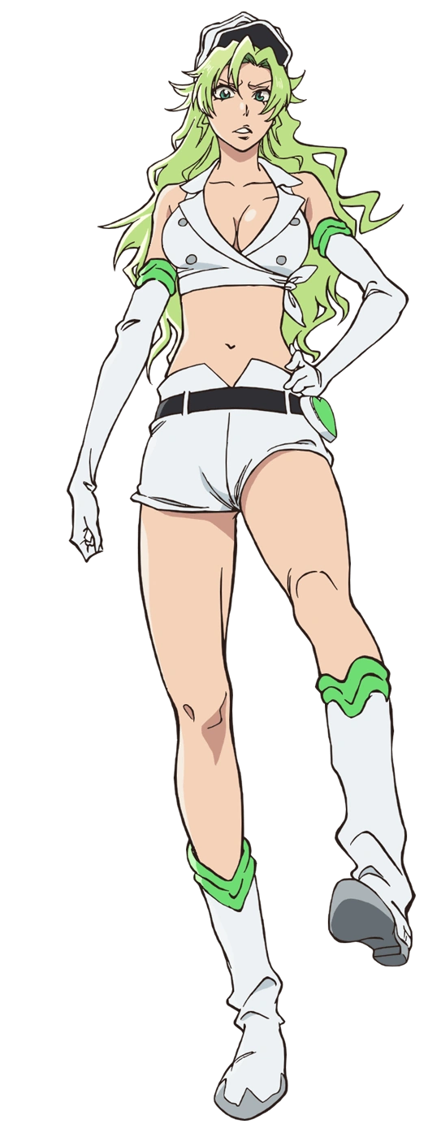
“My hair!?” With her transformation completely, Candice Catnipp had a panicked reaction about what had just unfolded. Her hair had changed, right? What if it was a mess? She’d die if she had to redo it so late in the evening! And so she bolted into the bathroom with (literal) lightning fast speed, stopping right before the mirror and breathing a sigh of relief at the sight of her green hair being perfectly styled.

This certainly wasn’t something Rukia would have cared about, but much like with Bambietta she only really existed now as Candice’s foundation, keeping her worst instincts subdued while her new personality attempted to bury thoughts of that old life. “I would’ve blown this whole building up if… Well, okay maybe not. But this room woulda been trashed!”

And you know what would really piss Candice off? Soul Society weirdos showing up to try and change her back!

“Rukia-chan didn’t come back so I guess it must have worked!” About twenty minutes after Rukia had disappeared, Orihime had finally finished the housework she had wanted to get done first. Apparently one of these fancy teleportation medallions had been sent to Ichigo as well, so if he was in Soul Society, well… She wanted to talk to him! It wasn’t like they had been fighting or anything. They were both new to exploring reciprocated feelings and Ichigo could be a little evasive because of it.

But that wasn’t relevant at that moment! “How did she say I use this? I just need to activate it with my- WHA—!?” The teen was given her answer, suddenly launched to Soul Society and then back out of it into a hotel room elsewhere in Japan. The medallion, like with the others, seemingly gone. But it was inside of her. “This is… I don’t think this was supposed to happen, was it!?”

Worse things were on the cusp of happening, however.

“Ah!?” They had begun to happen fairly quickly. Orihime cried out because she believed for a brief moment that she was falling, because her eye level had dropped so suddenly and rapidly. But a look of confusion spread across her facial features once it struck her that her feet were still on the ground. But her thigh highs were bunched up around her knees? And her pink hoodie was covering more of her shorts? Almost as if… “D-Did I just shrink!?”

It was the only explanation that made sense, and it was in fact correct. The teen had been 5’2” before, but if she had a means of measuring herself at that moment she would have found that she was 4’11”. What was perhaps more alarming to her, however, was that she wasn’t shrinking vertically anymore. So why was her sweater still growing loose? “Uh…?”

The girl had a big chest. She knew this but she didn’t really think much of it. But before her very eyes she could see those orbs collapsing, the weight of her bosom being drained away as her bra emptied to the point that she pressed her hands against her chest to try and comprehend just what was happening. “Is this even possible!?” Because she was so distressed she didn’t think much of her voice cracking here and there.

Before long her tits were, well… Did she even have tits anymore? She did, but they had become so small that the A-cups that remained felt practically non-existent comparatively. On the flipside, her thighs and ass had also thinned so that she was stalky without much in the way of feminine definition. But she was still very much a girl. Just one with legs so pencil thin that her thigh highs were sliding off.

“Hm…” All of that panicked energy that she had been reacting with previously seemed to dry up rather quickly. Her voice came across as quiet and monotonous, and not even Orihime’s face seemed very keen on expressing much emotion. Then again her face seemed quite different in general. Like the other two, any semblance of Japanese heritage was sapped away so that she appeared more Caucasian. Her eyes were wider in shape but her resting expression appeared quite fatigued. Lips thinned and her face rounded, all in all presenting her with a more youthful look? Not significantly so, and in fact she had actually aged up a year to eighteen. But she had a girlish look overall.

Her transformation was almost done and so her clothing began to repurpose itself. Her shorts and sweater became more comfortable as they mended together, both colors lightening towards white to grant her a one piece, sleeveless dress with a skirt that reached down to her barely existent thighs. And speaking of, her thigh highs made a return, gripping those thighs with a new grip as the cloth itself hardened into segments that almost resembled chain mail – attached to her boots. Gold lined them just as they lined the short gloves around her now shrunken hands.

The girl clicked her tongue. “I get it. This is a pain in the ass, isn’t it? This transformation…” She dryly murmured while holding a handful of her long, auburn hair. It was being held so that she could observe it with eyes that had turned yellow themselves, observing strands light up with a yellowish blond before shrinking one by one. She was between two identities now, but the new identity was clearly already dominant. She didn’t care that her hair was ultimately rendered at mere chin length, nor that a big old hat had appeared on top of her head.

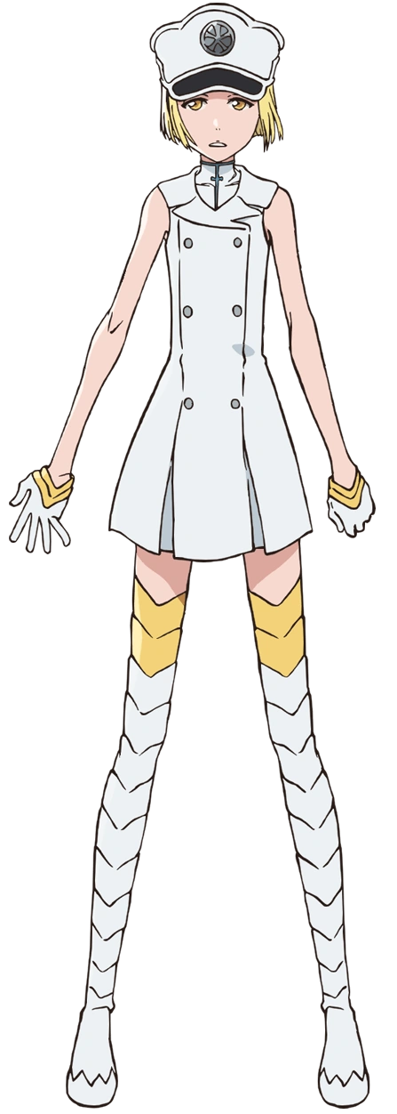
“Don’t tell me this happened to those other bitches too?” Liltotto Lamperd’s words were delivered in a cold monotone that almost felt like it clashed with the cruder wording she was using. Her body was notably childlike in design, at least when compared to the two Sternritter that had been ‘reborn’ before her, but she didn’t really care about that. “Ugh… Why the fuck do I have an interest in Bambietta like that?”

Liltotto didn’t exactly have any very obvious impulses for Orihime’s personality to curb, so instead it had manifested in a different way. Her affections for Ichigo had been reapplied to the woman that Ichigo had become. That meant that despite how much of a bitch or slut she thought Bambietta was, she was harboring romantic feelings for her now.

“I just can’t get it out of my head… I wanna know how she tastes.” Whether or not Bambietta would let her do that was a completely different topic. In all likelihood? She wouldn’t. But she could tell that Bambietta was in the room above her. Candice was in the room below her? “This blows. But better than being completely dead, I guess.”

But if their beings were mixed with others, could they really be alive?

