HONKAI STAR RAIL: TROPE CITY
CH7: LIKE, SO
BY CHALDEACHANGE
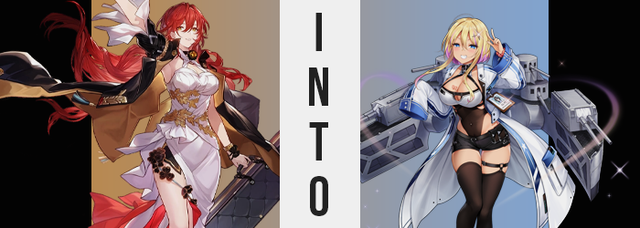

“Miss Rand? Would you mind directing me to the nearest powder room?”

Himeko might have been one of the most influential Nameless in the known universe, but even she had to use the bathroom several times per day. It was human nature after all, and she was absolutely still a human. Powers and influence be damned. When she stayed aboard the Astral Express then it was an easy solution. She knew where the bathroom was and she made sure it was always neat and tidy. But on Jarilo-VI? Well, she hardly knew up from down!

But merely asking someone had helped plenty. With the ordeal with IPC’s shady dealings behind the planet (with much credit due to Himeko’s last minute aid) it seemed that the peace they had all fought for was no longer in jeopardy. She could spare a moment to pee and tidy up her makeup. In fact the former had already been done! And now she was touching up her gloss. “I’m glad that everything worked out in the end. It would have been terrible for the people of Jarilo-VI if they’d been forced to pay that debt.” Or if the IPC had used the debt as grounds to occupy the planet.

She knew that Stelle was happy with this outcome too. March 7th as well, but that girl had decided to return to the hotel before them. Considering all of the energy that she often burned it wasn’t unusual for March to tucker herself out here and there. It wasn’t nearly as infinite as one might assume at times. Now that everything was wrapped up? She and Stelle could return to the hotel themselves before heading back to the Express the next morning. Or at least that had been the plan.

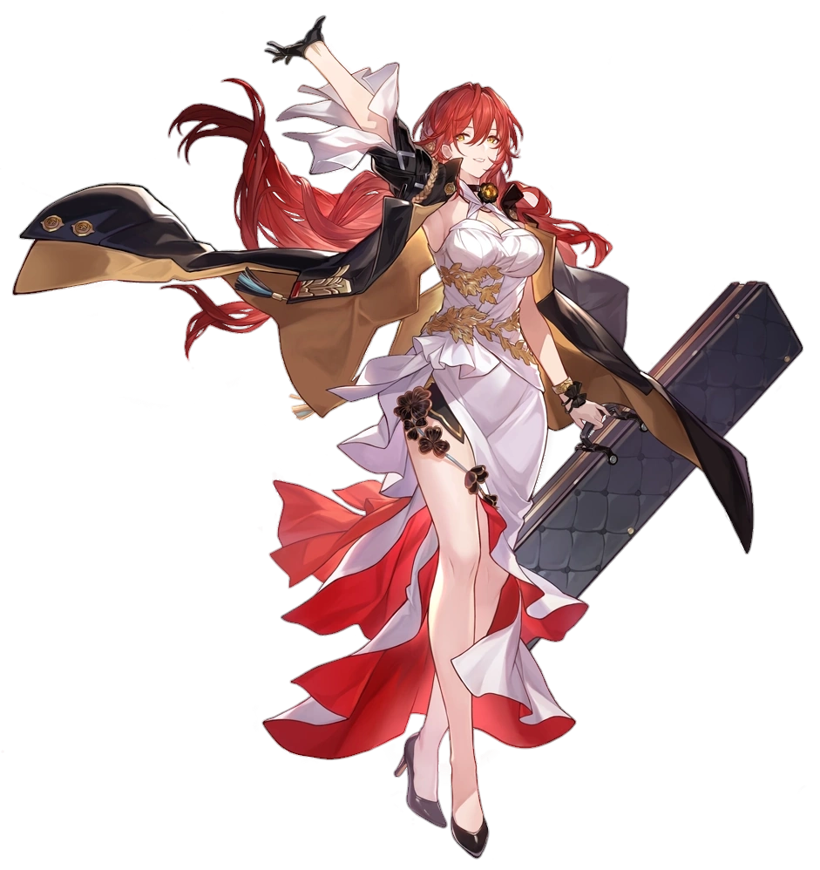
“Erm… Hm.” The red-headed woman didn’t really understand what had just happened? She’d placed her phone on the powder room bathroom while she tidied up her makeup. And then there had been a flash of light and, the next thing she knew? She was in a completely different location entirely. “Is this a ship dock?” The scent of salt water was overpowering within the building, docks located nearby without any ships of note within it. Himeko couldn’t deny the similarities, however.

Perhaps you could liken it to something like instinct too.

It was too warm for her to be on Jarilo-VI still. There were no unfrozen bodies of water there and she could see a vast expanse of water on the other side of one of the building gates. “I was teleported to another planet entirely? Was this the doing of an Emanator?” In terms of individuals that could teleport someone to another planet entirely, they’d have to be a powerful individual like an Ema… Eman… “Emal…? What was that word again?”

Why couldn’t she remember that word? No, it was worse than that. At first she may have forgotten the term, but at the very least she could remember what it was referring to. And yet as she pawed at a recollection of that word in the back of her mind? She slowly forgot what it even meant. “Erm…” Signaling the beginning of the departure of not only memories of terms specific to the worlds she knew, but also the beginning of a sharp drop in her intelligence. “It’s, like…”

Himeko shook her head in an attempt to return clarity to her thoughts. It was unfortunate that this clarity didn’t return as she had hoped, but it did toss her long, red hair around in a way that highlighted the fact that her hair was changing, seeming with highlights. Strands of her red mane had shown signs of paling towards blonde – albeit not down the entirety of ever hair.

On the sides and in the back? As this color change became more and more common it became cleared that these hairs, at least past her ears, actually lightened to a strawberry pink instead. But it all also dramatically shortened. Himeko’s hair normally fell down past her ass, yet while it remained long in the hair that framed her face? Everything past her chin on the sides and in the back, aka anything pink, was chopped short so that it was more of a bob.

“Um… Hehehe, maybe it isn’t worth rememberin’?” The problem of her memory had been pushed away just like that in the meantime. The woman not only sounded way too blasé about it, but the quality of what she was saying was deteriorating. She was beginning to sound more casual and less mature, but then again? She had begun to look as much as well, especially in the woman’s face.

That wasn’t to say that she had begun to appear significantly younger. The woman wasn’t about to dip back into childhood or anything. But the maturity that Himeko’s face typically showed off was smoothing away. Plump lips thinned a touch but pouted out in shape more prominently as a tradeoff, her eyes brightened both in quality and in color as blues took the place of their original coloration; but these descriptions might create the impression that her identity had still visually remained in some sense. It hadn’t.

As if to demonstrate that with her attitude, the girl had clicked her tongue. “OMG, what was like, bothering me and stuff?” She sounded like a vapid teen now; something she had never sounded like in her life. She looked like a completely different young woman. A completely different teen around the age of eighteen or so, at least above the neck for the time being. With her rounder face and eyes though? She didn’t really look like Himeko.

And this was a trend that was echoed throughout the rest of her body’s appearance. It wasn’t in a significant way but, for example? The maiden’s tits became a touch perkier. The skin around those breasts tightened and firmed, presenting them with a rounder shape while likewise adding an inch or two to her overall bust size. “Hm? Kinda tight around my titties…” She tugged at her cleavage window, showing off more of the creamy mounds that seemed a touch more… mocha?

It wasn’t just her breasts, in fact. Most of the skin across her body had slowly been developing a vaguely darker glow compared to her original, paler skin coloration. It was a very faint tan that had been developed naturally under the light of the sun, with her tits and bikini line remaining pale – the latter with a now blonde, trimmed bush of pubes to top it off. “And kinda tight around my ass, too?”

Himeko looked over her shoulder to try and get a look at her butt. It had swollen a little, perhaps sticking out an inch further than it had before. And gains had simultaneously thickened her tanned thighs a similar amount. But from her perspective? Nothing was actually different. Actually, how come I’m wearing a dress that doesn’t even fit? The dress was the problem instead of her body. Even as…

“Wowie! What was that!?” She had felt prompted to throw out her hands to correct her balance but didn’t seem to be able to process why that was. From her point of view it had just been a classic silly moment on her part, but from the point of view of an onlooker their impression would have been quite different. Her 5’6” height had plummeted, head pushed closer to her hips which were in turn pushed closer to her feet until she was only 5’1”. While her stature had diminished, her curves hadn’t, and so her big tits, ass, and thighs all seemed even bigger against everything else.


And the weight of these curves was highlighted just as quickly by her clothes. Gone was her dress, only to be replaced by a pair of very short, black shorts and thigh high tights beneath special, silver shoes. As her cleavage window deepened from the dress top stretching into a garment that was split between a black leotard base and an open neck top, a dark pink heart tattoo could be seen getting etched on the inside of her right tit. Eventually? A white and blue coat with long, puffy sleeves that reached past her knees rested open on her shoulders and a shiny, silver clip was embedded in her hair to the left.

“That was a totally weird feeling! Or, er… I’mma need a sec to remember what I was talking about!” The gyaru blink several times out of confusion, but she casually made the peace side with one hand as if to reassure an invisible audience that she was okay despite her confusion. It was just one of the many quirky habits of Marblehead, a Ship Girl who prioritized fashion and fun while still handling her duties to the best of her abilities. “YAAAAWN!”

…Not that she gave off that impression at that very moment. “Why’m I even at the docks? I don’t need to sortie, right? I’d like, much rather go tan outside or something instead!” She just wouldn’t go above and beyond what was required of her. Like ever. The only exception would be if her Commander made a special request to ask her to do something. Because she harbored growing feelings for him, the unserious gyaru wouldn’t hesitate if he asked her. “Well, whatevs! Nothing stopping me from doing just that!”

She flippantly removed herself from the docks not long after. She was going to hit the beach! It was almost astounding how much irresponsible she was compared to the Himeko she had once been. “Oo! Maybe I can grab a boba from the drink stall on the way down! Y’know? Like a little sipping and dipping?” Well she probably wouldn’t go out of her way to go into the water after the tanning began. Maybe she’d swim beforehand?

That perfect tan of hers wasn’t going to maintain itself!

