ASCENSION TALES
COMMISSION STORY
BY CHALDEACHANGE
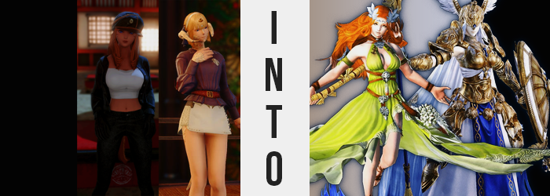

Sometimes it was nice to just do a bit of actual adventuring.

The issue at this point was that so much of Eorzea had been mapped these days that it wasn’t often that, if you set out on a journey, you would find something new and fantastical out in the sands, forests, or nearby seas of the continent. So when you were to ask adventurers why they ventured out these days, if it wasn’t for others reasons it was typically just for a small sliver of hope that they might find something new out there. Something that no one had ever seen before.

But then again, everyone recognized that there were low odds that they would be as lucky as the Warrior of Light. Based on the chronicles of their travels, they were always coming across undiscovered locations! It was enough to make any aspiring adventurer jealous!

“A good thing we’re not adventurers then, isn’t it?” A brunette Miqo’te woman chimed up as she walked alongside her blonde, Au Ra companion through a familiar forest. It seemed that the two had been recounting this very topic as they wandered through what was very much known. The speaker, S’aiya, was correct. She was a thief and in no way official an adventurer, even if she did go on adventures at the behest of her friends now and again.

On the other hand, Dreah had a little more experience in this area. She was a Dragoon who often took up all manners of jobs that led her into dangerous locales. She had probably seen more of the world than S’aiya, but contrastingly S’aiya had seen more of Eorzea’s shady underbelly than Dreah had. Still, the two were out on a bit of an adventurer. …Well, okay. It was a camping trip. The Au Ra had invited the Miqo’te!

“This is the site that was recommended to me, but… I… don’t recall them mentioning this rock? How strange.” It appeared that they had arrived at the coordinates that Dreah had been given back by a tour guide in Gridania. Apparently it was close to a stream of clean water, and that certainly appeared to be the case. But the guide hadn’t made mention of the strange boulder nearby. A big rock by itself wasn’t all that strange by itself though. It was what was on the rock that caught their attention.

Markings. “These are markings of the Twelve, aren’t they? Namely Nophica and Halone. But why would these be out here? I’ve never heard any mention of these…” Dreah made a good point. Pilgrimages to the known existing markings of the Twelve were very popular, and if additional markings existed than there was no doubt that this location would be included in some of those routes. Particularly with not only one, but two markings included.

“I don’t—"

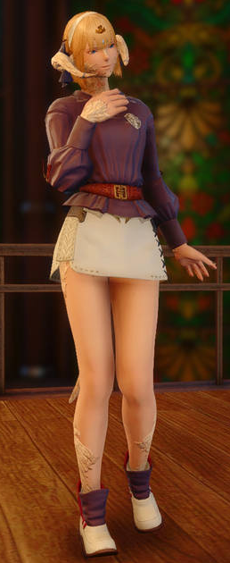
“You don’t what, S’ai… ya?” The voice of her companion had suddenly waned, and in turning to check on the Miqo’te? Dreah found that the world around her had changed. Dressed in light clothing, the biting chill of ice and snow now bit at her hands, face, and legs. She was standing in the center of a frozen platform, surrounded by an icy void and a crystal made of ice far off in the distance. “Wh-What!?”

She looked around frantically. Where was she? How had she gotten there? The questions she had were numerous, and when taken off guard the woman’s more sheepish personality had a tendency to resurface. “S-S’aiya!? Are you here as well!?” Her friend had been right beside her, so she had to be nearby, didn’t she? Then again, she still had no idea what mysterious force had managed to drag her here in the first place.

And she was understandably concerned that she might freeze to death. The only shelter nearby appeared to be that castle in the distance, but there didn’t seem to be a route there from where she was standing in the platform’s center. “What am I supposed to… do…?” Dreah had been taken off guard again. Was the platform she was standing on glowing? It wasn’t the whole thing, but the shape she could perceive… Was it not familiar?

Had she a higher perspective to gaze upon it with, then perhaps she might have put two and two together. Such was the thought that had crossed Dreah’s mind in that moment while marveling at the light that shone from below her, but she wasn’t aware that she would be granted a solution to this quandary, and certainly not in the way that it would inevitably be addressed. Because all the woman understood from her perspective? “…What’s going on with my clothes?”

She tried to tug at them, but it was difficult to even move her arms because her sleeves? Along with the rest of what she was wearing, they felt incredibly tight? Had they shrunk due to the cold? No, that didn’t make sense. “H-Hey!?” But the hows and whys were quickly relegated to irrelevance, because cloth began to rip at the seams, and her underwear was digging more and more into her loins and ass crack. It felt like her clothing was piercing her from all ends! Until finally… “WHAT!?”

The Au Ra’s body uncomfortably overcome the bindings of her clothing because there was simply much more of her body to begin with. And not in the sense that she was gaining weight – although that could be technically true in a sense of it. What was actually happening was that she was growing larger proportionally, meaning that the aspect ratio between her arms to her torso to her legs to her head? It was all consistent. She grew up to ten feet, then fifteen, until finally? She was twenty feet tall, standing in the arena’s center still.

“I… I’m a giant?” This was impossible, right? But there were spells that could alter one’s appearance, so perhaps it wasn’t all that farfetched? Distressed by her new gargantuan size as she was, it had slipped her notice that the biting cold no longer bothered her as much. Nor that the scales that otherwise ran across various portions of her body? They had crumbled away as she had grown sans her horns and tail. “Wait, this marking is Halone’s…”

At least being so tall meant she could better view the marking below her, and it was one of the markings that had been on that rock. The marking of one of the Twelve, Halone. But what significance did that have here? How was it related to her changed size? Since mortals didn’t exactly get to gaze upon bonafide deities, it went without saying that she didn’t grasp just how large a god might be.

Or that she was the same size as one now.

The blonde of the Dragoon’s hair appeared to be paling almost as if a product of the colder conditions, but of course this wasn’t the cause. Before long it was pure white, but as she continued to gaze down at that marking below her, the length of this hair extended significantly. For the sake of ease she always kept it in that usual, short bob. But it grew past her shoulders, down her back, and past her ass – all before curling up just above the arena floor. But everything past her ass darkened in color to a royal blue, to boot. “Uh? Why is… MY HAIR!?”

It was so long that it was inevitable that Dreah would notice its weight, scooping up some of the white with fingers that appeared an almost sickly pale color. In fact, all of her skin was bleaching towards a snow white not unlike the color of her hair near its roots. Just as her eyes began to glow the same pale blue that the light below was feeding up at her.

She shook her head. “No, something isn’t… right?” After a moment of adjustment her voice sounded deeper, sterner. And the act of shaking her head? It seemed to stir what resembled snowflakes to fall from her head. But what was actually falling was pieces of her horns, which were crumbling to reveal round, white ears beneath them. It was actually becoming difficult for her to process just what wasn’t right. She could just tell that something wasn’t what it should be.

In the meantime? With her body bare it was easy to see changes transpiring around her build. Her body was already toned since she was a melee fighter, but those muscles tightened even further so that you could probably take a shot out of the grooves of her abs. Her hips likewise widened, which allowed her thighs and rear to reach new levels of fullness – even though they only expanded a few inches relative to her new height.

“My body is… strong? No, of course it would be strong.” Changes that seemed questionable became less so, and she did not even address how her breasts appeared to puff up an additional cup size. Naked as she was, she was exceptionally beautiful both in terms of figure and strength. And her face both lengthened and matured some to better suit it. She looked like a woman in her thirties by this point. A giant one, anyways.

THUD!

And the last lingering piece of her previous race, her tail, hit the ground behind her after being severed from her spine. It lengthened and thinner, becoming a spear with a large, golden tip and a dark blue staff. The sound of it hitting the ground prompted the woman to turn around and pick it up, and once she had? Not only did she begin to levitate, but…

A set of golden armor then adorned her. A winged helmet that hid her blue eyes, a cuirass that still traced the breadth of her breasts, a white skirt with golden hip protectors, as well as matching shimmering boots. Even her arms were clad with gold, including the round shield that appeared on her leftmost wrist.
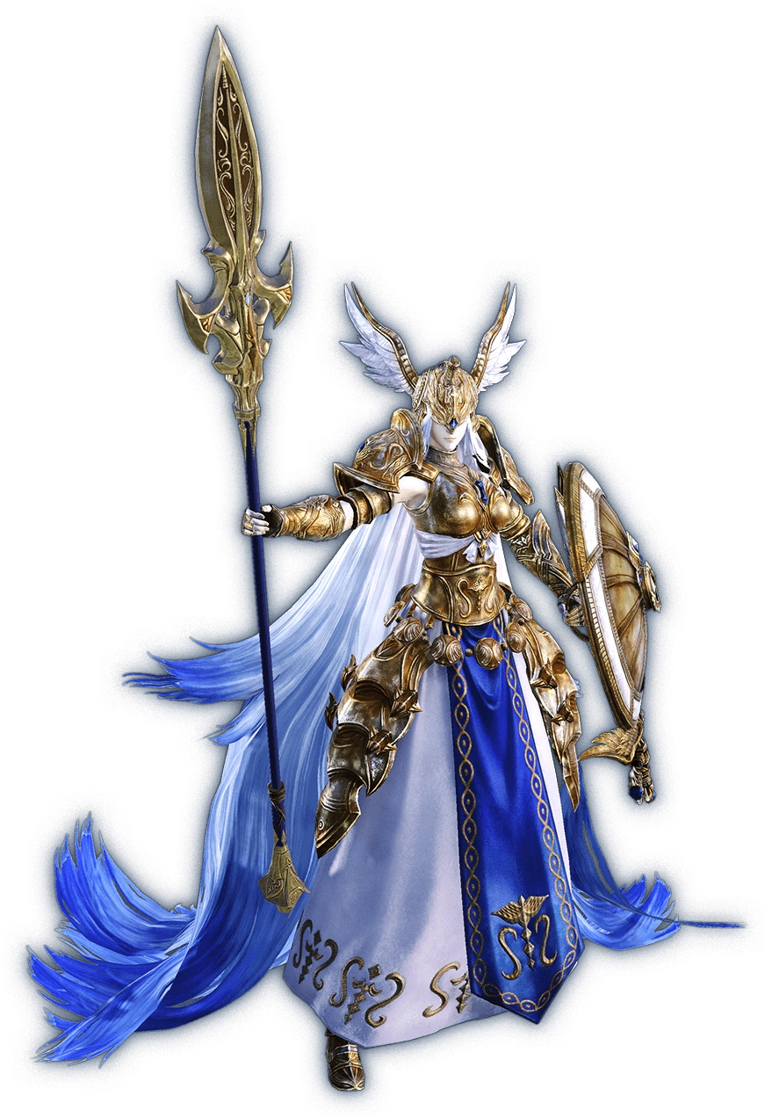
“Hm…” An understanding grunt came from the woman’s lips as her head turned to and fro, intentions clear even despite the fact that her eyes were hidden by the visor of her helmet. Every trace of Dreah’s existence had been erased from the mortal realm. No one back home would remember her, but then again? She could no longer remember herself. There was only Halone, the Fury, one of the Twelve. The mover of glaciers, the goddess of war.

But despite these imposing titles and the equally imposing air around her, this goddess was hardly such a terrifying person. In fact, she was merely looking over her domain to make sure all was properly put together before the Warrior of Light came to challenge her. “It appears that everything is in working order for our grand fight, but now time becomes my enemy once more.” For a god, boredom was the greatest enemy. That was why she was always thankful to have the company of the others. But one in particular was held in higher graces than the rest.

“I suppose I have time to visit her before the Warrior of Light visits next?”

And she just disappeared into thin air.

“I don’t really know anything about the Twelve.”

Such was the sentence S’aiya had been in the process of speaking when Dreah had suddenly been pulled asunder. Except it hadn’t been isolated to Dreah alone, because looking around after speaking? The Miqo’te was quick to realize that she was no longer in the wooded area that she had been in moments before. Nor was her friend in her company any longer. “What? Where am I?”

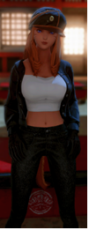
Yet looking around at what appeared to be an arena midst a field of wheat being teased by the wind at sunset, an immense tree in the background, she didn’t have the foggiest idea where she might be. “Why would there be an arena in a farmer’s field?” Not to mention she couldn’t exactly see a farm anywhere nearby.

Were the thief better studied in the lore of the Twelve, she might have understood things a little better, or there might at least have been a chance of her understanding. But growing up on the streets meant that she wasn’t as educated as most, and with all the things she had seen there? It wasn’t like she would have believed in the gods anyways.

And so when the field lit up beneath her in the shape of a marking? It was unlikely there was any chance she might have recognized it.

“What’s with the light?” It was a yellowish green and didn’t seem to glow across the entire arena she was standing upon. But she didn’t get the sense that it was dangerous? If anything… “I wonder how well this light will affect the nearby crops. In terms of benefits… Huh? Why would I care!?” She had started prattling on about the crops? Since where did she know anything about farming, much less care? The woman held her hand in her head, clearly feeling off mentally.

Although with her eyes closed as she attempted to make sense of herself, some physical differences began to emerge across her body. One such change was the color of her skin, which lightened from its natural Ala Mhigan tan towards something a touch lighter, but not entirely removed of its melanin. This skin appeared softer to the touch, but it was more than that. It really had become softer.

As the woman was still dressed it might have been difficult to see what the cause of this was, but her abs were featured in the window between her crop top and her jeans. Those abs had always been very notable considering the line of work she was in, by those ab lines were not only gone, but… While slight, her tummy appeared to be bulging a little. As if she was a little chubby?

It wasn’t even just her belly. The muscles in her arms and legs weakened to become softer and squishier too. Why do I feel so fatigued? The thought did cross her mind, but her thoughts were still in such a tizzy. A bunch of useless knowledge was flowing into her head, rendering her incapacitated. Like what did she care about the fertility of the land!? Or how to use earth magic, for that matter!

S'aiya already had an impressive figure, particularly where her chest was concerned. And while that chest didn’t exactly grow any bigger? There was a clear change that could be perceived even with that top of hers. She wasn’t wearing a bra and she never did because they were unnaturally perky despite their size (thanks to a curse), yet one could perceive their own weight beginning to weigh them down. They sagged a little, pulling her top down to show even more of her cleavage. It certainly didn’t make them look less attractive, but it did create the impression that maybe, just maybe, the woman was now older.

More evidence compounded to suggest this. Her ass and thighs rippled with additional weight, bloating larger and filling the back seat of her jeans so that flesh poked out and over the cusp of the waistline. Her thighs grew so great that rips formed in her pant legs and her hips widened, even. “Huh? What’s happening to my body?” It was enough to stir her from her tizzy and look down past slightly sagging breasts to see her lower body practically exploding from her clothes.

And just moments later, the balloon of clothing burst entirely. Because her point of view was rapidly rising as she grew to nineteen full feet. The flesh that burst out, now bare, was soft and jiggly. Certainly not unattractive, but there was something almost maternal about its shapeliness. Like she had the body of a slightly aged woman now, around the age of forty or so. “I’m… so tall?”

The edgy quality of her voice had softened, her words almost sounding as if they had been spouted by someone’s mother by this juncture. Her lips were fuller and her face rounder, now showing the age that her body resembled. Her eyes, nestled between longer lashes, had begun to glow gold – no longer shaped as they once had been, for her face was of another woman entirely.

“But was I not always…?” This tall? Passively she began to levitate, heightening her point of view even further. But it still didn’t seem as strange as it had before. Like she was accustomed to it. Like it was the viewpoint she held every day. As she floated there, S’aiya’s soft and ample bosom heaved with each breath. Though behind her chest, hair was lengthening past her shoulders and brightening to an orange, bangs parted in the front.

Being a Miqo’te, she naturally had a feline’s ears and tail. But those triangular, furry ears twitched their last twitch just moments before they were folded into her head, more Hyur-like ears sprouting from the sides of her head beneath her hair. While her tail?

THUD!

It fell from her body much like Dreah’s had. Rather than become a spear though? The end hooked into the blade of a scythe while the bulk of it became a wooden staff. “Oh!” The sound of it falling startled the woman, who turned around midair and lowered herself to pick it up. The moment it was within her grasp, her nudity was alleviated by the appearance of a long, flowing green dress that left her cleavage bare as well as doing little to hide the girth of her legs. Decorated with white flowers, she also wore sandals and a headpiece with two steel flowers on the sides.

By the time her posture had corrected itself her priorities had changed completely.

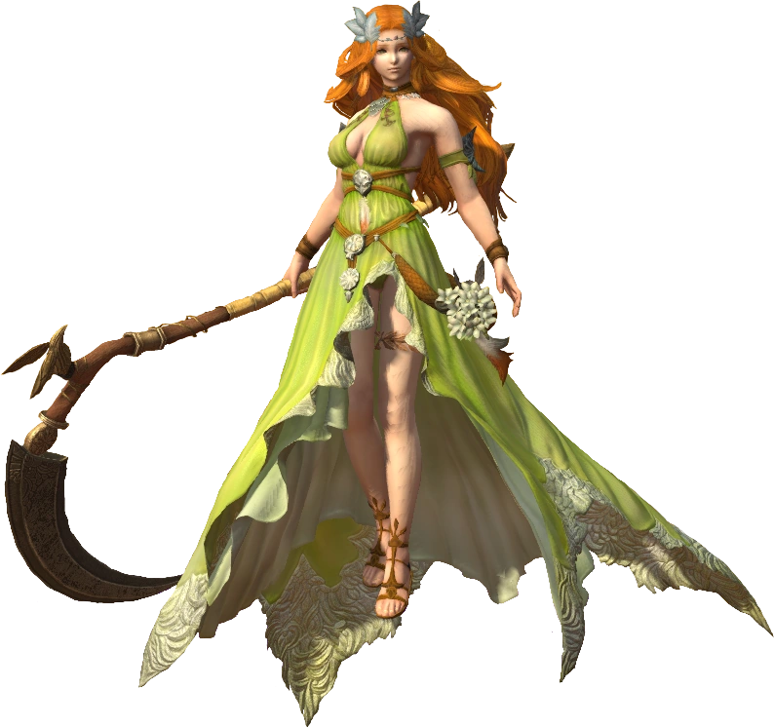
“Oh dear. Is this arena fitting enough? I suppose I could make beautiful flowers appear at my leisure, but this is a more fitting base arena for one known as the tender of soils and harvests…” Such were the concerns that now burdened the mind of Nophica, the Matron. She was the goddess of abundance, she who oversaw the element of the earth itself. And as things stood now? She could hardly fathom herself being something as small as a mortal, what with how she loomed over the land below.

In terms of abundance she certainly lived up to her namesake. Compared to the fitter, lither body of Halone, she was soft and supple with a bosom and rear to highlight this. But she did not need physical strength to pose a threat to the Warrior of Light when they next took their challenge. No, she was confident she could be challenging enough without that strength.

But Nophica did eventually sigh. Her arena was how she wanted it, so what would she do in the meantime? The idea of mingling with mortals had been becoming more and more appealing as of late. “Nophica? Do you have some time for me?” A familiar voice eventually stirred her from her thoughts, as Halone materialized from thin air before her.

The two were fabled to be enemies by mortals, but the reality of the situation? Well, it was the exact opposite. The two were lovers, both physically and emotionally. And Halone? She always stopped by when she was in the mood to be doted upon. Nophica smiled.

“Of course! I was just wondering what I would do with all of this free time.”

