**Acid Base Titrations**

**Worksheet**

Organic Chemistry Tutor

1. 28.9 mL of H2SO4 was completely titrated with 38.4 mL of a 0.250 M NaOH solution. What is the concentration of H2SO4?

2. 23.6 mL of a 0.460 M monoprotic acid solution was titrated with a 0.190 M NaOH solution. What is the volume of NaOH that should be added to the solution to reach the equivalence point?

3. 50 mL of a 1 M HCl solution is titrated with a 0.50 M NaOH solution. (a) Calculate the volume of the NaOH solution needed to reach the equivalence point. (b) What is the pH of the HCl solution before any NaOH is added? (c) What is the pH of the solution after 30 mL of NaOH has been added? (d) What is the pH at the equivalence point? (e) What is the pH of the solution after 125 mL of NaOH has been added?

4. 100 mL of a 0.50 M HOCl solution is titrated with a 0.250 M NaOH solution. (a) Calculate the volume of NaOH needed to reach the equivalence point. Calculate the pH when the volume of NaOH added to the solution is (b) 0 mL (c) 50 mL (d) 100 mL

(e) 200 mL (f) 225 mL (The Ka for HOCk is 3.5 x 10-8)

5. 50 mL of a 1.0 M NaC2H3O2 solution is titrated with a 0.50 M HCl solution. (a) Calculate the volume of HCl needed to reach the equivalence point. Calculate the pH when the volume of HCl added to the solution is (b) 0 mL (c) 40 mL (d) 100 mL (e) 110 mL (The Ka for HC2H3O2 is 1.8 x 10-5)

6. Bromthymol blue changes from yellow to blue as the pH of the solution increases. The Ka value for this indicator is 1 x 10-7. What is the color of a solution with this indicator if the pH is (a) 4.0 (b) 7.0 (c) 9.0? (d) At what pH will the first color change be visible for a weak acid – strong base titration using this indicator? (e) What about a weak base – strong acid titration?

7. Which indicator should be used for the titrations shown below?

|  |  |  |
| --- | --- | --- |
| **Indicator** | **Ka** | **Hin to In-** |
| Methyl Orange | 3.4 x 10-4 | Red to Yellow |
| Methyl Red | 7.9 x 10-6 | Red to Yellow |
| Bromthymol Blue | 1.0 x 10-7 | Yellow to Blue |
| Phenolphthalein | 5.0 x 10-10 | Clear to Pink |

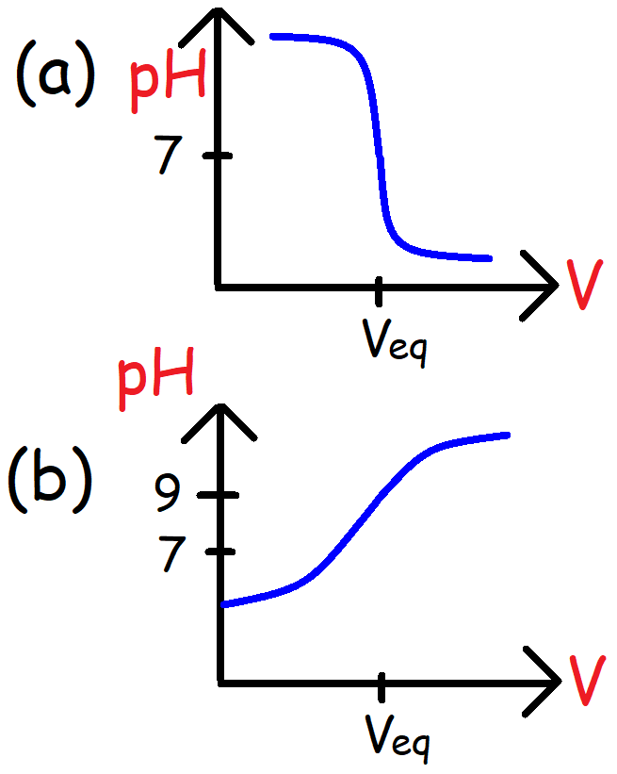

8. Which of the following statements is false?

A. The pH is equal to the pKa at one half of the volume needed to reach the equivalence point for a weak acid – strong base titration.

B. The pH at the equivalence point is less than 7 when a solution of HF is titrated with NaOH.

C. The pH at the equivalence point is equal to 7 for a strong acid – strong base titration.

D. The pH of the solution is always decreasing for a weak base – strong acid titration.

E. [A-] = [HA] at one half of the volume needed to reach the equivalence point for a weak base – strong acid titration.

9. Which titration will have an equivalence point with the highest pH?

A. 0.50 M HCl and 0.50 M KOH

B. 0.10 M NH4Cl and 0.10 M KOH

C. 1.0 M NH3 and 1.0 M HCl

D. 0.50 M NH4Cl and 0.50 M KOH

E. 2.0 M NH3 and 1.0 M HCl

10. Use the titration curve shown below to answer the following questions. (a) What is the Ka of the weak acid? At which of the point(s) shown on the graph is (b) [HA] = [A-]? (c) [HA] < [A-]? (d) [HA] > [A-]? (e) What is the pH of the solution at the equivalence point?

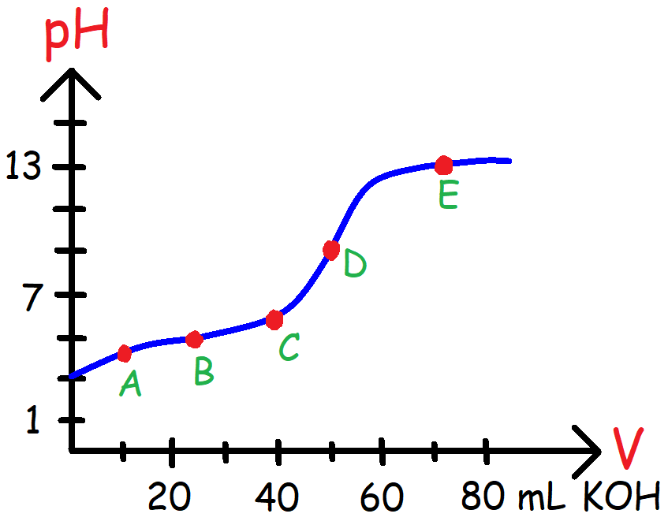

11. A 10 mL buffer solution has a pH of 5. A separate 10 mL solution of HCl has a pH of 1.

(a) What will be the pH of the solution if 90 mL of water is added to the 10 mL buffer solution?

(b) What will be the pH of the solution if 90 mL of water is added to the 10 mL HCl solution?

12. A 100 mL solution consists of 0.1 M HNO3 and 0.1 M HNO2. Which of the following species will increase in concentration if 25 mL of a 0.1 M KOH solution is added to the mixture containing HNO3 and HNO2?

A. H3O+

B. NO3-

C. NO2-

D. HNO2

E. HNO3

13. The pH curve below shows the titration of two different weak acids HA and HB undergoing a titration by a strong base. Which of the following statement(s) is true?

I. HA is a stronger acid compared to HB.

II. HB has a higher Ka value than HA.

III. HA has a higher pKa value than HB.

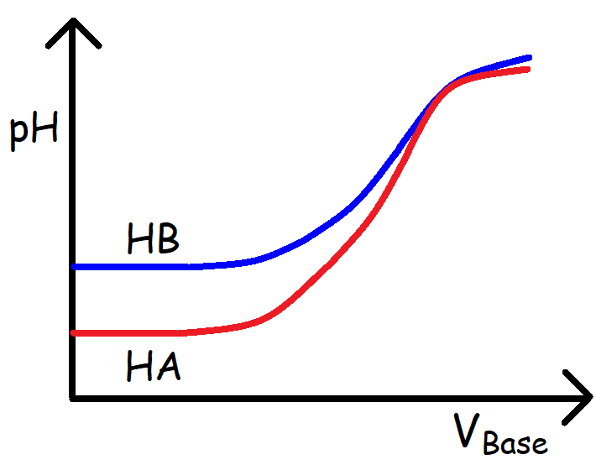

A. I Only

B. II Only

C. II & III

D. I & III

E. I, II, & III

14. Which of the following statement(s) is true?

I. The pH is equal to the pKa of the weak acid at one-half the volume of the equivalence point of a weak acid – strong base titration.

II. [HA] = [A-] at ½ the volume of the equivalence point of a weak base – strong acid titration.

III. The pH is equal to the pKa of the weak acid at twice the volume of the equivalence point of a strong acid – weak base titration.

A. I Only

B. I & II

C. II Only

D. III Only

E. I, II, & III

15. Which of the following acids correspond to the pH curve shown below when titrated with KOH?

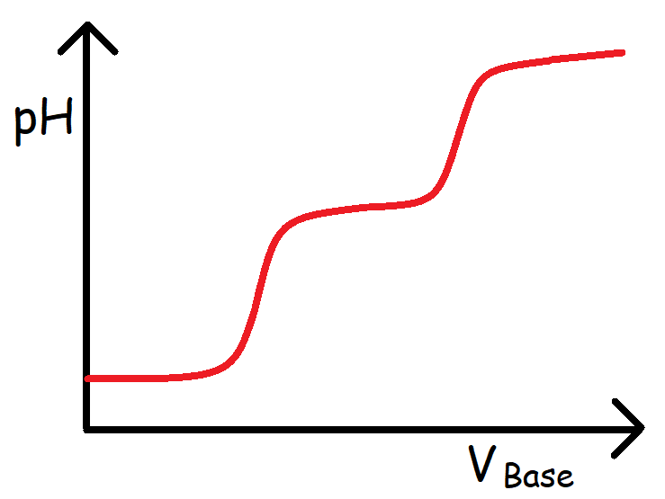

A. HCl

B. H2SO3

C. H3PO4

D. HBr

E. NH4Cl

**Answers:**

1. 0.166 M 12. C

2. 57.1 mL 13. A

14. E

3a. 100 mL 15. B

3b. pH = 0

3c. 0.359

3d. 7

3e. 12.85

4a. 200 mL

4b. 3.88

4c. 6.98

4d. 7.46

4e. 10.3

4f. 12.3

5a. 100 mL

5b. 9.37

5c. 4.92

5d. 2.61

5e. 1.51

6a. Yellow

6b. Greenish

6c. Blue

6d. pH = 6

6e. pH = 8

7a. Bromthymol Blue

7b. Phenolphthalein

8. B

9. D

10a. Ka = 1 x 10-5

10b. B

10c. C, D, and E

10d. A

10e. pH = 9

11a. pH = 5. Diluting a buffer solution will have no effect on the pH.

11b. pH = 2.