**Chapter 2**

**A TINY bit of Homework**

Amanda could not keep the smile off of her face! With each step she took, the tiny man slid up and down between her sweaty ass cheeks! She could feel his arms and head tickling her asshole like he was giving her a massage and the sensation was incredible! She could feel his feet brushing against her pussy lips every few seconds and the touch sent a shiver of pleasure through her body. She couldn’t keep herself from thinking of all the fun and… Nasty things she was going to use him for once they were home.

She took a few more steps, letting her feet hit the floor hard and with purpose causing her sweaty ass cheeks to jiggle and shake! The little man bounced back and forth massaging her anus as Amanda grinned. She pushed her shopping cart down the aisle until she got to the seasoning area. Slowly she scanned the shelves until her eyes closed in on a bright yellow box! Taco seasoning kit!

“Perfect!” Amanda said out loud as she bent over to grab the box, she made sure to keep her legs together and bend at the hips, sticking her ass out far so it spread wide and bubbled out! She reached for the box but then stopped, her hand moving over to grab the **EXTRA** spicy ones! She could feel the little man in her buttt squirming like crazy… not that he wasn’t moving around frantically before, now, it was like he had gone into overdrive! She could feel his little arms grasping her fat cheeks! It felt like a big ant was on her asshole! Amanda was about to stand back up when she froze, her stomach gurgled loud as a thick hot bubble of pressure began moving down her intestines! She smiled and massaged her stomach a bit while pretending to scan the shelves....

“Hmmmmmmm” she said out loud with a finger on her chin!

**BBBBBBBBBBBBBBBBBBBBBBBBBBBBBBBBBBBBBBBBBBBBBBBBBBBBBBBBBBBBBBBBBBBBBBBBBBBBBBBFFFFRRRRRRRRRRRRRRRTTTTTTTTTTT**

The fart was so loud that it could be heard clear across the shopping center, it’s wet abrasive blasts echoing in the large open space! Amanda froze with her hand over her mouth before bursting into a fit of embarrassed laughter! The little man in her ass cheeks was squirming so fast, moving so quickly! The sensation was tickling her a bit too much! Suddenly she felt him slip inside! Amanda quickly stood up straight with a shocked expression on her face almost letting out a little scream, she could feel him… inside her asshole!

Amanda looked back and saw a young man standing a few feet behind her, he was staring at her ass while covering his nose, his skin a pale shade of green! Amanda was so lost in her thoughts that she hadn’t even realized the odor! It was so thick and powerful, the kind of fart that crawled into your throat forcing you to taste it! Amanda gagged for a moment before apologizing and blushing then quickly pushing her shopping cart away from the disaster zone. The man stood behind her still in shock, coughing in her cloud of ass fumes!

“Oh god, oh no, oh no oh no!” Amanda muttered to herself as she took tiny little steps, anxiously trying to find somewhere private! The little man was **INSIDE** her asshole! She could feel his little arms poking out and trying to pry himself free! Each step she took though, her thick cheeks would force him deeper and deeper! His tiny hands grabbed the fat of her inner cheeks trying to hold on, but it was too sweaty! Amanda blushed as she felt his little arms slip inside! She stopped walking, too scared to take another step!

Amanda had heard stories of tiny men being lost inside of womens rectums, it was a death sentence for the shrunken guys, very rarely did they survive any sort of extended stay! Normally, if she had owned this tiny man, it wouldn’t be an issue, but this was for her class! She needed to take care of him! Amanda panted nervously as she looked left and right, the aisle she was standing in was empty… for now. She quickly reached back, pushing her hand down into her damp leggings and between her soaking ass cheeks! She actually grimaced from how wet and swampy it was in the depths of her unwashed ass! She glanced let and right once more before bending over and pushing her finger inside of her asshole!

**SHLRP!**

Amanda’s finger slid inside easily from how much sweat and excess shit there was on the rim of her asshole! Her manicured finger went deeper then she had intended though! Her anus closed on her knuckle as the tip of her finger pushed the little man even deeper!

**“OH FUCK!”** Amanda said out loud as she frantically began fingering her asshole! There were wet sloppy noises coming from behind her as she slid her finger in and out, trying to catch hold of the little man! She pushed on him with her finger tip, dragging along the inner walls of her anus but each time she reached the exit he would slip off! As she pushed her finger back in, he would be shoved deeper! She felt terrible and would never admit this to herself, but it actually felt kind of nice!

The squeaky wheels of a shopping cart signaled someone approaching as Amanda pulled her finger from her asshole and brought her hand out from the back of her sweat stained yoga pants! She could smell the stench of acidic shit the moment her hand was released to the free air! She waited and watched as an old lady came walking slowly down the aisle she was standing in…

“Shit” Amanda muttered to herself, she could still feel the little man wiggling inside of her! He could be suffocating with how deep he was!”

Amanda looked down to her finger and gasped! It was… **COVERED!** In a thick coating of light brown chunky shit! There were bits of green and red deep down inside the mashed processed waste that she recognized as the peppers from the pizza she ate last night! She wanted to gag but held back while reaching out and wiping her finger across a box of Cheerios! She had to double back a few times to get all the shit off and even then her finger reeked like a dumpster! A young couple entered the aisle and Amanda walked away quickly leaving the crime scene behind her. As she was leaving and about to turn the corner, she heard someone yell.

**“WHAT THE FUCK!”** Amanda turned back to see the young man dropping the box of Cheerios she had just ruined! He was inspecting his hand in a state of shock as Amanda blushed and walked quickly! She turned to the next aisle and stopped right away! Each step sent the tiny man inside of her deeper and deeper! She could feel him grasping at the inner walls, trying to climb his way out!

Amanda did a check left and right to make sure she was alone before reaching back into her pants. She closed her eyes, bracing herself for the disgusting sound of her finger entering her dirty anus, but suddenly she froze! Her stomach bubbled and rumbled with a watery thunder sending waves of pressure down into her colon! She removed her hand from her pants and smiled to herself…

“You know, that might just work,” Amanda smiled. She grabbed onto the handlebars of her shopping cart and squatted down, her big ass bubbling out so wide that it felt like her yoga pants might tear open! Her sweaty fat ass cheeks spread wide allowing her anus to be open and free, her thong still nestled over it like a safety hammock to catch the little guy. She could feel him crawling for her anus, he was just about at the rim, his hands clawing to get free! The bubbling got louder as Amanda pushed! Her anus sucked inwards and then BLASTED OUT!

**PPPPPPPPPPPPPPPPPPPPPPPPPPPPPPPPPPPFBNBBBBRRRRRRRRRRRFFRRTTTTPSPPpspppprpttttttttttttttttttttttttttttttttttt**

**(Tom’s pov)**

Tom had heard the stories of all the horrors little men had to go through, but he never imagined it would be so terrible! Amanda was beautiful, she looked like an angel! At first he was pleasantly surprised to have such a innocent and kind looking woman taking care of him. That was before they reached the grocery store! Up became down, left became right, Her sweaty fat cheeks became his entire world! Each step she took was like a fleshy earthquake, sending him flying through her crack and into her other sweat stained cheek! No matter where he turned, his face was filled with calmly ass flesh, there was no escape!

Far below Tom could see her anus, it looked like the deep gaping mouth of a kraken from the fictional private movies he had seen as a child! Its thick brown walls open and closed, letting loose puffs of warm air that had been brewing inside her intestines! Her cheeks shook left, and right, left and right, Tom could not control his movements as he sunk closer and closer to the giant hole!



Tom wanted to cry as he slid closer and closer to her anus, the heat was almost unbearable! It was already difficult to breathe in the cloud of anal fumes between her cheeks, but right next to her anus, it was pure hell! He began dripping with sweat as he reached out, grabbing onto the thick puffy anal rim to stop himself from falling inside!

**“OH GOD! PLEASE HELP”** Tom screamed with tears running down his cheeks! Her anus was pushing in and out almost past the length of his body! He was sprawled out like a star starring straight inside of her body! It was dark and atrocious smelling, the odor so strong that he couldn’t even put words to it! His hands began slipping on the oily sweaty flesh as Tom cried and grasped a long anal hair, wrapping his hand around it tight!

**BUBBLE RUMBLE GURGLE GROAN!**

Tom froze in a state of pure fear and shock as a terrifying rumble cam from within her and inside the hole below him! It echoed all around him like a terrible beast approaching! Tom wanted to scream but he knew no one would come for him, he was all alone in his new personal hell with no chance of escape! All he could do was hold on and enjoy the ride!

**BBBBBBBBBBBBBBBBBBBBBBBBBBBBBBBBBBBBBBBBBBBBBBBBBBBBBBBBBBBBBBBBBBBBBBBBBBBBBBBFFFFRRRRRRRRRRRRRRRTTTTTTTTTTT**

The rancid thick fart came out like a hurricane lifting him into the air and letting him hover between her spread ass cheeks for a split second! Her thick anus pulled inwards and pushed out as his ear drums **EXPLODED** like a bomb had gone off right next to him! Tom was thrown back into her thong as his ears slowly recovered! All he could hear was a high pitched buzzing! The odor was so thick and powerful that he could not even describe it! The fart just felt like pure heat! His eyes watered as the gas from Amanda’s body filled his lungs! It burned so bad and there was no air anywhere around him, the only thing he could breathe was her gas! Tom was so caught up with trying to survive the geqsour blast that he hadn’t realized that he began slipping! With the fart now over, he fell from the thong and **RIGHT DOWN** into her spread and gaping anus! It was still steaming with the fumes of her gas!

Tom reached out trying to grab the walls of her ass but missed by a mile! His feet and hands skimmed on the walls of her rectum as he slid down tumbling deep inside! He went feet first as the walls of her asshole sucked him in, grabbing his head and pulling him deep! All the light disappeared being replaced with pitch black darkness and an insane pressure! The wet walls around him pushed deep and squeezed like he was inside of a snake! **PLEASE HELP, PLEASE, I DON’T WANT TO DIE, SOMEONE FOR THE LOVE OF GOD HELP ME!** Tom screamed on the inside of his head, too afraid to open his mouth! Slowly he took short little gasps through his nose, sucking on the fumes and what little oxygen existed inside of her!



Tom began clawing at her asshole, digging his fingers into the fleshy walls and not caring if he hurt her! It felt like he was squeezing his way through a wet sock as he tried to get his head to her rectum! It felt like years but eventually he could see a spec of light! It appeared and disappeared every few seconds as her anus pulsed open and closed! Tom had never been so happy! He had never felt such ecstatic joy! He could feel a breeze of air from the real world on his face as he squirmed and crawled, clawing his way to freedom! He was just about to reach the exit of her anus when he saw it! Suddenly the hole widened as her finger came in!

**“NOOOOOOOOOO”** Tom screamed out loud, his mouth filling with oily anal juice and bits of her shit!

All he could do was watch as her giant finger entered her anus! For a split second he could see light as her finger pushed against her oily anal walls, squishing and filling any available space! It was like a giant worm coming down a tight wet subway tunnel, forcing him deeper and deeper inside! Tom held onto her finger as it mashed into his face, feeling himself be pushed deeper into the wet warm heat of her body, his only chance was to use her finger to bring himself out! Suddenly her finger began pulling out, but the skin was so wet he could barely hold on! He dug his nails into her skin but it wasn’t enough! Tom wanted to scream as his body smeared against the walls of her anus ! He screamed out loud and cried as he watched her finger leave! Her anus closed tight like a wet living door! Sealing him inside!

Tom could feel a wet liquid flowing over his feet until a mushy thick substance began covering him from the legs up! It felt like hot quicksand but deep down inside Tom knew what it was! He wouldn’t let himself even think the word through, if he ignored it maybe his mind could block out this horrible hell! The mushy warm mud like substance was up to his knees when he saw her finger enter again! Light appeared above him and Tom looked up, seeing one more opportunity to escape!

Her finger came down mashing into his face and he grabbed on immediately! Amanda kept pushing though! Tom screamed, inhaling her anal fumes and tasting the gas inside of her as she forced him down into the wet feces! Tom could feel it sucking in his body like he was being submerged into wet mud! It bubbled and oozed around his body as her anal walls clenched and sqquezed, threatening to break every bone in his body! Just when the feces head reached his neck, Amanda began to pull out, Tom held on for dear life as she dragged him up her colon! Just as he was about to exit her anus, he slipped and lost hold! All he could do was watch as her shitty brown finger left her anus, leaving him trapped in the smelly prison!

Tom could feel the hot shit bubbling below his feet as it oozed higher and higher! He could feel the pressure building all around him and knew sooner or later the shit would need to come out! He would be able to escape her ass, if he lasted that long, but he did not want to think about it! There was a sickeningly loud bubbling that came from all around him, it echoed down her intestines and colon as she clenched! He could feel her entire inside contracting as her colon put more and more pressure on his unprotected little body!

Tom was about to give up, accept his fate, but then he felt Amanda shift! Her body lowered and her entire colon and insides tightened! Tom couldn’t help but let out a terrible high pitched scream! It felt like every bone in his body was going to break in an instant! The pressure under his feet built higher and higher as her anus gurgled and puckered!

**PPPPPPPPPPPPPPPPPPPPPPPPPPPPPPPPPPPFBNBBBBRRRRRRRRRRRFFRRTTTTPSPPpspppprpttttttttttttttttttttttttttttttttttt**

The fart was like an atomic bomb going off right at his feet! Tom **EXPLODED** out of her asshole like a fucking rocket! He wanted to scream but the pressure and speed was so intense all he could do was squint and brace himself! Tom hit the back of her thong with so much force that he thought his wet broken body might explode right out the back of her pants but luckily it caught him… luckily was the wrong word though. Less than a second after he had hit her thong, her dirty wet anus let loose a hurricane of assfumes mixed with a rain of wet feces! Tom held his shaking hands above his face to block the blow as it fell down, caking him like wet mud! He wanted to cry as it splattered into his body, holding him down almost as if it was cement! His arms were thrown back leaving his face unprotected as he was **SMOTHERED** in shit!

There are truly no words for how terrible this was, Tom just lay there, given up, there was no hope for this new life! He could feel Amanda stand up as her thick sweaty pale ass cheeks closed in on him, smothering him in the mess of wet feces and pool of shit! For a moment, Tom was disgusted! How could she walk around with so much feces in her ass! What a dirty bitch! But then Tom realized, at his size, this was barely a mess, just a skidmark to her! His face was knocked left and then right as her cheeks shook, massaging the feces into his skin!

**(Amanda’s pov)**

**“**Oh, Excuse me” Amanda apologized to herself as she fanned behind her big ass! It felt so sweaty and wet, with the heat of the fart, it felt like she had shit her pants a little bit! The idea made her laugh as she continued shopping and filling her shopping cart with food! By the time she was done, the cart could barely hold anymore food! She made sure to load up on fruits and vegetables, as well as some spicy snacks and junk food! She hadn’t expected it to be so much fun farting on a little guy, Amanda had heard stories, even seen a few videos on Instagram of women ripping ass on little men! They would choke and gasp, some even puked! When the human body shrank, all their senses were strengthened! This made bad smells **MUCH MUCH WORSE!** Almost x10 the potency that normal people can smell! Amanda always felt bad for the little men in these videos, but now that she had her own, she understood the pleasure! She gave her ass a quick shake letting her ass cheeks jiggle back and forth shaking the little guy around! She could feel him bouncing around in her thong, nestled between her cheeks! With a big smile on her face she pushed her cart to the checkout line!

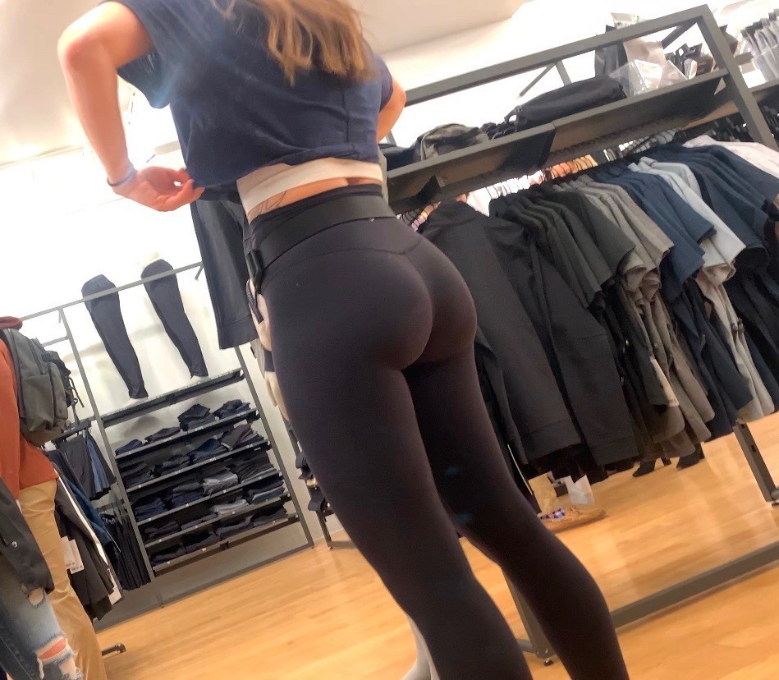

“Ugh!” Amanda let out a groan as she kicked the front door open with her foot and then turned using her butt to block it as it swung back at her! She backed in, grocery bags in both hands and sweat dripping from her forehead! It was like walking on the sun outside and she was ecstatic to be back in her Dorm room, even if the air conditioning was garbage, it was still better than nothing!

Amanda walked to her tiny kitchen and began filling her fridge and cupboards with the food she had bought before **PLOPPING** down on her couch and fanning her face!

“I need to shower!” She said out loud to herself before pulling a few of her school books from her knapsack. Amanda tossed them all out on the floor in front of her and then slid off the couch letting her big bum take the impact of her weight hitting the floor! Slowly she scooched forward and then flipped open her text books…

“I feel like I am forgetting something…” Amanda said to herself!

**“OH YEA!”** Amanda said out loud as she got up and ran to her kitchen! She came back with an alcoholic cider and opened the can before **DROPPING** heavily to the carpeted floor! Her ass jiggled as she hit the ground and she giggled a tiny bit! Amanda took a long slow sip from her cool drink before wiping some sweat from her face.

“Alright, time to get to work” she said out loud as she began reading the textbook.

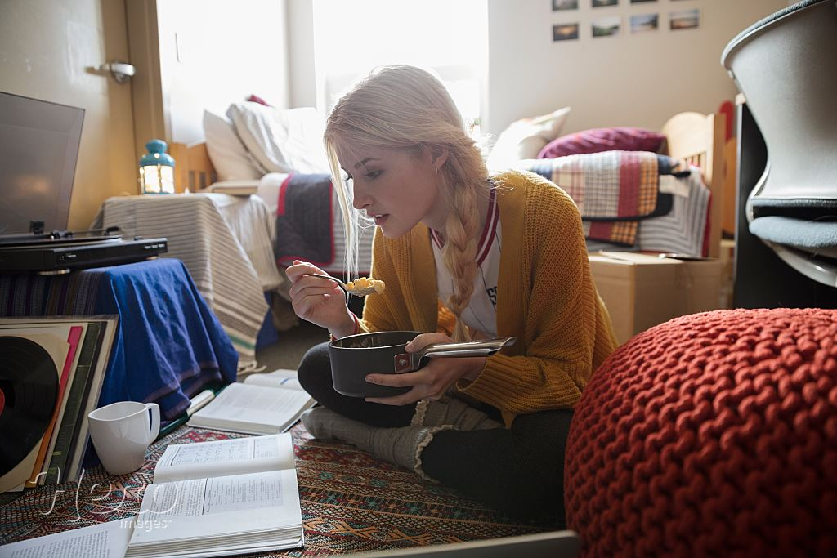

“The first male shrunk in the year 2022, Still to this day we do not know what caused the shift in biology! Some theorists suspect that the physical structure of the cell was distorted during the addition of extra fluoride to the world's water supplies! Men all over the globe began shrinking at an unprecedented rate! UGH… This is so boring…” Amanda said out loud as she flipped forward a few pages through the introduction.

*“There we go! Chapter 1 - A Little Work Goes A Long Way*” Amanda chuckled at the title while leaning back and sipping her drink! She could feel something pressing on her ass cheek, it must have been her thong all wadded up from the sweat and heat! She reached back and tugged on her underwear pulling it into her crack a bit deeper before continuing to read.



“When working with a tiny man it’s important to be careful, but that doesn’t mean not to have fun! The male body when shrunk can sustain up to 1000 times their weight, almost like an ant! Their small size makes them incredibly resilient! This is how they survive being sat on and squashed! They do have limits though, and pressure more than 1000x the weight of their body can kill them so be careful! As Well as being able to support extreme weight, their bodies can also heal extraordinarily quickly! Broken arms and legs, even a fractured spine can heal overnight! If your tiny is broken or hurt, simply place them in a warm compress and leave them to sit overnight! The adaptability was first discovered by Doctor Rhonda sp… **OH FUCK!”** Amanda shouted as she got up and ran to her bathroom!

**“I AM SUCH A FORGETFUL DITZ!”** She said out loud as she kicked the bathroom door closed!

Amanda peeled down her soaking wet sweat stained leggings and grimaced from how sweaty she was! She could already smell the stench of her pussy and ass filling the tiny bathroom! She always had issues with sweat and it was hard to keep under control, she was actually a bit embarrassed about it! She reached back to her bubbly sweaty ass and spread her cheeks with one hand!

**BBBBFRTTTPPPFTT**

As soon as her cheeks spread, a short raspy fart exploded out! The sound came out bubbly and wet from how much sweat and liquid was accumulated at her anus! She physically grimaced from the disgusting sound! Slowly she reached back, feeling around until she found him! He was stuck inside of her anus with just his head poking out!! Gently she grabbed his head and began pulling his body from her anal cavity!

The smell that filled the bathroom was akin to death! Amanda brought her hand up to her face and covered her nose as she dragged the little man from between her cheeks! She slowly held him up in front of her face as her eyes went wide with horror! He was coated, head to toe with thick brown chunky feces! She could see the pale dead white expression on his little face as he began gagging and heaving! He tried wiping the poo from his body as Amanda quivered! She had never seen anything so disgusting! The little man began puking just as she tossed him roughly into the sink! Without thinking about him, she turned on the tap and began washing her hands, desperate to get the little bit of feces off!

**“EW EW EW!”** She cried as she washed her hands! She could see him struggling to stay up in the giant waves that cascaded down burying him in soapy water but she didn’t care! She just wanted the feces off of her hands!

Amanda was gasping from the smell, that was when she remembered her ass! She wadded up some toilet paper and reached back, shoving it between her cheeks, pulling it out to see a thick dark coating of feces! Her jaw nearly dropped! She had no idea she had made such a mess back there! She began cleaning herself again, folding the paper and swiping it up her thick sweaty ass crack! It wasn’t until the fourth wipe that she gave up and kicked off all her clothes, finishing with a warm shower!

Tom watched from the flooded sink as his new tormentress undressed and stepped into the shower! There had to be some way out! Same way to escape! Tom pushed himself under the soapy shit scented water and opened his mouth, sucking in a big mouthful and then another, trying his best to drown himself! He had heard that the task was next to impossible to do on purpose but he was determined! He choked and sucked in more water while holding himself down! Eventually things went dark! For a second he had a moment of relief, a split second of peace and rest! He woke up though, choking and spluttering on the surface of the water! Tom could hear the shower turning off as Amanda stepped out and grabbed a towel! There was truly no escape to this new hell!