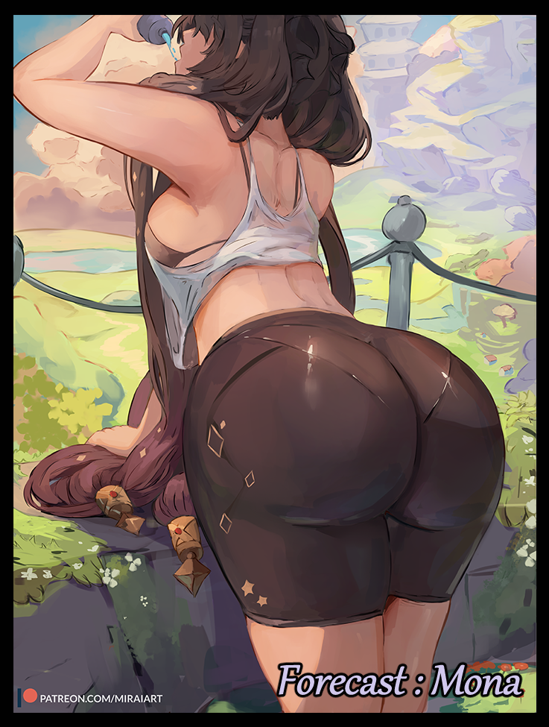

The world was a vast place that sheltered many individuals with differing traits that made them stand out as unique commodities amongst their fellows. From the exuberant classmate who just couldn't seem to go a day without engaging in non stop conversation with their friends to the more eccentric individuals who staved boredom away in their own strange way. One can't deny that at some point of another, they would've met at least one face they wouldn't be able to forget for a long time to come.

One of these individuals was a man going by ***Steven***, a bodybuilder leaning more towards the eccentric side of things than a chatterbox extrovert. But even amongst his quirky peers, Steven was unique in one regard, the thing that gave him the drive and willpower necessary for a super athlete like him to be so successful in his career participating in cross country marathons and other such demanding activities.

An animated, 2D character…in other words; a waifu. That was the source of Steven's incredible drive to bulk up and keep fit, trapping himself in a world where all he did, he did for her.

To most people, the man was rather polite, outgoing and eternally positive. But to those who knew about his personal life and interests, the man was more akin to a delusional oaf. An oaf capable of great things thanks to said delusions. Whether it was lifting weights or running an entire lap around the city he lived in, Steven pushed himself to greater heights with the thought of his waifu alone, returning home to a rather humble apartment that seemed plain for a man of his status. But one peek inside his room and it became clear where all his hard earned money was going.

Standees, posters, figurines and other merchandise littered his room from floor to ceiling, it was like a miniature mausoleum dedicated to the fictional character. A rather popular face to boot, making the rounds worldwide through some famous game that had everyone raving for more.

But such fierce devotion was far stronger than most would realize, capable of peeling apart the fabric of space and time itself, allowing for certain individuals to wield that power for their own uses. And the more Steven nurtured that burning desire, the more that power grew. Eventually becoming a ball of energy akin to a miniature sun that needed some form of release before it overloaded entirely, applying some measure of strain to the body that housed it in the form of unshakable feelings of paranoia, stress and even hallucinations. A mentos and coke situation to put it lightly.

It started with minor headaches that could be easily dulled by painkillers, but medication wouldn’t be able to fix the symptoms that came after; a pulling of the heartstrings on random occasions, a subtle throbbing in random regions of his body that were there one moment and gone the next. But the worst (and arguably the best if it weren’t for the side effects) was the aforementioned hallucinations. Manifesting as brief visions and masks over reality as Steven knew it until now.

Rolling hills and lush plains of verdant meadow painted over the cold grays of city streets and towering buildings. Multicolored slimes bouncing with gelatinous gusto by their owners' sides instead of an ordinary domesticated dog being taken out for a walk. Houses of brick, mortar and wood rising over concrete and rebar. There was even a time where Steven had been involved in a fight between gang members, except instead of burly men duking it out with fists and bats, he glimpsed shaggy, mottled simian like creatures wearing masks battering each other with tree branches fashioned into rudimentary clubs, all while they danced a funny little dance before the cops, dressed in medieval knight armor, come around the corner, wielding swords and slinging arrows instead of the batons and guns they were using. It was disorientating, sure, but Steven wasn’t sure if he was supposed to be concerned. He was actually starting to have a bit of fun in a life that admittedly had started to grow a little stale.

Until the unintentional orientation changes arrived in the form of strange erections and rousing desires for men, not all, but specific ones that were in abundance within Steven’s profession. Slim, muscle bound hunks, the kind with stylish hair, chiseled jaws and streamlined forms. It wasn’t an immediate reaction but one that built over time, leading to awkward conversations when either party discovered the intimate implications insinuated by a fierce blush, or a tent in his pants. It made many, including Steven himself, question his orientation and whether or not this was linked to all the hyper realistic visions he was having supplanting his hold over reality.

The real icing on the cake however, were the physical appearances of his waifu within the material realm, an apparition only he could see. One moment she would be crossing the street, oversized hat bobbing to her step and the next, she’d be high up on the rooftops staring skyward with an aureole of luminous water behind her. And at other times, Steven would only be graced by her peppy, high pitched voice drifting in from somewhere off in the distance shrouded to his eyes. Whispering indiscernible words out of the blue that were barely heard before dissipating, almost as if brief snippets into another world were being opened before closing. And then there were the even stranger occurrences where her appearance would be superimposed upon his own, temporarily giving him brief glimpses through the eyes of his beloved, a mental plague that would slowly give rise to more and more time spent in front of the mirror or on his camera phone, hoping she would appear after every blink.

Eventually things would reach a peak with both his social life and ability to keep participating in the sporting world, announcing a temporary departure from it all while he attempted to get a proper grip over what the heck was happening to him. Still oblivious to the ridiculous amount of energy borne of his own desires festering away inside of his heart. An inch away from spilling over entirely, washing over the one who bore it in an effort to fulfill his deepest longing whether he liked it or not.

And when it did, the world at large would never be able to recall a famous athlete by the name of Steven. Nor would he for that matter…

Although he was taking a break, the athlete hadn’t quite lost touch with his sporty side, ensuring he stayed fit through regular morning runs around the park near his home, all while trying to figure out the reason behind his increasingly lucid hallucinations and irrational feelings. Waking up, getting breakfast and watching some TV before heading back inside his room to get dressed in his usual sporting attire consisting of a loose white singlet, baggy running pants and form fitting underwear. He loved feeling the wind encircling him while he ran, and that factor would come into every decision he made when it came to his choice of clothing, choosing the baggiest ones that allowed for great airflow.

Once he was dressed and ready to go, the man steps outside, about to shut the door and lock it up before noticing the television rubbing in the background with its volume turned off and the screen displaying a news channel with a raven haired woman rattling on about the whether while pointing her hands to different regions of the country, magnifying the city Steven lived in before a four lettered word pops up next to a cloudy icon…and a small, chibi-styled visual of an animated girls face…he rubbed his eyes at that, shaking his head before reading the actual state of the weather; Sunny…

**"Crazy ass visions are getting weirder…maybe I really need to see a doctor? Bah! After the run…"**

He'd said so a hundred times before, always contemplating medical aid before either forgetting or discarding the thought. But today would be different, a choice would be made, and that altered weather forecast from earlier was simply the warm up, the telltale signs of the tsunami that would wash Steven away, remaining blissfully unaware as he trots over toward the park, ready to begin warming up before he begins the run proper.

Starting with simple arm reaches, Steven moves his arms from side to side as far as they can go. Stretching his muscles and loosening them up as they begin to bulk…before shrinking with each set, loosening up as intended before fading away, applying a visible shrinkage to the hardened pillars as they continue to exchange solid power for supple flair, gaining a radiant luster to hairless skin as it softens atop baby fat and tender meat adorning petite branches that were now shadows of their former selves, tapering off into small hands with palms healed of rough, callused skin. Extending into two sets of five dainty digits tipped with pale pink shells of smooth calcified skin. By the time he'd hit the sixty second, they were barely recognisable and comically small compared to the rest of his regular sized frame. But that was an easily rectified problem as Steven continued with the warmup unabated.

Kicking up his legs while bracing his hands behind his head, Steven begins to flex his hips, loosening the muscle tendons connecting his legs to his torso, lifting them up and rotating it in a full arc before planting it straight down, shifting from side to side as he does so. And with each completed set, bones begin to reshape alongside sifting globules of flesh and mass as new organs begin to form amidst the storm of movement; nicely shaped hips to frame a stomach that empties itself of solid abs, supplanting a rock hard navel for a toned one that juggled the qualities those of a gravure model with one of an athlete's before meshing then together to form an eye-catching core to the hourglass figure gradually taking shape with each jerk from side to side. And with how loose and baggy Steven's choice of clothing was, it didn't do much to hide the strangely effeminate traits his body was gaining. Hopping from feet to feet with a noticeable jiggle now especially prominent in the two rotund cheeks that made up a heart shaped ass ballooning forth where a solid rear once laid inert.

By now, the reduced muscle was starting to wear the athlete down, panting a little while beads of sweat rolled his forehead, over flushed cheeks before dripping down a heated chest that was starting to look a little…fleshy…than it did its former solid self, complete with painfully swollen nipples that had the appearance of red siren alerts as they perked up hard and erect, grabbing the man's attention after yet another sixty seconds had passed, putting his foot down with a grunt, slick hands hanging limp while he examined himself for anything odd...of which he could find nothing if the sort thanks to the slow but inevitable change of his mental state, plucking memories out like papers from a file before rewriting them, altering likes and dislikes while inserting new interests on occasion and spiking his synapses with bursts of tingling energy to boost his libido, masking it all with spikes if adrenaline and a little magic to prevent Steven from figuring it out until it was far too late to do anything…as if he could in the first place.

Continuing on with the final set of exercises, Steven assumes the same posture he had for his hip rotation, this time focusing on the muscles of his legs, applying the transformation that had hit his arms over to his legs as the bulky things begin to shrink, losing muscle and mass just as his arms had with one noticeable difference; a greater influx of flab and pliable fat that pours in around his thighs, lining them up nicely with his already inflated ass to provide a killer profile when viewed from the sides, and with an amazing thigh gap down the middle leading up to a fading member while strong, curvy calves populated the lower half, it was a silhouette the fetishist in many would want to have their heads wrapped in, embracing the warmth those thick, plump thighs of his could provide.

But unlike the other exercises, this one would be cut short by a sudden explosion of intense pleasure radiating outwards from between his legs. Even though the mask preventing Steven from experiencing the changes firsthand blocks out most of the alien sensation working its way up his arcing spine before fading out as subtle throbbing aches in his chest, it was still enough to cut his exercise short, bending over with an inquisitive frown on his face to inspect his groin, planting both hands on fat filled thighs while peeling off the hem of his pants to inspect his pecker. Again, nothing wrong there. Especially not when his memories betrayed him, informing him that he always had an unimpressive member even as it continues to recede, slinking back into a slowly widening pair of fleshy lips...

*'Not like that's bothered me much anyway…a runner doesn't need a big fat cock to perform to their best anyway…big…fat…'*

Shaking off the emerging dirty thoughts while frayed brown hair begins to lengthen slowly into silken strands loosening with a new coat of lustrous black emerging from the roots, Steven places her gear on the bench beside her, bending over in an unintentionally seductive manner, raising her delectable derriere high in the air while she sorts out her water bottle and dry towel, oblivious to her loose pants and underwear fusing into a singular, elastic mass as webs of fiber and nylon crawl over the sensitive skin of her thighs before slapping taut around the jiggling limbs, accentuating the curves of her lower half even further from how tight the short cut tights were, tracing the outlines of a juicy snatch just in time for emptied sacks to reform into smooth labia, containing the damp folds and moist innards of a woman's vagina linking up nicely to the heated womb situated just beneath her heated belly, staining the absorbent fabric just a smidge as her thighs rub together while taking a big swig from her water bottle, jerking her head back and sending a curtain of hair falling over her exposed back and shoulders thanks to the flimsy tank top her singlet had morphed into, leaving little to the imagination from how translucent they had become after soaking in a little of the sweat sliding down her bewitching body. A far cry from the burly, six foot giant she once was, stripped away from her without even batting an eye.

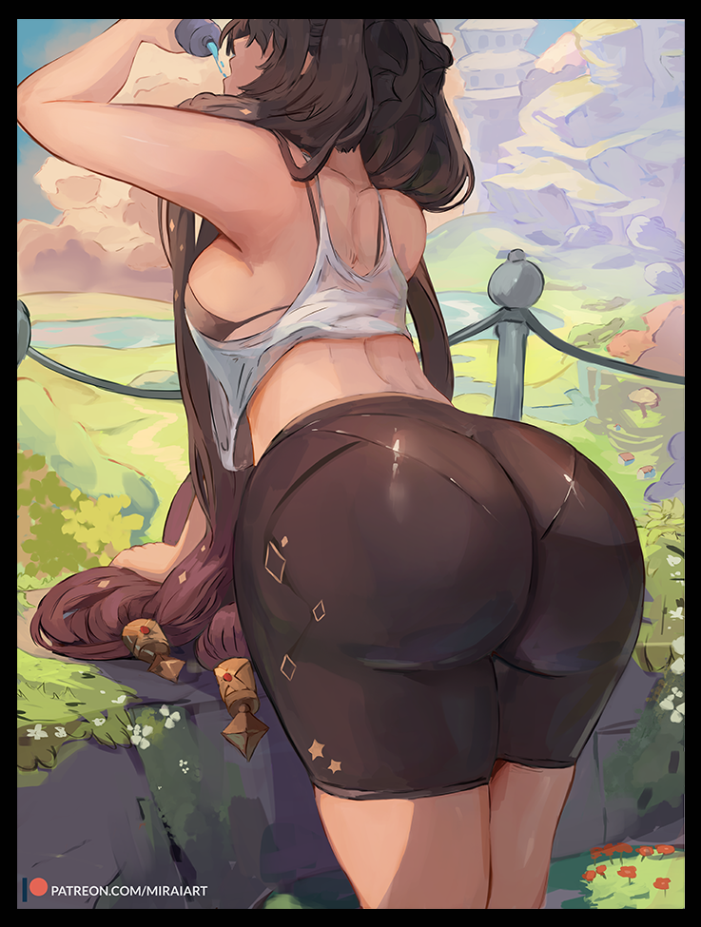

Coming off of pert lips with a wet pop, Steven's face finally succumbs to the transformation as her auburn eyes glazed over in a brief moment of mental retardation, shutting off her awareness as the world itself flickers like malfunctioning software, fizzling in and out of existence before the ordinary park around her vanishes in an instant, replaced by endless plains with healthy trees and fencing dotting the landscape, just like she'd seen in her hallucinations, except now she could smell the fresh air of the open wilderness, feel the warmth of the afternoon sun against her exposed skin, the tickle of the air as it caresses her borderline nubile young body, tenting swollen nipples atop budding A cup tits hugged tight by a black bra held together with string. And as her open lips drools sweet nectar down a shapely chin, wide eyes shrink and slant, rising at the edges while narrowing near the middle to form a calm and collected gaze, beneath which rests cyan green gems that hadn't quite regained their lively glow just yet as they stare a thousand yard stare out across the plains of a new world her brain was quickly being formatted to. All while invisible hands tie her wild mane of hair into twintails adorned with unique ornaments that seemed signature to the new identity ingraining itself within her pulsing brain, overwriting everything she was and could have been, until not even a lick of the name 'Steven' remained to plague the genius mind of one of Teyvat's most well known Astrologists.

In place of all her time spent rubbing treadmills and lifting weights, the young lady only remembered perusing books, scrolls and the stars using her profound skills in astrology. Instead of spending all her money on figurines and other merchandise that bore a startling resemblance to herself, that money now went towards funding her pursuits in astrology, snapping up anything with even an inch to the subject matter until she ran herself dry, sustaining herself off the bare minimum until she made enough again…which she would promptly throw away carelessly. And last but not least, her sexual preferences, losing any sortof feeling when gazing upon the female form but instantly feeling flustered and wet between her legs when her vapid eyes visualize the form of stunning men with handsome looks and satisfactory packages to boot. A deviation that would lead to startling developments soon to occur as a shiver of excitement runs through the unconscious figure of ***Mona Megistus*** leaning over a post along one of the roads just outside the city of Mondstadt.

Most importantly however, the problem of strange visual and auditory hallucinations remained. Albeit not unscathed like the rest of her memories, replacing the images of herself with those of notable figures she met on her many travels across the land before arriving at Mondstadt. The Traveler's naive young face framed by golden blonde, the fiery mane of Diluc, the nocturnal knight, tracing his slim muscular form beneath those thick suffocating clothes of his. For some reason or another, lucid dreams and horrendous illusions had been plaguing her for the past few weeks or so, all related to men that seemed to match her suppressed inner desires. Wherever there were men that fit the bill, what she could only assume to be a curse would make her see them without their clothes, it was like a filter she couldn’t turn off.

At first, she had freaked out, turning her eyes from the Traveler when he showed up wearing nothing at her front door, she’d screamed at him to put something on, but the moment his flying companion had told her to calm down and check her eyes to see if she was alright, she knew then that something was wrong. Everywhere she went, only the most burliest and handsome of men walked the streets of Mondstadt naked, it had her reeling initially, musing to herself about a joke regarding the city’s motto of being one of freedom. But over time, she found herself looking away less and less and staring with a longing to touch and feel those bodies more and more. That was when the turning point came in the form of dreams, trapped in these steamy mental scenarios envisioned by the curse that gripped her, forced to play the role of a willing sexpet for whoever had her eye that day.

By the time a week or two had passed, a haggard Mona had excused herself after realizing she must’ve slept with over half the townspeople in her mind. Trying desperately to alleviate herself in the privacy of her home now that the mental effects were beginning to spill over, afflicting her body with need as her breasts tingled with a yearning for a man’s touch while her womanly bits screamed for something warm and thick to fill the hunger within her everburning belly, almost unable to believe the sight of her puckered labia as its lips squeeze for a rod that wasn’t there after awakening from the first dream, covered in sweat and lying in stained sheets with an exceptionally large puddle between her legs.

Now almost a month into this sinfully pleasurable hell and she was nowhere close to finding out the cause behind her erotic visions and dreams. Compelling her to act like a total slut when no one was looking, masturbating by day before retreating into her dreamscape to get screwed by one of her imaginary studs before coming to, always before orgasm, leaving her clicking her tongue in frustration as her fingers move to wipe her swollen pussy clean.

She’d hoped to take her mind off of things through exercise, she’d heard from the curious bird companion to Fischl that venting stress through physical exercise was key to maintaining stress levels and a level of fitness. But after spending almost the entire day locked to her bed, fingers refusing to stop tweaking her nipples and now perpetually tingling privates, she was totally wasted and spent. Just walking her from Mondstadt had sapped her of strength, leaving her tired and vulnerable to yet another round of erotic imagination as her tongue flicks out with practiced precision, lapping up water dripping the tip of her bottle with lewd smacking sounds and occasionally releasing vapid giggles as if the bottle nozzle before her was something else entirely, rubbing and stroking the length of it with salacious hands all while jerking her scantily clad body as if she were really bent over someone’s bed in the thick of it.

But right before she could visualize a third to accompany her pseudo blowjob, a stranger's smooth hand comes to rest on her bare shoulder, spooking her awake from her lustful reverie as her entire body jumps in shock, tripping forward and sending her bottle flying as she struggles to catch her balance, flailing wildly until the instigator catches hold of her collar the the star spangled towel wrung around it, helping her to stabilize before moving away with the crunching of dirt ringing out beneath shoes that had been moving silently until now. Free to move now that the spell over her altered soul had been broken as she turns to face whoever it was that had interrupted her, freezing in shock when she realizes who it was.

The worst possible individual to come across her in this state; Kaeya Alberich, Quartermaster of the Knights of Favonius, the military arm tasked with defending Mondstadt from any and all harm. What was he doing all the way out here?!

**"Woah there! Sorry if I rubbed you the wrong way! Didn't mean to scare you. Mona right? Astrologist Mona Megistus?"**

**"Y-Yes…no offense taken there. I was just…t-thinking about something…were you needing something in particular?"**

**"Nah! Nothing of the sort, I'm just doing my duty; aiding the citizens. A special request by way of a close friend came in, saying you were in some dire straits. Hadn't left home in quite awhile so they asked me to keep a lookout. I'm sure you can guess who…is everything alright? I know the importance of staying healthy but running with a fever isn't the way to do it, you're bright red!"**

**"H-Huh?! O-Oh! T-This…It's j-just a little…hot today! Yeah, hot!"**

She was trying desperately to control herself, keeping her hands bound to her sides, shivering in a fit of uncontrollable lust with wide eyes turned sideways, sneaking glances every so often to her front whenever the urge to gaze upon the knight’s well built frame became too much for her to bear. But in her effort to stay her hand, the clueless Astrologist remains oblivious to Kaeya advancing upon her, only realizing something was off the moment her vision goes topsy turvy while strong but gentle arms cradle her gently, pushing her up against a solid chest in a bridal carry that leaves the twin tailed maiden flustered and at a loss for words.

**“Hold on now, things might get bumpy. It’d be a shame to have a girl like you bemoaning my reputation for being a gentleman…”**

**“W-Wait! Let me down! I can walk on my own!”**

No matter how much she yelled and kicked, however, there was no dislodging the stalwart man as he ignored his charge’s cries, speeding off down the road back towards the walls of Mondstadt in the distance. Normally she wouldn’t have said no to a free ride back to the comforts of home, especially when she was feeling this tuckered out. But her ailment was complicating things. While Kaeya was still dressed in his signature featherflight uniform, to Mona, he was stark naked, running all out in the nude all while cradling her like a babe. Eventually her cries died down, feeling incredibly aroused for being this close to another man in a good long while. She could feel his body heat, trace the contours of his pecs, press her head against the solid biceps he held her with. And worst of all, his erect pecker poking against her butt. Try as he might, the fact that it was hard at all meant he had to have seen her attempting to deepthroat her own water bottle, and if what he said was true…the thought of it made the blush on her face intensify even further as her eyes dull. Panting heavily in the throes of estrus, ignoring the Quartermaster’s concerned voice asking if she was alright.

She couldn’t take this emptiness for much longer, for too long she’d sequestered herself at home, hoping it would all go away. But no more. Once Kaeya had brought her home, he would seal his fate and her own…

Pushing open the door to her home by the edge of the city limits near the wall a few minutes later, Kaeya ferries a still feverish Mona inside, adjusting her limp body to lay her out on the bed before his eyes widen upon realizing the hand that had graced her thighs came away wet, slick with fluids that were too thick to be sweat. Eyeing the salacious juice with nervous disbelief.

**“T-This…Mona? Don’t tell me you really were-mnf!”**

At that moment, the young woman who had feigned her innocence leaps forward from atop the sheets, catching the knight off guard while wrapping her slender arms around his broad shoulders. Grunting and moaning aggressively as she presses her lips hard against Kaeya’s, not letting up until she feels his tense arms relax, going around her behind her back to undo the string holding her top together, slicing apart her flimsy, sweat soaked top with a dagger shaped from frozen moisture in the air to leave her topless before him, unable to help himself to her meager yet pleasant breasts as a large hand clasps the milky surface of Mona’s left tit before giving it a firm squeeze, kneading it like dough before parting with a harsh pinch to the swollen teats, eliciting a startled cry and an airy moan from the heated maiden as her head jerks back and away from him, breathing hard with a strand of glimmering saliva dangling between their open mouths with Mona panting heavily in lust and an eagerness for more while Kaeya breathes hard, catching his breath after realizing he had suddenly lost himself in the moment to his unexpected lover’s touch, about to pull his hand away until Mona intercepts them, gripping them hard before relaxing once his hand was firmly placed over her bosom.

For an astrologist, her delightfully devilish demeanor was a surprise. He would have expected this from the likes of someone like Lisa, but Mona…he’d always thought her too serious to ever indulge herself in the carnal desires of the flesh. Looking at her now was like looking at a completely different person altogether. The Mona of yesterday would’ve slapped and probably drowned him in a Hydro bubble. But the Mona before him looked like she’d readily accept his proposition with gleeful abandon. Her usual intellectual eyes were empty, burning with an ire for sex. Her hips were swaying from side to side, her legs spread wide without shame. And her snatch…it was drooling like a hungry maw, pert camel toe squeezing as if demanding something to fill its hunger immediately while excreting a woman’s honey on a near constant basis. And judging from how drenched her tights were and the radiant trails leading down her legs, he could only guess at how long Mona had been feeling this way.

This was probably why she’d locked herself up for close to a month. How long had she been trying to resist this sudden urge for something he knew she was a complete stranger to? She must’ve been embarrassed at first, scared even, but when the urge kept growing, she had given in. Indulged it, and now it was an addiction, a craving for the real thing she still denied…well, thanks to him, it seemed she had finally lost it.

‘Thank the Archon I found her in time…if she’d run into anyone else…’

Shaking his head before sitting down on her bed, the flustered knight sighs before turning to look his bedmate in the eyes, trying not to screw anything up considering this was probably his first time getting intimate with someone else. This wasn’t playing around, this was the real thing…but he still wanted to make sure she was okay with it before doing the deed. As much as Mona lacked in the curves department, he couldn’t deny that he’d found his eyes constantly drifting to her leotard clad hips and thighs, and her face was, admittedly, gorgeous to look at.

**“Mona…are you sure about this?”**

**“Shut up you dummy…just hurry up…and fuck me already!”**

**“Well…you said it…and remember, don’t go staining my good name if you come off disappointed~”**

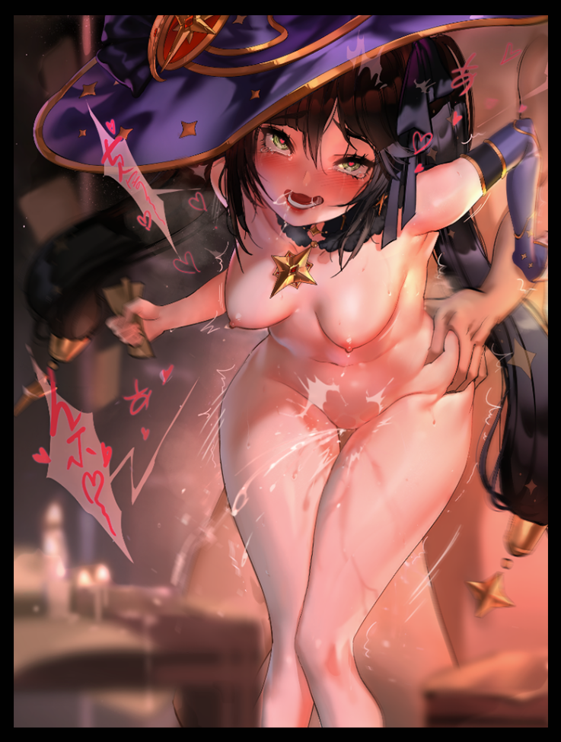

Following her rushed consent to get things started, Kaeya would take the lead, shoving Mona back onto the bed before grabbing her ankle with one arm while peeling aside her tights, revealing puckered pink folds of sensitive nerves the man wastes no time in stimulating, holding Mona’s famed thighs in both hands before raising her waist up like a chalice to drink from as he plants his face up to her groin, eating the astrologist out while her back arches in sheer ecstasy, choking out an incredible series of moans that serves to excite Kaeya even further for the real thing.

And once he feels her urethra begin to tremble, the mischievous man pulls away, taking a moment to undress and hang his clothes up on the nearby dresser before returning to a lust maddened Mona who had already leaped off the bed with her tights torn off and her oversized hat placed over her head, alongside her usual shoulder length gloves and choker strapped tight around her neck, the perfect combination of clothes that had Kaeya more than eager to return her kiss before spinning her around, grabbing ahold of her hips and ensuring inside of the minxy little astrologist would forever be shaped after his cock as she utters an expletive before bending over in shock to her first taste of penetrative sex, releasing a bladder load of ejaculate all over the floor. But her partner wasn’t interested in showing her any quarter, instantly picking up with his thrusts while the poor woman continues to scream her love to the world, bracing herself with Kaeya’s broad arms for support, letting her entire frame jiggle under his relentless fucking.

From now till the coming of dawn, the two would engage in heated sex the likes of which had never before been graced the lands of Mondstadt in years. Every known sexual position Kaeya knew, he tried on her. And likewise with Mona, all the tactics her dreamstate self had acquired in getting a man to dance in the palm of her hands were applied to Kaeya, it was as if the two were trying to outdo each other, to get either one to submit. But a supernatural libido and adrenaline was a serious combo. Enough for Mona to take getting her ass pounded while her twintails were used like handlebars and certainly enough for Kaeya to withstand his partner's unexpected use of her Vision in ways he never thought possible.

By the time the morning sun’s first rays bathe the city walls in vibrant yellows and blues, the pair were well and truly spent, having collapsed into bed in each other's embrace covered in sweat but too tuckered out to wash up. Kaeya’s bones were aching and his frame felt non-existent, allowing Mona to use his arm like a pillow while she slept, dreaming of nothing for once with a smile on her face after having her womb pumped full, load after load of piping hot cum now oozing out of her well used snatch while she laid there on her side facing Kaeya, whose presence only helped to assuage her mind of any remaining doubts and fears. Who she once was had been thoroughly eliminated, and if any part of that long forgotten dream had somehow made it past the explosive overflow of transformative magic that had sent Steven into the world of Teyvat in the form of his obsession, the Quartermaster had definitely made sure to screw her so hard she wouldn’t ever remember a lick of the old life she led till now.

She was ***Astrologist Mona Megistus***, and that was something that would never change…but at least now in this new split alteration of the usual sequence of events in Teyvat, it seemed that the astrologist wouldn’t be quite so lonely from now on if she were to ever run out of funds again…or Archon forbid that dastardly curse return to plague her loins once more…

*THE END*