I, SHTAR
AUGUST 2022 FIRST PERSON STORY
BY CHALDEACHANGE
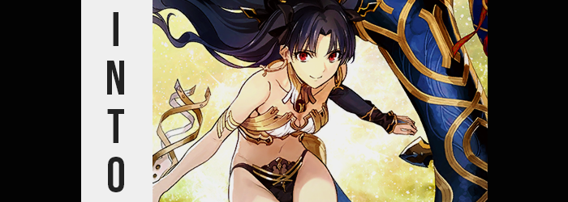

The Guaranteed SSR.

It was truly a blight upon this earth. Or at least this earth relative to gacha games. Some might consider it a blessing, but I most certainly didn’t. In Fate / Grand Order, it was a special gacha that took paid currency in exchange for a guaranteed 5* Servant. I know what you’re most likely thinking. ‘That sounds great! What could be wrong with that?’, right? On paper it sounds like a great idea, and it certainly is if you’re happy with just any 5* Servant.

But if you have a lot of 5*s already, or if you’re gunning for a very specific 5* unit, then it is conceptually a nightmare. In the latter case, it’s hard to get a banner with good odds to much less even get a new SSR. And in the latter? You’re basically toying with at least a one in five odds that you’ll get the character that you wanted. The odds of disappointment are good, and the odds of getting a duplicate are usually just as good.

Case in point: I hadn’t gotten a new Servant from a GSSR in years, much less the Servant I was gunning for. And I knew that applied to plenty of my friends as well. So when the 2022 anniversary rolled around, I let out a sigh as I eventually paid for the Quartz I needed and scrolled through the banners. “Which one should I go for? Does it even really matter? I’m not going to get a Servant I want.” I knew full well that this was the truth, of course. I wanted Space Ishtar more than anything, but

But a chance to get a Servant I wanted was a chance to get a Servant I wanted. And so after selecting the banner that would (ideally) bring me victory, I did what had to be done. I clicked the button to roll the gacha, and basically held my breath. If you think this all sounds very dramatic? Don’t lie to yourself! You’d do the exact same thing!

“This is going to be as long and painful as humanly possible, isn’t it?” By the sixth band of light, I had begun to get the impression that the SSR would be the final thing summoned in the set of eleven. And I wasn’t exactly wrong, seeing as how the rainbow sparks didn’t show up at all until the eleventh roll. “Come on, show me someone new at least!” This bar seemed low, but after years upon years of duplicates, I was more than ready for something new.

But as the golden card revealed its contents? Rather than anger or disappointment, I felt confused. “Wait a second, regular Ishtar?” It was, of course, a dupe. But on the other hand? She wasn’t supposed to be on the banner I had chosen! Had I made a mistake? Surely I hadn’t confused the two Ishtar banners? “Man, did I just get scammed, or what?” How could I even report this? I played in Japanese and didn’t even know how to use the report system. Not to mention the question of whether or not they would even do anything about it!

The heaviest sigh in the world escaped my lips. How could this be? Staring at my phone’s screen, I almost wanted to cry out in pain. Of course I didn’t, but the feeling was still there. At least until the summoning screen went away. Or, well, perhaps went away wasn’t the right phasing? The screen just turned white and began to glow. “Crap, the game didn’t crash on top of that, did it?” Did that mean it might have really been an error? Thank God!

The light began to shine brighter at a speed quicker than I could restart the game though, and in the end my skin began to feel a little tingly. I didn’t think much of it at the time, even thought there were indicators that I most certainly should have thought more of it. I just couldn’t really see them. For example? That the color of my hair was darkening to a brown a little closer to black. Or that my eyes had brightened to a more vivid blue. But even then when it came to my eyes? They had only changed in color to change colors once more later.

“I hope I didn’t lose all my progress! I did save my bind code, didn’t I?” I was naturally more concerned about my game suddenly lighting up like a Christmas tree, and the fact that the light still hadn’t dimmed, to pay much attention to why I tingled all over. Though, my face was beginning to make a good case for why I probably should have. After all, my features had begun to reflect those of an entirely different race. Eyes that were more almond-shaped than they had been highlighted this, but overall? One could say my face also grew more feminine by design.

The excess weight in my cheeks bled away, but the size of that face just in general grew smaller. Any facial hair I had was eliminated, my nose became smaller, and my lips? Rounder in shape, they also ended up bearing a more natural gloss. When all was said and done, my face looked like that of a Japanese woman. And one that was likely ten or so years younger than me. Being my face, though? Without a mirror, noticing this was more or less impossible.

That didn’t mean that other changes couldn’t clue me in though, and a tickling sensation at the back of my neck eventually prompted a hand to read behind me and grab… hair. “Huh? Wait a second…” This was odd because I always kept my hair short, so I shouldn’t have been able to grab anything. Yet not only could I, but I could feel it moving in my hand – because not only was it longer, but it was continuing to grow.

“W-W-Wait a second!” I blurted out in a fashion that was much more erratic than I had meant to. “Why is my hair so long!?” Such a thing wasn’t technically possible, yet now that it was long enough to pull across my shoulder, I couldn’t deny what I was seeing. It didn’t take long to lengthen to the point where it fell to my rear, but by then I wasn’t as fixated on my hair as I was the hand holding it.

Had my nails always been that long? My fingers that small? They looked like fingers that belonged to a girl. And what was with my complexion? It looked a little richer in color than it normally did. “Something’s noooot right here!” I was essentially stating the obvious at this point, because honestly? I didn’t really know what else to do.

Panicked as I was, I stood up. But even then, something felt very wrong the moment I did. Wasn’t my point of view usually higher than this? I felt much, much closer to my desk than I normally did. And weren’t my clothes a little loose…? “Am I shrinking!?” It took a second for this to click, but yes! That was one hundred percent what was happening. I was losing height rapidly, and considering I was on the higher end of the five-foot spectrum, the fact that I eventually dipped down to just over 5’2” really felt quite substantial, like I was viewing the world from a whole new perspective.

Pants fell from my waist, and my shirt felt incredibly loose as well. Idly, my waifish fingers padded my torso – and that was when I realized something else. I had gotten shorter, yes, but I had gotten smaller in other ways as well. I was thinner. Like a lot thinner. Going from someone with a gut to someone without one might have been more jarring than getting shorter. But my belly was also… tight? It wasn’t like I had just thinned. I had abs now, too.

Still panicked over my height loss though, it appeared to trigger something I hadn’t meant to trigger. Because my point of view began to rise, and rise, and rise… and my socks and boxers soon fell onto the floor. “W-Wait a sec!? I’m floating!?” With a voice that was sounding increasingly girlish, I cried out my newest genius observation. I was no longer rooted on the ground, but was instead just floating there, inches above my floor. This definitely was impossible.

I flailed about, and in doing so I accidentally whipped off my shirt. I was left completely nude midst the air now, and I did my best to avoid staring down at my naked self. Largely because, well, it didn’t quite look like a man’s body. Or at least not the kind I was used to seeing. Not only was I thin, but my hips appeared to be quite wide, giving an effeminate curvature into my stomach. But the shape of it all wasn’t really the reason I immediately assumed I was staring at a woman’s body.

It was my chest. “Are these…? Is my chest…?” My voice began to sound more and more familiar, almost like that of a specific seiyuu. And little did I know that I had begun to speak in Japanese as well. But I was much too fixated on my chest, because not only did my nipples look bigger, with much wider areola than normal? But the flesh beneath them pushed forward before my eyes, jiggling into what could only be a modest pair of B-cup breasts. Nothing substantial, but enough to indicate that I was a woman.

And I was a woman.

“Mmn!?” I couldn’t really control my trajectory while floating just yet, and a sudden tug that likewise came off as pleasurable forced me to squirm in place – my whole body doing a flip in the air in the process. My tits weren’t all that big, and since I was floating I could curl my waist upwards to see… even though I didn’t. But what I saw confirmed what I had felt. That… “I’m a woman now!?” It was undeniable that my dick and balls were gone, and instead? There was a pussy sporting a black bush in its place.

Curled up as I was, this position also made it easier for me to see how my lower half thickened. Akin to how I had grown breasts, meat surged into my thighs. They bloated to appealing proportions, skin taking on a nice sheen as they jiggled from their prompt growth. But the same benefit was afforded my ass, which bubbled and tightened. It was the kind of lower body that would probably get a lot of indecent art and comments drawn. Especially in the late 2000s.

I blushed profusely, unable to face this reality. I had become a woman? A floating woman? “And my voice… I totally sound like Ueda Kana.” The seiyuu of the Servant I had tried to summon. And the seiyuu of the Servant I had accidentally summoned. Wait. That wasn’t really the case, was it? It just couldn’t be! There was no way! I immediately went into denial, unfurling the ball I had inadvertently curled into to check out my new loins.

“TH-TH-THERE’S NO WAY! THERE’S NO WAY I ACTUALLY TURNED INTO ISHTAR!”

With a cry so loud it might have shattered my windows with just a little more volume, I could no longer stifle the shock at what had just happened. And as I did so, my blue eyes flashed gold, before turning red in its place. I had the body of a Japanese woman, of one Rin Tohsaka, and yet the memories that vaguely had blended with mind, as well as the fact that I was levitating within my bedroom, confirmed that this wasn’t quite right. I had become the Servant that I had accidently summoned.

I had become the Archer version of Ishtar.

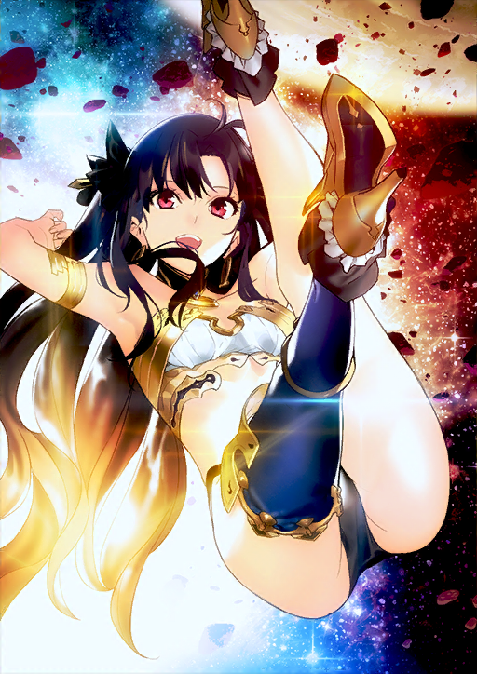
Flustered to a comedic degree, I struggled to swipe down at my desk while floating. I was attempting to grab my phone, but my shorter arms and smaller hands were having a rough time reaching – and I hardly understood how to control this state of levitation that I was trapped in. More than anything I actually wanted to be standing, not floating! But just as I thought the phone was within my reach, that I might be able to undo this strange situation somehow? My fingers only grazed it, knocking it off the desk where it broke on the floor.

“NOOOOOOOOO!” Truly, only the clumsiest of goddesses to contribute to such an atrocious outcome. “That was my only lead! How the heck am I going to change back from being a strong, powerful, beautiful…” Yet the more I began to describe Ishtar – the more I began to describe myself – the more convinced I became that, wait… “Actually, is this really all that bad?” Why would I want to return to being a weak man? Wasn’t it better like this? Surely some part of me disagreed, but Ishtar’s personality was becoming stronger.

While I’d just been floating there awkwardly before, my posture found more confidence. Before long I was floating on my side in the air like it was the most natural thing in the world. “Right? This is way better! Plus I’m sure this world is full of people that’d do anything for me, right?” I just had to find other FGO players out in the wild. But I knew one thing for certain.

If anyone accused me, the real Ishtar, of being a cosplayer?

I’d be very upset!

I guess to be called a cosplayer I’d first need to find some clothes though, huh?

