BABES 4 BACKUP
COMMISSION STORY
BY CHALDEACHANGE
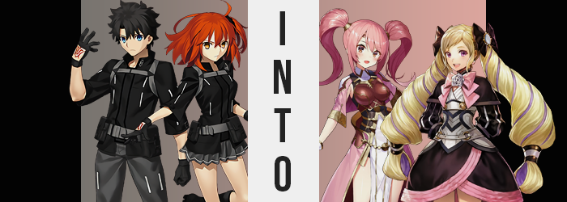

This situation was certainly a first.

The Chaldea Security Organization was infamous within its own right for solving incidents that endangered their planet. From Demon Pillars, to Gods, to evil beings from the depths of space; it seemed as if they had confronted and overcome them all. But the ‘within its own right’ came into play when you considered just how hush society was its existence. Even among magi they weren’t all that well known, their presence only available to those who sponsored or worked for them.

After all, who would truly believe the things they had been through? The obstacles they had overcome? It was all nigh unbelievable to even a magus, so how would a regular human without knowledge of the magical world respond to these tales? They would undoubtedly believe it all to be fiction. And so there was plenty of reason to believe that, while infamous among those that knew of its existence, to everyone else they just simply did not exist.

That was what had made this all so special, though. Both Gudao and Gudako, the brother-sister Master duo of Chaldea, had been called to the control room so suddenly, only to be briefed about something amazing. Beings from another world altogether had managed to contact them and were commissioning aid.

“They claim to be from a kingdom known as Askr, a location that had never existed even once throughout our world’s history. Considering the signal used, I have no reason to doubt their authenticity!” The young da Vinci gave this assessment with all of her chest, and was quick to move onto the second part. “And so, since we have a means of sending people there now thanks to them, off you two go! We’ll send Servants right after!”

Both siblings looked at each other, just a tad bit confused. Why send the Masters before the Servants in a case like this? Wouldn’t it be a greater risk for them? That’s what the two were thinking, but they would also dare not question da Vinci’s expertise on matters like this. If there was anyone that knew the risks, it would be her. The fact that she was proposing this method implied that there must have been some sort of underlying reason.

“The expression on your faces says to me you don’t know what I mean by having a means, but!” da Vinci tossed down a bunch of orbs. Red, blue, green, and clear. Where she had gotten them was anyone’s best guess, but what they did was evident enough. A portal had opened up where the orbs had struck, leaving the siblings to look confused. “Single file, please!”

The two blinked, but eventually the brother manned up. “I guess I’ll go first? I’m leaving everything in your hands, da Vinci-chan.” Bold as Gudao was, he hopped in without any second thoughts. Gudako, on the other hand, lingered. She didn’t exactly know how long she had to wait in between entry? Only to eventually to take a nod of da Vinci’s head as her cue.

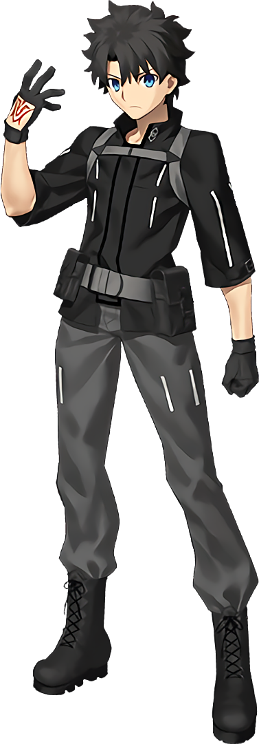
The world within the portal was a strange one. Gudao continued to walk forward through it, but was he really moving? He couldn’t exactly be sure. It was like a tunnel of light with an invisible walkway – the same colors as those orbs da Vinci had used swirling about at first. With time though, some of the colors began to fade. The most stunning of the four: red, clear, and green? They all disappeared, so that the bluer color of the sapphire gem was the only one swirling about the void.

“I guess I just keep walking, then?” Even though his sister was supposed to have come along with him, he could not see her on his tail. Considering the bizarre nature of this route though, he didn’t know if that meant anything. Portals being portals, it was possible he would arrive at his destination even after standing still.

But that blue light… it began to take an unexpected toll upon the young man.

At first it transpired in ways he did not even notice, but that didn’t change the fact that it was occurring. For initially it sought to override the man’s color palette, almost as if he was becoming the ‘Player 2’ version of himself in a fighting game. Among these changes was a sharper contrast to the color of his skin, making it all appear a little brighter and, in turn, healthier than it had before.

Yet in other areas it took on much more dire turns. Well, subjectively. It could only really be described as ‘dire’ if you didn’t like what was happening. Gudao probably wouldn’t, but from the perspective of an audience it might have been intriguing. Or, say, if you were a big fan of the color pink.

Because there was no shortage of vibrant rose, almost mirroring the color of cotton candy as it swept through the young man’s head of hair. Dark locks lightened from their pointed tips and steadily slithered through the bulk of it. In the beginning it looked more like a haphazard dye job, but it didn’t take very long for the blacks to grow obscure. So obscure, in fact, that it bled into his roots – guaranteeing that any hair that Gudao grew from that day on would reflect the very same color… until he became older, and it eventually grayed.

Of course this wasn’t isolated to the hair atop his scalp. It was reflected in his eyebrows, the hairs on his arms and legs, and even those buried within the depths of his boxers. The lad’s eyes weren’t spared from pink’s wrath either, albeit it a different shade. Rather than pastel, the tones almost bordered red by the time they had finished, although they did lean more into pink. He could hardly be faulted for not noticing. After all, these weren’t exactly areas that he keenly kept an eye on, and the blue light of the portal made seeing other colors difficult anyways.

“You know, considering it’s a portal I was expecting it to not take this long. Maybe I should keep walking after all?” He didn’t exactly have any other options – it was move forward or stand idle. It wasn’t like he could just curl up and take a nap. Well… he could, but it might be a problem if he spent hours trapped within. Who knew how such a stay might affect his body!?

…It was already getting plenty bad on its own. Resolved to keep moving forward – if he could even be certain which direction forward was – step came after step. But each stretch of his legs seemed to cover less distance, albeit a distance that was very difficult to gauge. In the beginning, because of this, he didn’t exactly notice. But from an outsider’s perspective, it was evident that his figure was regressing.

Whether it was his limbs, torso, or even the size of his head – it was as if he was unfurling to take on a daintier form. Fingers and toes shrank all the same, and ankles and wrists grew narrower in width. While it seemed like he was just shrinking, it was clear that it wasn’t consistent in the distribution of the loss. And looking at the young man’s face? A youthfulness was distributed that suggested he had slipped back in time. Perhaps not a very long time, but three to five years might have been an appropriate guess.

It was only natural that a loss of height would have been reflected in his outfit, and for a time? It was. Not only did gray pants fit loosely upon his hips, bound up only by the mercy of the thick belt around his waist, but the bottom of the legs were bunched up around her ankles. When it came to his black jacket, hands had practically been vored by the sleeves and the shoulders sat to only one side. “Wah!?” Eventually, after taking a step forward, the Master almost tripped because his foot had slid right out of his shoe. In an attempt to catch himself? The second came right out as well.

“What on… What’s up with my clothes? No, wait? Is the problem my body!?” It took the boy a moment, but it all did finally click. Waving hands around in a panic, his sleeves rotated like helicopter propellers. His voice sounded a touch higher too, but being in his own head like he was, that was hardly an overtly noticeable thing. Gudao’s mind began to race as he tried to process just what was happening, and he would have no doubt been even more surprised if he could see his hair.

Tragically, the forces bending his flesh were not done. Not quite yet. Hands and feet that had already shrunk soon began to bear new designs, daintier and daintier while scars faded from them just as they did the rest of his body. In fact they looked downright feminine, which was, in fact, a quality that was growing more pronounced and, in turn, quite literal.

The sides of his waist pinched in, muscle erased from Gudao’s abs and, well, the rest of his body to boot. Thinness appeared to be the name of the game for the most part, but there was an area that did the exact opposite. His hips. They pulled out to the sides, filling out his loosened pants and compromising his posture so that he almost fell forward if not for catching himself in the final moment. “H-Hey!?”

His cry was soft and girlish, perhaps matching lips that had become just as much so. In fact an increased femininity had made short work of his jagged jaw, leaving it round and eyes bigger than ever before. In fact they didn’t even seem to make him look Japanese anymore – instead better resembling those of a Caucasian background. In fact, little by little his mind had been adjusting so that he could communicate in a different language altogether; but that wasn’t something he’d come to realize.

The hair atop his head grew longer in the meantime, spikes lessened and becoming one with the bulk of a silky mane that spilled out behind him. When all was said and done it reached down to his butt in the back, and his shoulders at the sides, all while sporting a very natural curl at the tips.

“I sound like a girl, and… Oh no!?” Gudao was finally starting to get it. A hand reached down to the front of his pants, feeling around for his groin. He didn’t exactly find anything of note though, because by this point it had been reduced to a little nub that soon slid up and inside of her, replaced by perky lips. A maiden in sex now, flesh flared around her hips and butt next, growing rounder and plumper. The same could be said of her chest, for a pair of perky orbs swelled to life, filling out her jacket and the undershirt. They were only C-cups, but against her dainty frame they looked even larger.

As if to compliment the shapes of her new design, a flash of blue light from the depths of the portal stripped and redressed her in one, single moment. What she was left wearing in the end was an almost medieval costume made up of light fabrics and even an armor piece, thighs on full display and hair pulled up into twin tails.

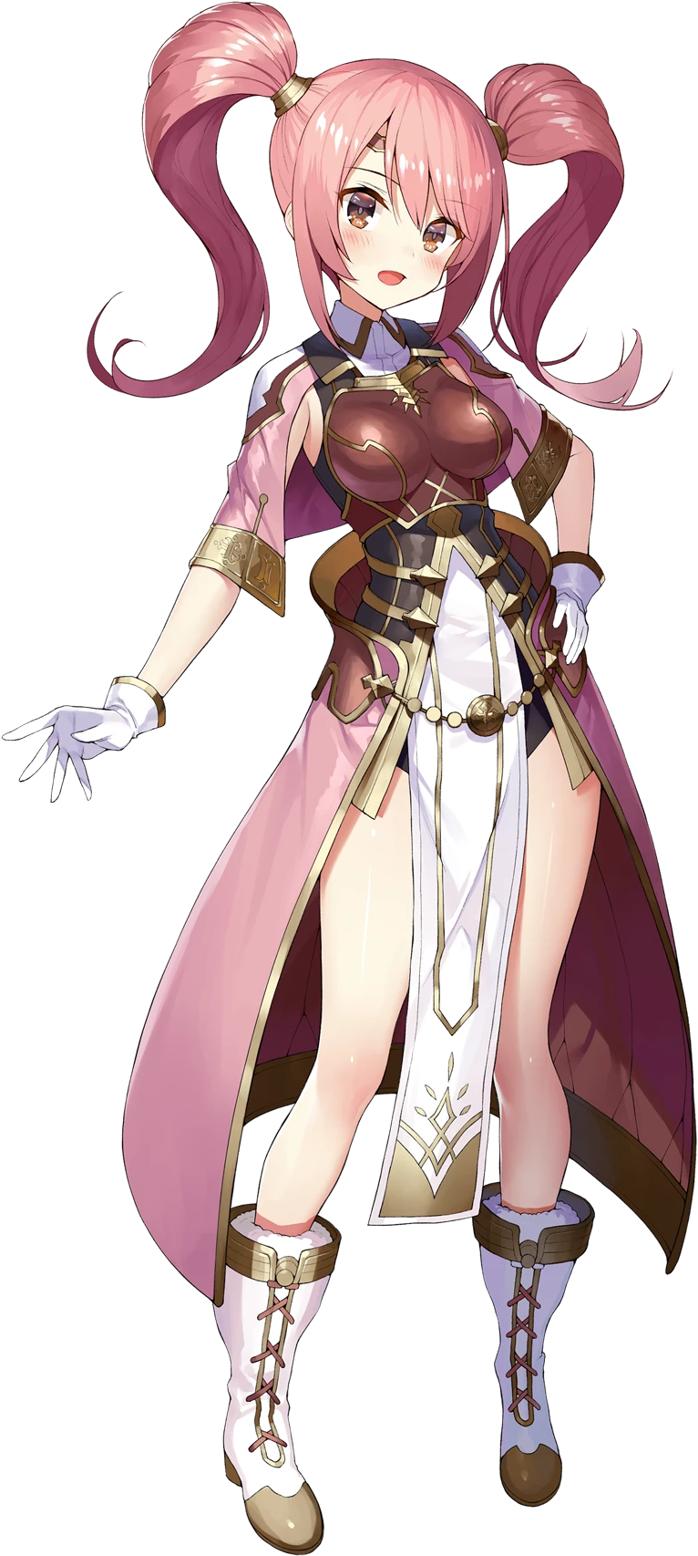
For everything that had happened to her, the young maiden at the very least had retained her personality. “Am I really some girl!? But I’m not supposed to be a girl! Why would the portal do this!?” That didn’t stop Gudao from being understandably upset about her situation, though. She looked and sounded younger than she had before, and her clothes? They were weird! Difficult to move around in, with armor bound to her breast.

She’d hardly had a moment to lament her current condition when the blue light grew stronger, and suddenly? She was standing in what looked to be an old library. “Mae? Earth to Mae? Are you with me?” The voice of another young woman snapped her out of it, and her head turned to face her. A fair lass with long, ginger hair dressed in white – she was pretty enough to make Gudao blush. It took her a moment to realize that the ‘Mae’ she was referring to was her though.

“Yup! I’m Mae!” She blurted out, but froze up almost immediately. What was with that sickly sweet voice? She had meant to say that she wasn’t Mae too! But faced with someone that knew ‘her’, she couldn’t bring herself to stop! Even her body language changed, fingers laced together and a smile upon her face. “What were we looking for again, Celica?”

…How did she know Celica’s name?

Back within the portal, the sister was in awe at the rainbowed colors of the portal she was walking through. “Wow, they’re so pretty!” She was really at a loss for words at the sight, and how could she not be? It wasn’t every day that you could take a leisurely stroll through something like this! Her enthusiasm was weighed down a little, but by the memory that she knew little of the threat they had been asked to come help with.

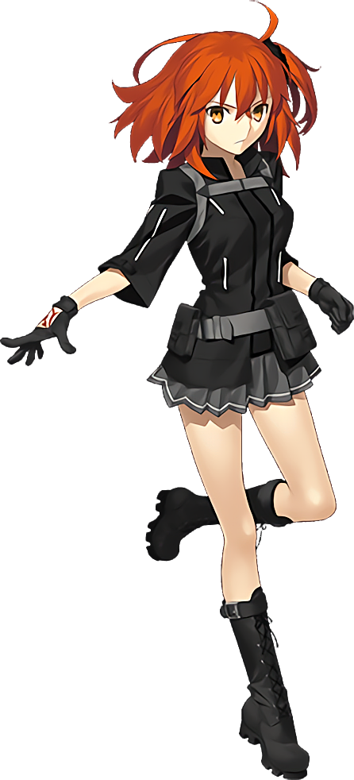
“Well…” Her enthusiasm did dwindle some, but only because the bright colors swirling about gradually became less varied the farther forward she moved. The red disappeared, then the blue, then the green, until only the silver remained. It was much less interesting than the other colors, but it didn’t really perplex her all that much. Of course, she didn’t know what had happened to her brother when a similar phenomenon had affected the portal for him, either.

The fact that the portal was one that would transform those who passed through it into denizens of the world they arrived in was something that no one knew. At least until it was too late, anyways.

Much like her brother before her, Gudako’s was quick to succumb to that which was being enforced upon her – yet it did not play out in the exact same manner. Compared to Gudao, who had dealt with a change in color first, it was the young woman’s proportions that were immediately robbed from her.

Yet she didn’t take much notice of it, not initially. Even though the front of her jacket seemed to slowly be growing baggier and flattening, because that which normally pushed it up had lessened in size. Namely? Her breasts! C-cups took a generous dive, emptying the cups of her outfit while the skin that once contained them tightened to better maintain their perkiness. When all was said and done they were little more than five-inch growths upon her chest, with nipples only several inches larger than one might expect of a man of her age.

Just as unfortunate in nature, these losses could be found in Gudako’s lower half as well. Her panties became looser without the full cheeks to stretch their cloth, and with thighs following after to leave greater gaps between her undergarments and her skin, they slipped clean off. “Wha!?” Which was, naturally, something a girl would notice. “What just happened with my panties!?”

Reaching down to pick them up from her ankles, Ritsuka gasped as her skirt fell from her hips too – leaving her completely naked from the waist down. She’d die if she emerged from the portal looking like that! But it gave her a good view of her hips and the surrounding area, allowing her to note that they had all shrunk. Her hips had lost practically 1/3 of their width and were more reminiscent in gait of a younger teen than a woman in her early twenties as she was. “And my chest!?” Naturally, eyes fell upon that area next. How had she not noticed her bra sitting there so loosely!?

“This is bad! Bad, bad, bad!” Rather than being fixated on how it was happening (there was little else to blame other than the portal anyways), she was immediately fixated on the implications of her issue. She had to cover up! Fixing it could come later, right? And so she naturally lurched back down to pick up her skirt as well as her panties. This only lead to another problem almost knocking her straight onto her smaller ass, though.

Gudako managed to catch herself, but that was despite the fact that shrinking limbs had sent her off balance in the first place. “I’m getting smaller, too!?” And her voice was rising somewhat significantly in pitch. At least this meant her jacket hung low enough that it covered her crotch, so small improvements? Four or five inches were knocked from her total size, and in the process her waistline grew a little thicker to lend credence to the idea that she was younger, and such not as well developed.

And girl did her face make that apparent! “Am I a kid now!? Oh no… I probably won’t be very useful at this size!” She was communicating in a language that wasn’t Japanese, but looking at how her eyes had become so big and round, it seemed possible that this wasn’t all that much of a problem. Her facial construction didn’t seem all that Eastern anymore really, not with thinner lips and a sharper nose upon a face that seemed much more… baby. She was around the age of thirteen or fourteen now.

The silver tunnel flashed light almost like lightning, and once her eyes adjusted Gudako realized that at least one of her issues had been alleviated. Her old Chaldea uniform had been replaced, but she wasn’t sure if she agreed with what she was wearing instead from a fashion standpoint. It was a black dress with puffy sleeves and a skirt trimmed with pink. Thigh high boots of matching aesthetic saw daintier toes kept in place, but the heels were so gratuitous that at first she feared she might fall. Upon her breast there was also a lilac-colored rose abreast a big, pink bow.

It all appeared much too childish for her, who was still mentally a young adult. “Hopefully they have different clothes when I get out of here…” Whenever that might be, but at least she was close to the point where the portal would eject her. There were just a few remaining, minor adjustments to be made. Such as a distributing a bright purple midst her irises, which ultimately made them look much bigger and brighter than ever before.

The bulk of the final shift actually contributed to a change of hairstyle, however. Her locks spilled dramatically out behind her, length almost quintupling. Fortunately it had already been bound into two tails thanks to a pair of black bows, but from within their grasp the swelling hair twirled and twirled, wrapping among itself like a pair of drills before finally peaking just past her hips, where it was tied into a pair of clasps.

From that point on it was just a matter of color. A glorious, pale blonde seeped up from once ginger roots, and swam towards these lengthened tips so that the original coloring was completely purged. As a result she had lost the final thing that had made Gudako herself – short of her mind of course. What was most unusual was the weave of purple that ran through both drills. It certainly would have been a pain to dye only those. Mind you, she hadn’t seen that the purple was buried even deeper within the twirls. “Wow! This hair is so long and thick…”

Gudako, despite her transformation, couldn’t stop playing with the long curls of hair that dangled from her head. It was incredibly soft and squishy in its blondeness, but she had a hard time trying to imagine how those pesky, purple streaks might have ended up in there. “This is so unbelievable… But I’m so young now! How am I supposed to be of any help like this?” Healing magic…? Wait, since when had she known any of that!?

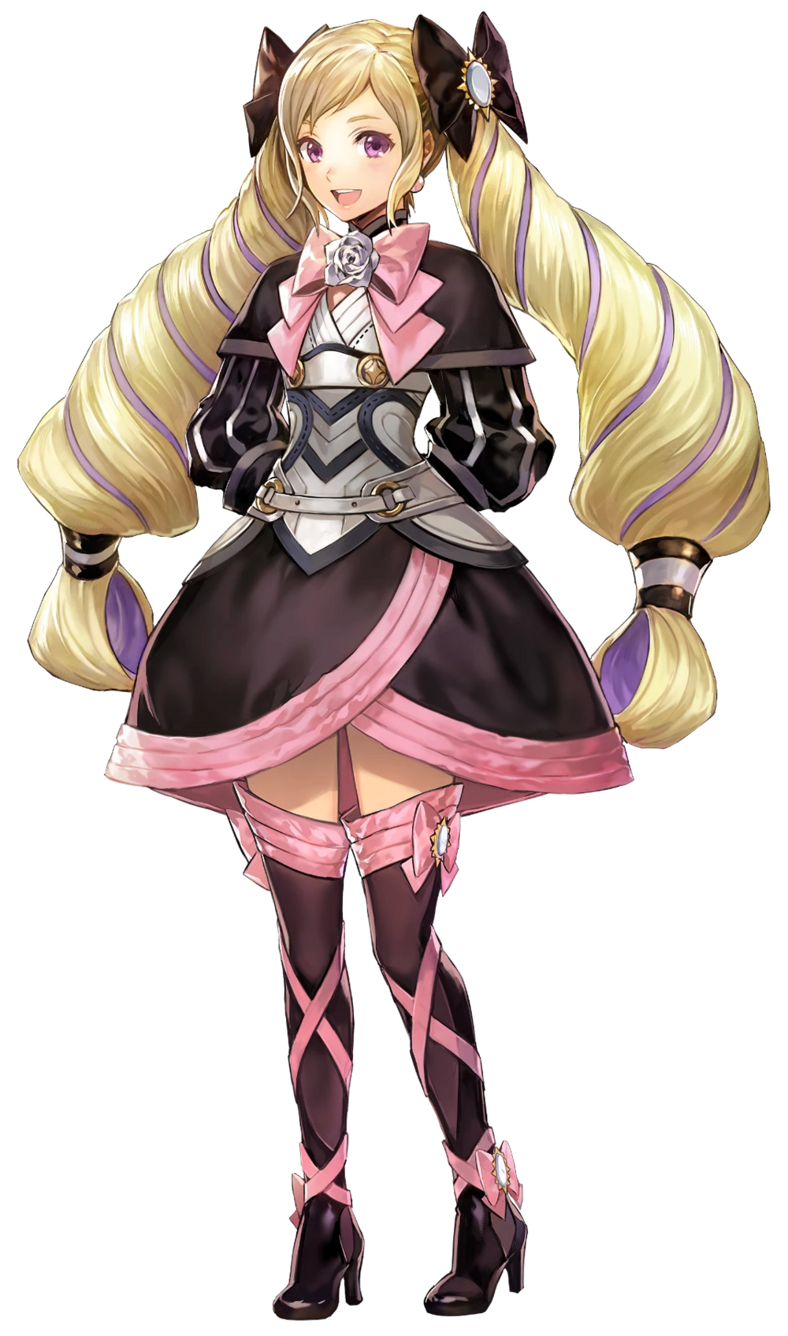
The silver tunnel brightened to a range that was nearly blinding, and the next she knew she was… in a hug? “Oh Elise, sweetie! It’s so good to see you again!” Gudako blinked. The one holding her was most certainly a woman, but her grip was strong, and their posture was… Well, the younger maiden was getting a face full of a pair of enormous breasts.

Yet while this woman should have been a stranger, this hug felt… comforting? She felt compelled to return it without delay. “It’s good to see you again too, big sister Camilla!” Wholly against her will, she had simply blurted those words out. There was no way she should have known this woman’s name, nor seen her as a sister, and yet that was the relationship that her mind was now being forced to accept.

Wait, was her name Elise now? That was kind of cute, at least…

