L’CIE YOU SOON
COMMISSION STORY
BY CHALDEACHANGE
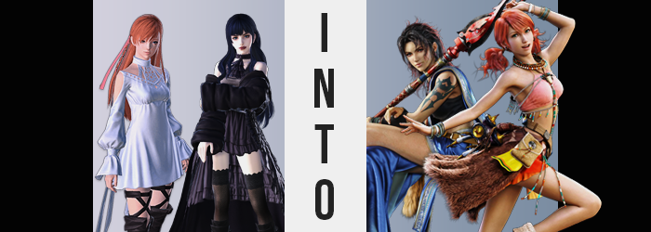

It had been roughly a month since Ryne had last seen the Warrior of Light, and things in the First had finally begun to settle in a meaningful way. Of course, there was no way to possible bring back those who had been lost, but recovery would be slow and gradual. Most of the denizens who remained could acknowledge that the ‘Warrior of Darkness’ and their allies had finally given them a chance at a future. Basically, everyone who had helped support Ryne personally had returned to the Source.

But that didn’t mean that she was alone. It was quite the contrary, in fact. Before the last of her allies had returned, there had been an incident with the Empty and Eden itself. Because of this, Ryne had met a girl her age named Gaia and the two had bonded; perhaps a little too well according to some, because they had fast become a couple at seventeen years of age. The past month had been spent spending plenty of time together and getting to know each other. And now they knew for sure that the affections they had felt were true.

“Would you two like to get to know each other even better? These special charms will help you better understand one another’s strengths.” Or so the merchant who had peddled two gemstone rings to Ryne had said to get her to purchase their wares. One ring had a dark blue stone, while the other had a pastel pink one. Apparently, she was supposed to wear the one that better matched Gaia’s image while Gaia wore the one that better suited her.

So, the dark blue one it was!

“…Eh!?” From what the ginger haired girl could recall, the giving of the ring to Gaia had gone well. It was the first ‘big’ gift that she had given her girlfriend and had been a little nervous at the time. Ryne could tell that she was confused about the color, because pink wasn’t a color that suited Gaia at all. Once she explained the significance and showed her the ring she would be wearing though, things made a lot more sense and she accepted it happily. Things had been going well!

Until they had put their respective rings on.

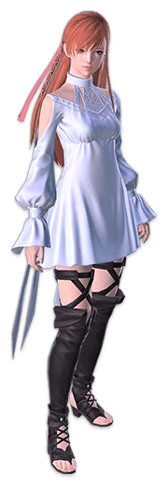
That was where any normalcy came to an end, however. Once both had their rings on, the gemstones began to glow. “I wonder if they’re supposed to do that?” The girl could remember asking this at the time. But she hadn’t gotten an answer from Gaia in the end. Because all of a sudden, she was here. It was like, at the drop of a Gil, the world around her had changed. She was no longer standing outside of her favorite café near the Crystal Tower.

Ryne was standing in an unfamiliar field, under an unfamiliar sky. The mountains nearby seemed strange, nothing like the ones she had seen during her travels of the First, like Mt. Gulg. “Wh-Where am I!? Gaia!? Are you nearby, Gaia!?” Calling out for her partner had been her first instinct, but unfortunately it hadn’t amounted to anything. Was that a small village off in the distance? She could see tents and huts, but she probably wasn’t close enough for them to hear her.

Just as curious, however, the ring on her ring finger was still glowing.

“I-Is it going to transport me somewhere else again!?” Unsure of what to expect, Ryne pulled off the ring and tossed it onto the ground in front of her. She was hoping that it would prevent anything else from happening to her, but she also hadn’t realized that it was already much too late. There were signs of this, too, but the girl hadn’t even considered the possibility to bother checking. Whether she realized or not in the end wouldn’t ultimately matter anyways.

The girl’s clear eyes flickered about the field and down to the ring again here and there. Its light hadn’t dimmed, but the light of those eyes had. A murky green settled amidst their original color, bringing with it a vague reconstruction of her eye shapes. They looked a little more angular with lengthened lashes. But there was something about them that was substantially more mature feeling, too.
This was something that actually extended to her entire face. Ryne’s face was typically small and cute even despite an age that was just on the cusp of maturity, but it almost felt like things were advanced four years as her perceived age increased… along with some adjustments that called her very identity into question. It became structurally longer in general, from her cheeks to her chin, to even her nose. Her lips seemed to become a touch fuller, and everything felt a little more hardened somehow?

“That was a bit of a… Eh? Why am I talking like this? Sounds kind of weird.” The sound of the girl’s voice hit her ear wrong for several reasons. To begin with? She felt as if it was getting deeper and deeper the more that she spoke. But more than that? Her accent felt vaguely off somehow, almost like she came from a different part of the world. That world being the… First? “Huh? The First what? Kind of a weird name for a place…” But she had been certain of it initially.

Ryne’s mind was in a strange place, and she only really had really scratched the surface of it. Not that she would be able to properly grasp what was happening anyways. If she had been then she might have realized that something far more dramatic had begun to occur to her body. It was swelling. Largely upwards at first, mind you, but there were other areas that would have grown in different ways later.

Her dress was fitted for her body as it was, of course, and she was just shy of the five foot mark ordinarily. So, it wasn’t really surprising that even the slightest bit of growth would end up compromising the outfit itself. Her arms and legs slid out further from her sleeves and skirt, the straps that were bound to her thighs sliding down along with her thigh high boots until they only reached her knees. She barreled all of the way up to 5’9”, and by then? The base of her skirt rested just above her hips.

The woman’s body swayed back and forth as she was unknowingly adjusting to this shift in her size. “Hold on a sec, what’s going on here?” The more casual manner way she was speaking was part of the mental changes that had befallen here, which were also apparently affecting her perception of what was happening to her body. That her hips had swung wider, or her shoulders were a little wider as part of her body maturing; she seemed ignorant to it all.

This naturally extended to her hair. It felt like only just yesterday that she had acquired her more auburn color after living with Minfillia’s blonde for her entire life, but those darker strands darkened even further now. All the way to black, the look of it becoming disheveled and shorter. What once reached the center of her back came to only reach the base of her shoulders. It also came across as a little dirty, like she didn’t make as much of a point to wash it as she used to.

Ryne shook her head from side to side in an attempt to push away the ‘fog’ that had washed over her mind that was simply a side effect of her mental transformation. It pulled her attention fully away from a body that was becoming stronger. Muscles bulged across her limbs and torso until she was incredibly fit, but her body odor became a little but stronger at the same time. Even darkened pubes grew a little messier. As did larger feet that had been crunched into much too small boots.

“Ugh, why’d I come out hunting dressed like this?” She couldn’t fathom wearing something so white normally. Not to mention so tight, as her swelling bust, and rump, soon demonstrated. It wasn’t as if either region grew substantially, but it did grow enough to be worth noting. It was just as notable as how the melanin in her skin had slowly been darkening until she had an olive tone, darkening even further on her left arm as an elaborate tattoo was shaped.

The woman shrugged it off and stretched, not noticing the weight of a foreign object in her hand. A long, crimson spear stood out, but it was part of all of her equipment changing. She was now clad in blue robes around her waist, a black, sleeveless crop top binding her chest. Even brown leather shoes and black, fingerless gloves. It felt more like an outfit a woman from the Rak’tika Greatwood would wear.

Not that she had the foggiest idea where that was now.

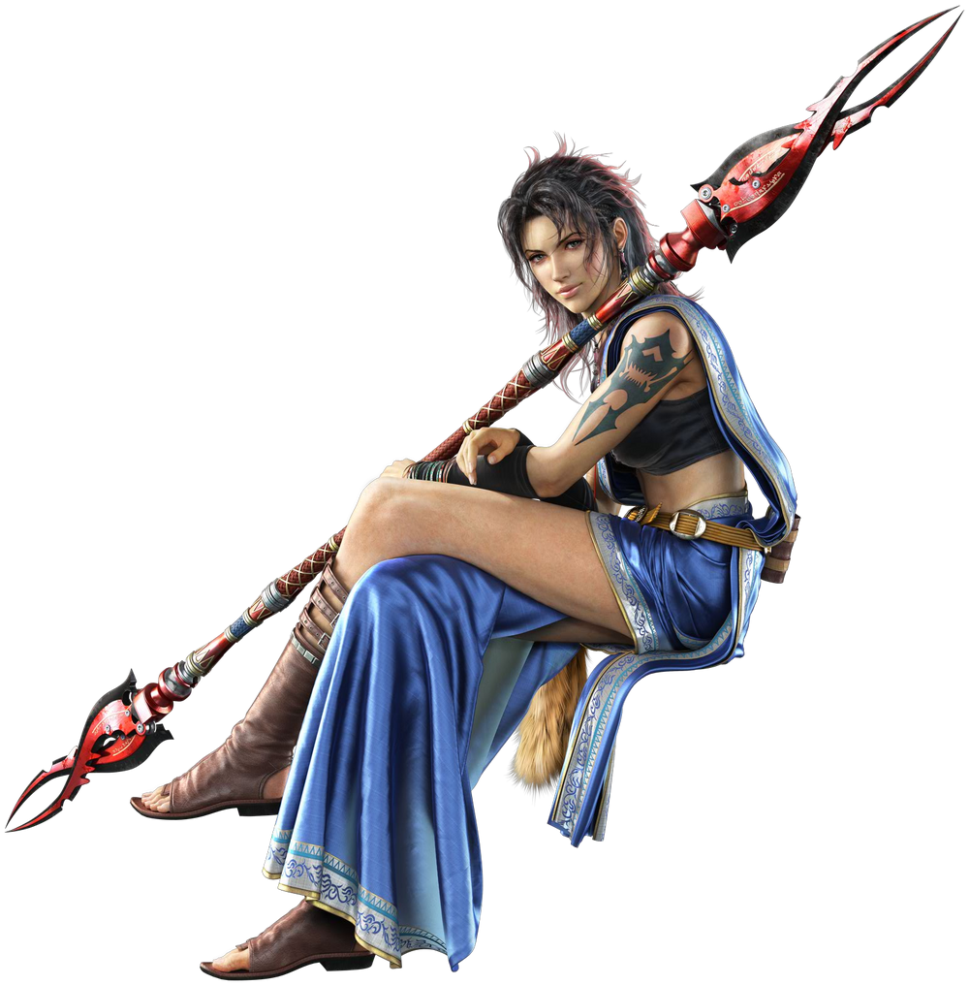
“I said I’d do the hunting, but maybe I should’ve brought her along anyways.” Oerba Yun Fang lamented not extending an invitation to the girl that she loved as she continued her trek across the field, spear both in hand and resting on her shoulder as she did so. Her travels with Lightning and the others had taken them to that small farming village in the background, but the village in question didn’t exactly have much in the way of restaurants. So, it had fallen onto their own shoulders to hunt and prepare their own meals.

Fang was bold, courageous, and confident; all traits that Ryne had admired in Gaia, yet they had been thrust onto her in this new identity of hers. The fit, dark-skinned woman rubbed at the back of her head, ruffling her perpetually messy hair in the meantime as she mulled the possibility of going back to get her partner. “I guess it isn’t that far. Ugh! Fine! I bet she’ll really appreciate it!” The two hadn’t verbally acknowledged it yet, but they were more or less officially dating.

“Hold up, Vanille! I’m coming!”

And she hurried off towards the village with this mission in mind.

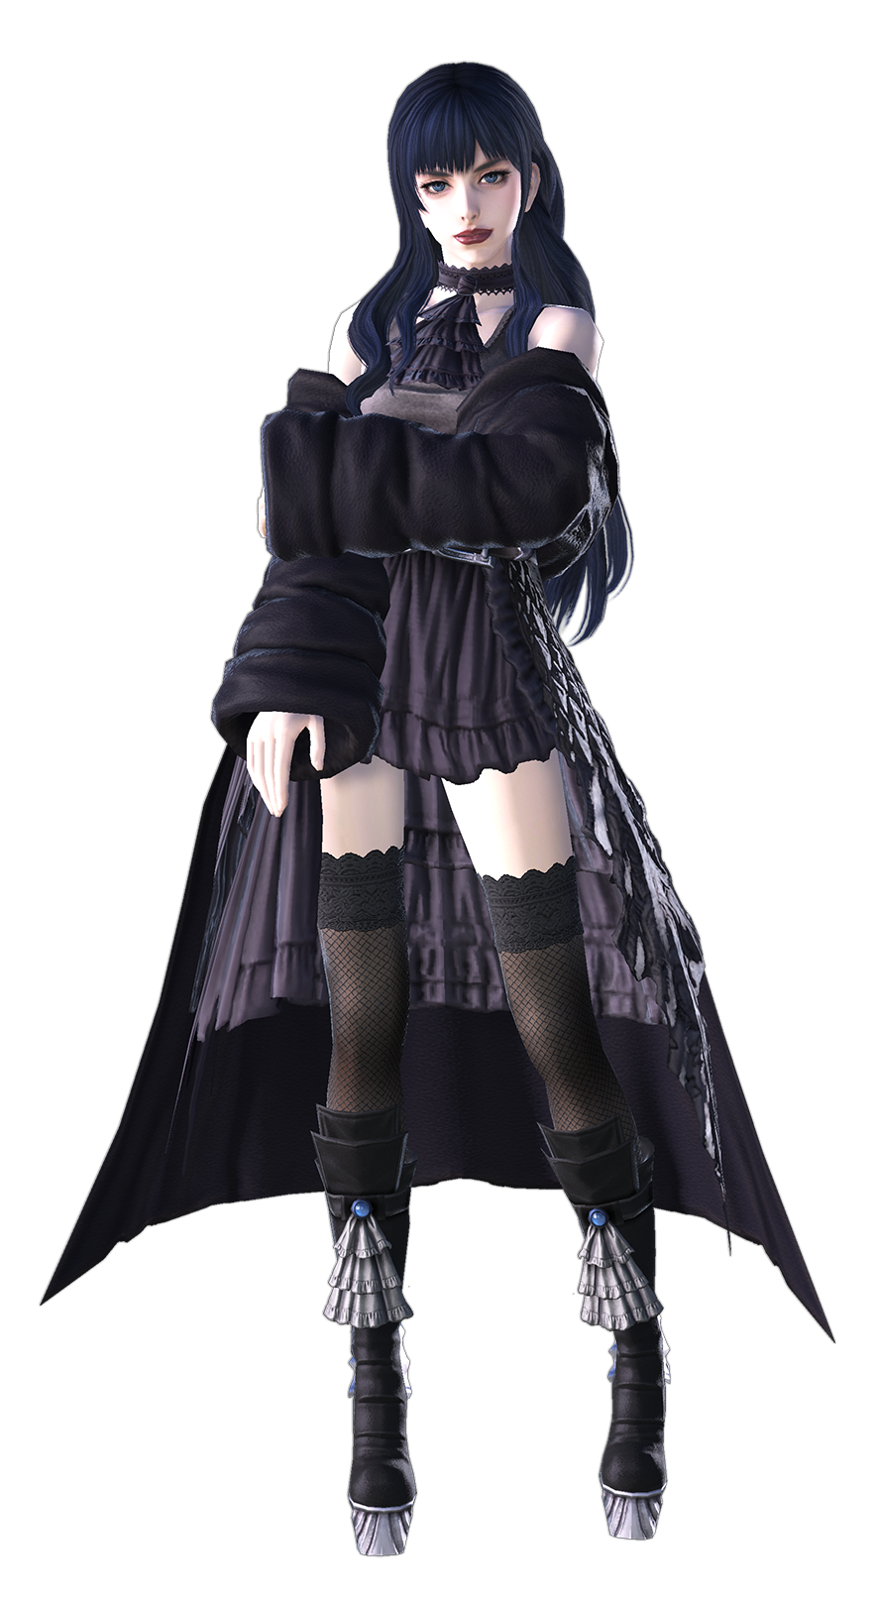
Gaia, meanwhile, was utterly stunned by her immediate change in surroundings. She seemed to be standing beside an unkempt bed that fit two people, a small window offering a view into a quiet village of the likes she had never seen before outside. She hadn’t seen all of the First just yet, not since taking back her life from the forces of a life once past, but she still felt fairly certain that this wasn’t a place in their world. “Could this be a Reflection?” Not that she was as well versed in this subject as Ryne’s friends had been.

The girl was equal parts shocked and annoyed. She had been so happy to receive her very first gift from Ryne and had wanted to shower her with affection once they had put the rings on. But seemingly? Doing so was what had landed her in this place in the first place. “Wait, if I’m here… Ryne put on a ring too, so she’s gotta be nearby, right!?” It almost felt like wishful thinking. But if she wasn’t in the hut, then perhaps she was outside.

But her ring was still glowing.

“Hm?” Something gave Gaia pause in the end, however. While her memories had only properly been restored recently, she was still the one who knew her own body better than anyone else. The way it moved, the way it felt; and that included the weight of it. If something had changed suddenly then she should have noticed and, at least initially, she did. Was it because her head felt lighter? She idly reached pale fingers up behind her neck. “My hair?”

And found that instead of reaching her butt like it should have, that hair only reached just past her shoulders. Had it been cut at some point? Truthfully, the girl had only realized half of the problem. The color of the hair that remained had lightened to a bright red that bordered pink – a far cry from its original color and much closer to Ryne’s somehow. Not that she was becoming Ryne, but that didn’t mean she wasn’t becoming like Ryne.

It was already clear that her transformation wasn’t unfolding in the same order as her girlfriend’s, since Ryne’s hair hadn’t been what had changed first. And this trend, which was incidentally the lack of a trend, only continued as the curves of Gaia’s body were enhanced next. It could be seen more in her breasts than anywhere else, or at least felt in how much tighter the best of her dress had grown. Even so? It was only about a single cup size, and when she looked down to examine what was causing the tightness, she came away from things with a very different realization.

“Why am I wearing black?”

Not only was that probably the most bizarre thing she could have possibly been confused about, but she had commented on it in a voice that was both higher and held an accent that resembled Fang’s. It stole away attention from how her butt and thighs had growing a little thicker too, much less how her pubes had brightened and become far bushier above her loins. She just couldn’t fathom wearing such dark colors! They didn’t suit her!

And in a strange way, Gaia was kind of right about that. She hadn’t been at first with how pale white her skin was. But the pigmentation of her flesh darkened a little bit, becoming a much richer pink that felt much healthier comparatively. “I do feel a bit strange just in general, I suppose?” The reality that she was speaking more softly, and much calmer was definitely part of it; not that she obviously could draw that conclusion herself.

“Oh!?” The girl became a little unsteady on her platform heels – shoes she wore to try and make herself seem taller than she was even though she was a similar height to Ryne. Even so, her body stretched a little so that she eventually reached the height of 5’3”. It wasn’t so much of a jump that she suffered dire clothing malfunction, but her feet were almost pushing out of the front of those boots by the time she managed to balance herself once more.

Gaia ended up looking a couple of years older by the time her growth spurt had ended, and this aided in creating the impression that she was a completely different person once her facial restructuring kicked in. The excessive makeup was wiped off her face as her lips shrunk and eyes rounder (while also brightening to bright green themselves). It was a cuter face that maintained a different beauty standard, seeming much plainer overall without the excessive makeup Gaia wore, however.

And then came her own change of clothing. A pink halter top, an orange and pink ombre skirt, beige boots and a bear pelt made up most of it. Her hair was tied into pigtails while her bangs were swept to the left. On top of this? A plethora of jewelry in the form of necklaces, bracelets, beads and piercings all covered her. All traditional accessories from the tribe that she could now remember being a part of. They all jingled as she moved about.

“I feel like something amazing just happened!” Not that the woman could possible have had any idea what that was. She simply stretched to try and shake off the odd stiffness that she felt. One she had first assumed was just from ‘sleeping in’ a little bit but was actually just a side effect of transforming so suddenly. After all, Fang had been forced to give a big stretch when her transformation had ended too for much the same reason. “That feels much better!”

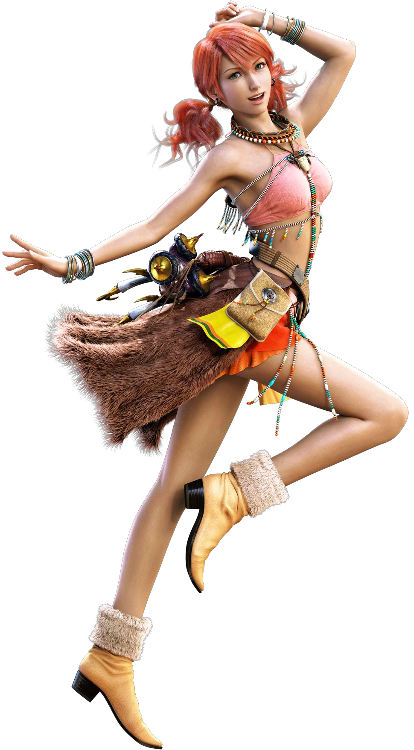
Much like it had been the case between Fang and Gaia, Oerba Dia Vanille embodied numerous traits of Ryne’s that Gaia had come to love. She was sweet, kind, and a little bubbly. “Oh? Did Fang leave without me!? Ah, well… I suppose I should do something for her for when she returns, eh?” And she was embodying those traits in that very moment, fretting more over Fang than anything. Even though she had technically been left behind.

The pink haired woman was just like that, and her bubbliness compared to Gaia’s more serious demeanor certainly stood out as she practically skipped out the hut door (after making sure to adjust her clothing, of course). “I wonder if I could buy her a new sash? The one she often wears is becoming rather worn out…” She was fairly certain that she had seen a stand when they had moved into town early evening the night before, and Lightning and the others had moved East to look at something apparently, so she had some time.

That was when she saw her in the distance. Fang was practically running through the village entrance with her spear at her side. Vanille waved enthusiastically, but it didn’t take the darker skinned woman to catch up and snatch her wrist, pulling her into a hug. “Hey! So, uh… Wanna come hunting with me? Not sure why I went off on my own. Kind of silly of me when you keep saying you want to do more together.”

Vanille blinked in Fang’s embrace. She could recall saying that, but maybe Fang was overthinking it a little? So long as they were together, she didn’t really mind if Fang went off on her own here and there! “Oh Fang! You don’t need to worry about me so much!” But even though she had said that she still snuggled into the taller woman’s chest. In the end, it was a good opportunity.

“But sure! Let’s make a day of it and get everyone a nice dinner!”

It would end up being the best dinner that they’d had in weeks, in fact.

