CASE OF THE CLUMSIES
APRIL 2022 REQUEST STORY
BY CHALDEACHANGE
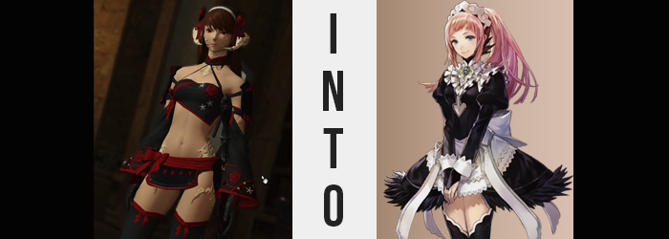

Everyone deserved a break once in a while, didn’t they?

Such was the thinking of the Raen Au Ra Paladin known by the name of Mitsu Kaisuri. As of late she had been taken up job after job, quest after quest, and while she didn’t mind the Gil and distractions afforded by a busier lifestyle, even she had her limits. For the sake of some much needed rest and relaxation, she had ultimately retired to her Goblet home with the intention of spending a couple of weeks there.

The issue was what to do with all of that free time. She didn’t have much in the way of hobbies, at least when it came to things that bore no relation whatsoever to her combat-oriented lifestyle. And so, several days into her little vacation, she got a little daring. Because of her profession, it wasn’t like she had many opportunities to try many of the uncanny fashions that caught her eye over the course of her travels.

And so, a few days later still? A number of outfits had been delivered to her doorstep. “Hm… What should I try today? Something eye-catching? Something that might make me feel like a new person?” Among her purchases, curiously enough, had been a maid uniform. When buying she had refused to question whether she had genuinely wanted to wear such a piece or if it had been something of a fetish on her own part. But now? It didn’t truly matter, because it was already in her possession.

It was the maid costume that she had ultimately decided to wear that day, too. It was somewhat difficult to adorn herself with, but before long she was not only clad perfectly in it, but she was practically skipping off towards Ul’Dah when it was complete. She was fairly confident that no one she knew would be about to recognize her, and honestly? She was a little keen on the idea of having others stare at her. Garnering a little attention now and again wasn’t exactly a bad thing, right?

But the Au Ra didn’t even make it out of the Goblet before she was stopped by a passerby. “Heya~! That outfit suits you sooo well! Have you ever considered working at a maid café? You could make a boatload of Gil, and hey! It might be something new to experience!” The Miqo’te woman that had stopped her was quick to make her business pitch. Mitsu did have some time between jobs, and she felt so good wearing the maid costume that, well… What the hell? The feline had told her that she could back out at any time, too.

And so, that night? She made her was to the Mists in Shirogane just to check out the place. She probably couldn’t commit to a full-time job, but she would at least take them up on their hospitality.

The maid café in question was in a quaint little home. From the walls to the table, to the floor – everything was fashioned out of oak. It smelled of fresh wood, coffee, and sweet treats, and there was certainly no shortage of beautiful women in maid costumes serving the plentiful guests. On the other hand, management had been a little too quick to try and scout her. So much so that it had put her off more than she had expected it to.

“I’m sorry, but I don’t have the free time to commit to working here. I’m afraid I’ll have to turn down your offer…” She was as polite as she could be at first, but they continued to press her while saying she had ‘the perfect look’, and with time Mitsu became more and more irate. Just as she had been about to yell at them, they pitched her an offer that was rather difficult to reject.

An exuberant amount of Gil for just a few hours of her time. They guaranteed her that if she just tried the job for an evening, there was no way she would want to go back to her old job. Something she knew couldn’t possibly be true. She had already made up her mind about it, and Mitsu was stubborn enough not to go back on that. Yet half an hour later, she was on the floor taking orders and trying her best to ‘look cute’.

Which she wasn’t all that experienced with, admittedly.

“As I thought, this really isn’t for me.” Eventually her first break hit, and the Au Ra retired to the break room where she poured herself a coffee from the pot and began to sip at it. Unaware of the fact that she had fallen for a trap. Not the shift itself, mind you, but it was the contents of the coffee pot that were wired to take advantage of her ignorance. The store owner had seen potential in her, they hadn’t lied about that. And they were going to use the entire shift to bring that out of her.

Of course, what was being administered to her needed to be something that she wouldn’t quite notice on her own. That meant when it came to consuming it and when it came to the effect that followed – and with only one cup, there were very specific aspects that would be targeted. Namely, those that made her an obvious Au Ra woman. Because for the plan of the café’s management to succeed, there had to be no trace of similarity between Mitsu and what was in store for her.

So, sitting at the tiny coffee table with her elbows on top, head resting in her palms as she awaited the end of her break, she didn’t exactly pay much mind to the very dramatic changes that had begun to afflict her physically.

Now, the elegant and poufy maid dress she had purchased did a good job of covering up her skin, but there was still places where it could be observed that the fundamental nature of her race was undergoing a shift thanks to the spiked coffee she had consumed. Cracks had been forming in the white of the scales that made her a Raen, and before long the segmented pieces would dislodge and disappear into dust. Whether it was the ones around her thighs, on the sides of her hips, her feet, neck, or even among her cheeks – it happened to all of the scales, leaving her pink flesh utterly bare.

Of course, there were parts of Mitsu’s body that were scaled beyond merely her skin. The same cracks were ultimately forged within the hollowed horns that functioned as her ears, and little by little they degraded and crumbled just as the rest of her scales did. The dust they were reduced to did not gather upon the shoulders of her maid dress like one might think it would, though, but instead appeared to disappear entirely after falling one or two inches. Her ability to hear wasn’t even interrupted, for once their bases had crumbled, a pair of rounded, Hyur-like ears had exposed themselves in place of the horns.

“I-I suppose it’s almost time to go back out there.” It was strange, but Mitsu hadn’t noticed. That she had stuttered despite her usual confidence. She didn’t really have any confidence regarding this maid café gig whatsoever despite how enthusiastic she had been about wearing the maid costume in the first place. At least, she hadn’t had much confidence when she had begun her break. That stutter of hers? It was actually unrelated and spoke to a more fundamental shift in the woman’s overall personality. It just hadn’t taken root enough yet for it to be more blatant.

That said, as she stood to set back out into the dining area to take more orders, the image of her scaled tail whipping about less and less could be observed behind her. Until it couldn’t be seen whatsoever anymore, replaced by… nothing. Much like a Hyur who had no reptilian features whatsoever.

Mitsu, looking at the door, exhaled and psyched herself up. “You can do it, Mitsu! You’re a real maid!” Was she? Where had that idea come from? She hadn’t even questioned it, and instead went back out into the café for another hour of work.

On cue, she returned an hour later for her second break. And Mitsu? She was feeling a little better about her performance that time. It had felt a little more natural overall, and while she’d made some mistakes? Those mistakes had come from unusual lapses in balance. Dropping a cooking here, tripping over that… Admittedly she was a little embarrassed, because she wasn’t usually clumsy at all. How strange.

“O-Oh, the owner told me I should have another cup of coffee, right?” She even sounded like she was in higher spirits, with her voice ultimately sounding softer than it did usually. And so making use of her better mood, she poured another cup of coffee and sat down to sip at it. “I think I did better that time…? But this is the same thing I do every day, isn’t it? But why doesn’t that sound right?”

With more of the coffee in her system, a new wave of physical phenomena was stirred midst the young woman’s appearance, beginning with her eyes. They soon turned a steely blue, but the color of her irises wasn’t the only shift that her optical sources saw. Her eyes grew bigger, wider, and lashes a little longer. If it had been isolated to her eyes alone, then it would have been debatable just how alarming or not this might have been, and yet?

It plagued the entirety of her face. For example? Her cheeks, lean as they were traditionally for an Au Ra woman of her age, swelled in slight so that they were undoubtedly fuller – which in turn simply added to the expressiveness of her eyes. This left her nose to appear smaller, which was then seized upon until it was, in fact, a little smaller. Cuter. If there was an adjective that best described how her appearance was developing, then that was most certainly it. She was looking cuter, and lips that formed into a plump, little, resting pout were a part of that.

Mitsu’s mind wandered to what she could do better while serving. The opposite point of view from during her last break, when she had been very close to walking out of the building altogether. She ended up so lost in thought that it made it much easier for her hairstyle to change. Not only did it grow longer, inheriting a silky smooth look and feeling, but from her roots an entirely different color stemmed.

Pastel pink was then born from the ashes of her dark brown mane. Hair that now fell down to just above her butt was completely dyed in it, yet in the process it appeared to be swept up into a neat, proper ponytail. When it came to the hair around her face, it ultimately framed it perfectly – with bangs rounded and swept very minutely to the right from a parting on the left.

“I suppose being a little less clumsy would help, but I’ve always been like that.” Had she? She most certainly hadn’t, but her memories were telling her a different story now. Plus how could she deny it when she’d caused so many accidents before this break? It was hard, seeing as her body wasn’t particularly well balanced.

And as if on cue, the woman’s build began to change next. The muscles she had honed as a sword and shield wielding Paladin practically melted everywhere except for her abdominal muscles, with arms and legs given little choice but to look softer as a direct result of this. She was weaker overall, likely incapable of wielding the weapons she once had. If anything, her frame was now better suited to the work of a thief or ninja.

Area that had softened soon became softer still, though. While it wasn’t much, the shapes of her breasts grew beneath the fit of the maid costume. It had been a little loose in that area before, but now the cups of the dress molded effectively around breasts that had swelled upwards a cup size above her toned belly.

If the growth was obvious anywhere, it was in her thighs and rear end. The tops of her boots had never quite fit right, but as thighs were engorged with meat, they filled in the angled thigh-high fits and even muffined slightly around them. All while the cheeks of her rear end burgeoned to the point that her lace panties were struggling to contain them, meat poking out over the tops. This had also pushed up the back of the skirt so that at the right angle you’d get a clever panty shot.

Had she grown into the uniform, or was it just a coincidence that the woman she had become, so strikingly different from the Mitsu of old, now fit into it?

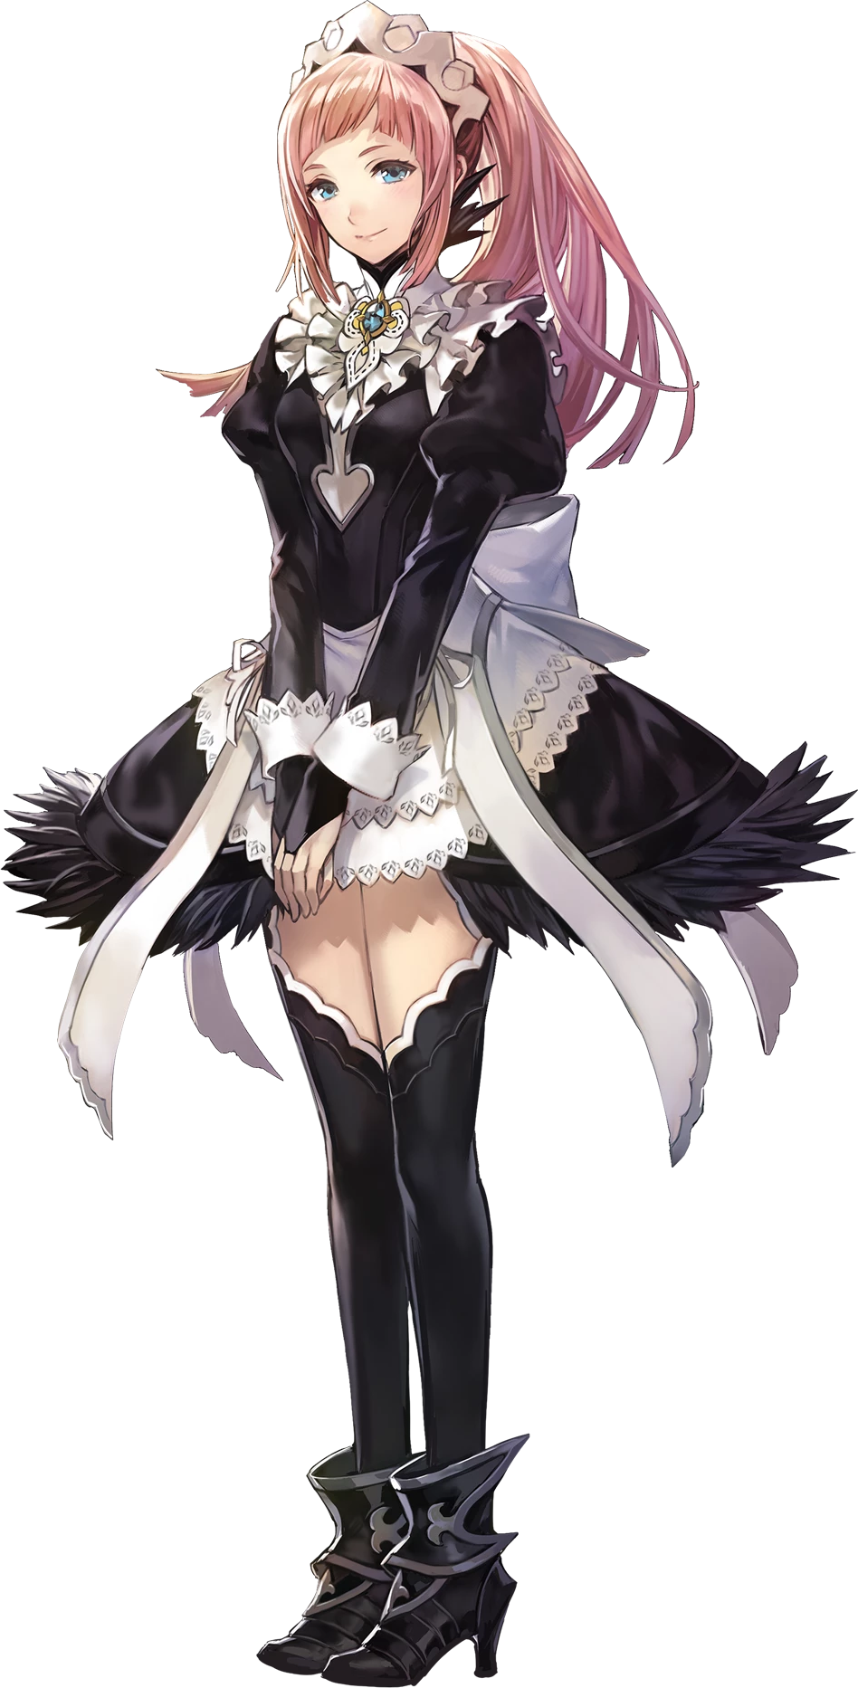
Humming to herself, Felicia finally finished off the final cup of coffee she had left lingering from the end of her last break. It was cold, but as a full-time employee of this establishment she felt obligated not to leave behind any excess or waste any of the amenities that were provided to her. Not that the little coffee that had remained at the bottom of her cup after her last break did much aside from finally remove the few dark strands from her pink hair that had lingered from before, and change a few of the old memories that had remained from her childhood.

She had already become the perfect maid for this maid café, just as the owner had intended. “I guess my shift is over, so I should… go… home?” Almost slipping on a puddle of water (just who had put that there?), she skipped over and punched her time card. It took the maid a moment to realize the folly in her comment, but she didn’t have to go anywhere after her shift, right? All of the maids lived here in this building!

Part of the reason it was a perfect job!

“Woah!?” While Felicia certainly had a great deal of potential when it came to maid work, though, she had just demonstrated why her fatal flaw made it difficult, too. Passing by an expensive vase in the foyer that led to the bedroom, she bumped into it and it fell to the ground with a CRASH. “Oh no! My wages are going to get docked for months!” It would only be months if she was lucky.

But she truly was lucky. Most employers would surely give a clumsy maid like her the boot, and yet they stuck with her despite her flaws. But this, of course, created loyalty. And clumsiness aside, the clumsy maid trope would definitely bring even more customers into the café. Felicia was a worthy investment, and the best part? They had told Mitsu not to tell anyone where she had been going. So no one would even know she was missing.

Just to keep her in check, though, maybe they should found someone to be her sister?

