PRESENTS FOR MACHINES
COMMISSION STORY
BY CHALDEACHANGE
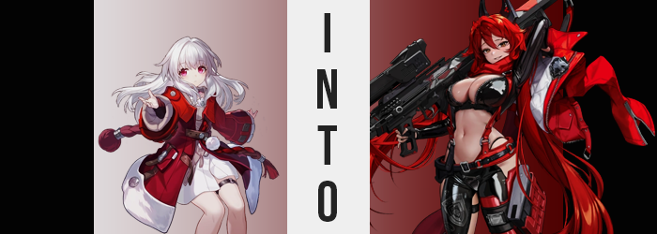

Jarilo-VI had finally entered an era of peace… again.

The departure of Cocolia and the Stellaron that had plagued the planet for hundreds of years had been the first era of peace that had been ushered in, but that had soon been compromised by outsiders. The IPC (Interastal Peace Corporation) had landed on the planet not long after the blizzards faded and a slight warmth had been returned to the lands, but they hadn’t been there to help even though the people that had taken refuge in Belobog would have benefited greatly from the aide.

Instead they were there to collect. The architects from era’s long past, when Jarilo-VI had begun to succumb to their eternal winter, had taken loans from the IPC in order to preserve their people’s lives. While these loans and resources had ultimately succeeded in accomplishing their goals, because the planet had been cut off from the rest of the galaxy by the great tragedy those debts had never been repaid.

But now that the planet was open for business once more…

But their plans had been thwarted by the efforts of Bronya and the crew of the Astral Express in the end. Peace had returned again, and in this case the IPC had even been helping the people of the planet rebuild here and there. “What holiday presents should I get everyone?” Clara wasn’t thinking about her planet’s past in that moment, but rather what she could do in the near future.

With the above ground and underground sections of the city of Belobog now mingling once more, the young girl had come to learn of holidays that were celebrated up top that she had never learned of down below. One of them was the Season of Festivities, a month long festival that culminated with a gift giving day near the end of the month akin to what might be considered Christmas on another planet. Clara wanted to participate. No, she would! She wanted to get gifts for Svarog, Seele, Bronya, Hook… Just about everyone! And that included the many machines that lived around Svarog’s camp. They were always helping her out and the girl had a very pure soul, so she saw the Season of Festivities as a good opportunity to repay them!

The problem she was having was a simple one. “I’m not sure what a machine would like as a gift. Gears? A firmware update? Hm…” Because they weren’t like people they would have different wants and needs, right? Some of them could think for themselves and feel emotions to a degree – she at least believed that Svarog did – but that didn’t mean that their preferences would skew towards the same things humans did.

And so she had spent her day asking around. Traveling from settlement to settlement, it had been her intention to pick as many brains as possible about what a machine might like to receive as a gift. From her fellow humans the suggestions seemed to be mixed. Much like her they had wondered if ‘machine-like’ gifts would be appropriate. Things like gears and lubricant for their joints. But Clara wasn’t sure if they would appreciate things like that since they were given them often.

On the other hand? Asking machines proved to be even more unhelpful. Most of the ones that could communicate seemed more than a little confused about her question, while those who were a little more advanced simply claimed that the did not require gifts from anyone. Her last hope had existed in Svarog, but while his words were as wise as ever they didn’t really help her think of an answer.

“We will appreciate anything you give us, Clara. It is the thought that counts.”

“But I want it to be useful too…” The girl kicked a can down a dark alley of the abandoned Rivet Town as she mumbled to herself. She didn’t realize that Svarog was ‘coincidentally’ tailing her, but the intention had more or less been to make sure she got through Rivet Town safely. He was following from a great enough distance behind that she hadn’t noticed, and he became increasingly on guard as she passed the base at the foot of the cliff that housed the old orphanage.

During their stay the IPC had left some machinery behind and Svarog hadn’t really had a chance to analyze just what it was yet. Strange, metallic pods had been among them in pairs. Clara was used to passing by them without much fanfare though and so she wasn’t even thinking about their presence. “I wish I had a better idea about what machines likes…” She uttered an idle comment that was more or less the crux at the core of her dilemma, naturally not expecting anything more to come of it. But ‘I wish’ had been a trigger phrase to the steel pods.

The girl didn’t even notice that one of them had opened, much less that a metallic hand had unfolded out in her direction. Svarog had, but he wasn’t fast enough. Before he could close the distance Clara had been grabbed and pulled inside with a scream, and before he could swing a robotic fist to break it he had been grabbed himself by the adjacent pod. Clara didn’t know that Svarog was out there though. She was just trapped in the dark… at least until the pod whirred to life.

“L-Let me out!” Clara protested as the pod soon filled with a dim, red light. Tiny hands pounded on the steel walls of the pod to no avail, the grooves and technology of its contents unfamiliar to her. Maybe there was a cord or something she could pull to turn it off? That was a thought that had crossed her mind. But in the end she couldn’t find anything loose nor interactable on the tin can’s insides. Just the lights that continued to glow shining down from above and a growing heat that filled the space.

It wasn’t so hot that she began to sweat at first, but the child began to work up one of her own as she continued to try and break herself out. But strangely enough? For as moist as her skin had initially felt from the exertion, that feeling began to slide away. Almost like she wasn’t perspiring anymore? But you couldn’t expect the girl herself to come to that conclusion. And yet, at her core? The girl was already becoming something that would push her closer to discovering the answer to the question she had wished for.

Her small body was becoming heavier. Not because her body’s figure or body weight had changed at all (yet), but because the frame that it was built upon and all the surrounding components were changing. “Heavy…” It did cross her mind for a moment, the idea that she felt sluggish, but she quickly pushed it aside as a matter of growing tired from moving around so much. The truth of the matter was that her bones had changed in composition; no longer bone but instead a far heavier, less destructible titanium steel.

That steel frame was just one of multiple shifts in her body’s composition that pushed her physical status from ‘biological’ to ‘artificial’, however. Everything from her blood, which became akin to a coolant, to her flesh, which was now a synthetic alternative, underwent this shift. Organs that were unnecessary were either disposed of or remade, such as her heart becoming a mere coolant pump and an internal power source keeping her body running. Even though her brain was replaced by a computer, eyes now mere cameras, none of it seemed to click.

Clara legitimately had no idea.

And in the end she was being forced to acknowledge much more blatant differences with her body. Size differences. “H-H-Huh?” It began with the girl’s stature and, by extension, her perceived age. Titanium bones and the synthetic flesh and skin that surrounded them stretched longer and, in some cases, wider. It seemed to be aimed largely at making the girl taller, which ultimately was a terrible combination when paired with the dress she was wearing. “I’m… I’m getting taller?” How could she not notice it?

The skirt of the gown was hoisted higher and higher as the inches piled on. She peaked up over the 5’ mark rather quickly and that alone was enough to lift the skirt so you could see the base of her hips. And yet she grew taller still, fingers lengthening and slandering along with her limbs, nails growing long. Of course, to maintain any semblance of consistency her feet stretched larger in kind. Each toe was a little bigger, each heel a little sharper. Until ultimately they don’t look out of place on her now 5’5” tall body.

“I… Hm…” Clara’s voice sounded a lot deeper and her expression appeared more mature; both figuratively and literally. Her facial features now reflected those of a woman in her twenties, and broadened shoulders (that had rippled her sleeves off her dress and jacket) and widened hips (that panties clung onto for dear life) added to this impression of a greater age.

But at the same time was she really Clara? It wasn’t as if she looked like an older version of the girl she had once been. In fact she looked quite different. Her facial structure was longer, her red eyes wider and more piercing by design. Thinned cheeks and a sharper chin, that was farther from her nose, all gave her face a distinctly different shape.

“Well I’m way hotter now, right?” That definitely wasn’t something that Clara would have said nor thought, but she was saying it like it was the most casual thing in the world. Her mind, or at least the digital version that now existed within her head’s computer, was being reprogrammed at a varied pace to come to terms with and inevitably not recognize, that she was changing. She was being given a new life. A new purpose. Did that purpose require her hair color change? No, but that was what happened next.

Almost as if it was absorbing the increasingly hot temperatures of the room, white locks turned ablaze with a glorious crimson coloring starting from the woman’s scalp and igniting its way to the tips. But it wasn’t just the color; once the tips had been reached that hair lengthened even further, falling down to the backs of her knees while Clara’s bangs became nice and fluffy. Not to be outdone, crimson hairs could also be seen poking out behind the front of her tight panties for an equally fluffy bush of hair had sprung to life within.

One hand banged into the nearby pod wall as Clara looked around with a befuddled expression. “So why am I in here? What’s going on?” She could tell it was extremely hot inside but that heat didn’t appear to affect her body. What it did affect, however, was the remnants of her child-sized outfit. The edges of each article were beginning to singe, suggesting that they might eventually catch blaze and burn away. But before that could happen her synthetic body pushed the remaining cloth to its uttermost limit.

Not that this was hard to see. The belt around her torso had long since snapped away, and so the white dress beneath her red jacket was completely exposed in the front. “Mm?” She glanced down just in time to catch the sight of that dress pushing forward around her chest, weight pooling beneath her nipples and stretching as mounds rose into hills, which then rose into mountains. Skin was stretched around supple synthetic weight. They grew to rival her head in size, but the chest of the dress could no longer contain them. Not that it mattered.

Because the white caught fire and burned away, leaving G-cup tits to bounce exposed.

“That’s better! Can’t have my girls getting suffocated.” It was odd though. Why did she feel like she’d once had a smaller bosom? She hadn’t been designed that way, right? Maybe it was just an odd side effects of her memory bank interacting with the heat. The very same heat that finally burned away her panties, exposing her hairy pussy and the undeniable fact that Clara was thickening beneath a tummy that had tensed with rippling muscle.

The woman’s hips were pushed wider not without reason, because the adjoined regions relative to her legs forced them to. Her bare ass pressed up against the back of the pod, swelling out a handful of inches behind her while the crack between each cheek grew deeper and deeper. Shaped like a perky heart, they were pushed up even further thanks to her thighs. They engorged with muscle and synthetic fat, each thigh nearly as thick as her waist. When all was said and done the woman bore an hourglass figure.

And there was no longer a single, visual trace of Clara.

She was a brand new woman.

The heat within the pod soon cooled off and the light above changed to green. On cue with that light’s color change, the back of the pod opened to reveal a number of metallic arms that reached out with pieces of clothing that the woman somehow new how to slide into as the arms fastened and tightened cloth and leather where needed. And there was a lot of leather, from the odd boots to pants combo that showed off the skin of her hips, ass, and the backs of her thighs, to the long sleeved, cropped jacket that showed the full depths of her cleavage.

A crimson jacket was dropped over the shoulders of the woman formerly known as ‘Clara’, with a matching scar and straps that attacked to the belt around her waist. Metallic, black horns were placed atop her head and without even thinking? She grabbed a large firearm that was handed to her from behind without even knowing it was there.

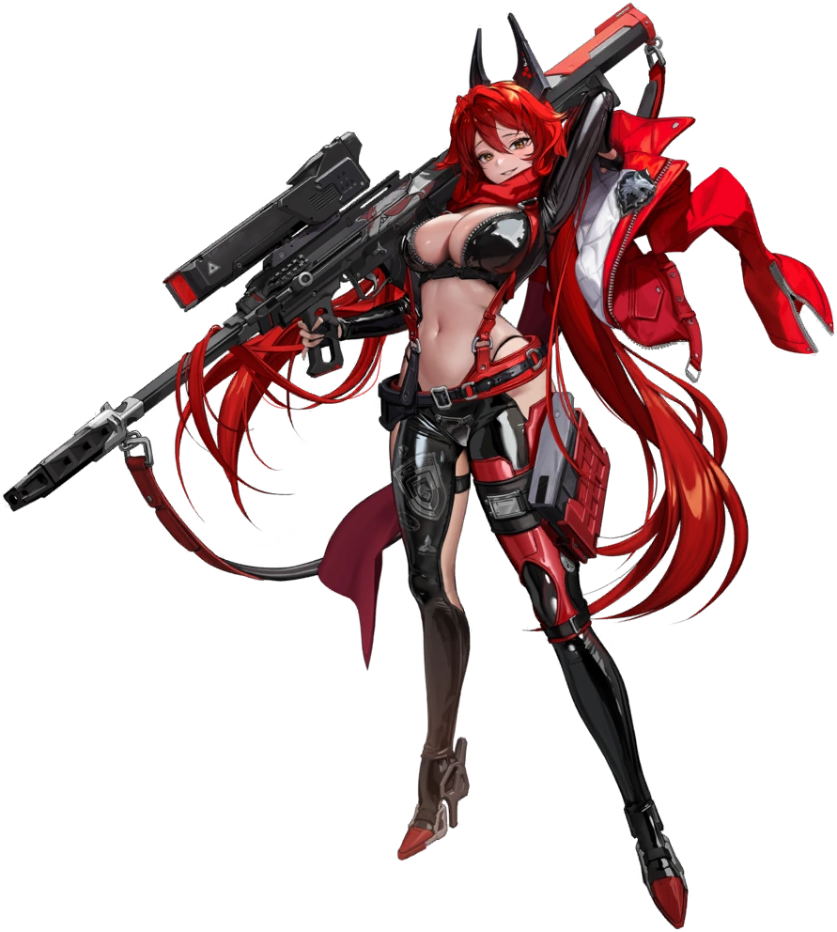
“Huh. I was making a fuss but I kinda like it in here. Pretty old-fashioned pod, isn’t it?” ‘Making a fuss’ was all that the Nikke, a combat android, could really call upon memory wise about what had happened to her within the pod. As she now perceived things she had been examining it because it was an antique (and she loved antiques) when a claw suddenly reached out and pulled her in. She remembered banging about to try and escape but, looking at the tech now? She’d been given a visual treat, hadn’t she?

At least until the glowing went away and it began to open up.

“Aww…” Of course, that wasn’t what had happened. Clara had been transformed and reprogrammed to grant her wish by this piece of IPC tech. A trap that an angry IPC staffer had left behind without Topaz’ blessing to dole out unnecessary punishment to the people of Jarilo-VI by transforming them into living weapons that could be controlled as necessary. Nikkes. And Red Hood was one such Nikke.

The cameras in her eyes refocused as she stepped outside. She recalled being deployed to Jarilo-VI and what that entailed. She and her partner were supposed to be keeping an eye on things, sending data back to the IPC. So long as they didn’t receive any damage they didn’t look like androids, and so it was easy enough to play along with the people who lived there. “Where is Snow White, anyways?” The Nikke she had been deployed with was named Snow White.

Upon stepping out into the cold she noticed that the pod beside her (the pod Svarog had been pulled into, not that Clara had known this) opened shortly after she’d stepped out. A cute and cheery girl with white hair and golden eyes stepped out. “Hehe! Is your maintenance done too, Red Hood? We’re twinsies!” This silly, innocent Nikke was Red Hood’s partner in question. Just hearing her talk brough Red Hood no shortage of relief, and what she said gave the busty redhead some clarity as well.

“Right… Maintenance. Can’t believe they’re using such old timey pods for that! Not that I mind, though. The machines on this planet are all pretty old-fashioned in general.” But Red Hood knew this meant they didn’t think or have emotions like Nikke did either. She smirked, watching Snow White’s back as she walked ahead.

“Hey, Red Hood? What do you think these machines would like as a gift for the Season of Festivities?”

“Huh? Kind of a weird question. Don’t know. Probably some oil or something?”

