CHANGING TONE
JULY 2021 REQUEST STORY
BY CHALDEACHANGE
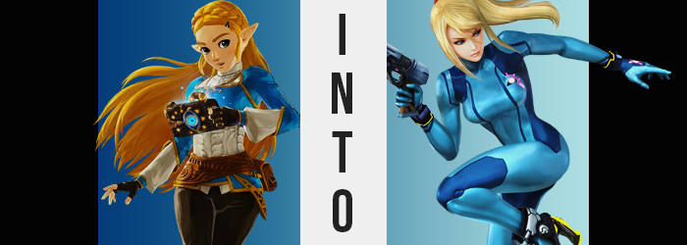

The Dueling Peaks were beautiful late at night. It was a view the young Princess Zelda had missed during her one-hundred-year absence from this world, left to seal Calamity Ganon alone during all of that time. While Link had offered to scale the southernmost mountain alongside the princess, she had opted to travel it alone so that she might gaze at the stars above from the shrine located there.

She hadn’t rejected his offer with any ill intention, but there was a lot on her mind now that Hyrule had been ‘saved’. There was so much that she had to do, so much she had to say, and while her head felt cloudy thinking about it all, the clear night sky brought her some clarity herself.

“How am I to do everything I need to? Link assures me that we can take it a little at a time, yet…” She had her fair share of doubts. After essentially remaining dormant for so long, it was only natural that she might doubt her capabilities. Particularly her physical endurance, which was something that hadn’t been tested in an exceptionally long time.

In fact, it was the traveling that she was most anxious about. Moving from region to region, repairing relations with those communities that had moved ahead several generations in her absence. She feared the wear this traveling might afford her, that she may arrive at place after place completely spent. Surely no one would judge her for this, but the princess had worked herself up into a tizzy over every little possibility. It was simply in her nature to do so.

Eyes gazing upon the sky, she finally finished her thought. “I truly wish I possessed the strength to not be a burden on anyone, lest of all Link.” The timing had not been intentional, yet as she spoke this desire aloud, a shooting star flew across the skyline. “Oh! I suppose that isn’t the sort of wish a shooting star might grant, however.” Of course she’d heard the stories about wishing upon a shooting star to have your desires granted, but for all the times she had done so as a child, these wishes hadn’t come true.

But there was a first time for everything, or so they say.

Putting the idea out of her head, the princess decided to wander towards the shrine. The evening breeze felt nice, but she was wary that it had somehow messed up her hair, however. One of the shrine’s sides was reflective, and since the moonlight was so bright—

“AH!?”
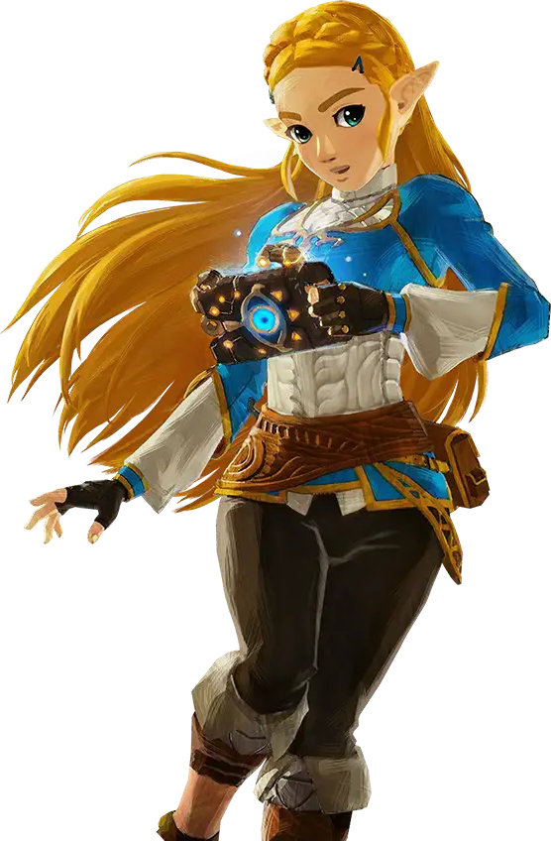
Her leisurely stroll was quite promptly interrupted, and panic immediately took hold as the princess found herself struck by something. Something that had fallen from the sky! It made contact with her torso, but didn’t knock her down. Instead, she was engulfed in a pillar of blue light that erupted the mountain below her, and that pillar? It stripped her bare. From her outer wear to her underwear, to her hair accessories – in the blink of an eye it was all immediately eviscerated.

“AAAAH!?” Once the light dwindled, Zelda was immediately aware of this fact, and so she threw one arm across her small but perky breasts, while she tried to cover her crotch with the other. It took her a moment to remember that she was alone on this mountain and had no need to cover herself. But what if Link saw the light and raced up the mountain? She’d never recover from him seeing her body!

Zelda had made it as far as in front of the shrine wall she’d been looking for, its glossy surface enough to faintly see her reflection, and she couldn’t help but feel a little insecure just looking at herself. She really had no reason to, she was an attractive young woman, but that wasn’t the kind of reputation she had. She wasn’t tall like Urbosa nor strong like Mipha. She had the beginnings of a figure, particularly where her thighs and butt were concerned, but nothing that would really turn a head.

Did the fact that she cared about this kind of thing mean she was growing up? Or was she simply becoming vainer?

She shook her head, realizing she had more pressing concerns. “I didn’t bring a change of clothes up the hill with me. What am I going to… do?” Her voiced concerns promptly turned to a question as the princess tilted her head at her reflection. Something appeared to be unusual. “What is that…?” There was something on her face, below the left side of her lip. She stepped closer to the shrine and squinted in an attempt to get a better look in her reflection, all while her fingers reached up to touch it.

There was a black spot. Was it dirt? She’d assumed so at first, but through touching it Zelda had a more shocking realization. “Is this a beauty mark?” A mole? She hadn’t had one there before. Her complexion had always been so flawless, and a mole wasn’t something you could just instantly obtain. Was it the fault of the light? Wait… She’d completely forgotten about that! How? It had been so shocking at the time, yet being struck by something had completely slipped her mind!

Something awry was going on here, and the princess was torn. Should she find Link? But how could she, looking like this? Looking like… “Wait. Wasn’t that groove at eye level before?” Another peculiarity struck the princess. This time, it was a scratch in the side of the shrine that had been right in front of her when she’d first begun to stare. Now? It was aligned with her chin. “Did the shrine shrink? No, that would be strange…” With Calamity Ganon defeated, it wasn’t impossible that the shrines might regress back into the earth, but that wasn’t what was happening here. “That means the only other possibility is…”

That she had grown taller.

Zelda had drawn so close to the shrine so that she could see her face that the rest of her body hadn’t been in view, but now she had no choice but to step back. What this revealed was a body that was stretching before her very eyes, limbs and torso alike elongating in a manner that was forcing her to appear lankier and lankier the longer the phenomenon wore on. “What…? This is… This is impossible!” The princess’ heart was pounding so hard that it felt as if it was going to burst out of her chest, for not only was her height jumping dramatically, even a distant glance at her face revealed that it was much more than a sudden growth spurt.

Maturity was settling into her features, her face both losing any excess fat and growing longer in shape so that any childishness was erased completely. Adding to this, her once big and bright eyes narrowed and the bushy brows above them thinned until they were practically pencil thin, etched in a way that gave her resting expression a much more serious look. “Thith can’t be…” Her words came out slurred, for her lips smacked together as they swelled to seductive proportions. More than that, though, her voice carried a newfound deepness.

The woman looking back at her in the shrine reflection hardly looked like the princess anymore – she barely recognized herself, and only through her long, golden hair and curves could she see any resemblance to her old appearance. In fact, with an additional foot of height, her previous figure had more or less been thinned out as a result, leaving her to look sticklike without much in the way of curvature.

Though, this was short lived. “Oof!” Zelda’s knees buckled without warning, and she nearly spilled forward, catching herself by the mercy of her hands against the shrine – and even then, those hands sported longer fingers with hardened, calloused tips. The cause of her spill had been a prompt popping sensation that had forced her hips to widen past the breadth of her shoulders. At the same time, her waistline pinched in to leave her tummy very narrow. The sensation felt weird like someone had just grabbed her body’s sides and forced them inward.

“Why is this happening? Was it because I made that wish?” But she didn’t look any stronger, and it wasn’t like anything else could have triggered it… Because, once again, she had forgotten about getting struck. Rather than dwell on it too much though, a hand ended up planted on her right hip, and she leaned sensually to the side while jutting out her chest. She wasn’t sure why she had felt compelled to do this, but as she grew more and more attractive, she kind of wanted to show it off.

Case in point: the hand that was resting on her hip was forced outwards a little further, if only because the weight of her lower half was shifting. The thighs just beneath each hip blossomed keenly, bulging 180 degrees around with fat, while her ass flourished similarly. Her buns ultimately grew big and firm, and yet neither area had reached their full potential just yet.

Meanwhile, Zelda adjusted her pose in the reflection so that her hands were pressing into her ass, forcing her chest forward. “I really look so mature.” Was she in her twenties? Thirties? She couldn’t be sure, but she didn’t care, either. So enthralled by what was happening now, she’d hardly even noticed what was happening to her mentally. Her troubled youth was a long-forgotten memory now, literally. Instead, recollections of a different life had taken its place. Memories of having one’s parents murdered by a space pirate, of undergoing dramatic training. None of it fit, but…

The princess hardly cared. With her chest forced outward as it was, the fact that her breasts were swelling was pushed into the forefront visually. Nipples both hardened and thickened, stretching to the sizing of a pair of gold pieces, while the flesh below matured at an alarming yet pleasing rate. Her B-cup bosom jiggled to life as it bounced into a pair of respectable D’s, each tit just as perky as it was it bouncy. They really brought her mature look together, even as her pointed Hylian eyes shrunk towards the sides of her head to take rounded shapes.

“Why am I doing this?” Zelda’s tone was sterner now, as the childishness that brought her to pose began to fade and the seriousness of a weathered adult began to settle midst the dust of her ego’s implosion. Sure, her body was attractive, but she wasn’t the kind of woman that went around flaunting it. That was what her new memories informed her of, anyways.

Her pose regressed back to a simple standing posture, but while doing so? Her body was promptly overwhelmed by a sudden tightness. For every body in the woman’s body had tensed up, clamping down upon themselves as if in preparation for something. When this tension finally released, the cause became clear. Almost like her body was exhaling, with everything loosening up in feeling came an expansion of her muscles.

Arms and legs grew quite swole, her flexibility amplified by tendons that were adjusted to bending in every angle imaginable. Why, she felt as if she could bound several feet into the sky! The muscle growth pushed the fat in her ass and thighs outward, leaving the skin around them tauter and their overall appeal significantly thicker. On the other hand, firm pectoral muscles left her breasts looking ever so slightly smaller.

Blue eyes locked onto her hair in her reflection now. “Hm?” Something about it had struck her as odd, briefly. It would be simple to assume it was because the shade of blonde it took was lightening from gold to a more yellowish hue, but instead if was the original gold that bothered the extremely fit woman. The new color looked correct, even as said hair shortened so that it only fell halfway down her back, with all of the natural waves entirely straightened out.

What had looked out of place? Why was there a part of her that felt like this body was all new, when another part of her saw it as familiar? Before she could arrive at an answer to that question, another flash of blue found her nudity problem rectified, as a skintight bodysuit born of light and dark blues plastered itself against her flesh, while a red scrunchie tied her hair up into a high ponytail. At her hip now rested a futuristic gun – far to futuristic for Hyrule, but it was something that Zelda recognized.

No, her name wasn’t even Zelda anymore.

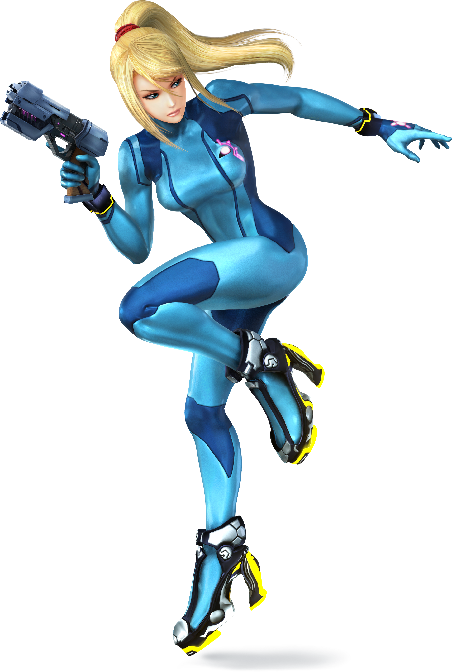
“Is this really my body? No, that’s an odd thing to say. Has it not always been my body?” The intergalactic bounty hunter, Samus Aran finally ceased her posing in front of the reflective panel in the shrine wall as she noted what strange behavior it was on her part. She wasn’t one to pose sexily in front of the mirror like a teenaged girl who had just realized she had become sexy (even if that were what had caused her to do so in the first place when she’d had more awareness as Zelda).

In fact, there was plenty that she was having difficulty explaining to herself now. Her seductive poses aside, why was her heart palpitating like she was anxious? She’d mastered steeling her nerves just as she’d steeled her body long ago. It wasn’t like her to worry or get too worked up over anything. “Maybe this planet is affecting me in a negative way…”

It was a statement telling of her current mentality. No longer did she see this land, Hyrule, as her home. She couldn’t even recall its name. Instead, Samus recognized it as an alien planet that she had touched down upon. And once she had made that distinction, the rest of her memories fell into place. She had crash landed here? Her ship was ruined? Well, it wasn’t the first time this had happened.

The woman examined the decline down the mountainside and reached for the gun holstered at her right hip, bodysuit still the only thing she was clad in. “Surely there are dangers down here for me to worry about. There always are.” She just wished she had her Power Suit.

But at the very least, she thought, she had the physical strength to persevere through this land.

