**PART 4**

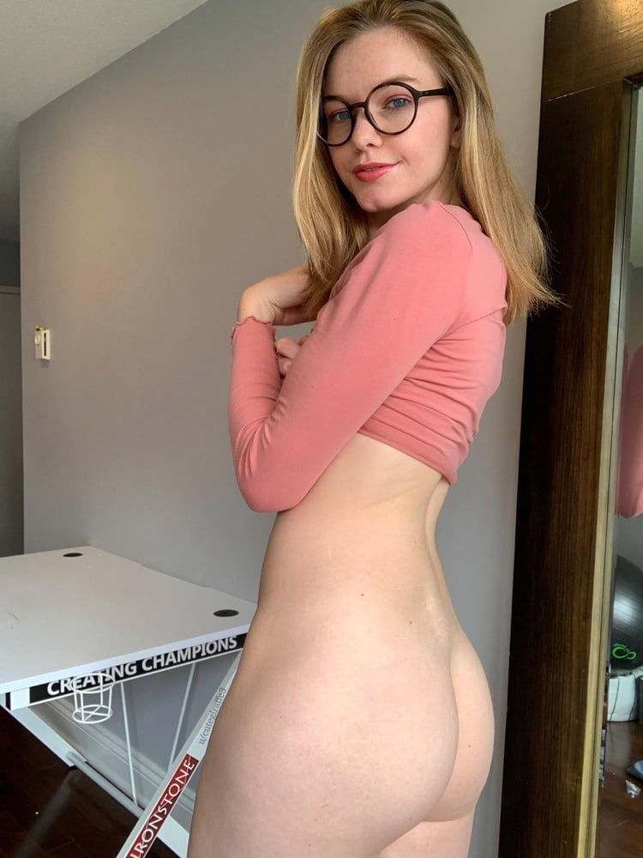

Kyle ran back to his car, his heart was racing the entire way! He slammed the car door and sat back in the seat while hyperventilating. He felt so used, so abused, this was not the job he had signed up for! He took the cheque out of his pocket and looked it over one more time, it was a lot of money, but he could still taste it, the burning fumes, the spice, it was embedded into his throat! Each breath, every swallow, was accompanied by the flavor and smell of Taylor’s asshole.

Kyle grabbed the mouthwash from his bag and began rinsing out his mouth over and over, spitting the alcoholic wash out of his window and onto the ground. It was a neon green fluid but after being washed around in his lips it came out almost brown!

He looked over his schedule and immediately felt the ball of nerves in his throat once again. The next client on his docket for the day was Alice. He knew that not every client would be like this, He had seen Stan serviced many women, and hardly any of them shit into his mouth, but Alice, she was sure she would do the same as Taylor! Kyle knew it!

He had to work up the courage to push the key into the ignition, everything inside of him was screaming not to go, not to drive to Alice’s home! The thought of Alanna pushed him forward though. He knew the only chance he ever had of being with her, winning her heart, was if he had a good job, a steady income, and a medical degree. This truly was his only path to happiness! Alice lived close by in the same rich elite neighborhood, it was only a ten-minute drive away.

Kyle sat outside the large estate working himself up to walk to the front door. He was already ten minutes late but it was so difficult, knowing what he was walking into! It was like willingly going into a lion’s den! He took a long deep breath and then grabbed his bag before heading to the large double doors. They opened before he even got to the steps revealing a stunning young woman with a big pair of glasses.

“So you’re the new guy huh?” she asked with a big smile!

“Finally, I was getting tired of that old fuck slobbering all over my asshole!” She said very abruptly catching Kyle off guard!

“Uhmm, I uhh... It’s nice to meet you” Kyle said nervously while sticking out his hand… she looked at his hand with surprise, like he had done something foreign.

“Are you joking? Is that any way to greet your new client?” she asked with a teasing tone…

“Uhmm..” Kyle stammered again as she laughed and spun around, bending over and sticking out her ass in a very animated fashion! She looked back over her shoulder at Kyle who was caught off guard by how forward she was! Her ass was big and fat, it was wrapped in a pair of tight pink leggings that dug between her cheeks. Each cheek was so big and round, they jiggled with her body movements like two mounds of Jello.

“What are you waiting for Doc? Kiss my ass!!!” She demanded with a grin as Kyle blushed and looked behind him. He was still at her front door, their property was massive but the street was visible from where he stood.

“Right here?” Kyle asked in surprise!

“Do I need to tell you twice? I’ll warn you now, I have a very short temper and **NO PATIENCE** at all! Not to mention **YOU ARE ALREADY LATE!** Normally I would deduct this from your fees but it was your first time today meeting Taylor, right? Haha I’m sure she kept you busy”

Kyle stood there like a statue blushing widely, his face beet red as he looked back and forth! Cars were driving by every few seconds, anyone could see! Slowly he got down to his knees, her big fat ass right in front of his face. Even through the yoga pants, he could feel her body heat! He began looking at her crack and upon further inspection, he could see there was a deep line of sweat running down it, the pants fabric was stained a darker shade of pink!

“Is there a problem?” Alice asked, sounding a bit irritated.

“No, no problem at all” Kyle said quickly as he leaned in burying his face between her ass cheeks! She cooed and shook her butt back and forth a tiny bit rubbing her crack on his nose! Kyle made a mental note not to inhale through his nostrils but he could still smell the odor! It rubbed off on his nose as he kissed her crack, puckering his lips, and smooching the inner area of her cheeks.

“Hehe, how’s it smell?” Alice asked with a giggle.

“Mhmm, quite potent if I am being honest… would you like to go inside and I can begin my diagnosis?” Kyle asked, trying to sound professional.

“Hmmm, I don’t know if you have earned the right to enter my home yet! Then again, you are a stranger! You could be anybody! I mean, do you even have credentials? Any form of I.d?” Alice asked in a very fake and sarcastic tone. Before Kyle could respond she jumped and smiled!

“Oh, I have an idea! She smiled and turned around with her ass facing Kyle again.





She bent over, her fat cheeks spreading wide as her dirty sweaty asshole came into view! It was repulsive-looking but nowhere near as dirty as Taylor’s had been! Alice looked back at him with a shit-eating grin on her face.

“I just finished a long workout, and haven’t had time to shower yet! It’s pretty swampy down there! So… If you are the Fart Doctor! Then you should be able to take a big fart right to the face? Right?” Alice asked as Kyle blushed and looked behind him again…

“Alice, I.. uhmm, I really don’t think this is appropriate right here! I mean, uhmm, anyone walking by could see!” Kyle said nervously…

“You know you are twenty minutes late for our hour session! The way I see it, that’s 35% of my time wasted that should be refunded right? Do you think my time is worthless?” She asked

“No, Never! I Just!” Kyle tried to explain but she interrupted him.

“Well, I want a 35% discount today **AND MY FULL HOUR!** And if you wanna waste more time we can wait here all day and I’ll take my session for free! How does that sound?” she asked with a glare but Kyle could tell she was enjoying this…

Kyle sucked up his pride and humiliation as he leaned into her ass! He could smell the odor of her ass from a foot away, it was a vinegary wet odor with a subtle hint of unwashed earth ass underneath! He leaned closer, and closer as the odor of shit got stronger! When he got within an inch he had to close his eyes, he didn’t want to see what he was going to push his lips up to! He could hear her giggling as his mouth slowly made contact with her wet sweaty anus, it was sticky and he could feel that it was unwashed and possibly unwiped.

“Now kiss like my asshole is your lover!” she said with a laugh. Kyle puckered his lips and pushed them to her anus as it spread wide releasing an atomic blast!

**BBBBBBBBBBBBBBBBBBBBBBBBBBBBBBBBBBBBBBBFRRTTTTTTTTBBBBBBBFRRTTTTTTTTTTTBBBFRRTTTTTTTSPPPPRTTTTfssssssffbbrrttppprttttttttttt**

The fart blew Kyle backward and out of her ass from the force and the surprising shock! Kyle was on his knees so when his ass hit the top of the steps he tumbled down them backward landing on the concrete driveway! The pain was intense and terrible as his body hit the sharp edges of the stone steps, but the odor of her gas was so much worse! It stunk of refried beans and old rotten eggs! He could feel a wet stickiness on his nose as his head hit the driveway.

**“HAHAHAHA HAHAHA OH MY GOD, THAT WAS HILARIOUS!”** Kyle could hear Alice laughing her ass off!

“So, the new Doctor just arrived, and I guess he has some more training to do because **MY FART LITERALLY BLEW HIM DOWN THE STAIRS!”** Alice said with an animated tone. Kyle looked up and could see she was recording with her phone taking a selfie video and then aiming the screen at him on the ground.

Kyle blushed a deep shade of red as she videotaped him and then turned her back, continuing to speak to her phone. He could see there was a brown liquid dripping from her crack and landing on her panties which were still with her pants around her ankles.

“Ugh, gross!” Alice fanned her nose while filming…

“I don’t know what’s worse! My gas, or the smell of his breath!” she laughed and ended the video while looking back to Kyle on the ground…

“Well, I guess you can come in, but remember, **I WANT THE FULL HOUR!”** she said while walking into her home and leaving the door wide open.

Kyle got up and hurried in behind her, closing the door as politely as he could but still managing to slam it. Alice kicked off her yoga pants and underwear, her bare ass visible in all of its glory as she walked through the house completely naked from the waist down. Her fat sweaty ass cheeks crashed into one another slapping and clapping as they swung back and forth, it was almost hypnotizing. Kyle followed her to the staircase and up the stairs, her massive ass right in front of his face.

“Soooo, how did you get into the fart sniffing business?” she asked without looking back. Kyle was about to answer but just as he opened his mouth, a brisk sharp fart sprayed from her clenched jiggly cheeks.

**SPPPRTTT**

“I Uhmm..” Kyle tried to respond as the foul stench of rotten eggs blew past his face, it stunk terribly!

**BBFRTSPPRTTsprtt**

**BBFRT**

**SPPPRTTTT**

Each step she took was accompanied by a greasy wet fart that blew a wave of stink over Kyle’s face! He could only imagine the horror show between her ass cheeks and a shiver ran down his spine as he pictured it. Alice began laughing as he choked behind her…

“Having trouble breathing?” she asked sarcastically.

“It smells very heavily, ugh, like eggs, I believe you may have a mild food allergy” Kyle suggested as he held his hand over his nose, he was able to mildly block the smell but the heat was still washing over his unprotected face.

“Hahaha is that so?” Alice asked as she reached the top of the stairs and led him into her bedroom. She lay down on her back on her bed with her legs up in the air, her glistening pussy was dripping wet and her asshole was puckering, spreading open wide. Kyle watched her with shock and surprise, this was not how he expected his first day to be. He got closer and could see her anus was filthy, the outer rim was now caked with liquid shit! There was hair around the rim but he hadn’t noticed until now from how light it was.

“Let’s see how good you are with your tongue, and while you’re at it, we can talk all about my, “allergy” to eggs” Alice smiled and laughed as she beckoned Kyle closer with one finger.

Kyle was shaking as he walked forward with his shoulder bag. He was a few feet away from the bed when a sharp high pitched fart cut through the room. Kyle jumped in surprise as Alice began to laugh!

**BBFRRTTTTTSPRPTTTT**

“Sorry, that one just slipped out! It was meant for your throat” she began to laugh!

Kyle got to his knees by the side of her bed and she slid closer inching her privates up to his face. The smell of her pussy was horribly strong, it reeked like sweat and he could see dried cum in the folds of her lips.



Kyle closed his eyes and stuck his tongue out, leaning forward and probing her sopping wet pussy with it. Her lips made a squishing noise as his tongue slid inside causing her to react with a deep moan! The taste of her pussy was so sweaty, it had a salty taste that was mixed into the musty taste of her unwashed cum filled lips. She reached down gripping Kyle’s hair with her fingers and pulled his head away from her.

“Not like that” she smiled and pushed him back, but this time his mouth was over her asshole and his nose was heading right for her pussylips!

Kyle had no time to react as she held him tight and forced his face into her ass and pussy! He gagged as his mouth made contact with her anus, the rim was so sticky and bitter now, coated in a fresh layer of her shit! He could taste the eggs, it was so bitter and rotten! His nose pushed deep into her pussy, squishing as cum leaked down his face! He could smell her insides even though he wasn’t breathing and making a conscious effort not to!

**BBBBFRTRTTTTSPPPPRPTTpspprttttttffrtttttttt**

Kyle could feel his mouth and tongue vibrating as a sharp explosion of gas rushed down his throat! He was still sore and recovering from Taylor, this was too much too soon! Her anus pulled in and out blowing out and pumping hot gas down into him. He could feel it filling his lungs, blowing out his stomach, filling him to the brim! By the end, there was so little room that he began blowing the gas out of his nose into her pussy! The lips of her pussy slapped in and out making wet queefing sounds, blowing the gas out at him and hitting his eyes!

Kyle began choking, he knew he was going to puke but Alice ran her fingers through his hair pushing him tight to her asshole! For a split second his mouth filled with vomit but she kept him so close and tight that he couldn’t spit any out! Kyle was still sucking down his vomit one gulp at a time when she let loose again, blowing it forcefully down his throat with the force of her gas.

**BBBBFRTT BFRRTT BFBRTTSPPPRppprtttstttt**

Kyle felt the fart blow down his throat and right out his nose, her pussy lips slapping on his face as the foul stink washed over him! The gas was so much worse coming out of her vagina, it had the stink of her ass but also the fishy unwashed smell of her rancid pussy! He tried to choke and gasp for air but she held him pressed to her so tight! Alice let out a moan as she began bucking her hip, rubbing on Kyle’s face.

**“MPPPHH MPPPHHHHHH”** Kyle moaned, begging for air in a muffled plea! Alice ignored him completely though!

**BBBBFRTTSPPPP bbbfrttpsppprtttttt**

Another fart was unleashed down his throat as she moaned and rocked his face back and forth. His nose was pressing in and out of her pussy, she was gushing with cum now and it was completely clogging Kyle’s nostrils! She gripped her fingers into his hair, squeezing tight and holding him with all her strength

“Keep your hair long! I like having something to dig my nails into!” Alice said with a moan as she began fucking Kyle’s face! Cum was running down his nose as her anus puckered on his lips.

**“GET YOUR TONGUE IN MY ASS!**” Alice demanded!

**“MMPPH MPPHH!”** Kyle pleaded with her

**BBFRTTTPPPPP**

**“NOW!”** She demanded as Kyle cried!

Kyle left her house an hour later a shaken and changed man! He was quivering, unable to walk without holding onto the wall. Alice walked behind him all the way to the door and he could feel her eyes on him, studying him. It was like her sight was burning a hole through his body!

When he reached the front door she handed him a check and smiled, Kyle could not make eye contact with her though.

“That wasn’t bad, you have potential though, I’d like to keep my usual time slot, once a week!” Kyle turned and began heading down the stairs to his car. His legs were so weak he could barely stand. When he reached the car he leaned on it for support. Why was he so dizzy, was it her gas? It felt like he had been drugged. He had just opened the car door when Alice called out to him.

**“NEXT WEEK, I’M GONNA SHIT IN YOUR MOUTH,** lucky for you! You were late today!” she giggled and closed the front door. Kyle wanted to crawl into a hole and die!

The rest of his day was filled to the brim as he tried desperately to make up for his lost time! All of the women he saw demanded extras and discounts for the wait and he ended up losing a ton of money!



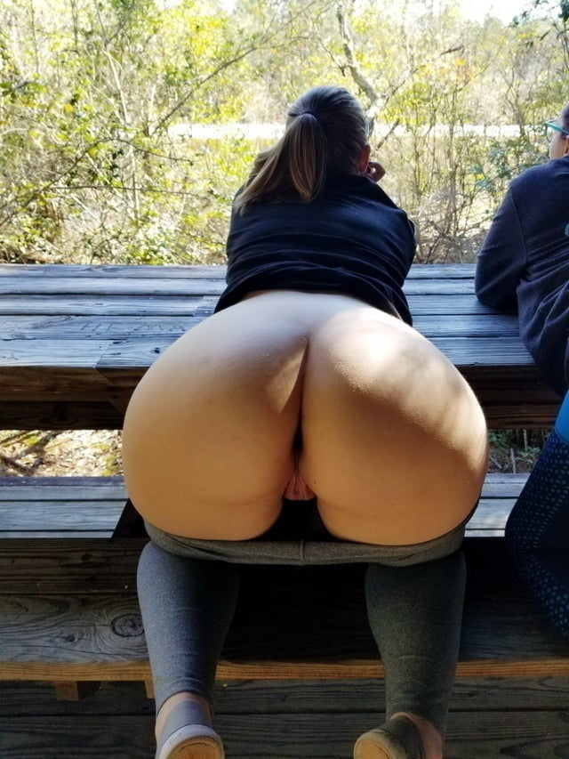

By the end of the day Kyle was spent, his mouth and jaw were so sore! He had licked so many assholes, so many pussies, given so many orgasms! He used mouthwash and cleaned his face over and over, but the stench, the odor of farts and pussy juice, it was embedded into his skin. He could feel a filmy build up in his throat that no matter how much he drank just would not go away! Every time he swallowed, it tasted like a mixture of every ass he had eaten that day!

He was very happy to know that this was his final client for the day. He could not wait for this to all be over! The final client was a modeling agency that has been using Stanley’s services for years. He had told Kyle about it during training, apparently, they called him in for different models all the time and paid very well.

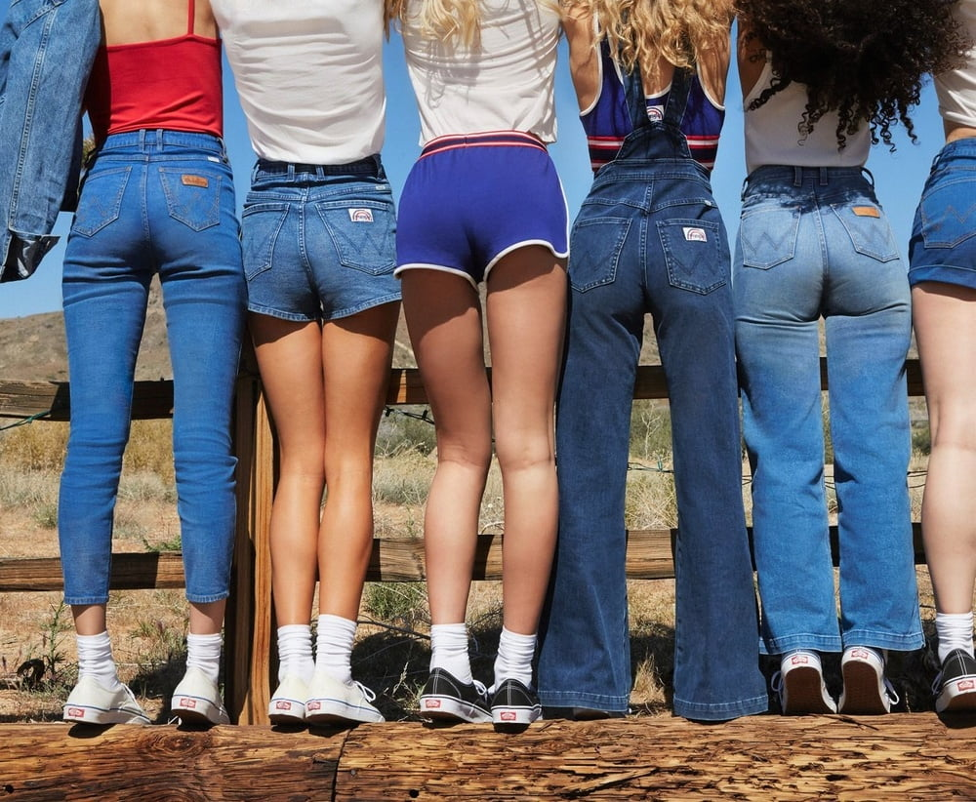

Kyle pulled up to the location he had been given, it was at a field beside a farmhouse. Several models were posing with their asses to the camera in an assortment of jeans and shorts while a large production crew of staff labored behind the camera. There was a lighting team, a makeup area with hairdressers, and all the like. At the back were several trailers, there were a few staff hanging out in front of one of them and smoking. There was a photographer and all sorts of staff around him, Kyle had no idea who to speak with.

Suddenly the photographer locked eyes with Kyle and began walking over…

“Are you, the guy?” he asked very carefully…

“The Doctor?” Kyle corrected him…

“Yes, of course, you’re the Doctor, the new guy, right? He asked very impatiently.

“Yea, that’s me” Kyle smiled as the photographer took a step back and began fanning his face. Suddenly Kyle realized he could smell the shit on his breath.

**CASSANDRA!”** The photographer yelled at the top of his lungs making Kyle jump. One of the models came running from the group and stood next to the photographer.



Kyle was a bit taken aback by the model! She was stunning, one of the most beautiful women he had ever seen in his entire life.

“This is the doctor who’s gonna help with your issue,” he said with a slight pause.

“It’s so nice to meet you, I’m Cassandra” she stuck out her hand to shake and Kyle met hers while smiling.

“I’m Kyle,” he responded.

“You two can use trailer number 4, we need her back in twenty minutes! **BE QUICK!”** the photographer demanded as he ran back to the camera.

“Here, follow me!” Cassandra said with a grin as she walked ahead of Kyle leading him to the trailer.

“Thank you so much for coming on such short notice! I have been having such a hard day, some of the other models said that you are a lifesaver for stomach issues, I just really hope I don’t gross you out, gawd, ahhh this is so embarrassing!” she laughed as she talked non stop. Kyle could not keep his eyes off her ass though. She was wearing a tight pair of denim jeans and even with her slim figure, she packed an amazing fat ass! The denim was wrapped over her cheeks barely able to contain them! It looked like the jeans were going to rip open at any moment!

Cassandra led him into the trailer and he closed the door behind them. She bent over and held her stomach with a look of pain on her face.

“Oh Gawd, this is so embarrassing, I have never farted in front of anyone before!” she laughed and blushed a bit.

“Haha it’s alright, just bend over and relax, we can figure out the issue quickly and get you back to work” Kyle smiled, happy that for once he was going to get off easy!

He watched as she walked over to a chair and bent over, holding onto the back end to support herself. Her fat ass cheeks popped out making them so much wider, the jeans were struggling to stay intact. He got onto his knees behind her, the odor of shit was already strong in the air. It was a thick musty smell, like rotting Chinese food or a dumpster that had been baking in the hot sun. Kyle could feel his eyes beginning to water as he turned away slightly to grab a bit of fresh air.

“Haha, are you alright back there?” she asked

Kyle was about to respond but his voice was cut off by a high-pitched whistling blast of gas! He could feel the burning heat of her gas even through the thick denim jeans!



Kyle wanted to die! The door was so bad, like onions being cut inside of his nose while someone blew an exhaust of fresh feces into his face! His eyes watered as he choked and coughed, trying to take in the gas! His vision began to spin and he had to rest his palms on the floor to keep himself from passing out.

“I told you it was bad! I’m so sorry!” Cassandra apologized with a nervous laugh as Kyle choked and gagged.

“It’s alright, I think that maybe” Kyle tried to speak but she cut him off again.

**“OOOH, I HAVE ANOTHER ONE!”** Cassandra pushed her ass out, the denim rubbing against his face and smothering his mouth cutting off his speech! Kyle tried to move away but he was too slow!

**BBBbbsspppprrppvvvvpppttttttttttt**

Kyle fell onto his back, his head was spinning from the odor of her gas! He rubbed his nose violently trying to get the smell off as his heart raced, he could feel himself about to vomit. His vision was hazy and took a moment to come back to him. When he could see again, Cassandra was above him, naked.

“I’m sorry, but I really can’t ruin these jeans! they are expensive and it will come out of my paycheque! I hope you understand!” Cassandra apologized while backing up and standing over him.



Kyle let out a cry as she squatted and smother his face with her ass! Her cheeks completely covered his face as his nose sank into her deep-set asshole! His mouth was completely covered by her wet pussy lips, completely cutting off any chance for air.

**“CASSANDRA!!!”** The photographer screamed at the top of his lungs!

“I promise I will make this quick!” she said while grunting!

**PART 5 COMING TOMORROW NIGHT**