A NORMAL DAY
COMMISSION STORY
BY CHALDEACHANGE
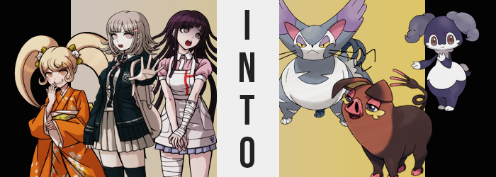

The Neo World Program.

A program designed by the Future Foundation that was meant to do something that had once been thought possible. To bring the living into a digital space where they could freely move around and do whatever they wanted. To maintain this world, which would be utterly indistinguishable from the real world if you already didn’t know better. There were numerous practical uses for such a program and if ever picked up by the right company could be used for endless entertainment.

But at this time the Neo World Program was both top secret and in use by the Foundation that had created it in the first place. It was being used for psychotherapy on the minds of some students of Hope’s Peak that had been led awry by Junko Enoshima… or at least that was supposed to be how it was used. Not only had remnants of her efforts infiltrated the system to set up a new ‘Killing Game’ within, but some extra data had been slipped in as well somehow.

From a video game of all things.

There was a singular individual that understood the true nature of the island resort that all of the students were trapped upon. Chiaki Nanami went by the title of Ultimate Gamer, but in truth? She was a digital construct of the Neo World Program meant to oversee it, designed in the likeness of a girl who had perished during the Hope’s Peak Incident. She knew the world was digital while the others didn’t. So she had seen it as her responsibility to try and make sure things turned out for the better.

…Even if Monokuma had put a hitch in the initial plans for the students.

“Why don’t you oink for me, pig!?”

“N-N-N-No…!”

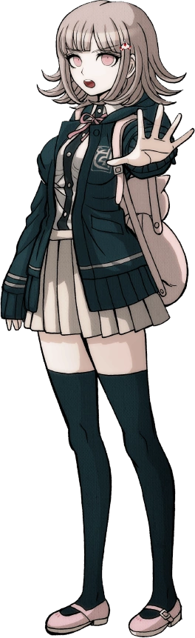
That included making certain that the students didn’t kill each other over petty reasons first. They’d already lost one. Nanami didn’t want to lose anymore. That was why this situation between Hiyoko Saionji and Mikan Tsumiki had caught her attention. Having hidden themselves along the beach, Hiyoko was bullying the poor nurse again. This could be a potential trigger for one of them to kill the other if left unchecked. Or so the AI had determined.

“Saionji-san… You don’t need to be so hard on Tsumiki-san.” By the time Nanami had made her presence known Mikan was already laying in the sand with Hiyoko’s petite body looming over her. It looked like Mikan had been pushed, but in all likelihood she had probably tripped all on her own and ended up in that position.

Hiyoko clearly didn’t take well to this interruption. She turned a little red and she sounded flustered as she barked out what she seemed to believe was a rebuttal. “Y-You! Mind your own business! Maybe you’re the pig then!” This really wasn’t the own that she seemed to think it was, but the moment that label had been thrown her way?

Chiaki felt strange.

Bloated? That was perhaps the word that was best used to describe the feeling. Like she’d just eaten a big meal, but it somehow could be felt throughout the entirety of her body and not just her tummy. She felt swollen, but she had put that all aside to try and calm Hiyoko down. “Saionji-san I’m not SNORT—!?” Out of the blue Chiaki had made a noise she never made. A loud snort had erupted from her nose and honestly? Her nose felt a little odd. Swollen, just like the rest of her body.

The AI had been willing to not think much of it if not for the growing look of horror on Mikan’s face and the growing look of humor on Hiyoko’s as they stared at her, neither saying anything and leaving the gamer to figure it out on her. “What…?” A hand slowly reached up to touch her nose and pink eyes went cross-eyed to try and examine her schnozzle. “SQUEAL!?” This sound bubbled up from the back of her throat and was a direct response to the information she had ultimately gathered about her nose.

It wasn’t the right shape nor color. She could see it and it was a bright, pinkish red. It must have occurred when she had snorted, but this nose was flat and scrunched up, having inherited a triangular shape while her nostrils were significantly longer and tilted to the sides. Like a pig. Her pink eyes darted around, colors changing to a plainer brown as she did so. This was a digital space so was something affecting her data!? It was no use – for some reason her authorization with the Neo World Program had been cut off.

“AHAHAHA!”

Hiyoko was laughing her ass off but it didn’t get under Chiaki’s skin. She was trying to weigh whether or not she should reveal the nature of this island to the other girls while her body’s changes continued without pause. You could see it in her complexion, skin darkening to brown beneath her chest while her face and upper torso was more of a dark orange shade. This skin was tougher in appearance and to the touch… like an animal’s hide.

There was the matter of the girl’s ears too. They had taken on the same orangey color as her face before transitioning to the brown at the tips, but the greater issue was the tips themselves. Slowly but surely her ears had grown larger, floppier, and more triangular in shape. They also moved so that they were up and closer to the back of her head, pointing forward and hanging above her eyes. The ears of a pig with yellow lining.

With the situation growing more dire, Chiaki decided to just rip the bandaid off and tell them that they were in a digital world. They might not believe her but it was better than nothing being done at all. And yet when she went to open her mouth? “OINK! OINK!” She couldn’t mouth human words. Partially it was because she couldn’t seem to remember how, but her lips and tongue also felt too swollen to speak properly. Oinking and snorting through her flat nose was all she could do!

“That’s right! Oink for me little piggy!”

“S-Saionji-san!”

Mikan had at least made an attempt to get the little rich girl to be a little more empathetic if not helpful, but Hiyoko continued to laugh her butt off. Chiaki’s transformation had begun to take a turn for the silly and she just couldn’t stop herself, not when she was watching the girl inflate. From Chiaki’s perspective it was like that swollen feeling she had endured had finally paid dividends. Her stomach and chest were both inflating, pushing against her clothes while her bra became unnecessary – her breasts were absorbed into this tanned hide mass until not even her nipples remained.

“OINK! SQUEAL!” Heavier and heavier she became, but her jaw also became unhinged for a moment before settling back into place. It felt like her face was pushing forward, and in a way it was. The tongue within her mouth became rough and long, teeth better suited for chewing plants. Eyelashes disappeared from the tops of pinkened eyelids while thick, yellow ones were fashioned on her lower eyelids. “SNORT!”

She was having problems standing on her legs by the time her neck had thickened so much that it was nearly indistinguishable from her torso. The strangest thing was that Chiaki had already determined she wasn’t becoming a regular pig. Seeing her hands, like her feet, harden into a pair of dark orange, cloven hooves before arms and legs shortened had triggered a recollection. Of a monster hunting game. Am I becoming an Oinkologne!?

Maybe it wasn’t all that surprising that she was a Pokémon expert.

With limbs shortened she was afforded no choice but to fall forward with a squeal. Her clothing had fit her uncomfortably with her hide so thick and round, but that burden was alleviated as the pig disappeared into her clothing, her body shrinking until she was only three feet tall. She’d been entirely hidden by a now oversized outfit, and when her piggish head finally emerged once more? It was entirely bald. Finally freeing her entire body, a curly tail with a three pronged end was also revealed.

She was completely an extremely feminine looking pig monster.

The Nanami AI was incapable of doing anything but oink and squeal as her plump body fumbled around on the sand in distress. Her human mind was still present, but it was at odds with her new body’s instincts as a Pokémon. How had that data ended up in the Neo World Program? How had it been applied to her own form!? These were questions that she just couldn’t ask because she couldn’t speak in a human tongue!

“N-N-Nanami-san! What happened to you!?” Of the two other girls present it was ultimately Mikan who had picked herself up and ran over to the Oinkologne. Unfamiliar with video games she didn’t really know what her peer had turned into aside from being a pig, but… A pig? She anxiously looked over at Hiyoko, who seemed to be enjoying this situation just a little too much. “D-Did you do this!? Y-Y-You called her a p-pig, and then…?”

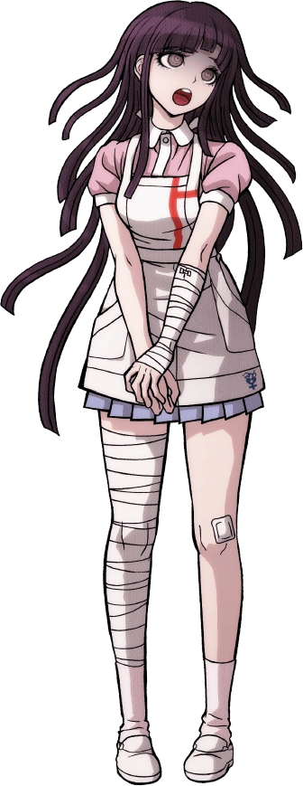
Could this have been her fate? Hiyoko had been calling her a pig first. So did Nanami save her? “O-Oh no!” She turned her attention back to the pig and gave it a hug, something that seemed to perplex the Pokémon. “Th-This happened to you because of me, s-so I’ll take care of you until w-w-we can change you back!” It was the right thing to do. Mikan might have been a little weird, but she never forgot her debts.

“BWAHAHA!” This declaration only made Hiyoko laugh louder though. She looked like she was going to keel over from laughter, not a single iota of empathy shown for what had happened to their classmate. “It’s not like I could do something like that! But really? You’re gonna take care of a pig!? Pfft! A pig’s servant! That’s just as funny as you actually being a pig!”

Mikan wanted to retort, but she just couldn’t. She couldn’t think of the words; this wasn’t her forte. But she also felt increasingly distracted. She felt a little unusual, like something deep down was changing. She felt really swollen around her tummy… and her butt… and her thighs? Why? Why did it—

RIIIIIIIIIP!

“Eep!?” The sound of cloth ripping and ultimately snapping overshadowed Hiyoko’s continued laughter, silencing her a moment as she observed the source: Mikan. One of her hands had reached behind her, patting down the back of her skirt because what had snapped was… her panties. Her face turned bright red, but she was also shocked. She could tell from just a few pats. Her ass was bigger!? It was pushing out behind her in a shape that was maybe a little too round. “…Urp!?”

…It wasn’t just her butt. Hiyoko’s laughter became even louder as she witnessed a confused Mikan bloating from the front, her skirt and top pushing forward as her tummy grew bigger and more bulbous. “Wh-What’s happening to deeeee!?” Was she becoming a pig like Chiaki? Was Hiyoko somehow doing this!? Both hands pushed down on her tummy. It was extremely soft and squishy. If not for her nurse’s apron then it might have been exposed, but it kept the front hidden.

In the back though? Her ass continued to grow larger and rounder. Both cheeks ultimately merged into each other so that there was no crack whatsoever, whereas her bellybutton was erased in the front. Yet for how round her lower half was becoming? Her chest and up remained narrow.

In fact maybe a little too narrow, as her breasts ultimately flattened away into naught with not a single nipple to show. Mikan’s shoulders pushed inward into they were almost level with her neck, presenting her with a very bizarre almost alien appearance. “Indee changing!? But—Ah!? Dee shrinking!?” She lamented not being able to keep up with her changes, but the bulbous shape of her lower half became less pressing of a concern now that her body’s height was dropping.

As her stature barreled down towards a meager 2’11”, making her around the same height as the Oinkologne that Chiaki had become, the coloration of her body began to differ. Her skin was adopting a very soft, almost velveteen aesthetic as its colors changes away from human pinks. Hands, feet, and much of her torso were bleached to a snow white. This included much of her face around the girl’s mouth and eyes.

But the rest of her body? Legs, lower torso, arms, and the top half of her head? The velvet-textured fur that sprouted was a very striking navy blue. These patterns elicited impressions of a maid perhaps with the white on her torso looking like an apron, but it was difficult to see with her old clothes and bandages still smothering her shorter body.

“I-Indeedee!?” By the time her head managed to poke back up through the neck hole of her pink top, it was clear that her humanity was on the way out. Not only was her head larger and rounder relative to her small and bulbous body shape, but her brown eyes were large and beady, her nose was seemingly absent, and her mouth was upturned into a cute smile with thin, black lips. A pair of pink markings could also be seen above her eyes.

Mikan wanted to ask Hiyoko for help but she couldn’t. The sounds she was making weren’t human, and try as she might she couldn’t seem to vocalize those human noises at all. Strangely though? The oinks that Chiaki were making were sounding more and more coherent, prompting her to look over to the pig now and again.

Not knowing what else to do, the tiny girl used her hands to pull off the rest of her body. But it was difficult. Her arms were extremely thin and only became thicker near her hands, which had been reduced to only a trio of white fingers. Standing felt odd too seeing as she was so round, and legs had shortened to only about five inches in length with feet that were almost like a cat’s paws with three short, rounded toes. “Indee…”

An instinct kicked in and Mikan’s brown eyes began to glow purple. Before she knew it, her old clothes peeled off of her and were added to the pile of Chiaki’s own. I-I have psychic powers!? That seemed to be the case! While using them though? Her hair had pulled up into two twin tails that ultimately hardened into a pair of downward pointing, dark grey horns that almost looked like croissants. Stripping herself had also revealed a fluffy tail above what now counted as her butt.

The Indeedee that had once been the Ultimate Nurse might as well have been the Ultimate Maid now. She was small and had a round lower half, but she was still humanoid unlike the Oinkalogne that had been watching her transformation with concern. “Indee? Indeedee!” It was strange though. Now that she was like this? Mikan could understand the pig’s oinking. Nanami was trying to explain what a Pokémon was to her, whereas the Indeedee has hobbled over to pet the pig in a comforting manner.

Mikan really wanted to be helpful. Nanami had stepped in for her and she wanted to repay that, but this wasn’t the full reasoning behind this desire to give aid. It just felt inherent and instinctive. Such was the nature of an Indeedee, who loved to serve and were sensitive to the emotions and intentions of others. Needless to say, she didn’t like the vibes Hiyoko was giving off.
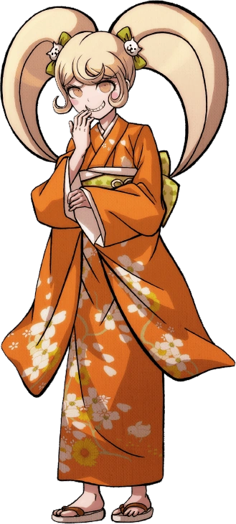
The kimono-clad teen hadn’t stopped laughing. From Hiyoko’s perspective yeah, something really weird was happening. But she’d just watched the girl who’d stepped in for that stupid Mikan turn into a pig! And then Mikan herself had turned into a weird little imp thing that couldn’t say anything that wasn’t a variation of ‘Indeedee’. “Bwahaha!” Snot was almost flying out of her nose she was laughing so hard!

“A stupid, fat pig and a bottom-heavy little gremlin thing! I can’t believe you both became fatasses HAHAHA!” She was probably deriving a little too much joy from their situations, both Pokémon now glaring at her from afar. Nanami almost wished that karma was real. “If I was that fat I’d just off myself!” Thankfully to both the Oinkalogne and Indeedee’s amusement?

Karma was real.

RIIIIIIIIIIIIIP!

“AH!?” Hiyoko’s own transformation wasn’t even afforded a warning sign before it began, the sleeves of the girl’s kimono tearing right off thanks to her shoulders, which had just pushed to almost double their width all of a sudden. This left her looking surreal, but only for a moment before weight begun to pool into the areas between them. It almost looked like her breasts were growing larger, the front of her orange kimono pushing out.

But the reality was that beneath the cloth? Her nipples were gone and her chest didn’t technically have breasts. It was pushing forward with a soft, chubby fat without the indentations of a bosom. It pushed forward and escaped the kimono’s folds, revealing beneath the cloth a soft layer of white fur that transitioned into grey around the neck. “N-NOOOO!?” For all the laughing she’d done at the other two girls, she certainly wasn’t laughing now.

There was so much weight in her upper half that the Japanese teen was immediately pushed down onto all fours, forcing her to accept the posture of a common animal long before Chiaki had during her own transformation. The arms that were pressed into the sand soon thickened so that they were bulky both with muscle and fat, rounding out the sides of her chest but also shortening… along with her legs which were changing in tandem.

“NYEOW!?” The cry she made was strangely cat-like, but considering the fluffy grey fur that was spreading around chubby arms and legs it didn’t really look all that out of place. White fur wrapped around her hands and toes which fused so that there were only three digits per tiny, shrunken paw, retractable claws growing uncomfortably so that the girl winced.

The Oinkologne and Indeedee made no effort to help even as Hiyoko’s kimono ripped more around her hips, which had flared out to give her a widened lower half to boot. After Hiyoko had done nothing but laugh at them, they saw no reason to give her a helping hand. They even laughed as a new appendage shot out of her body, a gray-furred tail that curled out several times at her rear.

Much of the dancer’s body was that of a very bulky feline by this juncture. Shoulders, chest, and hips were wide, and her torso thickened in kind – albeit it was still much narrower than the arms and legs that bookended it. A white band of extremely fluffy fur wrapped around the center of her body because, after all, she was becoming a Pokémon that was coveted for its fur.

Hiyoko couldn’t believe this! She wanted to cry! But she also felt tired. Like she wanted a little cat nap. “Mrrr….” Any attempts to speak in the human tongue amounted to cat sounds that suited her face with an increasing accuracy. Her nose had been pulled forward into a beady, black, and wet alternative, with her face being pulled into a snout in general. Her lips thinned and were upturned, hiding sharp teeth and a lengthened tongue with a rough texture. Perfect for grooming herself.

White fur grew over much of her face, though her cheeks and forehead saw grey grow instead – with zigzagged pairs of whiskers shooting out of those cheeks in question almost eight inches each. “MROW!?” A sharpening of the dancer’s vision provoked another cry. She would find that every little movement distracted her, and physically? Her eyes were now yellow with purple eyelids.

All that really remained of Hiyoko Saionji was her beautiful, blonde hair. It didn’t disappear, but with ears sliding up the sides of her head that hair began to fuse with them to give them a greater mass. Before long a pair of upright, feline ears took the place of all the hair on top of her head. They were very thick with gray bases and purple tips that had four unusual looking prongs each, while the insides of those ears were purple.

With her body shrinking down to three feet, her self-inflicted nightmare came to an end.

“MRRROW!?” Hiyoko didn’t exactly have a mirror nearby, but she didn’t need one to recognize the fate that had befallen her. Now that the Purugly was a Pokémon herself she could understand what the Oinkalogne and Indeedee were saying, the two snickering to each other about how she’d ‘eaten her own words and become a chubby monster herself’. Mikan had used her psychic powers to completely strip away whatever clothes remained on the feline.

Her feline body was both rotund and bulky. Despite being about the same size as the other two girls, she felt slow and heavy. The look on her face was stuck in an intimidating glare that didn’t seem to affect the other two whatsoever. “Mrrr…” And while Hiyoko should have felt extremely angry about all of this? She was a little irate, but more than anything she felt tired.

The Purugly was a cat at the end of the day and they could be notoriously lazy. She didn’t feel like making a fuss or even hissing over at the other two Pokémon that had already begun to talk about warning the others. That didn’t really matter to Hiyoko. Fine. Whatever. She was a fat cat, so what!? After pacing in a circle several time she curled into a ball and closed her eyes.

Maybe this was just a dream and when she woke up she’d be back to normal?

She wasn’t that lucky of course.

