YOR FUNERAL
MAY 2022 FIRST PERSON STORY
BY CHALDEACHANGE
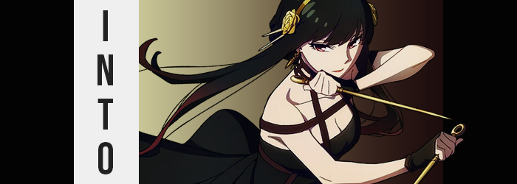

A new anime season was always exciting, but I couldn’t deny that there was some growing fatigue on my part. Not because I had any issues with watching anime or getting into new series, but because the seasons were constantly oversaturated with the same things season after season. Of course the most notorious of these genres was the isekai genre, which had become debatably pretentious despite how many times someone tried to put a new spin on the formula. But there was also always a plethora of idol shows and bizarre originals.

So, this season, it was nice to find a series that felt like a breath of fresh air among an otherwise stagnated process. SPY X FAMILY was taking the world of anime by storm, presenting a spy plot alongside cute family comedy moments thanks to the strewn together Forger family. Whether it was the badass fight scenes involving the father and mother, Loid and Yor, or the cute comedy moments provided by the esper daughter, Anya – there was just something for everyone to love on the surface level.

Even I was caught up in it, so much so that I had decided to read the manga after just a couple of episodes and had become entirely endeared to this fictitious family. It was consuming all of my spare time, all of my thoughts – it was an easy source of serotonin, really. If I was feeling a little down, I just watched a cute Anya scene or gushed over one other character.

“Man… Yor is so hot.” I wasn’t the one thinking it, the entire fandom was pretty much in agreement. If the fanart she received was any indication, most everyone had caught on. But there was one individual in my life that did not like that interpretation. A nekomata that had taken to the series just the same and had come to idolize the character of Yor so much that she took offense to anyone talking about her like she was a source of fanservice.

YOU THINK SHE’S SO HOT!? THERE’S MORE TO HER THAN THAT! YOU’LL SEE!

As I was viewing risqué images of the character in question, and as such had made that comment, the disembodied voice of what sounded like a child boomed inside of my brain. Of course, I only had one reaction to hearing her voice. “Oh no.”

The next I knew; I was standing in a room that was both unfamiliar and not at the exact same time. Familiar in the sense that I had seen it before, but unfamiliar in that I had never seen it from this point of view. After all, I had observed it in episode 3 of SPY X FAMILY when Yor had moved into the Forger home. Because this was Yor’s room. “Oh, great. I’ve been spirited away to face God knows what.” I stopped short of saying ‘again’, because while I was acting nonchalant about it, like this had happened before…

I couldn’t remember such a thing ever having happened before.

And that made me anxious more than anything, for my understanding of the situation began to degrade more and more the more I thought about it. “Wait… How did I get here!?” I had completely forgotten the answer I had originally known. Panic had beset me even though, from my point of view, it absolutely shouldn’t have done so whatsoever just moments ago. Had my mind been tampered with? Could minds me tampered with? Again, it almost felt like I would have believed that for a time, but…

I was so disoriented that I was missing some key takeaways and clues about what was actually unfolding – primarily regarding my body of all things. I had been subjected to transformations at the nekomata’s hands before, but she had successfully duped me by erasing those specific memories so that the transformation would be all the more entertaining for her in the end.

And so the relatively sharp drop down to the height of five foot seven took me by just as much surprise as it would have had it been my first time. “Huh!?” My sense of balance felt like it had been compromised, and so I had thrown my arms out to prevent myself from falling like it felt like I was. Yet with feet planted firmly on the floor, there was no way that this could have been possible, technically.

“Did I just get… smaller? Small… er? Um…?” What had been that unusual crack in my voice? It had left it sounding temporarily higher and softer for but a single word before returning to normal. But that wasn’t the last I would hear of that voice, either. It almost sounded familiar? Why wouldn’t my own voice sound familiar, though…? “But that wasn’t my voice!” Nor had that been something I should have thought, aware of myself as I was.

I certainly hadn’t been wrong about the fact that I had gotten smaller. From my shirt feeling looser to my pants pooling around my ankles, there were obvious signs of this fact. But there was an underlying loss that I hadn’t quite grasped – although it could also be considered a gain depending on how you looked at it. It was that all of the excess weight had drained from my flesh and bone, taking me from a man that was quite hefty despite his height, and fashioning me into one who had become trim.

Not only trim, but muscular as it appeared. My stomach had hardened into a six-pack, and you could make out that they were protruding around my arms and legs. They weren’t so abundant that they were ugly, and there was still a smoothness to my skin that… Wait. Men didn’t typically have skin that smooth, did they? Its color seemed richer and creamer, too, and all of the extra hair on my arms, legs, and torso? If it wasn’t gone outright, any that should have been there had been shaved away.

“Let’s think about this. I was spirited away to Loid’s home, but this is my home now too, isn’t it? Er… No, what am I saying? Um…?” The voice had returned, but this time it was spouting things that didn’t align with what I could remember. Wasn’t this a room out an anime? An anime is the kind of show that Miss Anya watches, isn’t it? If only Yuri and I had— “What is happening to me!?” The things I was thinking and saying sounded like things a certain character would think or say, but subconsciously I was too fearful of drawing that line.

Because I was worried, deep down, that my mind would question how I could possibly be anyone else.

Even if I wanted to deny it, that didn’t change that it was a reality that was growing increasingly apparent. Observing my hair, you could easily see how the locks were not only darkening to black but had begun to look shaggier as their lengths increased. Farther and farther behind me they cascaded, eventually stopping halfway down my back in softer, silkier forms that contributed to the fact that I was looking more and more feminine.

The sound of my voice had already confirmed the fact that I was becoming a woman, truly, and my longer hair and shorter stature had merely contributed to it. By the time change had rolled around to my face, on the other hand, it had become all but blatant. A tingling possessed my lips briefly as they had both swollen and widened, taking on a redder color than they held normally, while on the whole my face became longer, fairer, and prettier. Like a beautiful woman’s. One who possessed narrower, crimson eyes and fluttering lashes.

“If I put two and two together… um… like two corpses…?” Communicated through my plumper lips now, my voice seemed stuck in the soft and high, and as I frantically tried to understand what was happening to me I found myself making darker and darker analogies and comparisons. I had a growing fixation with murder and death, one not even I had noticed because, well, mentally I had passed the 50% mark of what was me and what would be the new me. That is to say, what would be Yor Forger, the assassin.

The feminization process continued, although I was hardly fit to pay it much mind any longer. Rather than thinking it was weird, my mind was at the point of thinking any remnants of my old form were strange. Like why were my fingers so short and neatly cut? It didn’t really matter, because both areas grew longer before my very eyes, and I didn’t even question it. The same could have been said of my feet, which had shrunken within my socks.

“Ah!?” I almost fell again, this time because there had been a sharp jolting sensation in my lower body. My hips had been yanked wider, and as a direct result my knees had been forced to point in towards one another. The ample gap that had been left between them, my pants still holding on to widened hips, was ultimately filled in with an encroaching weight, however. They grew thicker and tenderer, disguising some of the raw muscle that had developed there in their newfound shapeliness.

And for a moment it had been very uncomfortable. I had bitten my lower lip because not only were my swollen thighs pinching my dick between them, but my ass had also swelled into a peach shape behind me – tightening my boxers and grinding them against said dick at the same time. Fortunately for me, this comfort was only passing, and I breathed a sigh of relief as my dick, well… Became not a dick, and I could properly call myself a woman without any doubt. With a cute little bush of black above it!

Not that I was at the point of doubting my sex anyways.

“So if I were to cut someone into little ribbons, then…” Evidently, I had gotten really into some thoughts about murder thanks to my attempt to process my transformation, and now my thighs were rubbing together as I thoughtfully considered the best way to kill my next target. My cheeks were so pink at the thought of it! Though it would be a pain to wash the blood off of everything as always…

I was so caught up in these thoughts, in fact, that the final changes that ultimately transformed my torso passed without me batting even an eyelash. That included the sides of my tummy pinching in to bless me with a curvier gait. But it also included the eruption that saw my flat and muscular chest soften and swell, pushing out and up my t-shirt so that my attractive tummy was on full display – while a pair of perky, youthful, DD breasts stood proudly upon my chest.
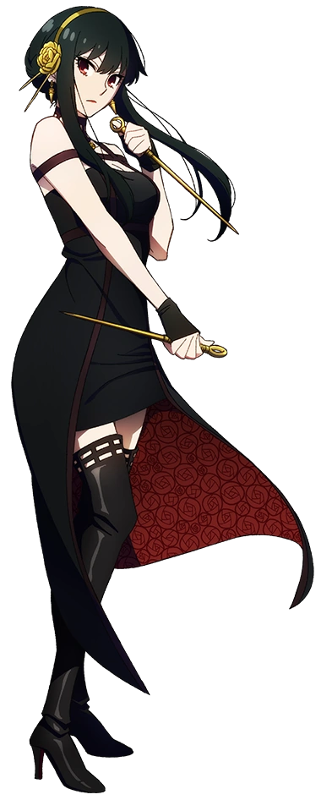
Physically there was little doubt that I was Yor Forger. And mentally there was little doubt as well. I couldn’t remember much other than having to pursue the life of an assassin to provide for my little brother and I. Although because of Loid, I was now technically marrier? And I had a cute, little daughter as well! …Even though I always felt insufficient. I didn’t know the first thing about raising a child…

Wasn’t I forgetting something else, though? “Oh! I can worry about that later! Since Loid and Miss Anya are out, I should get changed and go take out that target…” It was pretty late, but my ‘husband’ and ‘daughter’ were at a children’s birthday party. Which had worked out since I had just received new orders earlier that day. “I can’t go dressed like this, though! When did I put these on…?” None of the clothes I was wearing fit at all! Weren’t they fashioned for a man?

Not that it took me all that long to strip down into a nude and put on the dress that was synonymous with my moniker, the Thorn Princess. But even just wearing my favorite dress left me feeling rather excited.

Nothing riled me up like a good killing.

