LOYAL SERVICE
BIWEEKLY STORY #87
BY CHALDEACHANGE
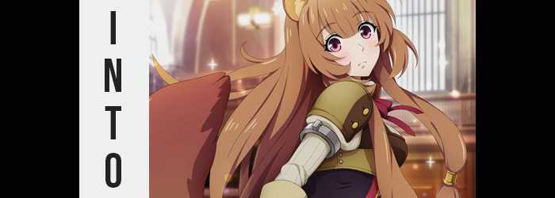

The Rising of the Shield Hero was a popular series in some circles, but in a sea of isekai properties I couldn’t really say that it had ever stood out to me personally. I had seen a little of season one, and that was about it. Not to say that it was bad or anything like that, but when you reach a certain point in your life you don’t have the free time to consume every anime airing – you need to pick and choose between the ones that stand out to you.

It was a series that was essentially set around the adventurers of the titular Shield Hero, Naofumi, who was stolen away to a fantasy land and deemed what was considered the lowest and most useless hero of them all. He would struggle against the societal norms of this fantasy realm and turn what it meant to be considered the Shield Hero on its head through a series of badass encounters, and the accumulation of a party of women that were both cute and attractive.

Had I the time to get into it, maybe I would have. And I had expressed as much in an internet post a few weeks ago. That was why I was surprised to find it on my doorstep. A package from another user on Reddit named ‘twotailedcatgirl’ that I had never interacted with. Why had they sent me a package? How had they gotten my address? Even after sending them a few DMs about it, all I had gotten in response was “just open it ;)” which really wasn’t any less suspicious.

“It has to be harmless, right?” The box was pretty light, but when I shook it around there was definitely something inside. Had it been a bomb or drugs or something, the postal service would have caught it too. Without any way to confirm the mystery short of doing so, I finally opened it with a pair of scissors and took a gander in size. What I found inside was, well… “Cosplay accessories?”

That definitely appeared to be the case. From rounded, fuzzy ears on a headband to a fake, fluffy, brown tail that looked like it attached onto a belt, there were items in the box that looked suited to a costume. What kind of costume? Maybe something a furry would wear, or some kind of anime character…? “Wait, Raphtalia?” It took me a second, but after remembering twotailedcatgirl had only interacted with me over a The Rising of the Shield Hero post, that name popped into mind.

Raphtalia was the main heroine of the series. A slave girl of the tanuki race that Naofumi saved. I hadn’t gotten super far into the series, but I wouldn’t have been surprised if she had a crush on him or something. “If they wanted me to get into the series, wouldn’t sending my a bluray set or something be more productive?” I was honestly left scratching my head. What was I supposed to do with cosplay gear that was designed for a character that was a woman? Maybe I could just return it to the sender?

As I turned to go back to my computer to print a return slip, though? I paused. What was this weight on my head, much less behind me? “Huh!?” Hands, exploring, found the headband on my head and the tail attached to my pants. How had those gotten there? The box was empty too, so I wasn’t feeling things. “Did I put these on without realizing? That can’t be it, right?”

There’s no way I put them on without- “OW!?”

Any concerns I’d had about how those accessories had ended up on my body were very quickly overwritten by a set of sharp pains I’d felt that had prompted one of my hands up to the ears, while another to the tail just above my butt. It felt like something had sharply dug into my skin, and upon examination? “What the hell!?” That was exactly what had happened. The headband the ears had been on were gone, as was the loose base of the tanuki tail. Instead, all of the features were stuck to my body.

And slowly but surely? I could feel them. Blood and warmth traveled from my body into these new body-parts, bringing with them the sensation that they were very much a part of my body. More unsettling was the fact that they began to move, with the tail swishing back and forth, and the ears twitching. Of course I could hear through them, and they were much better at hearing than my regular pair.

“This is impossible. Why are they stuck to me? That’s not…” A thing that could happen? Yeah, but it had. More was transpiring than I had even realized at that very moment, with the brown of the fur these new parts sported seeping not only into the hair atop my head, but the hair of my loins and brows as well. In the case of the hair on my head, it all began to grow at an alarming speed. Growing fluffier, locks cascaded down by back while layer of it framed my face and fell down past the front of my shoulders.

“My hair is… Crud! What is happening here!?” I’d intended on swearing there, but a less crude word was ultimately blurted out in its place. Nonetheless it didn’t take away from how panicked I felt, as my hands ran through the long, light brown hair that had fallen in front of me. The length of this hair on the sides had masked that my human ears had disappeared, and even the fingers that ran through the hair itself had begun to look off.

Perhaps ‘feminine’ was a better word? The more they ran through my hair, the smaller my hands became. Gradually, the nails upon them lengthened slightly, and the overall look of my fingers was much fairer. Mind you, this was happening with my feet at the exact same time, with heels rounding and softening as toes became smaller. Both my hands and feet at their new size probably would have looked out of place on my old height, and yet…

“Eep!?” I was just as bewildered by the girlish cry that had jumped from my lips as I was the sensation that had caused it. The feeling of my body’s height unraveling at an alarming speed, as the t-shirt and sweatpants I was wearing quickly became far too large for me. I had dropped all of the way down to 5’3”, and I had also, miraculously, become thinner. Not typically the fittest of fellows, everything from my belly to the excess weight on my limbs had thinned. And in their place? Some degree of muscle tone had been forged instead.

I blinked, unaware of the fact that my eyes had turned a pinkish-red in the process – and had likewise seen the lashes upon them grow longer. This was ultimately part of a larger trend that saw my face reconfigure into an appearance befitting of a beautiful young lady, with eyes that were big and expressive, a nose that was as cute as a button, and lips that were pleasantly plump in their definition. “Why is this…? I’m not becoming Raphtalia, am I?”

Where had all of my panic gone? I felt much calmer now, and that was something that was conveyed through a voice that was, well, identical to that of Erica Mendez’s English portrayal of the character. I gulped, because this of course meant becoming a girl. Not that the warning signs weren’t already there.

After all, my sweatpants hadn’t fallen from my hips after I’d shrunk because my hips themselves had been forced to accommodate with a new gait. They’d widened and just barely caught the waistband of my lower wear, while the area both directly behind and below them soon found new bloat. My thighs thickened with tender meat that pulled the skin tight around them, yet there was still a sizable gap left between them in the end – not that my loose boxers left that very visible.

On the other hand, my rear end swelled plump and perky, like a fresh fruit ripe for plucking. It left my boxers feeling tighter in the back, which in turn ultimately pulled the front of them against my dick – an uncomfortable feeling to say the least, albeit one that only lingered temporarily. “N-No! Not that! Not my…” My cheeks turned strangely rosy as I thought about what was happening to my dick, but I didn’t even try to stop it because wouldn’t that be too indecent? Not that I would have been able to stop it even if I’d tried, and before long I had a pussy housed beneath a small bush of the same brown that the rest of my hair was colored.

“Okay… so I’m a girl. A girl with animal ears and an animal tail…” I attempted to compose myself once more, trying to ignore the feeling of my body completing its final adjustments. Among which included the sloping of the sides of my tummy to curve more naturally into the lines of my hips. I pursed my lips, unsure of even how to proceed if I was correct. I didn’t even feel like myself, with the tanuki’s personality shining through over my own.

In the end, I hardly even batted an eyelash as the front of my t-shirt pushed forward once more. Yet while it had initially done so around my belly, it was my chest where the bloating emerged in this case. Two breasts, not particularly big in size, protruded from a chest that had moments ago been entirely flat. Of course my nipples had swollen too, but since I was neither cold nor aroused they remained soft and withdrawn. “And now I have breasts…”

I really wasn’t sure what to make of this. In terms of body and personality, I could only assume I was identical to Raphtalia from The Rising of the Shield Hero. The way my fluffy tail moved about, the weight of a girl’s breasts upon my chest; it was all as authentic as the twitching of my tanuki ears. But my memories? They hadn’t changed. I could still remember being my old self, as well as everything about that old life. My room hadn’t exactly changed, either. Which left me with a big question.
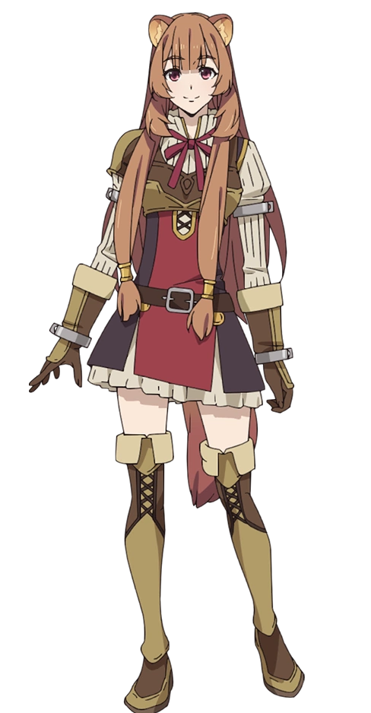
“What… Am I supposed to do now?” I wasn’t who I used to be, and that was troublesome enough. It wasn’t like I had any clothes that would fit a girl, and I’d have to go out and buy some, much less tell my family. But the bigger issue? Was that I wasn’t human. I had animal ears and a tail, so how was I going to blend into society? Always wear a hat and a super big skirt? At least I was cute, though? You could never fault anyone for being cute!

…Unless being a cute tanuki girl resulted in me being the center of some mad science experiments, in which case I would undoubtedly curse this form for the rest of my life.

Since I didn’t really know much about Raphtalia and wondering if her sizes were posted for when I went to the clothing store, I clumsily slid onto my computer to search her Wiki. Which was harder than you might think because there was no comfortable way to sit on my chair without my tail getting in the way. I managed to get to the Shield Hero wiki, but the page for Naofumi suddenly caught my attention. And for some reason I couldn’t stop looking at it!

“Ah, Naofumi-san…”

…Crap.

That part of her personality was there too, huh?

