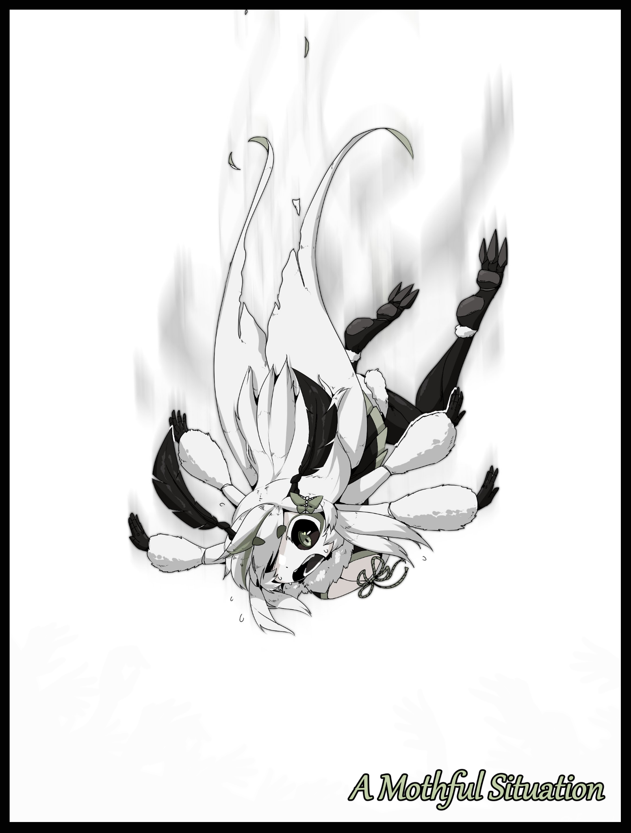

Torrential rain falls upon the darkened cityscape. Pattering against glass and cracking against concrete while drowning out the bustle of overwhelming traffic and the frantic hubbub of large swathes of humans rushing to and fro, shoving past each other to seek better shelter their meager umbrellas could not provide against the unforgiving shower.

What was supposed to have been a crystal clear, pleasant Saturday evening had unexpectedly turned sour. With rainfall thick enough to obscure anyone's vision and a biting chill, it seemed unlikely that anyone's evening plans would be continuing. And with the weather going from bad to worse, the last day of the weekend seemed at risk of being blanketed in gray clouds and endless rain.

While the streets rapidly emptied themselves of activity, a man dressed in dapper attire strolls calmly past the dwindling crowd moving in the opposite direction. With nothing to shelter him, the gaunt figure was drenched from head to toe, eliciting cartoonist squeaks as his waterlogged socks squashes underfoot, each step flooding the overly humid interior of his shoes with rancid sweat mixed runoff that would no doubt be a perfect haven for mold to grow in if left unattended. While the man's brash behavior was certainly questionable, no one seemed willing to approach the sullen fool when his despair stricken face seemed ready to engulf anyone unfortunate enough to bear witness to it up close.

From his choice of clothing, it was easy to guess he was either headed to or from an important event. Maybe a company dinner or a social gathering involving the elites of society, either way, one only needed to take a single glance at his overall mood to realize it didn't work out. The aforementioned look of the dead on his face, drooping shoulders, a slouch to his posture and an awkward gait that made each heavy step forward look as if he didn't even have the strength to will his legs forward. All of it was made worse by the fact that he didn't have an umbrella on his person despite the terrible weather.

But it wasn't a failed corporate meeting that ended with his resignation or a meetup with friends gone wrong. While it was something closer in vein to the latter, the incident that had left the man shaken was something almost everyone could agree should never happen to anyone at all; a broken relationship.

He'd been dumped by the one person he thought would never leave him…and there was no second chance to mend the cracks that had formed beneath his notice until it was too late.

Born ***Brian Lemmings***, the man had a rocky start to his childhood as the boy that couldn't seem to make friends. Always being the one without a partner and the one that would get picked on without fail. But the boy had smarts, and at so young an age, such a gift was also a liability. A double edged sword in the truest sense when he inevitably began to develop a debilitating view of the world around him that would stick for the rest of his life.

The bleakest outlook in every scenario was his normal. Because if you were always expecting to be disappointed and left hanging, then the worst one could feel when the inevitable eventually arrived was…nothing. That was Brian's mindset in everything he did. His parents and teachers encouragement fell on deaf ears while classmates goading continued to push that mentality. All except one who constantly stuck by his side since his first year at high school. A curious redhead with the name of Emilia.

It was about midway through the first semester when he first met her while walking down the corridor to the canteen, exchanging the briefest of glances when they passed each other by. And then once again during a project that demanded at least two people work together. Left without anyone else to pick from, the two outcasts had been forced to make contact that day.

He could still remember the surprise when he heard Emilia was a social outcast much like he was. But unlike him, her attitude to life was one of hope. The two exchanged their contrasting viewpoints, laughing when both found faults in each other's principals. While Emilia saw his pessimism as a detriment in the long run, Brian scoffed at her 'Light At The End of The Tunnel' mentality, arguing that it was better to just keep it all toned down and in check so one wouldn't be hurt in the end.

**"But then you'd just be hurting yourself all the way!"**

**"Nuh uh, can't get or be hurt if you never feel down in the first place…"**

From there, the two would maintain constant contact over the course of their highschool life well after the project's end. And although Brian got some flak for being seen with Emilia who the girls branded an 'attention seeking bitch' because of her red hair, the young man simply brushed it off, using it as proof of his ongoing banter with Emilia, his first and only friend.

**"See? Can't get hurt like-ow!"**

**"That's not pessimism, that's just ignorance…"**

From there it was a blur of memories, scenes that were currently playing like a rustic slideshow in an older Brian's mind while his body continued pushing through the rain on autopilot. He remembered having lunch with Emilia at the gardens, the climactic point in their relationship that culminated in a confession from Brian and their first kiss in the same lab where a school project had brought them together.

He thought himself lucky that day, that someone else could find comfort in a pessimist like him. But little did he know that life wasn't that easy to cross without its share of pitfalls and steep hurdles.

It must've been some point when their paths diverged after highschool. While the two still remained in contact over the phone, a physical separation was the trigger that ultimately led to the fracturing of the bond between them. While Emilia met with new friends in art school after being empowered by her time in highschool, Brian spent his alone working on grueling homework expected of a business student, digging himself deeper into a pit of self deprecation and isolation, spending less and less time calling and answering his girlfriend's concerned calls and more time brooding about what impossible task laid ahead of him. After just a handful of years growing accustomed to Emilia's presence by his side, not having her close at hand was devastating to his psyche. Serving to reinforce his prior beliefs even further, convincing him that deep down inside he was still the same weak brat who should just mind his own business.

By the time the two met up again during summer break, Brian had been irrevocably changed, set on a path of self destruction despite the facade of his old self he tried to put on, made less effective by the sickly pallor of his skin and the heavy bags under his sunken eyes. And the more he looked at Emilia, who still had that radiant smile and lively air about her. The exhaustion simply kept growing.

But Emilia wasn't one to be fooled so easily, and so by the end of their 'date', she prods Brian for answers, gaining nothing in response besides an insincere **"It's all good…"** followed up by an equally hollow farewell and good wishes. It left her stumped when she realized just how much Brian had changed in the span of a few months…not like her oblivious boyfriend knew it when he was too absorbed in his mental gymnastics planning out next week's schedule to meet deadlines in preparation for crunch and last minute disruptions.

Stepping off the beaten path into the nearby park in the present, uncaring of the viscous mud sticking to his polished shoes. Brian wasn't too surprised as his mental flash forward through time reminds him of everything he had done to Emilia in the time since their departure after that failure of a reunion; missing many of her calls and messages and only ever replying with monotone statements, being a cold husk on the few outings the two had with little effort made to reciprocate Emilia's attempts to cheer him up and remind him of their relationship. Whether Emilia simply had enough of him or his ineptitude towards upholding his responsibilities as her boyfriend, he knew the fault laid squarely on him when she would eventually come forth and call it quits.

But as much as he planned for the worst, it was only then did he realize that he never really saw the worst outcome for his relationship with Emilia. He didn't even read the dissatisfied tone in his ex's voice when she had called him out soon after both were done with their education, with Brian having landed a well paying job at a banking firm while Emilia had become a well known name as an influential artist. Not like that mattered much when they were simply two estranged lovers who never quite hit it off with each other; a strenuous relationship that was doomed to fail the moment their paths diverged.

It was too late to do anything but reminisce and regret. While Emilia had parted with a conflicted frown on her face, Brian was roiling with inner turmoil. So much so that his external senses had been dulled and blocked out, remaining ignorant to the deathly chill permeating his bones the longer he exposed himself to the elements. Already his undershirt looked more like a semi transparent sheet of plastic than it did fabric and a noticeable tremor was rocking him hard as a result of the potentially fatal temperature his body was reaching. But the threat of collapse didn't seem to faze Brian one bit. If he was aware of the concept at all, he didn't show it in his stubborn demeanor, trudging on through the thicket and coarse tree trunks as if he couldn't see them at all, bumping his broad shoulders against unmoving bark while smacking his clueless face against low hanging branches.

But while the devastated man continues to beat himself up over his emotions, the dark of night and the strengthening downpour begins to make navigation difficult. With slippery roads and a curtain of rain that worsens visibility, it was already going to be a pain in the ass for regular folk to get where they wanted to safely. So imagine what would happen if a depressed individual wallowing in a maelstrom of his own making started bumbling all over the place with little to no awareness of his surroundings? Nothing good obviously…

Beneath the notice of all but a select few individuals however, the forest reserve in the center of the city was one of the last few locations on Earth that contained a portal to an alternate world existing side by side with ours. While humans reigned supreme on this end, creatures from the realms of fantasy and imagination roamed the other. From nightmarish daemons of the underworld to the noble elves that called the woods their home, it was a safe haven for the supernatural and surreal.

The portal in the city's well maintained forest led to a domain for the mischievous Fae, maintained on both ends by secretive members of the city Council and guardians that kept watch over their end of the hidden passageway between space and time. While the tiny, imp like creatures bore similarities to their Fairy cousins, they held a side to them that their more light hearted kin were strangers to.

A temper, and on the contrary to their fickle hearts and mischief addled minds, the Fae hated negativity more than anything else. Simply sensing it in the air was enough to rile them up, and as Brian unwittingly continued on his endless path toward the portal, the negative energy radiating off of him was like a suffocating miasma, one only the spiritually attuned could sense, instantly alerting the Fae on the other side to the strangers approach.

Knowing nothing, they could only assume the worst; that there was an invader coming to take advantage of their home. Never before had they sensed darkness of this magnitude, not in a long, long time, but they wouldn't simply back down and let its source taint their home.

Despite their diminutive stature, the Fae commanded powers far greater than most other magically imbued races, surpassing the healing ability of their Fairy kin when each individual Fae had the mastery to manipulate the fabric of reality itself. And when they all came together, their power was absolute. While they waited for the would-be intruder to come closer, the small creatures bickered amongst themselves, arguing about what they each thought would be a fitting fate for the unfortunate human should he cross the boundary. A tree one quipped, while another joked about the imps needing one new member to give them a hand. Until a female Fae puts forth an enticing idea in that strange language of theirs that had the motley crew nodding their heads in agreement. Roughly translated, it meant;

**"Why not make another Moth person? They're always happy! And they always make such pretty clothes from their silk…and it's been awhile since we last heard one sing right? That would certainly help liven up the forest, wouldn't it?"**

With the finalization of their plan, the excited Fae take their positions around the rare fairy ring that serves as the gateway between worlds. Normally they were considered a simple natural occurrence in the form of mushrooms growing in a circle, often associated with folklore, bearing ill omens and signs of witchcraft that gave them their peculiar name. Although on this particularly stormy night where the link between realms were at their strongest, such a description was suitably fitting for anyone that wasn't on the Fae's incredibly small checklist of visitors that were free to come and go. People like Brian for instance, who was less than a few steps away from the fairy ring situated in the middle of a clearing in the woods. Still stuck wallowing away in misery, unaware of the fate he would ultimately consign himself to the instant his right leg enters the circle.

In an instant, the rain stops and nauseating rays of sunlight beats down on the shivering man, blinding him for a moment and finally providing enough external stimuli to jump start his reflexes as he moves his lead laden arms out of the way to stare at the impossible scenery around him; cyan green skies framed on all sides by towering trees with luminescent branches that were far larger than the man made structures that should've been there, towering over him in the distance with alien creatures sporting four wings strafing the clouds.

But Brian wouldn't have much time to ponder over the impossibility of such a thing and whether or not this was some hallucination as a large quad jawed worm rises silently behind him, forming itself from strands of silver string emerging from the blades of vibrant grass carpeting the forest floor with its flesh colored innards oozing a saliva like fluid that drips from its flapping maw and pools on the ground, emanating a strong honey like scent that instantly captures the attention of Brian's runny nose but not his dullard mind, still staring a thousand yard stare off into the heavens even as the shadow of the worm falls over him before the lumpy thing falls, swallowing Brian whole without much resistance as the surrounding Fey emerge from hiding with a round of applause for capturing the foul human. Simply ensnaring Brian in a cocoon of silk however, was not enough. Even now as the worm tightens itself around the unmoving human to conform to his silhouette, the negative energy he bore in his very being was beginning to taint the air around them. If left alone for too long, the Fae would soon find themselves driven mad, an unacceptable outcome.

And so they would begin the process of purifying Brian, stringing his cocoon high up into the branches of one of the massive trees above them with the intent of uplifting him from the metaphorical bog his soul was entrenched in by remaking everything about him from the ground up. Once they were done though, the human would be irrevocably changed for the better, whether he liked it or not, undergoing a metamorphosis within his fleshy prison as the deliciously sweet syrup within works to melt away his ruined clothing and shoes before pooling around his bare skin, soaking into the pores and fusing with his flesh, reshaping it into something more as the Fae's tried and true transfiguration magic directs the living goop, bleaching Brian's khaki tinted hide a snow white coloration with gunmetal grays along the length of his arms and legs while hair follicles vanish altogether, removing any rough blemish to the pristine layer of skin wrapped taut around rapidly slimming limbs losing most of the flabby mass the overexerted paper boy had gained after years of a repetitious routine involving sitting still in front of a computer or a book for hours on end. But there was more to the changes going on beneath the surface than just a luxurious moisturizer bath as Brian would soon find out…if he could be bothered to even notice his 'skin' was now tougher than titanium while remaining soft and enticingly plump to the touch, sporting barely visible segmented gaps near the joints of his limbs and other mobile portions that allowed for ease of movement…much like the shell of an insect worked to allow the critters the terrifying mobility they were known for.

Since his capture, the man hadn't bothered to move an inch despite the disgusting humidity and slimy walls pressing against his body. Even when his expensive suit, smartphone and wallet were all digested into muck, the faintest sign of a response was a dejected sigh. As if he was sick and tired of it all. Who cared if he really was about to die in the belly of a monster or if this was some lucid dream he was having while his unconscious body goes cold out under the rain? His life was a sham and his loved ones were either far out of reach or gone forever.

With Brian's resolve for apathy firmly set in mind, the proceeding changes were free to ravage his body without resistance as the goop digests useless extremities in a morbid display that would make a grown man squeamish while realigning nerves and accelerating muscle growth to fit the new structure the goop was supplanting Brian's meager human form with. Branching new fur covered limbs that extend into clawed talons just above his shoulder bones while said skeleton begins to reform, liquefying beneath hardened skin to hide the putrefying mess of calcium and flesh that flows like jelly, sticking fast to the new exoskeleton shaped in the form of a highly attractive female as sensitive nerves and hyperactive glands layer themselves around globular, perky masses protruding off the front where a portly chest once was, cupped at the base by chitinous material to form pert breasts that droop ever so slightly down a toned navel framed by broad hips with a noticeable curve highlighting the subtle rise of a womanly belly before sloping down gently towards a freshly opened slit lined with fleshy labia oozing a mixture of bitter cum and other melted unmentionables down slowly inflating thighs connected to more of the dark chitin that made up the entirety of Brian's curvy calves and triple jointed feet fashioned after heels to mask their inhuman nature.

By now however, even an idle mind like Brian's would have grown curious by what was happening, taking slow cursory glances in the darkness just in time to view a fuzzy coat of miniscule scales shaped and linked together to give the appearance of fine fur flowing around his neck and altered arms in strange locations, flexing clawed digits in deflated wonderment before noticing the presence of sensitive breasts hanging off his chest, tipped with pale purple nipples that stood out, swollen, erect and dripping with more of the ooze falling down all around him, working to spread and finalize the changes that had gone unnoticed all this time. Changes made noticeable by a gaping void between slick thighs, the trouble of moving his own two limbs when an extra pair kept interfering, a softened fringe that likewise, was no longer truly hair but scaly extensions mimicking the former mammalian traits he had clearly lost at some point or another during his brief moment in limbo.

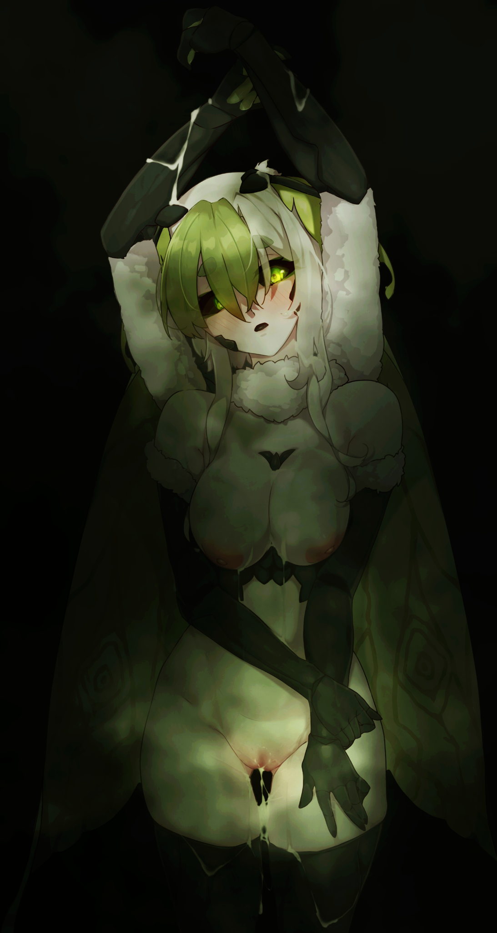

Normally, people in Brian's situation would have begged their captors to undo the changes and free them from their ovoid prison, but Brian felt no such fear. Thanks to the Fae's magic, emotional outbursts from their victims were suppressed, leaving him feeling a strange weightlessness akin to an out of body experience and a sense of comforting peace that sedates his brain, encouraging him to remain still and accept the changes. All while his rocky ass finishes bloating into a hearty bubble butt while leathery wings coated in silken powder droops down over an arched back, powerful joints masked by a new head of platinum 'hair' tinged and intermixed with locks of vibrant green, matching up nicely with bioluminescent irises situated at the center of blackened eyes within wide lidded eyes that no longer looked like they belonged to those of an overworked human but rather an otherworldly being of unparalleled beauty, complete with squeezable cheeks and a small mouth from which gentle sighs and exhales were vocalized.

With the manifestation of large feathery feelers pushing out of the top of her skull, Brian's metamorphosis into a human insect hybrid was complete, leaving her free to explore her body if she wished. But no such desire came forth, she simply laid within her cocoon, not wanting to move an inch, letting her nubile young form soak in the intense heat produced by the rapid alteration of her body's mass, feelers twitching in remorse while her wings slowly shifting behind her.

But as she laid still, trying to will herself to the sweet embrace of sleep. The Fae's magic begins to work on her brain, phantom fingers probing for weaknesses before jamming into the vulnerable gray matter, jolting the moth girl awake with a womanly cry as her body begins to spasm as if she was suffering from a seizure, eyes twitching rapidly in her skull while new joints open involuntarily, unveiling a completely functional set of mandibles extruding from somewhere behind her jaws while her wings begin to buzz against her will, joining in on the growing cacophony of thrashing legs, twitching arms and mindless babbling that come out the other side of the rumbling cocoon as muffled roaring much to the chagrin of the Fae outside as they eagerly await the emergence of new life.

Meanwhile, careless fingers continue to dig and scrape, pulling away vital knowledge and erasing memories with reckless abandon, scrubbing the former human's brain clean of everything she once was in favor of a brand new set that would grant her a new pursuit in life to follow after.

Deleting a boring old sob story about a human raised in a dreary city, the whimsical authors begin to pen a strangely cartoonish story of a young Mothgirl that was the last of her brood to hatch from a non existent mother's clutch. Spending her days in the forests as a bubbly spirit free of troubles while longing to make contact with another of her mind. And her name…what was…ah right, she didn't have any parents so she wouldn't have one…but at the back of her mind, she could've almost sworn she remembered having one. It was on the tip of her tongue now, but for some reason she just couldn't say it.

Because with the basic alphabet plucked from her brain like a thief stealing candy from a kid and the bulk of her memories as Brian torn to shreds, the flustered Mothgirl could do nothing but groan and growl with a frown on her face as she struggles to remember her own name while control returns to her body, manipulating her four arms with increased precision and a notable grace to her movements, cupping her exposed breasts with a pair while palming one between her legs and the other to scratch at her head. Compared to earlier when she struggled to move one hand without another following along, it was as if she'd spent years learning the ins and outs of her insectoid body.

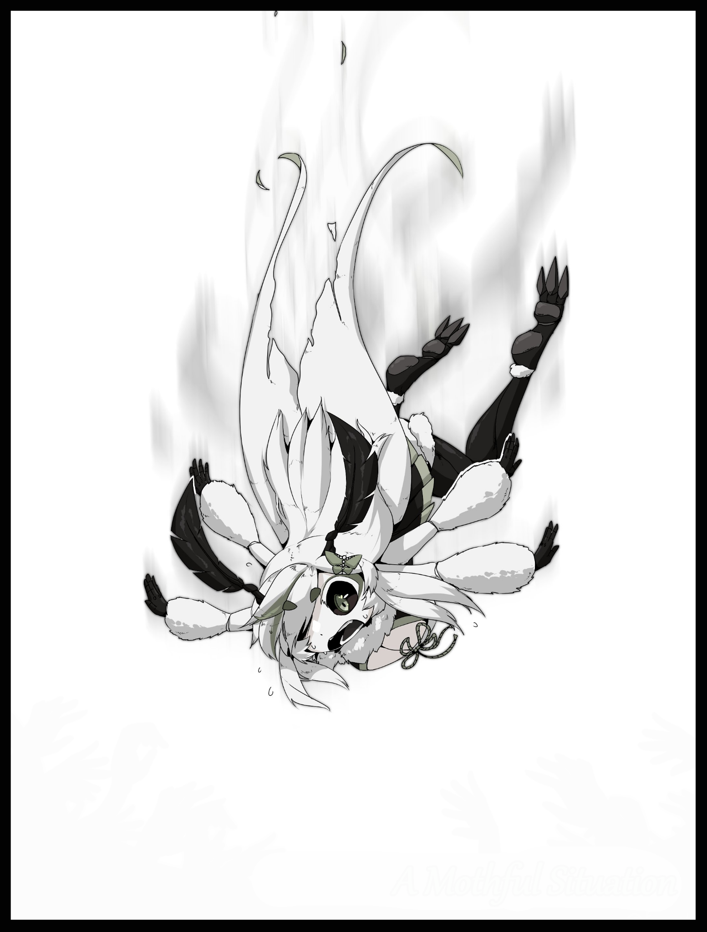

The Brian of old had been a tall 6'9, slightly obese human man in his late twenties. But the Mothgirl that had overwritten him in both body and soul was far larger than he ever could've been; towering a head or two over her original body with a bodacious figure decked out in pronounced curves and bountiful flesh clad in a porcelain smooth exoskeleton boasting the durability of a tank and the flexibility of kevlar. And with limbs armed with digits that could apply the gentlest touch imaginable or rend flesh and bone with ease, it was a clear upgrade on all fronts save for the forced gender inversion and the fact that she was no longer strictly human in any sense of the word.

But as one of the Fae's spectral fingers returns to pluck that last forgotten remnant of the human she once was away from her brain, the Mothgirl's eyes widen in realization, sensing a jitter coursing through jelly like innards that forces a clawed toe to shiver, involuntarily nicking the soaked floor beneath her feet. The final straw that finally rips apart the webbing thanks to the breach and her rabid trashing from having her brain probed earlier. Sending her free falling through the air in a shower of gunk and broken cocoon, speeding rapidly towards the viridescent canopy far below her headfirst, shedding scales in a panic as she squeaks in fear, quad arms flailing wildly while immense wings flap in an effort to fight the sheer winds pushing up against her. All while her body, considered a fledgling one, rapidly matures, gaining thicker plumes and a grander mantle in the form of a majestic collar and larger wings that, while still inefficient to fight gravity at the speed she was falling, proved enough to save her from certain death.

Giving it her all in one final push, the Mothgirl utilizes her stronger musculature to her advantage; swerving her body at an angle to cushion her fall against the treetops while pumping out one final flap of her newly empowered wings that slows her descent just enough so she wouldn't instantly splatter herself to pieces across the branches, crashing through layers of buoyant leaves and bulbous flowers before eventually breaking the final layer and coming to a stop on her poor behind, taking a brutal impact to her rump that crooks her feelers the wrong way while leaving a sizeable indent in the dirt, recoiling in pain as she flops over onto her side with a whimper. All while multicolored spheres descend around her, with the closest one, a pink orb surrounding a diminutive humanoid creature sporting wings much like the Mothgirl's own to keep her afloat.

Drifting in closer to land a gentle peck on the startled giantess, the Fae girl mouths a greeting to her in an indecipherable tongue consisting of chirps and squeaks that should've been her first time hearing it. But on the contrary, her newly awoken memories told her otherwise, filling in the rest of the gaps past her goopy origins as a larva, encountering the Fae who had bestowed a name upon her, living with them and the other denizens of the forest before maturing past adolescence into the motherly woman she now was; a Matriarch of the species, identifiable in the way her weathered feelers now sported a reddish hue nearing her head alongside the same being present in certain segments of her body, a sign that she was ready and waiting for a suitable mate to approach her so that she could be inseminated with sperm to begin laying the groundwork for the next generation.

With the rest of her immature form aging rapidly beneath her notice as dark, rough chitin gives way to smooth mellowed carapace, the Fae's magic grip over Bel, the forest's sole resident Mothgirl, snaps. With their goals achieved and the source of the miasma eliminated, the mischievous creatures could no longer tamper with her being, as per the rules that bound their magics; No one being can be altered more than once, it was a rule made by their governing deity in an effort to ensure their creations antics never got out of hand.

And as Bel opens her mouth, she replies not with words but with a wonderful song made audible through her sweet voice that lulls the surrounding Fae closer, de stressing them from their earlier brush with the negative emotions of man while treating them to the song of a Matriarch Mothgirl, one that hadn't been heard in these woods for many years now considering there had been a lack of intruders to transform until now.

Fae communicated through chirps and the twisting of sound bites, so a song served just as well to convey Bel's wellbeing to them all. And while she sang, her many arms busied themselves with weaving together a warm, encompassing set of clothing to provide her naked self some measure of decency. With her emergence from the cocoon a bygone memory, all Bel had to go on was that she had fallen out of the sky after staying high up for too long, none the wiser to the Fae's manipulation.

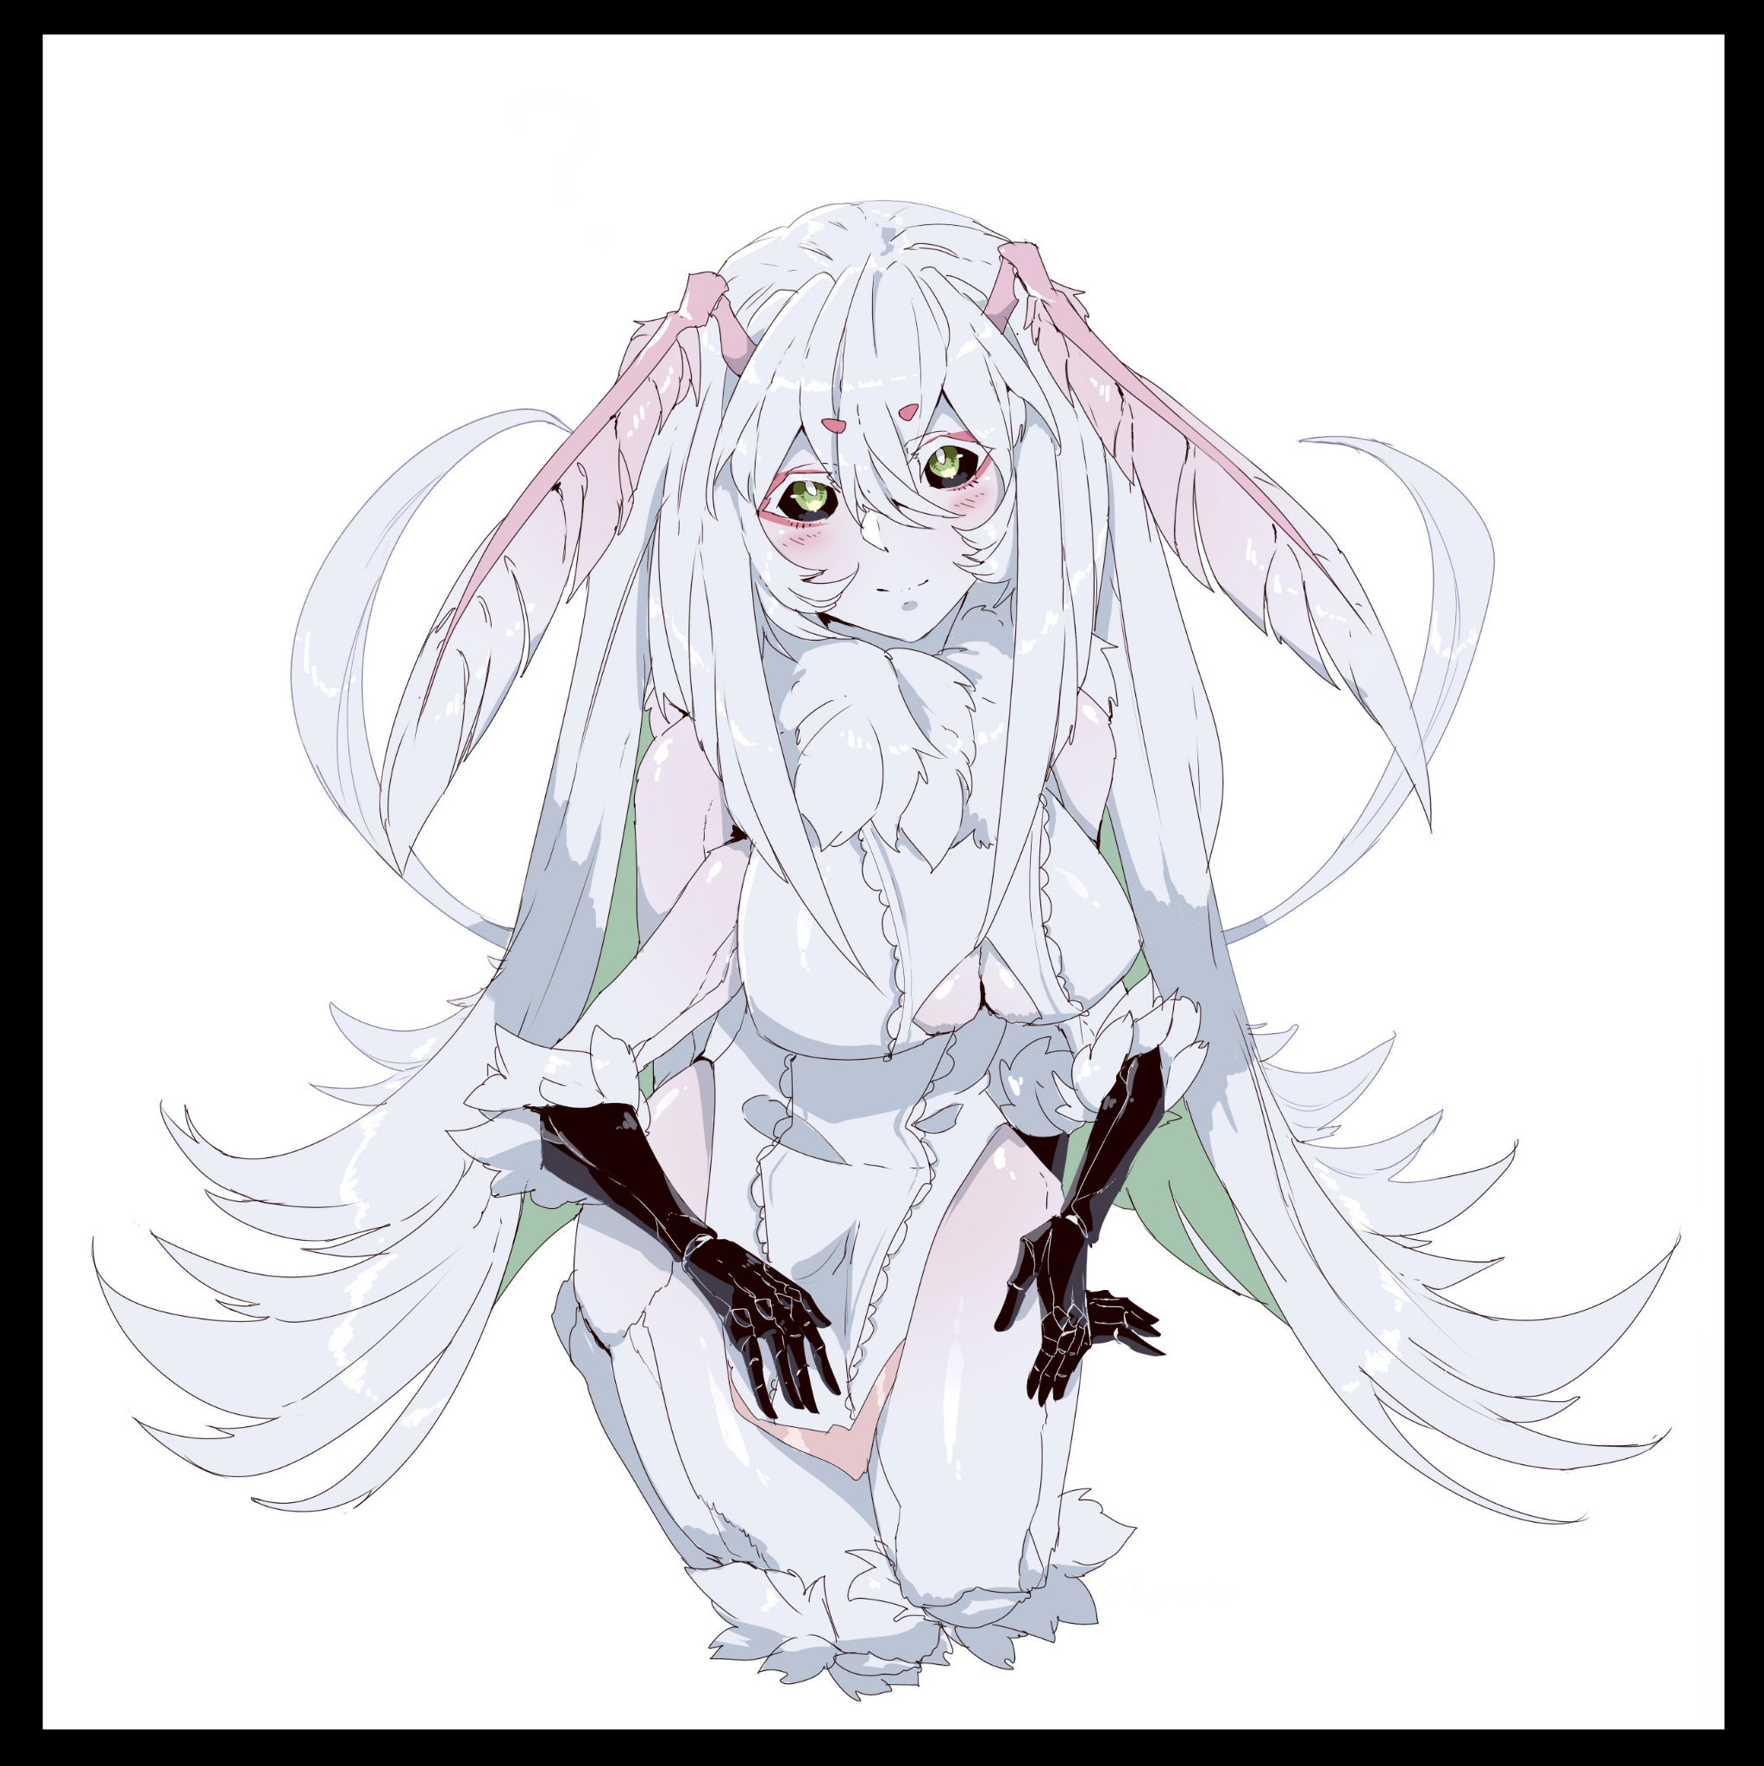

Slotting her arms through the sleeves of her newly crafted top while rising to a kneeling position, Bel's song enters its climax, raising her arms for her adoring audience to rest on as her heavy eyelids flutter shut. She had never felt so at peace before, so rejuvenated. It was as if a weight the size of a mountain had been peeled off her shoulders, giving her all the freedom she could ever think of to live as she saw fit. To weave her silk into marvelous creations, to keep her companions in the forest happy and maybe, just maybe find a male to settle down with one day should he come wandering by just in time to hear her singing voice whenever she would perform in the serene wilderness with the forest as her stage.

And whoever that lucky man was would be given exclusive rights to hear another side of Bel. A song that he would have to work for in order to have her sing it; a song that would mark their coital unity and all the bliss it would entail forever.

In the meantime however, she had her myriad brothers and sisters to play with, looking to them now as they crowded her shoulders and played in her furry scales, praising her song while asking for tiny clothes much like the one she wore over her plump body and other such items only Bel’s luxurious silk could produce…with help from her craftsmanship of course! She loved adding her own flair to her creations no matter how small, perhaps that was why she seemed to attract a massive audience asking for her services to be rendered unto them.

Meanwhile back on the other side of the portal that slowly loses its energy before dissipating until the next surge of magical energies forced another rift open. No one would ever remember Brian Lemmings as the murky skies departed, allowing for sunlight to break through and herald the dawn. And while Emilia would eventually find her fated one, so too would Bel find solace in the arms of a traveling Mothman who had come from a far off land to see if the rumors of the Songstress Matriarch were true. And despite their awkward first encounter considering it was Bel’s first time seeing a male, it didn't take long for the two to give in to their urges and hormonal instincts. Bel’s unfertilized brood spurred her to pin the muscular male down while he in turn could not say no to his engorged pecker telling him to grant the would-be mother before him her deepest desires.

But after a heated night and a shared bed destroyed, Bel and her partner would begin a true romantic relationship together, with Bel moving from the forest to her hubby’s hometown where all manner of fantastical creatures gathered as one. And there, her tailoring skills would truly shine, making the rounds as fast as word of her singing did. It also offered her plenty of challenges considering the varied anatomy she had to deal with. But that didn’t mean she forgot her adoptive brethren of course, for every month, she would make sure to visit the Fae governing the portal in her birthplace, catching up with them, singing them a tune or two, showering them with gifts and after her first brood were hatched, introducing her children to their uncles and aunts.

What was supposed to have been an awful situation for Brian had become a blessed one for Bel, and even if her old persona was aware of what had become of her, she probably wouldn’t mind it at all…probably…

*THE END*