DE-NILE IS A RIVER…
COMMISSION STORY
BY CHALDEACHANGE
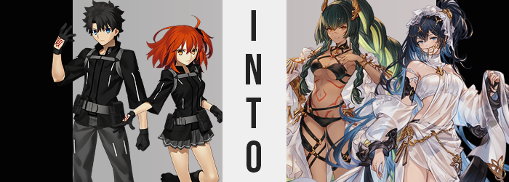

“Should I really be doing this?”

The Assassin class Servant, Nitocris, loomed over an ancient Egyptian tablet within her room in Chaldea. It was the summer season and so it was inevitable that a summer ‘incident’ would soon unfold. That was why she was in her swimsuit Assassin Saint Graph as opposed to her usual Caster one. She was simply preparing as adequately as she could! And part of that preparation was making sure that she wouldn’t have a lonely time on the beach!

Chaldea was a place where historical figures from all over the world came to gather. But when it came to the Pharaoh’s homeland, Egypt? There was shockingly few representatives. The woman didn’t exactly have anyone to spend her time with at the beach aside from Scheherazade, and this year? Her closest friend wouldn’t be able to join in until the end due to something she was helping the Queen of Sheba with. And Ozymandius? He was always doing his own thing.

That was why she had turned to the tablet. It had been rescued from a Singularity; an item able to grant any wish… within reason. Despite being an ancient pharaoh herself, Nitocris didn’t exactly know how it worked. Would it even work? She ultimately offered her wish to it in her native tongue, not really expecting much deep down. That would have been too good to be true, right?

“Please allow Chaldea to summon more Egyptian summer Servants!”

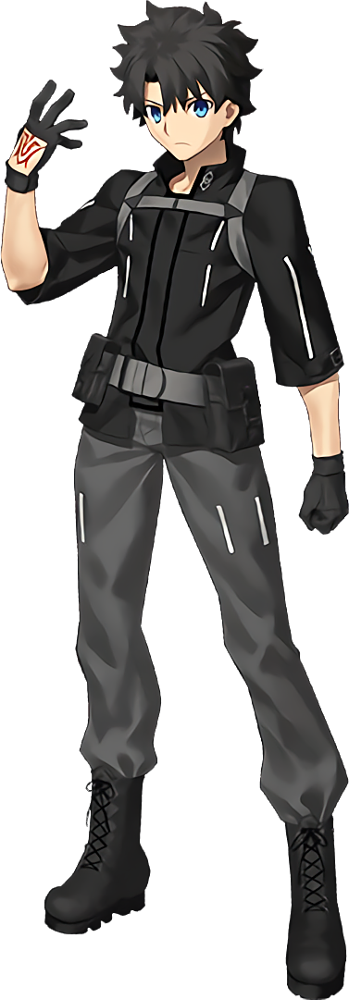
Incidentally, Gudao had also been thinking about any upcoming summer shenanigans around the same time Nitocris had posed her desire to the tablet. “It should be any day now…” He had been flipping through an album of past summer events, including the most recent one that centered around Artoria Caster. He didn’t have any way of knowing that he would be taking a one way trip to Dubai soon. It wasn’t as if he could see the future!

But he was also utterly unaware of the subtle change in the air of the room around him once he put the album back on the shelf. If Nitocris’ desire had been for Chaldea to summon more Egyptian summer Servants, well… It wasn’t a desire that could be answered as literally as the pharaoh had meant it. She had been too vague. And so? The magic had settled on a workaround. Gudao, as one of the two Masters, was one of the best representatives of Chaldea, right?

And a new Servant couldn’t be conjured from nothing.

But it could be constructed from something. Something with strong ties to Chaldea, and there really wasn’t anyone more perfect for that position than Gudao himself. Well, aside from his sister, at least. But more on that later. She was actually about to deal with her own problems elsewhere in the facility. Just as Gudao was beginning to face some himself. He just hadn’t noticed the earliest signs. Even though those signs probably should have been completely blatant.

“Huh?” Something did feel a little off from the young man’s perspective, even though he couldn’t quite place his finger on it. So, what was the truth of the matter? Well, it was a little unusual. His arms, his legs, and even his torso; it had been slight, but they had all pulled inward in length. This fundamentally meant that the Master was now shorter when it came to his height, but not excessively so. He had been 5’5” in the first place, but with this loss? He was 5’3”. It was only a two inch loss, so there wasn’t much in the way of clothing malfunction or anything of the like.

At least not from this height loss. There were other ‘losses’ that ultimately led to the fit of his clothing becoming a little less consistent, though. Much of it was due to Gudao’s build. He didn’t really look it, but he’d actually become quite buff over the years he had worked with Chaldea. All of the muscle was fading, however, leaving naut but a bit of firm toning around his arms, legs, and tummy.

Regarding the lattermost area? His tummy even seemed to pinch in at the sides around the waist, presenting this figure with a more effeminate shaping when paired with a slight parting of his hips away from each other. His outfit loosened and stretched to fit this build. “Wait, something’s wrong with my clothes, right?” By the time the Master had finally managed to pinpoint a problem, he had somehow ended up landing on the wrong aspect of it. Something that was wholly on purpose on the part of the magic changing him.

Well, perhaps it would have been incorrect to continue referring to Gudao with that pronoun.

Because she shuddered. With this context in mind, it probably surprising to hear that the cause of this shuddering was a changing of her sex. Her shaft and balls alike had pinched inward at the base of her pelvis, and everything from her scrotum to the tip of her dick was eventually pulled into the moist conclave of her new pussy. Gudao didn’t seem to register this change for what it was and, in fact, now saw her gender as female. She had always been female as she remembered it.

“Hmm…” There was a playful hum to the sound of her more effeminate voice as she tugged at her clothing absent mindedly. The coat of her Chaldea uniform had begun to seem far tighter, especially around one key area: her chest. With her sex changed, there was realistically only one reason that could be – and that was the explanation. A chest that had once been without any fat had begun to swell with it.

Nipples had become plump and erect first and foremost, and from there mass began to accumulate beneath them. Skin was stretched around this fat that pooled, given no choice but to succumb to the contents that couldn’t be disposed of. A-cups, B-cups, C-cups… They grew from nothing into shapes that were extraordinarily sizable in just fifteen seconds; peaking at respectably large D-cups.

This bust was soon matched by Gudao’s ass. The back of her pants pushed out behind her as pale cheeks burgeoned forth, her crack deepening while cheeks eventually grew out and over the waistline. Both sides were highly grabbable, and the boons that couldn’t quite fit within her swollen cheeks were moved down into thickening thighs as well. Her pants could hardly even contain them in the end. “These clothes really are inconvenient. But it’s strange…”

They looked familiar, but she couldn’t seem to remember putting them on?

She frowned to herself, not feeling just how her lips had been bloating in the meantime. They were fuller, pinker, and much more acutely shaped like the lips of a young woman. Something that was shared with the rest of her face as it became increasingly feminine in design. A smaller nose, bigger eyes… but there was more to it than that. The racial profile of her facial features lost their Japanese qualities and instead were pointedly… Egyptian.

Around the same time, the length and style of Gudao’s hair was changing too. In the most extreme sense of the word, for her locks were growing exponentially. They spilled well past her shoulders and down to her ankles, the color of her raven strands lightening to a mix of greens of both dark and light that occupied the upper and lower layers, intended to intertwine in a fashionable manner. Bangs crossed over top of her eyes, and the hair at her head’s sides twisted into long braids that reached her hips.

She shook her head. “Something’s not… right?” But the woman still couldn’t figure out what. She somehow still seemed to believe that it was her clothing, even as her eyes lit up with a faded crimson color. But her hair and eyes weren’t even the full extent of her palette swap, as the pale of her skin was gradually… darkening? Not towards an extremely dark color, but the natural melanin levels of her flesh were dialed up so that she developed a very bronze tan over her entire body.

Aside from where a number of red tattoos etched themselves into her skin though. Around her navel, under her breasts, down into her pelvis, and even one across the bridge of her nose. Had the woman remained clad in her old uniform then they might not have been as noticeable, but because those clothes changed, they were revealed in their entirety.

The woman was left adorned in a black bikini with detached, white, frilled sleeves and hip accessories. Her hair was done up into a braided ponytail with golden decorations holding them in place. Black latex ran across her body in interweaving bands, some reaching down to golden heeled sandals.

While she wasn’t literally from Egypt, the swimsuit clad Diviner was clearly a woman who hailed from an Egyptain-inspired locale. Her tanned skin, dark hair, facial shape, and the way that her new swimsuit was accessorized were all suggestive of this. And when you heard her name, Horus, there was little room for doubt at all. Nitocris’ desires had been answered in an extremely roundabout way, that much was clear. A Servant could not be created from nothing, but with a base it had very much been a possibility.

And thus, this very sane Berserker had been summoned.

“Hm… I wonder if it would be suitable to go for a swim under the moon and stars?” Horus herself didn’t seem to be all that concerned nor perplexed about her new identity, and she shuffled about a room that had been redecorated to suit her new existence. She picked up a resort pamphlet from her dresser and had begun to flick through. To think Nitocris of all people would invite her to such a place! She had to admit, she was certainly interested.

Especially if she was coming too. Not just Nitocris, but another from the Skydom that she hailed from. “When did she say this trip would be? Within a few days? I wonder how much more I can do to prepare…” Reality had seemingly been altered too. Not just to accept Horus as a real fixture of Chaldea’s summoning pool. But it had also been modified so that Nitocris knew about Dubai in advance. Somehow.

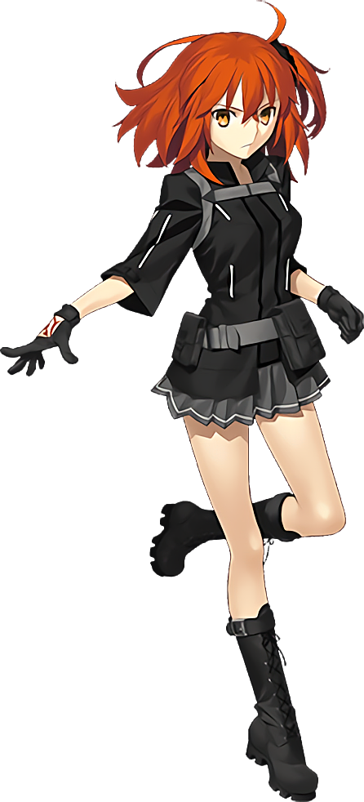
Meanwhile, Gudao’s sister and fellow Master, Gudako, had just finished a swim in Chaldea’s pool. It wasn’t a very big pool, no bigger than one that you would find in a standard gym – which made sense considering it was part of Chaldea’s gym amenities. The ginger haired woman had finished up, dried off, and had retreated into the changing room to switch into a loose, white tank top and a pair of loose, white shorts. She hadn’t brought a bra since she was just ducking back to her room. “That was refreshing! I definitely needed that after a long day of farming!”

She wasn’t sure why her brother had been given the day off and not her, but she supposed it was only fair. Da Vinci would likely do the opposite sometime soon, and considering the time of year… “It seems pretty likely I’m going to be getting a ‘holiday’ soon whether I want it or not.” The summer Singularities were a constant. Not a single year passed where one didn’t occur, for better or for worse. It was just a matter of what form it would occur in this year.

But also, being a Master of Chaldea, she was unaware of how Nitocris’ wish was affecting her as well.

What was destined to happen to the sister was similar in nature to what had happened to the brother. But it also wasn’t exactly the same. To begin with, things unfolded in an entirely different order. Gudako’s eyes changed before anything else, with their amber colors darkening instead to a steely blue between lids that seemed to round and expand. Those eyes no longer appeared Japanese, nor did the structural design of her face in general. Lips became plump and perky, her cheeks thinned, her jaw narrowed, and even her nose pinched smaller.

She didn’t resemble her old self at all facially, and that trend spread quickly into her hair. Much like had been the case with Horus, her mane rapidly spiraled out of control. It all grew at an exceptional speed into an equally exceptional length, strands curling in slight at the ends as they fanned out and fell down to her ankles. This hair was much wilder in design than Horus’ and darkened not to green but instead to a very dark blue with a lighter shade making up the layer directly underneath. The scrunchie that held her hair to the left slid out.

“My head feels so heavy. How… odd?” It was odd, wasn’t it? Just as odd as the sound of her voice, in fact. But Gudako didn’t quite seem to be able to place that, nor that her demeanor had softened ever so slightly. She appeared as, and was acting like, someone who wasn’t herself. Which was more or less in line with what had happened to her brother.

What was so clearly the opposite of what had happened to her brother was what happened with her height, however. Instead of becoming shorter like Gudao had, the 5’2” Gudako instead shifted upwards. Her arms and legs stretched along with her fingers in toes, ultimately bringing her height up to a 5’5” that saw her uniform sit a little illy upon her body. Her jacket and shirt were almost showing off her tummy, and her skirt was teasing her underwear. Things only worsened in that regard.

Gudako found herself clicking her tongue with surprise. The reason? She could feel the tightness of her outfit, and it was largely focused around her chest and butt. This made a lot of sense since, because she had become taller, it made sense that other parts of her body would grow in kind. Her breasts were part of this, but realistically? In the grand scheme of things, they didn’t really grow that much. Only a cup size, because unlike her brother they weren’t starting from zero. “Ngh…”

Most of this discomfort came from her panties, actually. Lengthened fingernails had been pushed into picking a deepening wedgie. The cheeks of the woman’s ass were expanding rapidly, chewing up the cotton of her underwear while simultaneously pushing her hips to widen a few inches. She was very much an ass girl in the end, one who possessed a notably thick pair of thighs on top of it all. It essentially made her very compatible with Horus, who was more of a boob girl than a butt girl.

Perfectly balanced, as all things should be.

A butt that was all the more highlighted when, in the last burst of magic that spread across her person, changed her attire into a swimsuit as well. A pure white bikini top with golden trim, a black bikini bottom, and translucent white draped across the entirety of her body almost like a wedding gown. “I feel much lighter all of a sudden!” Something that was surely helped now that some of her hair was tied up into a side ponytail, bound by a veil-like cloth. Gold chains ran all over, from across her face to her hips. Black sandals matched black cloth that wrapped her wrists together behind her back, as well as a portion that almost looked like a pair of black leggings, too.

Tefnut’s porcelain skin did not make it as clear as Horus’ visage did about her point of origins, but this swimsuit wearing Primal, summoned as a Caster, was also from a place of Egyptian-like origin. The same place as Horus herself, in fact, though it was clear that Tefnut’s appearance had more of a Cleopatra-like inspiration than anything else. “I came to the pool for a swim, so I suppose I should commit to it.” Thinking about it though? Wasn’t this swimsuit a little bit overkill for a leisurely swim? She could have come in just the bikini portions but had instead elected for the entire ensemble. It almost seemed like a waste of time dolling herself up.

Any memories of swimming only ten minutes before were gone, but was it really all that surprising when so much of her life’s history had been altered? Not just according to her own memories either, but according to the memories of everyone who had ever met ‘her’. She strode forth and out of the changing room with the grace that her pure white swimsuit suggested she possessed. It truly was a look that probably didn’t need to be wasted on the pool, but the more Tefnut thought about it? Well, she supposed she could have just chalked it up as practice for when they did eventually go to the beach.

There was a good reason she had been swimming so much. Well, aside from the fact that she had been cursed into a swimsuit that she couldn’t remove aside from when she bathed. “To think that Miss Nitocris would deliver me such an invitation. I suppose considering what she sees as ‘shared roots’, she must have given one to Horus as well?” Horus and Tefnut may not have been from the Egypt that Nitocris knew, but they were from functionally similar places. She didn’t really get too hung up on the details.

Nitocris’ desires had been answered in these two women, at least. Though an unfortunate side effect of the tablet’s use was that because reality had shifted, not even the Assassin could remember using the item in the first place. But there was one issue. Gudao and Gudako had succumbed to the tablet’s power, but were they the only ones? There had been no limit stated in her desires. Had others in Chaldea been affected as well?

It was very much possible.

