BEACH-I THE ROCK
CH1: EXTROVERSION
BY CHALDEACHANGE
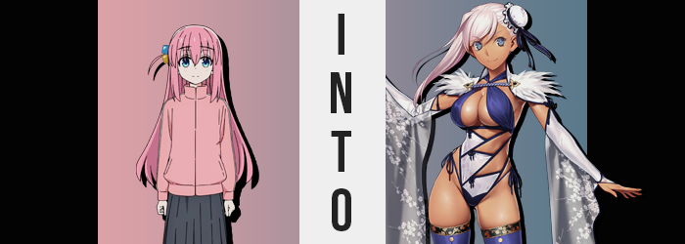

“How did you get yourself into this one, Bocchi?”

Was it even a good question? The Japanese teenager knew how she had ended up in her current predicament, and even the location within which she was sulking more or less gave enough of a clue. She was sitting on a short bench pushed up against a wall opposite a door only a couple of feet away. That door had a big hook hanging off of it that branched off into smaller, less useful hooks. It was very clearly a changing booth that she assumed the fetal position within.

Based on the girl’s reaction, those who didn’t know Hitori Gotoh would likely be alarmed to learn that she was upset about… going to the beach. She was a textbook example of an introvert with social anxiety dialed up to eleven, and while that didn’t make her any worse of a person than an extrovert, it did mean that she did have some difficulties with sudden social events. Heck, even social events she knew about well in advance.

All of her friends had been expecting this though. Patience was always on the menu when it came to Bocchi’s antics, and despite the difficulties? Her awkward personality was something that all of the members of the Kessoku Band, the band she had joined, all loved about her for better or for worse. But the Kessoku Band had been her undoing! All because they had wanted to end the summer with a beach trip.

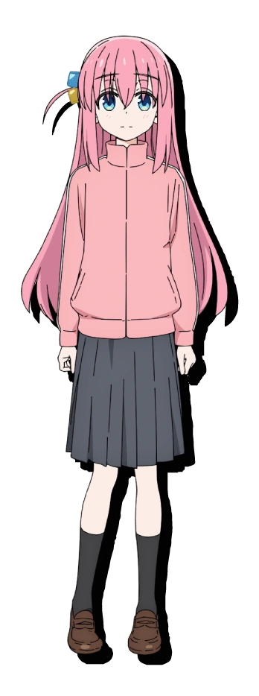
“I found a swimsuit, but…” Bocchi eventually lifted her gaze from her knees and pointed it towards the bag nestled in the corner of the changing booth. There was a strange looking rainbow stone dangling from the zipper, but that wasn’t the point. It was the two piece swimsuit inside that Kita had helped her pick out. It was nice, but it… showed too much of her skin! As someone who already had social anxiety she didn’t want people staring at her! But if she walked out of the stall in her same old jersey and skirt she just knew Kita would push her back inside!

“I wish things like this didn’t bother me as much… It’d be better for the others too.” Of course all these words amounted to in the end were an honest wish. She couldn’t change herself that dramatically and certainly not in a way that would solve her immediate problems. And yet something strange happened. Bocchi had lowered her gaze again after looking at her bag only to find something prompting her to look up again. “Uh…?”

Her posture unfurled and she stood out, small feet carrying her to the corner of the room where her bag was. The rainbow colored rock on the zipper was glowing? That was probably weird, right? She’d found that stone on the side of the road and decided to turn it into a good luck charm for when she was out, but she couldn’t have possibly imagined it might glow!

It was going to do a lot more than that, actually.

“That’s not… supposed to do that?” Bocchi might a well have been preaching to the choir there. Under no circumstances would anyone consider a glowing rainbow stone ‘normal’, especially not if that light somehow caused all of your skin to tingle – even the skin hidden by your clothing. “I-I-Is it radioactive!?” The ball she was curled up into finally unfurled and she stood up straight in the small space. Raising her hands to her face, she had sought to shield herself from the stone’s dangers.

But the sight of her own hands ultimately gave her pause. “E-E-E-EH!?” There were freckles on her hands? The fronts and the backs. But what the teen didn’t realize was that these same speckles were spreading over much of her body including her face. More and more of them were compiled, seemingly blanketing her body with what seemed to be a natural, sunkissed tan. “D-Did my skin just get darker!?”

She could see it on her hands and her arms by pulling up her sleeves, but what Bocchi couldn’t see was that it wasn’t everyone. Beneath her jersey and skirt there were some unconventional tan lines that ran across her breasts, tummy, loins, and butt – even a set around her neck (though her collar hid them). The base of her thighs down to her toes as well as her forearms were left notably pale too. The sight of her pale complexion having darkened was seemingly enough to prompt the girl to short circuit though.

She just stood there, lower lip quivering as her changed color palette only worsened. Blue eyes that leaned more into green tones became steelier in their blues for one, and her hair? Vivid, bubblegum pink dulled to a much more bleached, platinum pink that really contrasted with her now tanned skin. It wasn’t until her body was compromised in a more noticeable way that she eventually snapped out of her stupor.

“WH-WHA!?” It would have been a miracle if no one outside of the changing booth had heard Hitori screaming, but unfortunately for her there was a reason no one had. The glowing stone had suspended time outside of the booth, and reality was slowly being rewritten so that everything that happened within would be considered ‘normal’ once that light eventually waned.

Her newest outcry had come about because she had almost fallen over… and the changing room was getting smaller! At least that was how her brain processed it in that moment, but her body had been growing taller. The jump from 5’1” to almost 5’5” might not have sounded all that dramatic, but it was enough to lift her jersey and shirt to show off her tummy, or lift her skirt past her knees, or for her jersey’s sleeves to pull up to her elbows.

Bocchi blinked. “I-I’m so tall!? But… But… Wait, aren’t I always this tall!? N-N-N-NO!?” Not only had that assertion been wrong, but she had sounded strangely confident when she’d said it. When the girl in question typically had negative levels of confidence. Still, it had left her feeling strong momentarily. She hadn’t realized that she felt much stronger physically too, though. Muscle now lined her body in all the appropriate places, leaving her clothes feeling tighter and presenting her tanned flesh with a toned appearance.

Not all was tight and firm though, at least not for long. If her usual outfit was already struggling to contain her more muscular physique, then it began to have one hell of a time with the more mature figure that began to settle into place. In fact this maturity already registered upon her face, for lips had swollen plump and her nose had grown a touch. It was almost like there was less and less of Bocchi herself in her appearance as eyes narrowed and she became more traditionally beautiful with a slimmer jaw.

She looked like a completely different woman entirely!

Felt like one, too. “Oh, huh. These clothes are kinda tight.” The voice she spoke with had a confident, big sisterly allure; her stutter had evaporated and the woman herself didn’t appear to be questioning it at all. That seemingly extended to the bloat that soon came to develop her body, though. That ‘big sister allure’ built several more times over.

Her skirt already appeared shorter since she was four inches taller, but the bottom hem was pulled up even higher as hips swung out into child bearing proportions. More of her thighs were exposed as a direct result of this and it highlighted just how said thighs were swelling. Inch after inch, tanned and pale flesh alike burgeoned forth into rounded, plush shapes that were just as wide as her waist. Yet her hips were so wide now that a generous thigh gap still remained between them.

Ass and breasts both grew in tandem in near equal measure, with a firm yet slappable ass flipping up that skirt in the rear into a fulfilling heart shape. Farther up, the zipper of her pink jersey was yanked down by the sheet force of her bosom swelling. Breasts exploded into J-cups that lifted up the shirt beneath the jersey, barely containing these honking new tits that bounced free without a bra. “Woah!?”

She only marveled at them with such obscurity for a moment, for one more flash from the rainbow stone filled the room before its light dimmed. Once it had dispersed? An elaborate yet beautiful swimsuit adorned the woman’s body, perhaps unsurprisingly being a perfect fit for all of those tan lines. Even her hair was pulled into a right-swept tail while the left had been done up in a bun.

“Huh! I came here to… go to the beach with the girls, right!?” Standing proud in her ornate swimsuit, there was very little left to the imagination when it came to Musashi Miyamoto’s voluptuous body. The copper tan that covered her body was little more than an illusion that could be dispersed if her thigh highs, sleeves, or swimwear were pulled back even a little to reveal paler skin underneath, but she honestly wasn’t all that bothered by mere tan lines!

It was strange though. Who were the girls she had come to the beach with again? She felt like they were all really close, but she couldn’t quite visualize them? “Another weird lapse in your memory, Musashi-chan!?” The Servant laughed at herself. She’d probably remember eventually! Definitely! Perhaps! But she definitely wasn’t going to remember while cooped up in a changing booth, right? Actually, wasn’t that in itself a little odd? She wondered as much as she picked her rainbow stone off of the floor, no longer bound to a bag.

She had come to the beach in her swimsuit already?

