ZERO ONE
JANUARY 2022 REQUEST STORY
BY CHALDEACHANGE
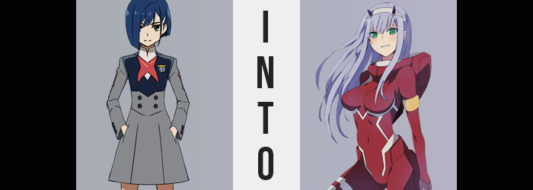

Ichigo really wasn’t sure if this was a good idea, but it was an idea she was willing to at least try. It had become plain as day as of late that she would never be partnered to pilot with Hiro, the boy whom she both adored and had feelings for when all was said and done. To pilot a FRANXX you had to be paired up with an individual of the opposite sex, and growing up with him as she had, she had always hoped that he would end up her partner.

But then she had come into the equation.

Zero Two. A mysterious girl with horns that had come out of nowhere, one that clung to Hiro and called him ‘darling’. It was beyond agitating for Ichigo, who had been aspiring to stand at his side for what felt like the entirety of her life. “Why couldn’t it be me?” She said the quiet part aloud while picking at the lock of a locker in the girls’ changing room.

This was the location where they all put on their pilot suits before piloting, but as it was so late at night there was no one around but her. In fact, uncharacteristic of a leader, she had technically entered without permission. But she was there with a purpose. While Zero Two didn’t typically change with the other girls, she’d heard a rumor that a spare pilot suit was kept in that very locker in the case a spare was needed.

You see, Ichigo had a theory. That perhaps there was nothing special about Zero Two after all. How could she have such high compatibility with him despite only now meeting him? It didn’t make any sense! So the suit… It had to be the suit! There must have been something about it that made her more compatible, so if she was wearing it? Then she should have been able to pilot with Hiro as well!
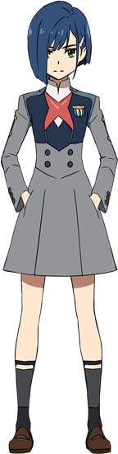
“Aha!” After breaking into the locker, Ichigo felt validated. The rumors had been true, and there really was one of those crimson pilot suits within. She wasted no time in stripping down into her birthday suit so that she could slide the thick, rubbery bodysuit across her skin. “Augh…” She had definitely expected it, but the girl still couldn’t help but lament how loose it was around her chest, butt, and legs. There was no denying that her figure wasn’t up to the same standards.

…At least for now.

Ichigo had wondered more than once if that was what Hiro saw in Zero Two. Did he have a thing for women that were more curvaceous? No, that was pretty much what every boy wanted, wasn’t it? It felt pretty unobtainable for her though. Maybe when she got older? But she didn’t have the time to wait around! If she didn’t win Hiro’s favor soon then he might be lost to her forever.

“…Maybe I didn’t think this through.” The girl had been so caught up in her plan that it wasn’t until she was dressed in the pilot suit that it dawned on her: how was she going to get permission to pilot with Hiro? Could she sneak him out to a FRANXX so they could deploy without being permitted? Did she have to just go into hiding until they had to deploy and then sneak in to Strelitzia wearing the suit? “Now that I have this… Darn it.” Defeated by her own lack of foresight! Hiro really did make her crazy.

But just as she was going to strip back down and put the pilot suit back where she had found it, the maiden felt… uncomfortable. Initially it was hard to pin down, but it was kind of like a very potent migraine had just washed over her? Did she need some sort of medicine, or— “OW!?” Both wincing and reaching hands up atop her head at the same time, Ichigo felt the sensation of what she could only identify as something erupting from her skull. And her hands were quick to identify just what it was.

“D-Do I have horns!?” Considering she had almost impaled her palms on them, that certainly appeared to be the case. There was no easily accessible mirror, and so she could only make out what she could feel, but there were two tiny spikes poking out from her skull. She just couldn’t make out how they were a dark blue in color – and identical to Zero Two’s in shape and size. “J-Just like her?”

No, that couldn’t be right, could it? Maybe she’d just fallen and hit her head, and what she was just feeling were two very… sharp… bumps? Or she was dreaming? She could be dreaming, couldn’t she? That was entirely possible! How else could she explain the horns, or the fact that her hair appeared to be growing longer? “…Huh!?”

Fingers were quick to dance from her horns to the hair she could see crawling down the sides of her face. Her dark blue locks appeared to fall farther and farther, soon cascading past the loosely fit chest of Zero Two’s pilot suit. However? Just as quickly as it fell did the color suddenly lighten, taking on a pastel blue that appeared to bear the same contrast level of Zero Two’s hair without inheriting the pink.

“This is too uncanny! I must be going crazy!” But even then, her eyes began to glow a much brighter green than normal, and the words she delivered had been carried across lips that were plumper and rosier than she was used to. “Ah—Ah—!?” For but a brief moment Ichigo felt as if she was on the verge of a sneeze only to keep it down at the last second – because the cause of it, her nose shrinking, had reached its due course.

Ichigo’s eyes grew wider. Partially from surprise, but partially just inherently as well. Blue paint rubbed the corners of her eyelids, presenting even more similarities between herself and Zero Two. Well, then again, with lashes now longer her face essentially appeared to be identical to that of her personal nemesis. “There’s no way I… I… Huh? What’s wrong with my voice…?” She really must have been going crazy, because she could have sworn her voice sounded identical to that girl’s.

Not just the voice but the attitude she projected as well. While her comments were still born from concern, there was a nonchalant feeling to her tone. Very casual, very uncaring. And it only grew stronger, ultimately manifesting in her attitude about her transformation. There was one change in particular that soon got her thinking ‘Perhaps this isn’t so bad’ in fact, and it was one that addressed one of her previous anxieties.

Because the weight of the chest she had been lamenting had begun to grow. The vacant cups of Zero Two’s bodysuit slowly filled up with nipples burrowing into the latex of their confines, briefly spurning the girl to shudder before she became accustomed to the feeling. “Oh! These feel… Nice!” Ichigo felt downright giddy, and what was with this confidence? Was this how it felt to know you were attractive?

That confidence received another boost immediately after, for the loose nature of the latex was addressed in its entirety. Her lackluster showing of hips parted wider, and in the process that rump of hers became better defined, altogether perkier. Not even her thighs escaped this boon, while the hairs above her crotch between them took on the same blue as that which rested atop her head.

Ichigo could hardly believe what she felt with her own body and saw with her own eyes. The curves she observed were not her own, and yet they somehow felt accurate, nonetheless. And even though they weren’t? How could she resist the rest she felt in possessing them? Was this how Zero Two felt? Where all of her confidence came from? Even though with horns like hers, there was no way she was a human? But then again, were any of them really?

Pushing her few lingering doubts aside, Ichigo licked her lips – noting just how much plumper they were than she remembered in the process. While at least in terms of recollections she was still very much herself, it was almost as if her new, more appealing form had come with some bonus confidence. It was actually a little more extreme than that in essence, for she was mirroring Zero Two’s personality traits as an individual. She was definitely more confident, to the point that she felt unstoppably chaotic, but that confidence came with a desire to be dominant.

Not to mention a desire to carry herself in a very provocative manner.

“Huh! Well this isn’t so bad! I feel really good.” Regardless of the previous anxieties that she had felt over the course of her transformation, she somehow felt right at home with her new body. Fingers traced her embiggened breasts, those that held up the inside of her bodysuit, and her mind? It wandered back to Hiro. Except in ways that were much more mischievous and even more scandalous than she would have done as her old self. “Now there’s no way that the harlot can compete with me! I have her looks, her confidence, and a history with Hiro!”

But how was she going to explain this to the others? Would she get in trouble? The old Ichigo might have fretted over such things, but a wave of her delicate fingers dismissed these thoughts. It would all work out somehow. “I probably need a different name though…”

“Oh! How about Zero One?”

Partially to piss Zero Two off, but what Ichigo didn’t realize? By the night’s end, she’d believe herself to be Zero Two’s twin sister.

