Heavenly Bodies
A Mercynaries Story from SinComics.com

The landing vessel's comms screen crackled and popped as the small ship shuddered. The Captain grunted and pointed to another soldier feverishly typing away at a station under the screen.

“Comms...”

“On it, Cap. Some kind of interference from the planet. And… you should see the boss's smiling face in... Any second now...”

On cue, the screen fizzled back up once again.

The Captain sat back in his chair and ran a large hand through his hair. “As I was saying, HQ, ALPHA squad has arrived ahead of schedule. Gunner, Comms, and I are approaching the landing zone. We will-”

A muscled arm thrust itself in front of the Captain's face and flexed for the screen. Gunner grinned for the screen and boasted loudly. “Mission hasn't even started and ALPHA is already kicking ass. Two days ahead of schedule, boss! Like to see the chumps in DELTA-”

“Gunner! Finish your scans and for the Collective's sake, be quiet back there.”

The crew of three represented the Collective's finest genetically enhanced super soldiers. Perfectly healthy, the pinnacle of human ability, and an unfortunate awareness of this that led to egos like Gunner's.

The Captain leaned back in his chair to finish off the transmission back to base. It would be days before HQ received it but he didn't have the time to do any editing before beaming it back home.

“We will proceed with the mission as planned. Survey the planet to see if it is habitable for human colonization. Set up and maintain the outpost. Commence research for establishing supply lines and on-site resource generation. ALPHA squad will remain until the survey is completed. ALPHA squad, signing off. For the Collective!”

Captain rose to salute and then nodded towards Comms.

Comms flipped up his headset and smiled, “She's on her way back home, Sir.”

“Thank you, Comms. Now prepare for landing procedures. Once you completed your tasks, suit up. Heavy hazmat. The planet may match near-Earth chemical and atmospheric conditions, but we don't know what kind of diseases or conditions exist beyond initial scans.”

Gunner raised one of his many prized weapons. “Or what kind of beasts!”

Within hours, the crew had finished the initial construction of their outpost using the materials stored on the landing vessel. Comms connected the final supply tubes from the ship to the building and gave his team a thumbs up. “All systems green, Cap!”

The Captain dialed up the final checks, confirmed the process, and the building shook to life with a blasting chug and hum, pressurizing the outpost and sealing it off from the new planet surrounding it.

The trio stepped into the decontamination chamber and cheered as they popped off their helmets.

“Finally! Nice to breath something other than air that comes from the suit's canisters.” Comms hung up his gear and stretched.

Gunner tossed his helmet into the case. “Yeah, nothing like trading up suit air for recycled outpost air. Like ma used to make.”

Inside, the group naturally spread out to their favored positions. Comms flipped up the monitors on his station, Captain started unpacking supplies and running checklists to ensure nothing was damaged in transport, and Gunner flopped onto the lone couch that counted as luxury away from the Collective.

Captain loaded a white cube into the cooling unit. “Don't get used to it. We're back out into the field come morning.” The unit let out of a puff of chemically cooled air and the Captain reached back inside. Tossing a bottle to each man, he raised his own. “But for now, drink up, celebrate a good start, prepare for research tomorrow, and if any of you bums throw up in my brand new outpost, you're sleeping outside!”

ALPHA squad trudged through the mud slopped jungle of the new planet. The hazmat suits provided enough of an impediment that even Gunner kept quiet on the journey. They made their way through overgrown plant-life and sawed through thick trees and bushes to make some semblance of a path.

Several hours into their trek, the trio stopped for a breather. Comms tapped the radio in his helmet.
“It's creepy, right? It's not just me?”

“Whazzat?” Gunner scrapped a chunk of thick reddish mud onto a rock.

Comms waved his gloved hands to the air around them. “The quiet. It's so damned quiet. It's unnerving.”

Captain nodded. “I'm happy for an uneventful mission, but Comms is right.”

“It's bugs. No animals is one thing, but I haven't seen so much as gnat-one. This jungle should be crawling with them.”

Gunner rolled his shoulders. “No mosquitoes and you're upset about that? This place sounds like a paradise.”

Comms shook his head. “It's a jungle paradise without animals, insects, or even flowers. No bugs, no flowers.”

The trio surveyed for several more hours, taking scans and samples as they went. The world was lush, a vibrant green ball unsullied by pollution or human interference.

At a rushing stream, Captain raised his hand to the air before tapping his radio. “Gunner, survey the area. Comms, load up another collection pod. I want to test the water. The river will be a good resource node.”

Comms and Gunner nodded in agreement and got to work. Comms and the Captain headed to the water's edge while Gunner kicked his way through the overgrowth. Comms loaded each sample into the pod, watching the containers spin before the machine spat out chemical analysis and safe results.

Comms waved another readout to the Captain. “Sample Eight came through green, Cap.”

“I read you. I want to take a few more deeper down and get some mud by the rocks.”

Gunner leaned up against a tree, flicking a small bud with his thumb. His radio burst life. “-ner! Gunner, get over here!”
His legs were pumping hard as Gunner sprinted over the vines and rocks and back towards the stream before Comms could even explain himself. Gunner vaulted a felled tree and into the clearing by the water.
Cap was half underwater with Comms desperately holding onto their leader's legs. Comms himself was slipping deeper into the muck, unable to get traction to pull back.

Gunner's radio crackled with Comms's panicked shouts. “Shoot it! Shoot!”

Gunner circled around them to see thick green vines snaking around Cap's waist. The water thrashed with other tentacles, whipping and slapping the air, water, and its captive.
Gunner dropped to a knee and raised his weapon. “I can't! The Captain is too close.” Gunner fired a few blasts safely into the water away from Captain but the tentacles continued tugging unabated. Gunner rushed over to Comms, wrapped one arm around his waist and reached out to a tree with his other. With a hearty yank, Comms reeled back, dragging the Captain's helmet back out of the water.
Attached to his head was a pale yellow plant, puffing and shaking as its vines thrashed back towards the water, trying to claw its way back down. Unable to get back to the stream, the creature's tentacles lashed back at the Captain, wrapping around his helmet, and pausing before they contracted to the sound of a crack that split the jungle.

Gunner and Comms reeled back. Their hazmat suits were made of the Collective's strongest body armor. No gun on the battlefield could split them, but this lowly plant managed to. Gunner flashed his hand to his holster and unsheathed his blade in a quick, smooth motion. He plunged the knife into the creature's thick mass, twisted it, and yanked it back towards the sky. A shimmering green ooze sprayed out from the creature as it finally loosened its grip. Comms stumbled backwards with the Captain and the creature rolled back into the water with the cracked helmet and an oozing wound.

Gunner spun back around. “The Captain?!”

Comms shook his head. “He's out cold. Labored breathing. Pupillary response... functional but slow.”

“Let's go. Grab his legs. We're getting him back to base.”

In the outpost, the Captain was sprawled on the medical bay as scanners worked over him. He hadn't stirred since arriving. Comms finished hooking up the last of the fluid sacs and the machine started pumping them into the patient.
Comms tapped his radio. “Readouts show his vitals are stable. Nothing more we can do until the scans are ready but no red flags so far.”

Gunner nodded and headed towards the exit. The two entered the decontamination chamber and scrubbed their suits before finally removing their protective wear.

Comms stowed his helmet and nodded towards the sealed medical bay. “No signs of pathogens. Clear bill of health on inhuman materials. Maybe just shock? Got the wind knocked out of him?”

Gunner grunted as they entered the main sector of the outpost. “I've watched Cap split a man's skull in half and then punch it through another solider's ribcage. No plant gave that soldier shock.”

Comms watched over the reports from the med lab all through the evening. The Captain was stable but the med bay had to increase his nutrient supplies multiple times. All scans reported the Captain was okay, so it appeared as if that creature had just... drained him.

The next morning, Gunner and Comms stood outside the med bay lab as the Captain finally stirred. He was propped up on his elbows, eyes half closed, and mumbled like he was coming off a hell of a bender.

“-No can do, Cap. I know it's tight quarters in there, but you're on bed rest as all day.”

A string of groggy curses burbled from the room once more.

“Gunner says he's happy you're okay too, boss. I have him setting up defenses in the area. The outpost is totally secure and I'll have the perimeter scanners calibrated in no time. Consider this some R&R.”
Comms closed down the radio channel as more curses came through. He grinned and waved cheerfully at the Captain in the medical bay, knowing that would annoy him plenty.

That night, Gunner and Comms suited up to deliver the Captain some solid food. The three soldiers packed into the medical room and grunted together over chow. Comms fiddled with scanners and surveyed samples as Gunner finished giving his report detailing just how many disrupters he managed to pepper around the base. Even if the planet wasn't deserted, Gunner would have blown any inhabitants to bits in the name of the Captain's safety after the incident at the water.

“So are you two nannies going to let me get back to work?”

Comms gave an apprehensive nod towards Gunner. “Well-”

The Captain shot Comms a dirty look. “Unless that machine explicitly says otherwise, we can't be down one man on a three man crew this early into the survey.”

Comms shrugged. “Scanners say you're clean. We wouldn't be in the room with you if they didn't.”

Gunner slapped their leader on the back. “Way to go, Cap.” He collected the meal containers and headed back to the main outpost.

Comms stayed squatting by the machine, silently. He finally glared towards the Captain. “C'mon. Spill, boss.”

“I'm sick of sitting around. There's too much to be done.”

“Be serious boss. What's wrong?”

“The Collective's best is not going to be outdone by a plant with an attitude. What's wrong with YOU?”

Comms shrugged. “I don't like what I see.”

“You're not much to look at either.”

Comms laughed. Captain wasn't much of a comedian, but it was a good sign. “Not what I meant. You're two inches shorter. I had to triple your nutrient drip while you were out to stop your body from cannibalizing itself for resources. You were burning through so much energy, your muscle mass has dropped by-”

“So I got knocked out and got sick on foreign planet. I'm not the first person to get a fever in a jungle. But now I'm fine. Feeling good and it's out of my system.”

Comms handed the leader a tablet with two wavy lines on the display.

“What am I looking at, Comms?”

“I'm not a doctor, boss, but I know communications. One on the left is your vocal scan from medical sign-offs before the mission and the one on the right was taken just now. It's small, but there's a difference in the-”

“Comms, a plant tried to choke me out. Yeah, my throat is sore.”

“You got an answer for everything, Cap.”

The outpost was silent and pitch black at night. What moonlight did make it through the hazy atmosphere was eaten up by the jungle canopy before the light could shine on the facility. The quiet was broken by a shout from the edge of the outpost. Blue lights flickered to life, highlighting the edges of the rooms and objects.
Comms stumbled from his room, alert and wide-eyed.
“The hell was that?”

Gunner was already pressed against the wall, his hand at the firearm on his side.
“Came from down the hall. Captain.”

The two nodded and made their way down the hall, checking the rooms bathed in the soft glow of the blue warning lights. Gunner scanned his tag and rushed into the bright lights of the Captain's quarters the instant the door slid open.

The Captain stood shaking, supporting himself with one arm on the bed. He still towered in the small room, beads of sweat running down his forehead.
“The hell is-”
Gunner and Comms looked him up and down. The Captain's uniform strained against their leader's now bulging chest and hips. He panted, his shallow breaths still causing his chest to rise and press the two newly formed globes against the taut fabric. It looked like somebody had taken the Captain and stuffed his shirt and pants but didn't bother to change anything else about the super soldier.

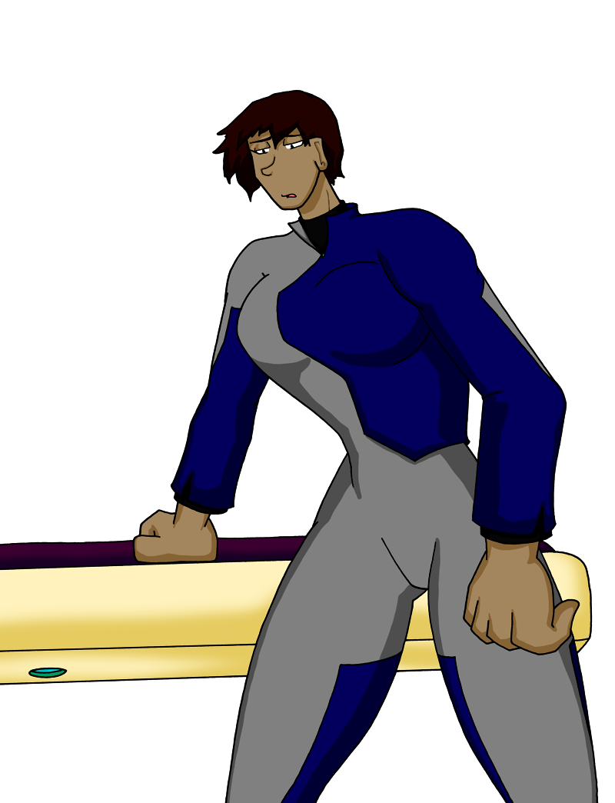

Captain gripped his stomach and look out to his men, “What's happening?”
Comms shook his head. Those dulcet tones were not the Captain's.

Comms looked over the med bay's scans. “It's all normal!”

Gunner angrily gestured towards their leader's hefty bosom. “That ain't normal!”

Captain grumbled, a soft edge to a once granite roar. “Comms, tell me what's-”
He grimaced and gripped his stomach once more. His back arched and he shifted nervously as his hips thrust out further and his pants became even tighter on his backside.
The crew nervously fidgeted as the Captain let out an effeminate sigh after the latest transformation.

Comms shook his tablet as it chirped and lit up another cheery green tag. “The scans are coming back fine. No impurities! Genetic makeup, biochemistry... All fully human. Safe and healthy.”

Gunner grabbed Comms by the shoulder and shook him. “That's what the original scans said too! Are the machines broken?!”

Comms shook his head. “D-Diagnostics check out. Everything is operating as normal. I-I don't know!”

The Collective transmission ended and the researcher nodded in approval. He wasn't used to space travel. He greatly preferred life on the station. And back on the station, he didn't feel so... tiny. The Collective had the Universe's best army, but next to the hulking brutes, the scientist felt like he was an ant about to be stepped on without a moment's notice.
He shook his head and replayed the transmission over in his mind. Visit the planet, make contact with ALPHA, get them to report and back online, and complete the survey. It was just another house call...

One on the soldiers snapped the fingers on his beefy paw and startled the researcher back to reality.
“Your suit is right down here. Get changed and meet us at the drop pod. Your gear is already packed for transport.”

The researcher nodded and scurried off, happy to be off the bridge and out from under the heels of the soldiers.

The researcher checked the seals on the suit repeatedly as the Collective soldiers made the final preparations on his drop pod.

Finally, a soldier gave him the thumbs up before she motioned to her partner to close the hatches.
“You're good to go, Doc. Stay safe down there.”

The researcher nervously laughed. “ALPHA will do that for me.”

The soldier snorted to hold back a laugh. Her partner flicked the final switches and rolled his eyes.
“Yeah, give our regards to the Amazons.”

The two derisively laughed before they exited the room. The researcher's pod shuddered as the floor opened up and he could see the foreign planet below him. He gripped the arm pads tight and clamped his eyes shut.

On the surface, the researcher steadied himself after the fall. He double and triple checked the suit for damage before collecting his bag and sealing the pod. He slowly made his way to the navigation points, trudging through mud and thick vegetation before reaching what looked to be a simple path hacked through the brush. He passed several scanning nodes and recognized the defense pods the Collective used for makeshift fencing and turrets on any colonies foolish enough to attack the Collective. He gripped his case tightly as he crept passed them, even though he knew they wouldn't open fire on him.

Reaching the outpost, the researcher scanned his badge and a chime sounded inside the outpost. He heard doors sliding and boots on the thick plastic of the pod. Finally, the outer doors slid up and he was face to enormous bust. They were amazing. Two soft globes just barely contained in a Collective undershirt. He looked up to see the face of a grimacing woman looming over him. She was gorgeous. She had a good two feet on him, was muscular but not overly so like the soldiers on the transport ships, curves that only a super soldier would bear with such grace... The peak of an athletic human -

“Get in here.” Captain grabbed the guest by the shoulder and shoved him into the decontamination chamber. As he was sealed in, Cap pointed him over.
“You leave that on. Never take it off around here.”

Inside the facility, the researcher looked around. Leaning against the back wall waiting for him was another woman. She was still tall but looked downright petite next to the Captain. She gave a friendly wave.

The Captain jerked a thumb towards her. “That's Comms. Over there, Gunner.”

She pointed towards the sitting area where another woman was all but pouting, sitting awkwardly in a chair she made look tiny. She too would have loomed over him when standing, but her muscles had faded considerably and she had the unbelievable position of being even curvier than the leader. She looked like she was putting active effort into not bursting out of her uniform and the researcher clutched his case to maintain composure.

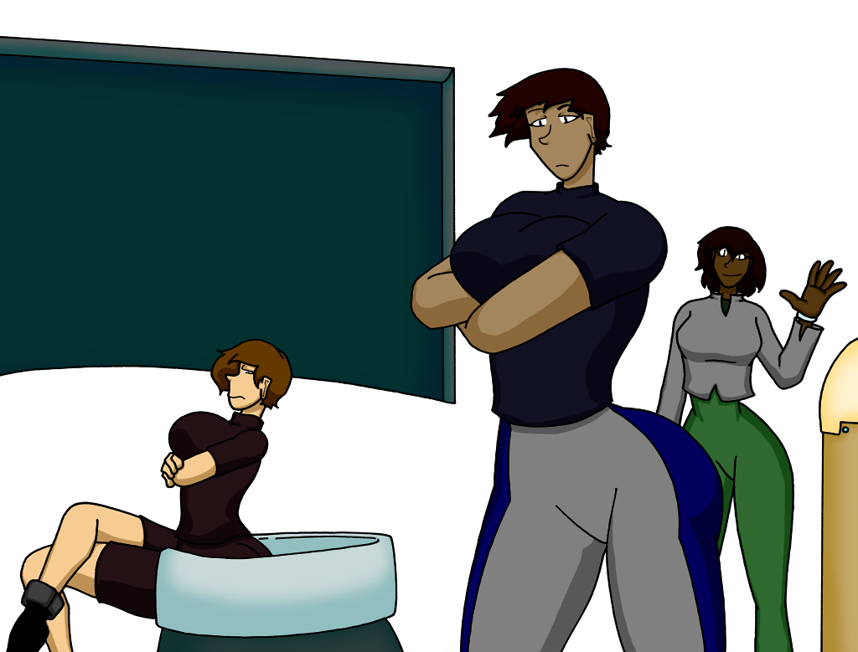

“I'm – I- The Co- Oh my...”

The Captain narrowed her eyes. “The Collective sent you to get our mission underway again. Now hurry up and cure us.”

“Ye-Yes. Well, by that I mean, no. I was briefed on your... situation... but this is a unique medical case. I will need to do research to find out what has happened before I can derive a cure...”

Gunner bolted up from the seat, bobbling and unsteady, as if even she wasn't accustomed to her body. “What happened?! I'll tell you what- ”

The Captain raised a hand. “Get started setting up your lab. We added a sealed node off the med bay. Run decontamination in and out, every time. What's the location of the drop?”

The researcher nodded. She... he had a commanding presence that was hard to object to. He handed a tracker to the Captain.
“I landed h-here. The supplies are packed above. HQ sure packed a lot of food, eh?”

The trio were already headed out the door. The researcher frantically waved as best his suit allowed. “Your suits! You can't go out there without-”

Comms turned back. “Doc, we're as infected as it gets. No point.”

The days passed and the researcher was integrated into the group as best he could be, sealed in his suit or his research pod. He had to eat alone and was by himself as the squad did their work outside the facility. He relished their interactions for an excuse for companionship, as gruff as it was.

Captain flexed his arm as blood flowed into the tube. The room thrummed with the steady whirr and pounding of Gunner on the treadmill.
“Getting tired of giving blood, Doc.”

“S-sorry, Captain, you know how important it is.”

Gunner turned, still pounding away on the treadmill. Despite his plentiful curves and heft, he maintained the same stamina his genetic engineering granted him. He could run for hours, and the researcher found he could watch for just as long. It was hypnotic the way she bounced and-
“I think the new guy is just doing this crap for his amusement. How long have you been here and we're still not fixed?!”

The researcher snapped back to reality. “That's not- I can't be expected to- Just-”

The Captain snapped back. “Gunner! Give it a rest. It's not helping anybody.”

Gunner turned back to the display and continued his run. “Yeah, well. Neither is the doctor.”

Days passed before the researcher could give a presentation to the squad. He pointed to a readout on the large screen, knowing the trio didn't know what they were looking at.
“So you can see it's here, at this level... An impurity.”

Comms shook his head, his long hair flopping side to side. “No, no, we scanned. Nothing-”

The researcher nodded. “It's so minute that I'm not surprised the field gear missed it. I was sent down with the full toolsets, trained for this, and it still took me all this time to reveal. It's so minute that only the most specialized gear could pick it up.”
“But Comms, your scans were right too. It's not a foreign body. It registers as human.”

Captain tilted his head. “But that's impossible. We're the first ones here. No other people. No animal life.”

The researcher nodded. “Nothing living, right? How far out have you been?”

Comms handed a display to the researcher. “After the attack on the Captain, this is as far we built scanners. White is the deep scan, gray is just surface.”

The researcher nodded. “We have to head back into the field. It's the only way to find out more.”

The squad combed the planet, setting up scanners as they went, dragging the frightened researcher along with them the entire way. Captain effortlessly slung the medical supplies on his back as the researcher struggled to carry around his scanners, constantly checking his seals and helmet, slowing the party down in the process.

A week into the journey, they scanned a valley and Comms perked up.
“Captain. Cap! Look at this!”

“What am I seeing here, Comms?”

“Look at the ground scans. The scans are passing through softer ground, but look at the regularity. If it was natural, they wouldn't be placed like this. I think we found something...”

Captain nodded. “All right. That's a few hours' hike away and it's already getting dark. Set up camp here for the night and we head out first thing in the morning.

Gunner and Captain built the tents while Comms and the researcher continued their scans and discussed the implications in hushed but excited tones. Finally, they powered down their devices and Comms gave the small man a slap on the back and a smile. The researcher smiled, and then doubly so as the squad packed into the small tent. It was clearly built for just three and the researcher had to squeeze between his companions. He slept well after the day's hike and with such plush accommodations.

As the morning sun rose, Captain and Gunner snuck off to the outskirts of the site. Comms and the researcher slowly made their way closer with the survey equipment and their gear, until they finally received a message. The researcher's suit crackled as Captain's ill-fitting feminine voice spoke up.
“Head on over, you two. There's definitely something here, but it's deserted. Nobody has been around these parts for... ages.”

When Comms and the researcher arrived, Captain was already sorting through what appeared to be an abandoned house. More elaborate than a hut, but built out to be home to a large family in comfort. The entire village was grown over but distinctly humanoid. The buildings were sized to fit the researcher with ease, but while Gunner and Captain had to duck to enter the homes, they fit inside just fine.

Captain waved the two over. “What do you make of it, Doc?”
He had cleared away windswept dirt revealing a skeleton resting on what appeared to once have been a bed. The researcher hurried to its side and examined the bones.

“No signs of physical trauma. I'll have to run tests to know for certain, but it looks to be pretty darn close to an adult human. Maybe a little shorter than five feet tall in its day?”

Gunner popped his head through the door. “Found a lot more bodies out in the field.”

Captain nodded. “War dead? Village rounded up?”

Gunner shook his head. “Nah. All peacefully spaced out. Everybody in their place.”

The researcher and Comms moved through the different houses while Captain and Gunner moved deeper into the town. Most of the remnants of the civilization were given proper burials, but a number of the houses had skeletons laid out to rest in quarters.

Captain gave the pair an hour before returning for a verdict. “Location is secure. Scans don't find anything. What did you figure out?”

The researcher shrugged a little and waved towards the latest bones. “It was a quick survey, but all the bodies in the houses are in roughly the same condition. Adult, some minor wear and tear associated with old age, but no signs of trauma or violence. Everybody looked to be pretty darned healthy.”

“And the bodies in the graveyard?”

“Mostly the same. A few younger specimens but always with injuries you would associate with accidental deaths. A fall, that sort of thing. Never any weapon damage.”

“That's all? Whole town just decides to up and die?”

“Well...” The researcher hemmed and hawed while typing away on a device. “It's too early to say. I really need to set up some gear and-”

“Spit it out, Doc.”

The researcher pointed towards the skeleton. “You see the way the bones are here. There's a lot of that, combined with what we find around the legs and-”

“What's it mean, Doc? We have more experience making enemies into skeletons but generally don't stick around after that.”

“I think- I think they're all women. And, eh, uh... Well put together women?”

Captain furrowed his brow, understanding what the researcher was trying to delicately say. “Comms?”

“Out of my league here, sir, but the houses back it up. Most of it has all decayed, but what scraps of clothing we can find... It's petite. Dresses. Small in the waist, extra room at the chest and hips... Haven't seen a single pair of pants cut for a man.”

Captain nodded and tightened his grip on his weapon. “You two with us. Stay close. Gear up, Comms. Gunner found a more developed site on the far side of the town. We're going now.”

Comms nodded, packed up the scientific gear, and had a gun out in what seemed like seconds to the researcher. He followed as far behind as he could without feeling like he was dropping out of their protection.

The site Gunner was surveying was more built out than the housing at the entrance to the town. Their boots clunked on metal after they transitioned off the soft earth for the rest of the village. Compared to the homes, the new building seemed like a tower. Enclosed, several stories high, and built of sturdier stuff. Comms held up goggles and did a quick check of the darkened interior before turning back to the squad.

“All clear, Boss. Nothing on scans or visuals. Ghost town.”

The trio moved forward, checking their corners and moving quickly through the open space. As Gunner rushed forward to a staircase and Comms rolled around a corner, the Captain motioned for the researcher to follow inside. As he crossed the threshold, the researcher gritted his teeth and sucked in air.
“Guh!”

Captain spun around, checking the higher floor before rushing back.
“What is it?”

The researcher dropped to his knees and clutched his helmet tightly. The radio was nothing but labored breathing through gritted teeth, wet and quick.

“Answer me, Doc, what is it!?”

The researcher screamed and dropped to his side, still clutching his helmet, now shaking.

“Get him out! Gunner, Comms! Let's move!”

Captain and Comms carried his limp body out of the facility in a sprint, with Gunner covering their exit, eyes darting all over the town, desperately wishing somebody was there because that would have at least made sense.

“Comms, tell me what's going on! Seizure?”

Comms grabbed some of the researcher's equipment off his suit and started scans. “N-No. Nothing. He's... Everybody else okay? Captain, you sick?”

Gunner and Captain shook their heads in the negative.
“Did he hit something? Tripped a security system?”

Comms shrugged. “We all walked through there. Nothing happened to us. Guy is just- Seems like a pain response. Brain activity is lighting up, but it's all within acceptable tolerances...” Comms held the researcher down to stop his shaking. “Wait- Got something on the scans, it's... Genetic? Y chromosomes are lit up all over his body.”

Comms pulled out an attachment from the scanner and jabbed his own arm. “Double-X and don't feel a thing...”
Comms looked up to the Captain with concern.
“I'm way out of my league, boss. I've never heard of something like this. I-I don't know how to stop this.”

Captain tossed his weapon to Gunner and knelt by the twitching researcher's side. He put his giant hands to the side of the researcher's helmet and gave it a swift but powerful jerk.

Captain left the makeshift shelter and watched the sun rise over the jungle. He turned around and gave a nod to the small village. It cleaned up nicely and was a far sight friendlier than the Collective's outposts for the time being. A few plus-ups with water treatment and pumping and they were doing just fine. Captain closed the door to his hut he claimed for quarters and started his rounds.

Gunner was already at the site they deemed the warehouse and was fiddling with the nutrient processors. Food production would have been the first thing on Gunner's to-do list after an armory was set up no matter their location.

“Yo, Gunner. Seen Comms this morning?”

“Hey, Boss. Yeah, he was moving some supplies in and out of the facility. Check the lab.”

Captain gave his man a thumbs up and strolled off towards the facility at the edge of the town. He could make out the hums of the Collective tools bouncing off the metal walls and followed the strings of lights to the rooms christened as the lab.

Comms was carrying testing supplies over to a woman just barely contained by a stitched together dress recovered from one of the native homes.

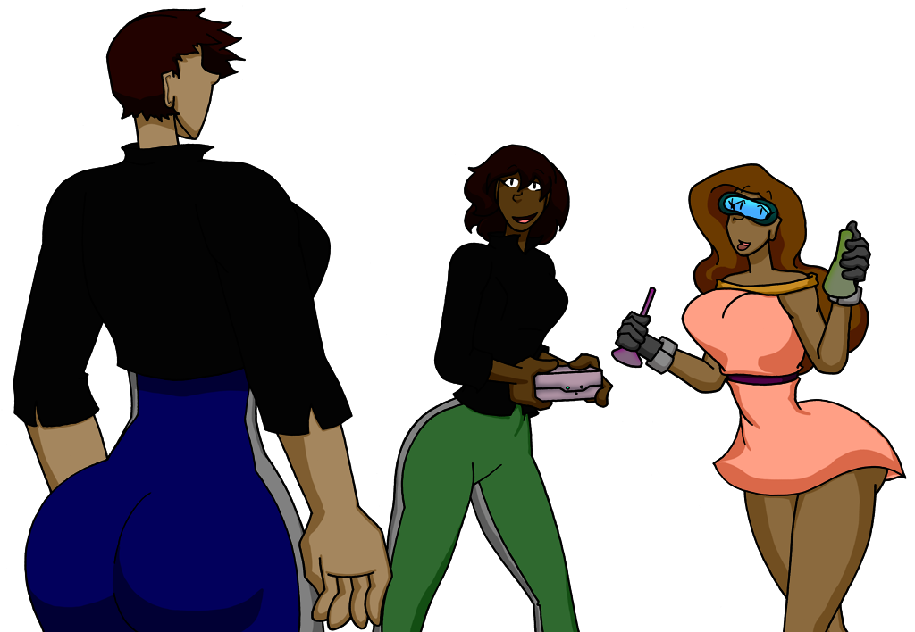

“Comms. Doc. How you holding up today?”

Doc brushed back a lock of the hair that grew out rapidly and nodded towards his unmissable bosom. “Third day in a row they haven't grown so it's promising.”
He pulled up the dress's top and tried to pat down a skirt that was failing to cover up as intended before taking the box from Comms and feeding a wire through the side.

Captain nodded. He wasn't sure if the researcher got a different strain or it was the squad's own genetic engineering that held off the worst effects of the disease, but the new guy was doing the best he could and clearly was trying to put on a good face for his squad.
“What's the screen say, Doc?”

“The best we've come up with based on the scans and samples we've taken are that the societies and planet died out a few centuries ago. Without men, there were no more births. The final generation just lived their lives, cleaned up, and... turned the lights out after themselves.”

Cap nodded. The story hadn't changed after the pair started more intensive study. “Any 'why's yet?”

Doc shook his head, brushing back his hair once more. “No idea, but it's supernaturally powerful whatever it was. It could have lain dormant for generations to spread before being triggered and hit the whole population at once. Or maybe men just stopped being born until the final generation was all female? We can't tell much because all the scans and samples register as natural females. ...Same for us. Safest bet would be that it all started with the humans but eventually spread out, infecting animals too. Eventually, the only thing left on the planet were creatures that could asexually reproduce.”

Captain leaned against the wall and closed his eyes. “Comms, call upstairs and request the next supply drop and confirm cancelling the next visit. For the safety of the Collective, we're quarantined down here until they ship us down some answers.”

Doc raised a finger. “And another batch of new clothing, please. The last drop was outgrown faster than hoped.”

Captain nodded in the affirmative. “Add it to the list, Comms.”

***********************************************************************************
Read more Mercynaries comics and stories at: https://www.patreon.com/SinComics

