KINGDOM HEARTS PLUS!
JULY 2021 REQUEST STORY
BY CHALDEACHANGE
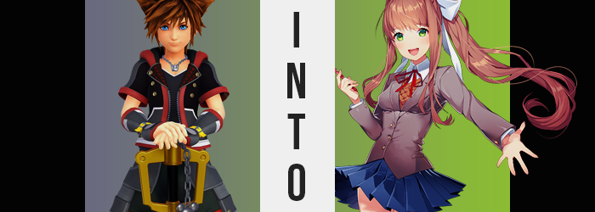

“I think I’m going to go crazy if this keeps up!”

Perhaps Sora was being a little dramatic, all things considered, but he just didn’t know what to do about this. He’d spent all night doing his best to try and fall asleep, but much to his dismay his Gummiphone kept going off. That was all fine and well if there was someone on the other end. It could have been an emergency, right? But not only was the caller unknown, every time he picked up there was no one on the other end.

Not a word nor a breath greeted him. And the second he hung up? It began to ring again. It was honestly extremely creepy. All the more so that it continued to ring even after removing the phone’s batteries. “What is doing this? Magic?” Despite the fact that he was sleeping aboard the Gummi Ship with Donald and Goofy, neither of them was woken by the jingle at all. Sora felt like he, alone, was cursed. At least he could count out this being the work of any of his enemies. What would they be trying to do? Annoy him to death?

If so, he certainly wouldn’t die, but he certainly was growing more and more annoyed. He hadn’t slept a wink! He was on the verge of exploding! Until finally… “CAN I HELP YOU!?” The boy had been passive the entire time in his attempted answering, but he had finally had enough. Almost as if waiting for him to snap, this time there was finally an answer. Or, at least, something akin to one. For all he could make out was a young woman’s giggling. “Hello?”

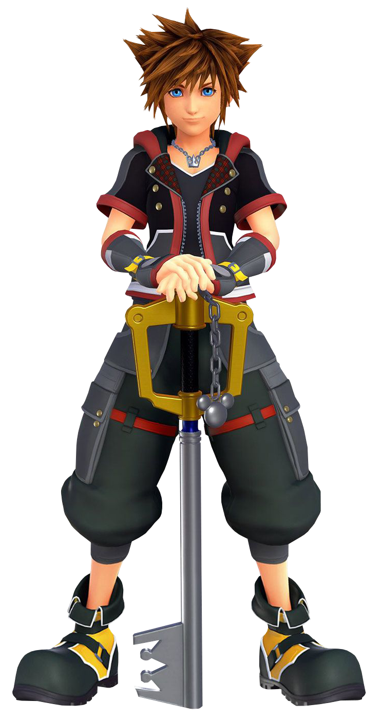
Could giggling even be called a proper response? He wondered that for a moment. Clearly, whoever was on the other side of this call was toying with him and he wasn’t a fan of it. “Look, I don’t know why you’re laughing, but this isn’t really funny—!?”

Suddenly, the sensation of falling took hold and Sora almost stumbled to the side even though his feet had remained rooted on the… ground? “Huh!? Where am I!?” He was certainly standing on something, but this was no longer the interior of the Gummi Ship. Instead, it almost looked like the inside of a computer? That was the best way to describe it based on his various digital forays across his adventures.

Everything around him was a solid blue, from the ground to the sky, to the walls – if it even had any. Rather, this place appeared to more resemble a well-lit void than anything. “This is weird…”

But this is your playground!

These words echoed in the back of the boy’s head as if they were his very own thoughts, yet to his understanding they did not match neither his inner voice nor his personality. “This is my playground? I don’t even know where this is. Not like I have time to play, either…” Unsure about what was happening, blue eyes danced around the space again thinking maybe there was a clue to be seen now. There wasn’t, but not because the clue didn’t exist in the first place.

It was simply hard to see a clue that was present in the optics you were perceiving your surroundings with in the first place. The clue was actually in his baby blues, which instead speckled bright green almost like drops of yellow dye had been splattered against his irises until not a single fragment of their past blues remained. But, more than that, the crevices of his eyelids changed – forcing these eyes to appear wider and, by extension, making them more expressive and feminine. Although, at the same time, their almond shapes certainly gave him a much more Japanese vibe.

Lengthened eyelashes certainly did Sora no favors here though, nor did the fact that his brows thinned and lightened from his dark chestnut to a rosy, coral brown. Not to be outdone, this same color soon found its way sweeping through not only the hair atop his head, but also the hair that sprouted from his arms and around his junk down below. While much of the hair across his body shrunk just as soon as the color changed, the opposite effect could be found affecting that which sprung from his scalp.

As the coral brown teased his roots, they tugged upon themselves harmlessly to yank out more and more hair; hair that ultimately had little choice but to cascade down his back as quickly as it was plucked. It tickled his shoulders in a way that was prominent enough to catch his attention, and by the time a hand managed to reach back to take hold of it, it had all fallen past his hips while all of the spikes had flattened. Framing the sides of his face was hair styled to rise and fall, but that didn’t matter to Sora.

After all, he’d pulled forward a bunch that was dangling back from behind, and it was alarming enough as is. “What the heck!? Why is my hair so…!?” Both the color and the length were wrong! Even his bangs were hanging lower than normal, swept slightly to the left. “Wait… My hand too? MY VOICE!?” Plenty was happening at once now, such as his Adam’s apple slipping away while the pitch of his voice rose higher.

There was a dramatic shift in the boy’s facial features beyond just his eyes as well, bringing femininity into the forefront of it all. Swollen, glossy lips and a petite nose soon rested between soft but narrow cheeks, his head on the whole a little smaller while his appearance better resembled that of a teenaged Japanese girl. On the other hand, or both hands, literally, what had left him aghast was just how slender his digits were. Decorated with nails that extended an inch past his tips, they certainly better resembled those of… “Am I becoming a girl?”

It was the only thing that made sense when all was said and done. From his hands to his hair, that was what all the signs led to. Yet, while this should have terrified him? The voice in the back of his head was bringing him some sort of comfort, manipulating his mind so that instead of panic, he was keener on embracing his transition.

Why wouldn’t I want to be the fairer sex?

That was a good question… Was it? He couldn’t imagine wanting to be a boy, but he was one! He was… “EEP!?” Had been one. Because the squeal that jumped from plump lips had been born as a direct result of the feeling of suction between her legs, leaving Sora with a girl’s genitals in the place of her once inconvenient dick. Why would I prefer to have a dick? It would always get in the way! …That was true, but she didn’t have to think it. “In fact, let’s hurry up the rest of this, shall we!?”

The voice that had once been a mere echo in the back of Sora’s mind was now the predominant influence in her ego. That was more than apparent based on the confidence she was now exuding, and by just how readily she had begun to embrace her change. With a snap of her fingers the clothes that she was wearing disintegrated into disappearing pixels, leaving her bare (presenting neatly cut pubes and all) just in time for the most dramatic of alterations to take place.

For example? The sides of her torso pinched inward ever so slightly, waistline presented with a notable arch while her hips swung wider in the process. It was only a few inches of width, but it was enough to leave a sizable vacancy between two legs that had once been rather close together – and had once had a dick hanging between them. If she looked a little shorter, it was because she was. But only a single inch.

With a pace to rival the parting of these legs, the space between them soon found filling; for the girth of the two legs that surrounded it were fed additional weightiness that became abundantly apparent. Pale skin stretched with fatigue around thighs that not only burst with fat, but were fed the muscle that had once existed there as well to give these legs a significantly weaker look. It was a trend that left her tummy looking soft and her bellybutton looking deep, all while likewise turning once strong looking arms into a pair of noodles by comparison.

“This really isn’t fast enough! We have poems to write, you know!?” Poems? Sora didn’t even really know what she was saying, she was just blurting out words as if they were entirely natural. As natural as the cheeks of her ass, which took on a pudge to rival her thighs at least. They didn’t bloom with any excessive meat, but the springy buttocks that the weight contributed to was both soft and round – it would certainly be appealing in the right pair of pants.

Sora looked the part of a teenaged girl almost entirely now, from the bright and beautiful face that wore an almost constant smile, to her shapely hips and rounded rear. But she was still missing something crucial, and she gave little reaction as it – or they – came into play.

Her nipples hardened all on their own, areola stretching until each nip went from an inconsequential size to the size of a large coin. They adjusted before the bosom to be even came in, and it didn’t waste any time following after. A once strong looking chest, now flattened entirely by her muscle loss, found flourish once more. But not through strength. Instead, tender teats jiggled by the contribution of fatty tissue that built the foundation of a girl’s bosom. This weight jiggled enthusiastically while expanding, skin pulled taught around a swelling pair of breasts that continued to jump in size until a fair pair of C-cups rested beneath her narrowed neckline. Sora skipped a moment in place, the jiggle of her new curves bringing the comfort of familiarity.

She giggled to herself as the rest of the mental dissonance was dispelled. Said dissonance was her old identity, though. What was left was a seemingly bright and cheerful girl. “Better!” The eighteen-year-old snapped her fingers once more, and this time it summoned new clothes to her naked flesh. A gray blazer over a brown sweater vest and a white dress shirt, decorated with a red ribbon beneath the dress shirts folded collar. A pleated, blue skirt that hardly covered her thighs at all sat comfortably on her hips, while black thigh highs and white, pink-tipped slippers decorated the girl’s feet. Of course she was now wearing the appropriate undergarments, and her hair found itself held up in the back by a white bow into a high ponytail.

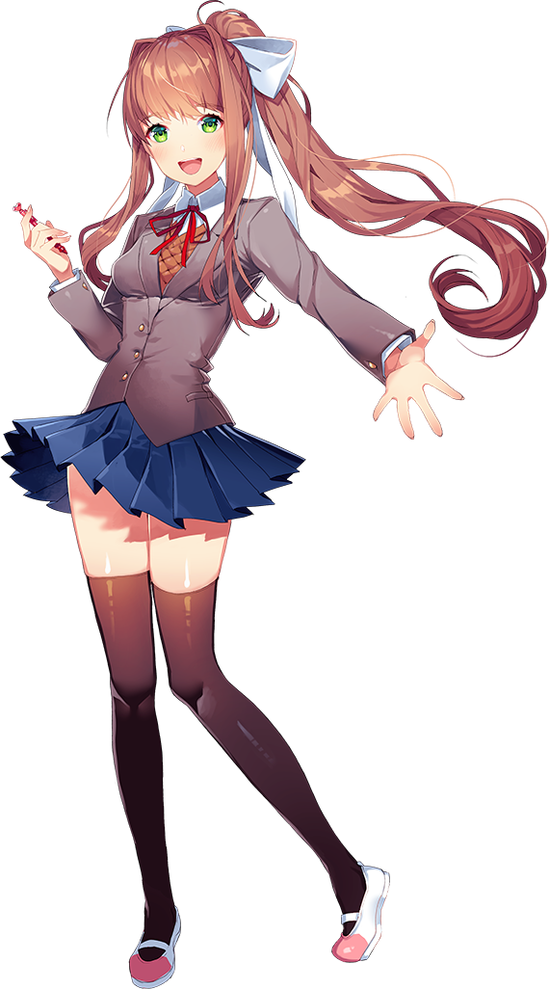
“Hmm… I’m not really digging the blue, you know? This isn’t the type of setting any high school girl should be found in!” Both dressed and composed once more, Monika gave the void around her a quick glance. Her memory was a little foggy, but this was her world, wasn’t it? So she could do whatever she wanted with it, more or less!

With a snap of her fingers she put this theory to the test. The void disappeared – or perhaps it was better to say that it had been overwritten – and in its place an old-timey, Japanese classroom took shape. Her feet rocked back and forth against creaky floorboards until she wandered over to a desk that she knew to be hers. “Mhm! Much better! This is the school my friends and I meet at every day!”

Despite how peppy her voice sounded though, there was something off-putting about her words. Or at least in how she said ‘friends’. A smirk with no shortage of menace eventually played across her lips, the girl no longer burdened by a desire to do good that had just moments before struck her so blindingly.

“So, who wants to play a game!?”

