MY DAILY SOLDIER LIFE AS A MONSTER GIRL
CHAPTER 4: MILADY
BY CHALDEACHANGE
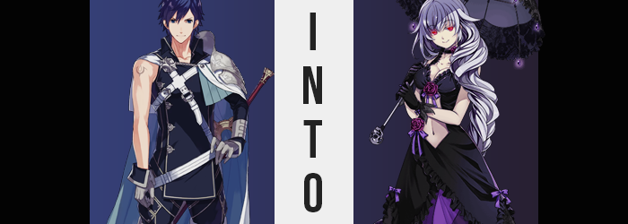

Slowly but surely, the defenses that kept Askr secure were coming undone. Night had passed, and first sunlight struck the city with calm, for whatever was meticulously picking away at the warriors of the kingdom, it was doing so with such secrecy that most hadn’t taken notice of it. Even if the princess, prince, and captain of the guard were nowhere to be seen.

“Hya! Yah!” The king of Ylisse, Chrom, was among the warriors that had been summoned under the power of Askr’s summoning abilities, and he had been spending the early morning training with his daughter Lucina at the kingdom’s training facility. His daughter had stepped into the refreshment area to drink from the fountain, but the king himself continued to swing his treasured Falchion again an invisible foe.

Like many of the warriors that had been brought here from different worlds, Chrom had seen his fare share of strife over his life’s course. He knew the power that maintaining one’s physical strength allowed, and that if he skipped even a day (within reason) that he may not have the power to protect what was important to him.

His daughter first and foremost.

So when a presence he did not recognize appeared out of what felt like nowhere behind him, the king immediately spun and pointed his Falchion at their head. It hadn’t been intentional to point it there, but the presence ended up belonging to a small girl. A girl with black twintails, and a single eye. “Who goes there!?”

The one-eyed girl merely chuckled. “My, your highness, you sensed my presence to quickly? Would you truly harm a defenseless little girl?” Playing up this unproven innocence, she raised her hands to prove she was unarmed. But Chrom did not falter, nor did he lower his weapon.

“If they meant my family harm, I would not hesitate to strike down a family, no.” He could see through her. This was a foe; he did not doubt it. But where had she come from, and what were her intentions? Before he could ask however, her crimson eye began to glow, and not only did his body freeze up, but his vision blacked out.

The next he realized; he was trapped within a box of mirrors. “What!? Where am I!?” Unlike past incidents involving the Backbeard girl, he still had recollection of being attacked. But where was he, and why had he been stripped naked!?

CAN YOU HEAR ME, YOUR HIGHNESS? I’VE ABDUCTED YOUR DAUGHTER AS WELL, I THOUGHT IT MIGHT BE FUNNY TO SEE HER REACT TO WHAT HAPPENS TO YOU BEFORE I DO THE SAME TO HER! FUFUFU!

What the child was saying didn’t make sense. Was she looking to execute him? All he knew was that there was a deep burning within the bottom of his gut. “Ngh… You won’t get away with this!” Or so Chrom said, yet he’d already been taken down to one knee. The shame he felt, knowing that his daughter could possibly watching this, that Lucina might perceive him as naked… it made him incredibly upset!

And yet there was naught that he could do about it. As the candy he’d involuntarily consumed during the hole in his memories took effect, the blue of his eyes was completely washed out as a crimson began to glow, and the color of even his hair washed out into a silvery gray. Seeing his own reflection in the mirror, he couldn’t help but think he appeared to be a much more menacing version of himself. “What...? Who…? Why…?”

It was a lot to process, and as he stared at his own glowing, crimson optics, his head began to pound as well. Painful to the point of distraction, Chrom was forced to close one of those eyes to better deal with the pain. But in the meantime? Weakness began to wash across his frame. Not a literal weakness, and in fact the more he would transform, the stronger he’d feel. Instead, it was merely weakness in aesthetic alone.

For his body became slender. Shoulders pinched inward towards his neck, and much of the meat upon his belly subsided, leaving it with an inward slope that looked more effeminate than anything. What stood out in regard to this weakness most of all, however? His thick, swollen muscles deflated almost like sponges being wrung free of any moisture they’d absorbed. Arms and legs settled at a thinness that made him appear powerless, while his belly continued to change, becoming flat without any grooves born of muscle mass. Perhaps most jarring of all, his chest became less and less broad until not a speck of obvious strength could be seen.

It all left him appearing quite waifish.

His height had not, and would not, decrease, but the king could not help but feel like he was looking at a completely different person. Still, his stomach still churned as the candy he’d consumed radiated with the power of a curse, and he could not bring himself to stand even though he felt angry. “Why you…!” A thought stopped him from getting too angry though, or perhaps it was something more like an impulse.

A true lady wouldn’t let her anger show.

Chrom’s expression softened a little in response to this, scowl giving way to a much more neutral expression. The softening was actually much more literal than first intended though, as femininity washed away his masculine facial structure, melting it all down to something much fairer and naturally beautiful. This meant softer cheeks, rounder eyes, longer lashes, a petite nose, and abundantly sized lips. In fact, he could no longer recognize his own reflection any longer after the crawling that had seen his face changed completed. But she? She could recognize her own reflection.

While the king’s face had been in the process of shifting, his genitals had undergone a timely transformation of their own. Balls had folded inward first, almost as if they were sucked up into a new gap at the base of his pelvis. But his dick? It followed suit, the head flattening by the time it was tugged up into her pussy, leaving what was left to fold into her new lips. Silver had already decorated her pubes just as it had the hair atop her head, and so all that remained was for them to be shaved into an intended landing strip.

“Oh my!” She blurted out, both in response to the feeling of having her genitals replaced and the new, womanly shape of her facial features. The phrase, delivered ever so much like your stereotypical princess, was communicated with her softer lips, in a much softer and womanly voice. It had all been shocking, truly, but while she hadn’t recognized her own reflection for a moment, it all looked so familiar now.

Meanwhile, back down at her waist, her hips had begun to widen into more ladylike proportions. They grew several inches outward, creating a gap between her thighs and shifting her posture, which was still on a single knee, slightly. That gap did not last long though, not as fatty tissue found its way beneath the surface of her skin, bolstering their size and shape alike so that they were round and tender. Only the slightest gap remained in their wake, and through it?

You could make out her ass. At least, once it had finished a growth of its own. It bubbled with womanly meat, bouncing to attention, and jiggling with delight, blessing her with a rump like a peach. Higher up, nipples erupted, engorged and thick, to signal the advent of the tits that would swell from a chest once rife with powerful muscle. These breasts were large, but as they jiggled with life it was clear that this size would not be too excessive, settling with a boing in the realm of smaller D.

The pain and energy radiating from the depths of her tummy finally waned, and the Hel woman rose to her feet once more, sweat pouring from her naked flesh. “Well, that was an unsavory experience. And I’m afraid my memories are quite jumbled. My name…” Holding her head, she was unsure of her identity briefly. She would recall, but not before the last ounce of the candy’s curse saw her properly clad in suitable attire.

A lacey, black dress swathed her sexy visage, exposing her cleavage and being sure to reveal her navel with a well-intended cut out. Purple ribbons and bows accessorized this ball gown, with a black rose stationed at the lowest point of her cleavage. Matching, black gloves wrapped around her hands, and heeled boots lifted her step ever so slightly.

But it was her hair that stole the show. Like a sea of snakes it began to crawl, slithering longer until it spilled far down her back, before being hoisted over the front of her left shoulder by a mysterious force which likewise braided it near the bottom. She could smell the scent of rose perfume wafting not only from this voluminous mane, but from her entire body, and it reminded her of home – and her name.

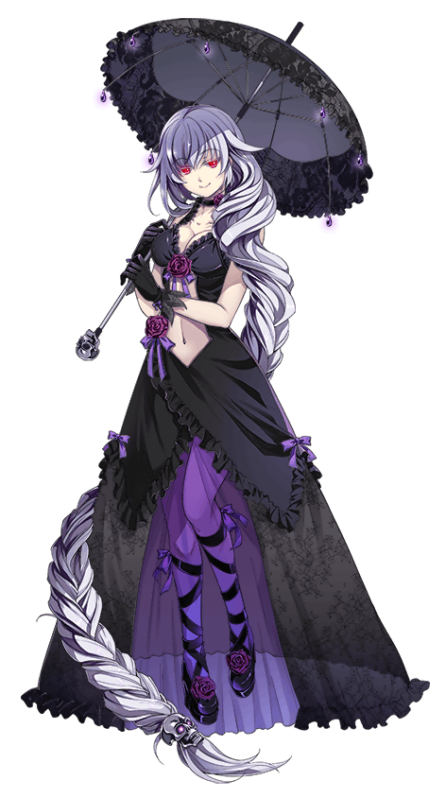
The Hel, Halifa, raised a single gloved index finger to one of the mirrors that contained her. Despite the fact that Chrom could not topple them with all of his strength, her touch alone was enough to shatter the entire box, and she stepped out of it with great elegance before dusting herself off. Her red eyes glowed with delight as she looked around.

“Ah, so I was brought into the confines of a ruined castle?” That certainly seemed to be the case, and she could sense the presence of other monsters as well. Not to mention a great power that even she knew she would need to respect. “The aesthetics are lovely, but I do believe I could use some company.”

She glanced around the room, sparing no time for the shattered glass on the ground even as her heels crunched against it. “Could you fetch me a partner, dear Backbeard? I happen to have an itch I just cannot scratch, and I can hear you behind that door.”

Surprised she’d been sensed, the one-eyed minion peered around the slightly open door. “No, but one will be ready for you in just a moment.” After all, Lucina had been pulled away in despair and was now being subjected to her own transformation.

