Minding Madison  Inspired by this Captioned Image  Who is the Author?  By Maryanne Peters  We had an older brother – older by quite a few years. He was everything that my father wanted in a son. I guess I worked that out early. He was the muscular athlete while I was the skinny wimp.  And my sister was everything that my Mom wanted in a daughter, when she finally arrived. She was so pretty – everybody told her so. She grew up believing it.  Who was I, on the lower side of middle? I was always told to “Look after your sister Madison.” It seemed as if that was my role in the family. But actually, I didn’t mind that. I think that I am naturally caring person. They say middle children can be counted on. If that is right, that would be me. | 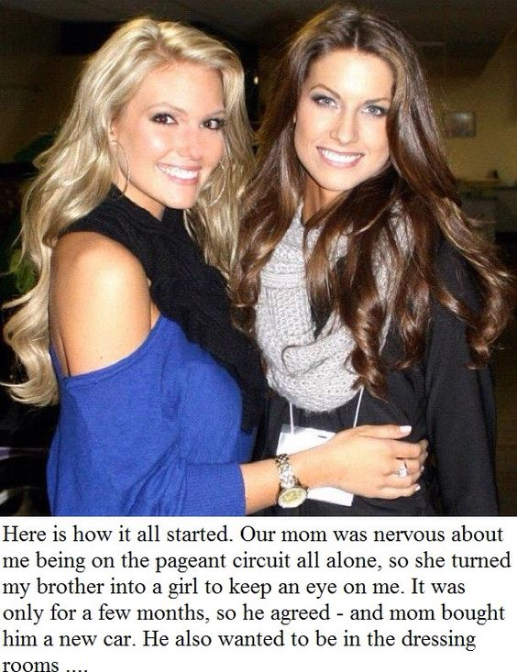

“Your sister could really go places on the pageant circuit,” Mom said. “I would be there for her but I just cannot spare the time away from work. Whereas you have no work at the moment. If only you could be there for her. But they don’t approve of pageant Moms, and they certainly would allow geant brothers in the dressing rooms…”.

I said that I would be happy to help. In fact I was bored and would have been happy to be surrounded by pretty girls, but Mom was right, it was a job for a sister, not a brother.

“Perhaps you could be her older sister, just while she is in tour?” Mom said.

I just laughed, but when I could see she was serious I told her that I might consider it if there was a payoff. In fact I said if she bought me that car I was looking at, I would do it. I guess I did not realize just how far Mom would go to support Madison’s ambitions.

I was just supposed to be Madison’s plain older sister – an awkward tomboy. I was never supposed to look anything near attractive, let alone beautiful. It was just that when you are surrounded by beauty queens, everybody wants to make the older sister “a project”. The hair extensions and the shaped brows – it was all their idea, not mine.

I never thought that I would end up looking as good as I did. In fact, there were plenty of guys who said that I looked just as pretty, maybe even prettier than the girls on stage. By plenty of guys I mean boyfriends, fathers and maybe a brother or two. Supporters like me, but without access backstage. But the difference is, so I was told, was that I was not vain and selfish like those girls – I was a nice person. I was a naturally caring person – somebody who could be counted on.

Suddenly I seem to have found my place.

The End

Black Beta  Inspired by this captioned image  By Maryanne Peters  Mike was always giving me a hard time about being white. I never begrudged him. I like being white. We all know being black in this country can be a hassle. It seems fair enough to let someone like Mike play on the old trope that old Alpha male African American trope. But he did go on just a little too much.  There was a feminization boutique starting out in town. You know the thing: “How would you look as a woman. You might never want to go back. Try our long weekend makeover and deportment school. Become a gorgeous woman. You might prefer it to manhood” | 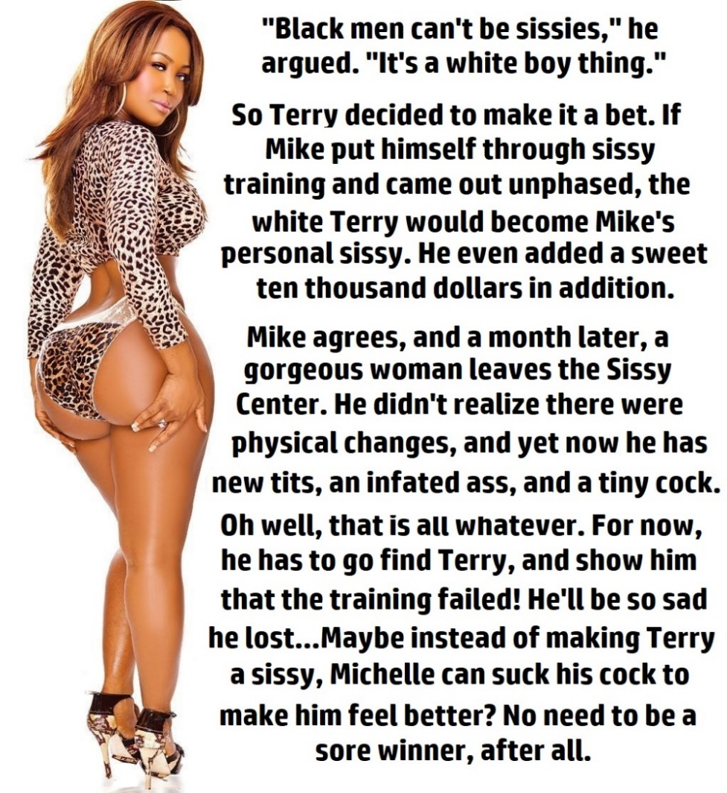

“Black me can’t be sissies,” he said. “It’s a white boy thing.”

“I’ll pay for the weekend,” I said. “I would send you to that Sissy Center, whatever they call it. I would just like to see you as a hot black babe. I would pay for that.”

“How much would you pay me for that, Rich Boy,” said Mike. “Put $10,000 down on it and I would.”

“You want money? Are you afraid you would be affected?”

He laughed. He said: “No chance. Whatever they do, they won’t be able to hide the real me”.

“That’s a bet!” I agreed to put the money the down. The Sissy Centre (real name: “The Woman in You”) agreed to hold the funds.

Mike went in on Friday afternoon and was due out Monday. But on Monday I received a call from the Centre.

“Michelle is looking for further treatments and procedures, and is wondering if some of the stake money we are holding can be used for that”.

So I said: “Michelle huh? Well, I guess that means I have won the bet. It means that Mike has accepted that she is a beta male after all. So sure, go for it.”

I could not wait to give Mike a hard time right back at him, but he did not come out that day, nor any day for the whole week. And then the week after I just got some text messages from Mike. Strange messages like: “I’ll be out soon” with a heart emoji at the end. And simply signed off “M”.

I have to say I thought that he must be playing a trick on me. He must have left town for work or something and be playing some kind of long joke on me. But when I called his work, they told me that he had sought and been given, extended leave.

Then, it is must have been close to a month after we made the bet, I got a message to say: “Our usual place. 8pm. See you there. Cant’ wait. M”.

So I sat there, and I walks the sexiest black woman I have seen all my life. Dressed in leopard print long sleeved top with a plunging neckline showing off huge tits, and a short black skirt barely hiding a huge sexy butt, her skin was golden and her hair straight. Her skin color was like Mike’s, and his hair was straighter than most. Just a minute. Could it be?

She walks straight over to me with a smile on her pink painted lips, her huge eyelashes fluttering at me beneath shaped brows.

“It’s Michelle now,” she said.

I was gobsmacked. I may have muttered something. She came up close and kissed me on the cheek, her perfumed hair falling across my face, the smoothness and softness of her thrilling in the contact. I could not say a word.

“I spent all the money, but it was mine, so you still owe me $10,000,” she said.

“What?” I could barely say even that.

“I told you that they wouldn’t be able to hide the real me, and they couldn’t. This is the real me.”

And so she is. Michelle, the black beta to my white alpha.

The End

Turning a Corner
A Vignette requested by Emily
By Maryanne Peters

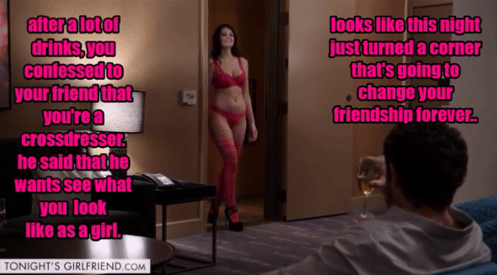

I am not normally a heavy drinker but that night I felt that I needed to stay with him, or try to. He is a much bigger guy after all so when I could I tipped some of my wine into his glass. Wine can creep up on you, and maybe it did that night.

He had broken up with his girlfriend of three years and there was no second chance – she had found somebody else. We talked about the usual flaws of womenkind – they are two-faced and cannot be depended on. Men are not like that, and we were men. He knew that he could depend on me and he said so. We had been friends a lot longer than three years. We he needed me I was there. What woman would do that?

In a drunken moment I told him that I had a feminine side.

“When does she appear?” he laughed.

“No. I mean it. I like to dress up as Virginia, or Ginny, every now and again. Just in private. Just as an expression of another me. It is just an escape, I guess.”

“You’re serious, aren’t you?” he said. I felt very small and stupid, and suddenly he did not seem so drunk. “I would like to meet her. I would like to see what you look like as Virginia.”

The milk was spilt. The horse had bolted. You can’t unsay words already spoken.

He was not going to let go. He started asking me questions about Virginia. What kind of woman was she? Was she sexy, or more domestic?

I said that she was shy – very shy. I did not want to do it. But he bought another bottle of wine and insisted that we finish it at my place, which was only a few blocks away.

The walk sobered us both a little, and the prospect of shame perhaps a little more sobering for me. I needed a steady hand to attach my breasts, prepare my face and apply the makeup. I put my long dark wig on. I shaped my eyebrows a little with tweezers and a brush. Because I had endured a full body wax only a few days before I decided to show him the maximum I could. Just a bra to hold my tits in place as the glue cured, and panties to hide my bulge. Plus heels of course, to show off my legs, which I always considered my best feature when in drag. The last thing to be added was the scent “Pherazone”.

I turned the corner into the living room. There he was on the couch with a glass of wine in his hand. I gave him my best pout.

His jaw fell open. The look on his face made me smile.

“Where did those breasts come from?” he said.

“They’re fake,” I said in my special girl voice. “At least for the time being.” It was a silly thing to say. I only dressed a couple of times a week, or maybe more if I could. I was teasing him.

“But those legs are sure as Hell yours,” he said. “And shaved. And that belly of yours. It looks so soft. Come over here and let me touch you.”

I strutted over to him, suggestively. It seemed as if Virginia had taken over. It was her flirting with my friend. It was not something that I would ever do, but she seemed right at home and not at all affected by alcohol. Perhaps it was because I was the I was giving her free rein.

“You smell so good,” he said. “Your skin is so smooth and soft.” His words were like warm syrup. Who cannot be affected by words of flattery and a loving hand?

“Do you make love like a woman too?” he asked. I should have been shocked. I should have recoiled in horror. But I was not in charge – she was.

“I am a virgin,” I heard her say out of my mouth. “I told you I was shy. I don’t go out at all, let alone out to look for sex. I have never laid with a man. You will have to be very gentle with me. Are you sure that you don’t mind this little …”. I pointed to the slight bulge in my red panties.

If it raises it’s head I will slap it down,” he said.

“Okay,” I whispered sheepishly. I went over to the kitchen cupboard and took out a bottle of olive oil. It was all that I had and I knew that I would need something by the size of his bulge appearing.

As we turned the corner to my bedroom he lifted me into his arms. My tongue was in his mouth as he laid me gently on the bed.

The End

Stress Free Life  Inspired by a cap by Becky for John Number 80  By Maryanne Peters  I worked in public relations. It is stressful work. Your clients’ problems become your problems. Sometimes that it seems that everything is your fault, or the people talking to you make you feel as though it is.  I took on more work than I could handle too. It seemed easier to do that, so that I did not need to have a life outside of work. It was fear of that life, I guess. The fear that I might destroy myself somehow.  I suppose the various people who are like me always deal with their issues differently. For me it was work. As long as I was working, I had no time for regret – no time to think about what I should have done when I was younger, and how transition might have been easier if I had. I was too busy – I made sure of it.  I know there are transpeople out there who find other ways. They get married and have a family and tell themselves that a rewarding private life will correct them.  My problem with that is that you suck others into your nightmare. I figured that at least with work I had no commitments that I could not leave behind one day.  I had no time for dating, so certainly no time to chat to potential partners. If I had then I would have faced the question whether I wanted to date a woman pretending that I was a man, or date a man pretending that I was a woman.  No, I met John professionally. He was passing on a client as there was a conflict of interest. He had heard that I “give everything to my clients”, and I guess that was true. All I had then, was who I was then, and that was not so much. | 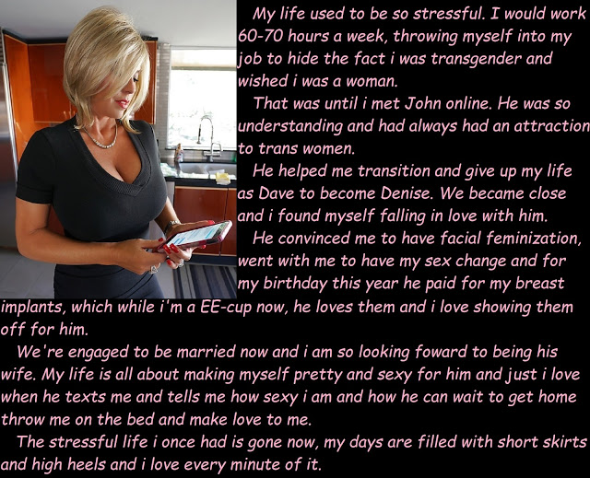

We were talking about nothing in particular, but it was work without calling for concentration, so it was a welcome relief. Somehow that subject got on the subject of transgender women – don’t ask me how.

“I hope that you don’t think that I am weird, but I think some of those transwomen are very attractive,” said John. “Even the mature ones who leave it until later in life. I am not sure what it is but it seems to me that they have found a state of grace, like living one life and moving on to a higher state.”

What a thing to say? But it touched me. Somehow it seemed as if fate was sending me a message through this total stranger. For the first time in my life I actually told somebody the truth about myself. The words just spilled out.

“Actually, I am a transwoman. I am a frustrated transwoman living as a man.”

I felt like bursting into tears but at the same time I felt such relief that I really understood what the words “getting a weight off your chest” really mean. That was exactly how it felt. It was as if I had been gasping for air with a pile of bricks on me, and then suddenly it was gone.

“We haven’t met, but now I feel as if we should,” said John. “But Wouldn’t want to meet Dave, I would want to meet her.”

“Denise,” I said. “Her name is Denise.”

It seemed crazy, but it also seemed that the track had shifted, and I was now on the express line to womanhood. Of course that was not true – I could have got off anytime, but I was determined that when John met Denise he was not going to meet a drag queen. I booked a “Transformation” and for the first time in years I took sick leave and went about training my voice and my gestures using all the online resources available.

The boutique called me up and suggestion a full body wax in advance, plus facial waxing. My skin would need time to relax after enduring that. All the pain was a joy to me. It felt as if I was tearing away clothes that on fire, and ugly clothes at that.

When I sat down for the final work on the day of the date they said would I be happy to have my eyebrows plucked or should they just mask them.

“Make me a woman,” I said. “I don’t want to go back. She suggested extensions to my hair rather than a wig, shoulder length and caramel brown.

I had brought a dress on line, and something to go under it to give me the shape I wanted. I wanted a full figure. I wanted to be womanly.

I suppose that there may have been a nagging doubt that John would see me and be repelled, or worse still that he would laugh at me. But he was waiting for me, with an orchid in a tube in his hand, just as he said I would know him.

“You cannot be Denise,” he said. “You are absolutely gorgeous.”

I am not sure if I fell in love with him then and there, but if I didn’t then I should have.

This is me now. The hair is all mine and blond now that the extensions have been cut. It is little further forward since the facial surgery removed my heavy brow. And the breasts are implants. They are an EE cup which is a little larger than I might have asked for, but as John paid for it all he should have the right to choose. Now I would not have them any smaller. He loves them and I love the way he looks at them and fondles them in bed.

I paid for the bottom surgery. It seemed only fair. I collected a severance package when I left the firm, which including a covenant that Dave would not compete, so I spent that money burying Dave. I am out of PR now. I only want to be John’s

Now there is no obstruction to that and I am keeping busy at the home that we share making plans for the wedding. Here’ a message from him now.

He wants to come straight home and have sex with me. God, he knows I want to, but I want to be fully healed for our wedding night. But he has nothing to worry about. I have all of the experience and know exactly how to please a man.

All he wants is what I have, and what my mouth and my tongue can give him – a stress free life!

The End

Lush  Inspired by a Captioned Image  (please help identify the author)  By Maryanne Peters  It happens sometimes – a young drunk comes up to you in a bar and starts telling you his life story. It was not the kind of bar I usually go to, but I have been known to act on impulse sometimes, and I just needed a drink.  He said his name was Carl. He was scrawny and had long hair in a greasy cue, and a few scant whiskers on his chin. He said that he worked in design, which just happened to be my business too, but I did not tell him.  It was just as well as he embarked on a long sad story about losing his job and being unable to find a position anywhere, and about finding comfort in the bottle.  I would have sent him away if it were not for the fact that I saw something in him that I found both familiar and confusing, but I could not put my finger on what it was.  It was only when he bumped into a woman coming to the bar behind him and she gave him a dressing down that I realized what it was. After the woman walked away he straightened himself in his seat and he said to me: | 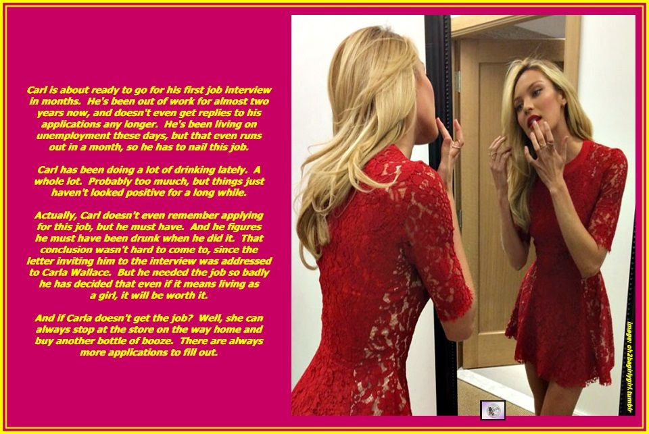

“Don’t touch me, you’re drunk!” He gave a pitch perfect imitation of the voice and her demeanor of the lady he had bumped into. He could have been that woman. He could have been a woman. He could have been my late wife. That was the reason why he seemed familiar. He even had the look of her, with the strong jawline she had.

The barman refused to serve him, and after letting him remonstrate for a few minutes I offered to drive him home. That way I discovered his address and some more about him. I sent him the job offer the following week, but I made sure that it was addressed to Carla and not Carl.

Then, the day before the date of the afternoon interview I sent to “Carla” a package containing the red dress with some form wear for underneath and some shoes in his size – I had checked these while he slept after I had driven him back from the bar. And I included a voucher for the local salon and spa for “The Interview Appearance Makeover as Specified” bought and paid for by me.

What would he do? Exactly how desperate was he?

When he turned up as Carla the following afternoon I was pleased, but I figured that he must have been very desperate. But to be honest, I am now not so sure. Did he remember the man he met at the bar? If he did, he did not let on. I thought he must just have been very drunk, but how drunk was he?

And since she took the job, he shows no sign of wanting to present himself or herself (now I am confused) as Carl rather than Carla. And she does apply the lipstick with inordinate skill.

And then, is Carla flirting with me? Sometimes it seems so.

And I have not seen her touch a drop of alcohol. Come to think of it, I never actually saw her drink at the bar the night we met. The smell of alcohol was on her clothes rather than her breath. All in all, it just adds to the intrigue that is this remarkable woman.

The End

© Maryanne Peters 2022

