WHAT A PAIR
BIWEEKLY STORY #73
BY CHALDEACHANGE
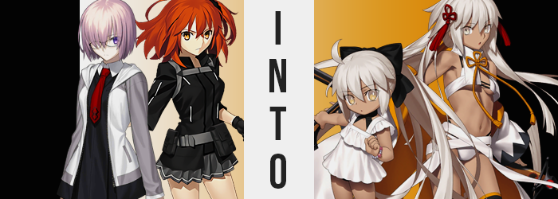

It was very, very strange for Mashu to find herself entertaining the company of Oda Nobunaga. The Archer had crashed into her room without notice, and before the Demi-Servant could make sense of the purpose behind the visit her room had been practically turned upside down! Where did the kotatsu in the middle of her room come from? Her bed was even gone!

…Not that there’d been much else in the room other than the bed anyways. It was hard to own things when you spent your entire life holed up in that space.

Before she knew it though, she had ended up caught in Nobunaga’s pace. She was sitting opposite the Japanese girl, with a large sword now laying across the kotatsu’s table between them. “Um… Isn’t this Okita Alter-san’s…?” It was her katana, wasn’t it? She’d given it a name and everything, something Nobunaga was quick to remind her of.

“Umu! You’re right! This is that tanned Okita’s precious blade, Rengoku! Or, well, it’s a replica! Ahahaha!” Nobunaga seemed content with laughing her ass off, but Mashu hardly understood the comedy in what was said. Had she missed some sort of punch line? Before she could even pose that question, Nobunaga had slammed her hand on the table. “This isn’t the real Rengoku though. It’s something like a copy, and something went a liiiittle wrong. So I want someone from Chaldea to hold onto it for the time being!”

There was a lot to unpack there. A copy of Okita Alter’s sword? Something had gone wrong? She definitely needed a little more context here. “Uh… What do you mean that something went— Eh!? Nobunaga-san!? Where are you going!? At least take back the kotatsu and give me back my bed!”

Evidently, Nobunaga felt she was too busy to answer questions considering how quickly she got up and bolted for the door. “Sorry! In a rush! You’ll do great, Mashed Potato-chan!”

“IT’S MASHU!”

Eyes dropped back down to the extremely long katana sitting on her (apparently) new kotatsu. “I guess I need to do something with this. She just said to leave it with Chaldea, so maybe I should bring it to da Vinci-chan?” Despite the sword’s size, Mashu was confident she could lift it. She possessed the strength of a Servant after all. Yet, the moment she picked it up? Something felt very wrong, so much so that she immediately dropped it. “What was… that feeling?”

The best she could describe it was like ‘something’s essence leaping inside of her’, strange as that sounded.

But strangely sounding explanations hardly did any injustice to the fact that Mashu was now at the mercy of a power that she didn’t understand, and she was very quick to learn that. After all, she immediately felt something off about her own body. It was a feeling that provoked her to look down at her chest, and no sooner than she had? The front of her dress emptied! “M-My breasts!?” Hands wasted no time reaching up to pat that area thoroughly, finding only empty bra cups and tiny, underdeveloped nipples. “H-How!?”

Just as quickly though, her clothes tightened around this area. Her bra basically disappeared, but the dress was rewoven to accommodate her, uh, lack of tiddy so to speak. But not very long after, a similar power saw to the dress’ skirt and the fit of the tights around her legs, for both her ass and thighs had dwindled away into nothing. A flat butt and thighs that only held the slightest bit of weight.

“This can’t be happening… Did the sword do this?” What else could be the cause, really? She had to find someone that could help reverse this, or at least that was how she felt… but Mashu would soon find doing so would bring about some difficulty. First of all, she probably needed to bring the sword. Which was now missing. “Where did it go!?”

There was nothing on the kotatsu, and that didn’t change regardless of how high on her tippy toes she stood! Wait… Wasn’t something wrong with that statement? Why would an almost fully grown woman need to stand on her tiptoes to see the top of a short kotatsu? “E-Eh!? Now I’m getting smaller!?” Voice climbing higher and higher as it happened, it was almost like the Demi-Servant’s body had been stuck into some sort of compression chamber.

Her limbs shortened along with the hands and feet attached to them, and while length was lost, there was a delightfully cute chub left to everything that remained. Whether it was an adorable stomach bump, or just how soft her chubby arms and legs appeared, once she bottomed out at 2’8”, there was no denying one very obvious reality: while she still resembled Mashu, she now appeared as herself as a toddler. Her mental abilities had been left untouched though, and her clothes had all shrunken along with her – including her glasses. In a way, she almost looked like a Chibi Mashu. Or a living Nendoroid.

“Why on Earth did I…? I look like a small child!” Flailing about, likely too small to even reach the control panel for her room without jumping, she was really just in awe at herself. Since she hadn’t been born naturally, Mashu didn’t really have any memories of when she was small. Her body felt cumbersome in its smallness. While flailing though, something else did catch her eye. On one of her tiny, little hands was a dark brown marking. Was it a freckle? “There’s more of them…”

Not only on the front of her hand, but the back of it as well! No, pulling up a teeny sweater sleeve revealed that they were all up her arm too, and they were multiplying! At an astounding speed they filled the gaps of white, ultimately blending into each other as the child’s complexion was irreversibly altered. Skin dyed a dark tan, Mashu couldn’t help but feel like it seemed familiar. “Hm…”

Simultaneously, however, the mauve in the girl’s hair was washing out. It dangled longer and longer behind her in the process, falling to her feet while a ribbon tied the white that remained into a big ponytail. Gold shone in her irises around the same time, with pupils inverting so that they were as white as her hair. The corners of those eyes narrowed, and her chubby face took on some familiar features. The features of a Japanese Saberface. Like Okita Souji. Or in this case, a tiny Okita Souji Alter.

Her clothing turned to golden particles that left her naked for but a second, for they reattached themselves to her Saint Graph so that she ended up clad in a frilly, one-piece swimsuit. The feeling of bare feet against the cold ground made her shudder and pout.

“Uhh…? So was that really the sword’s doing? Why?” Everything had happened so quickly that Mashu had hardly been allotted a moment to compose herself and process what had happened until it was already too late. This wasn’t a situation she could undo all by herself, clearly. But it really could have been a lot worse.

Her memories and identity had been preserved wholly though. She smacked round, chubby cheeks with her little sausage fingers and tugged at her bathing suit. “I’m a kid, right!? But why is my skin so dark, and my hair so light?” The colors reminded her of Okita Alter, actually. So had the fake Rengoku really been the trigger!? “This is bad! I should find Nobunaga-san! Or at the very least, Senpai!”

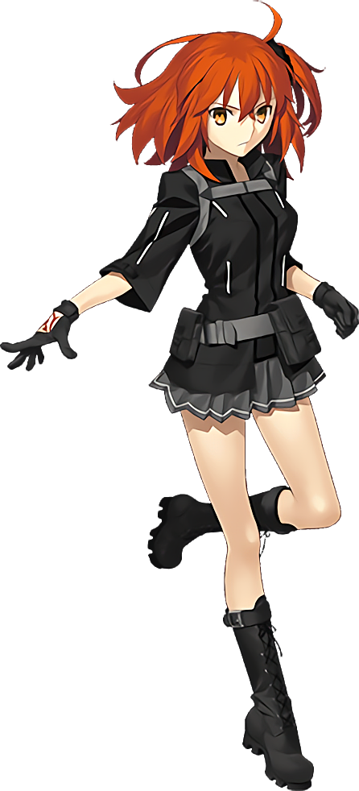
In the end, her search for Nobunaga turned up little. How did a Servant just straight up disappear!? Well, they could go into spirit form and that was likely what Nobunaga had done, but the ill result was that the tiny child, no older than three or four in appearance, had been given no option other than to visit Ritsuka Fujimaru in her own quarters. And on sight?

“Aww! What a cute little Okita-chan! Are you lost? Do you want some candy?” Mashu’s Master began to fawn over her on sight, clearly so caught up in how adorable the child was that she hadn’t stopped to ask how she had come into existence in the first place. Ritsuka was pinching Mashu’s cheek and everything, forcing the little girl to withdraw.

It took her a moment to recompose herself. “N-No, senpai! It’s… me? Um… Senpai? Is something wrong with your eyes?” Halfway into her first attempt to try and explain things she was forced to stop before she could do any convincing. Something more pressing had come up – namely the fact that Ritsuka’s eyes had begun to glow a mixture of silver and gold. Like Okita Alter’s.

She really shouldn’t have let her Master touch her, because now the effects had spread.

“Rengoku? Why are you calling me senpai? No… You’re not… I’m not…?” The woman shook her head and took a step back. What was going on with her memory? It felt off somehow, and while she should have been made anxious by this realization, it instead pacified her. No panic was worked up at all – perhaps because she recognized herself to be in good company? Her little Rengoku was here after all!

Fluffy white began to dye the tips of Ritsuka’s hair, and it wasn’t long before it swept entirely through her natural ginger much like the very same color had stolen Mashu’s mauve. Continuing down that similar vein, it soon blew out behind her, hairs incredibly long and straight wriggling down behind her like snakes. Not even her ahoge was spared from its grasp!

Now, Mashu had been trying to call out to Ritsuka while this happened. If she got her to realize what was happening, perhaps, then maybe they could slow the effects somehow? That had been the intention, but Ritsuka wasn’t listening at all. It was like she had checked into Cuckooland because her mind had begun to wander densely off to topics that shouldn’t have been as pressing as her body transforming! Things like ‘What am I going to have for dinner?’ and ‘Isn’t Rengoku just the cutest?’. You know, important things.

Tanned speckles soon found their way across her pale skin, bringing about a third similarity for her to share with the transformed Mashu once her flesh was entirely dyed. More and more, she began to resemble Okita Alter – and this was clear enough in her face too. While a Japanese native, her eyes still took a sharper angle as if to accentuate the silvers and golds of her eyes even more strongly. More and more, her face continued to take on that standard Saberface look. Whether you loved it or hated it, there was no doubting it once you saw it.

“Mm… I’m hungry.” With a voice that now sounded like a deeper variation of the voice that Mashu now spoke with, she began to state her thoughts aloud much to the child’s dismay. It was clear that Ritsuka wasn’t listening, and without seeing under her clothes the older woman already looked more or less identical to the real Okita Souji Alter.

Beneath her robes, however, some final adjustments were underwear. Her overall figure was becoming much trimmer – what with muscles tightening to the point that they almost looked non-existent in her arms, while her tummy had become so tight that it was practically rippling. Fitness saw her legs lean as well, and overall both her thighs and booty had become much slenderer than Ritsuka’s typically were. Strangely enough though, they were also slenderer than Okita Alter was normally, as if she wasn’t even whole.

This was exemplified similarly by the young woman’s tits, which diminished gradually while muscles saw the rest of her body lean out. Once impressive for a young Japanese woman, they were practically halved in size and didn’t at all fit into the cups of her bra as paltry B-cups. Again, this size was smaller than the Servant she was based upon was usually seen with.

In a flash of gold, her clothing turned into particles and began to swirl around her once a Saint Graph had been established within the depths of her soul. With her tanned flesh momentarily naked, it was clear just how lacking her figure was. She was even shorter than the regular Okitan. But deep down she knew why, and Mashu seemed to understand it as well. After all, they had someone become one. They were two pieces of a puzzle, and if they became whole once more that figure would be returned.

The sparkles returned to her skin and solidified, taking the shape of a white bikini with a haori draped over her arms. Black thigh highs with gold trim clad her legs, and red decorations lingered in hair that hung loose behind her. And, just like that, her transformation was complete.

Mashu was horrified by the final result. Her words hadn’t reached her Master at all, and now standing before her was a carbon copy of Okita Souji Alter. Was she really a carbon copy though? In terms of chest and height, she appeared to be a little lacking. Not to mention her connection to this woman felt far more intimate than it had been as Master and Servant.

Because they were now one in the same, of course.

“Rengoku? Why are you looking at me like that?” The new Okita Alter crouched down before the child and rested a hand on top of her head. Each attempt she’d made to convince her senpai of her old identity had ended in failure, so deep down Mashu knew she’d have to try and pursue a different route going forward. She left her gaze downcast for a moment, before looking up to smile at the Okita.

“It’s nothing, my lord!” Something deep down told her that this was the best way to reply. It honestly felt natural. Disturbingly so. “Let us get something to eat, shall we?” And so, hand in hand, the two wandered off towards the cafeteria. But at her first chance of doing so, Mashu was going to run to da Vinci-chan to help.

If she could even remember by then, that is.

