**CHAPTER 1**

**COVERING HER TRACKS**

Allison took a look to her left and then right, there were 5 guys, and 4 girls including herself making a group of ten. Everyone had the same look on their faces, a mix of fear and anticipation. They had been dropped off by plane onto an abandoned beach with nothing but a giant locked box sitting before them! Behind them was a thick dense forest covered in vines and brush!

All of them had been selected to compete in a series of challenges known for being outrageously dangerous! In each competition, 1 female and 1 male winner were crowned, the others were all killed in the process!

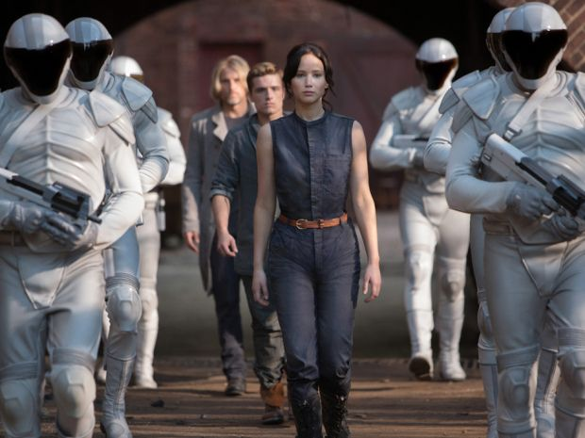

They were minutes away from beginning and Allison wanted to cry! She was not fit for this kind of thing! At barely five feet tall she looked like a child next to the other competitors! None of the men or women around her were speaking, all of them stretching, trying to mentally and physically psych themselves up for what was to come! She began to do the same, mimicking to try and not stand out, she couldn’t stop herself from shaking with fear though!

Allison locked eyes with a blonde girl standing a few feet away from her, she smiled, trying to be kind, The blonde laughed a little under her breath before sliding a finger slowly across her throat, signaling that she was going to murder her! Allison looked away quickly and bit her lip, trying to stop herself from crying. She knew the blonde saw the tears running down her cheeks.

Suddenly the box before them clicked open and the top automatically flipped up revealing the contents inside! The walls of the box fell increasing the area space as multiple weapons were laid out. There were Knives, a handgun, a machine gun, a baseball bat full of nails, a bow with a quiver of arrows, and more! Everyone looked at the weapons as a voice came from a speaker echoing across the island.

**“THE LAST 2 COMPETITORS STANDING WILL WIN”**

There was a slight pause as everyone processed the information before things turned into chaos! Everyone but Allison lunged at the weapons, grabbing anything they could get their hands on! She watched as they began fighting, it was terrible, One guy got a handgun loaded and began firing off as screams pierced everyone’s ears! Allison’s heart was racing, she began to cry and did the only thing she could think of to survive! She sprinted into the forest as fast as she could, with no weapon!

Allison ran as fast as she could, tripping over vines as she got up and continued! She could hear screams behind her as gunshots rained out! Someone had got the machine gun loaded and was letting loose as bullets echoed across the beach! She kept running, and running, and running, and running until her legs gave out!

She collapsed to her knees gasping and panting for air! All she could hear around her now was the sounds of the forest!

Katniss jumped into the crowd and began wrestling to get a weapon! One of the other women pushed her back and kicked her in the chest knocking her to the sand as she gasped for air! The woman who had kicked her grabbed a large knife and turned around, coming right towards her, that’s when the gunshots blasted out! The woman froze and dropped, the knife landing right next to Katniss, she grabbed it and rolled over on the sand, quickly getting to her hands and knees! With all of her strength, she plunged the knife into the ribcage of the man holding the gun, it instantly fell from his fingers and landed in the sand! Katniss jumped for the gun but someone else had grabbed it first! Things were so chaotic!

More gunshots began cutting through the air of the beach as Katniss hit the sand and kept her head down! She grabbed the only weapon she could reach, a bow with a quiver of arrows, and then crawled towards the forest on her belly! She got to her hands and knees as soon as she reached the brush and instantly began to run! She wanted to get some distance from the other competitors, then she could formulate a plan. As she was running, ducking under vines and dodging trees, she realized she had lucked out! Her weapon was silent, and as long as she collected the arrows, it was unlimited in its ammunition.

She ran for five minutes until the gunshots were far in the distance. Katniss had only stopped for a moment when her stomach began to bubble uncomfortably. She was tall, beautiful, and incredibly smart, she was born with all the right cards, except for one! Her stomach was constantly a mess, it was even worse when she was thrust into situations that caused her stress or anxiety! She checked out her surroundings once more before having to stop and clutch her stomach in pain. She could feel the pressure building in her stomach and accumulating near her rectum! She began to push, softly letting out a warm stream of gas while holding back the barrage of feces! It felt so nice to let loose! Her stomach pain immediately ceased.

It took less than a second for the odor to reach her nose, and my god, it was foul. Her gas was always bad, but this, holy fuck, Katniss said out loud while fanning her nose! It had such a strong fermented egg smell, so bad that it made her eyes water!

Katniss knew she couldn’t stay here, it was too close to the beach, she had to make some distance between her and the other competitors. If she could stay out of sight maybe she could wait until the end, pick off the winners from a distance. She decided to climb the closest tree, try to get an aerial view from above the treeline to see the layout of the island. She had gotten about 17 feet up and was standing on a thick tree branch when she heard it, a piece of wood near the ground snap!

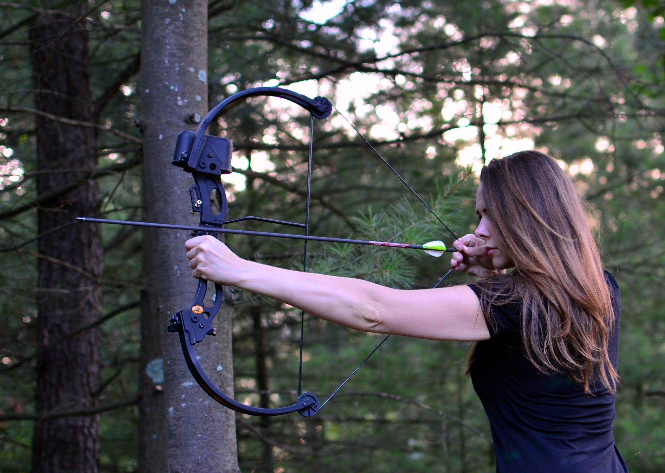

Katniss ducked down and took out her bow, quickly putting an arrow on the string and pulling it back. Her heart was beating a million beats per minute as she tried to steady her breathing and not give away her position. Then she saw her! The short little redhead came wandering out of the bushes, right past the tree Katniss was up in! She had the arrow pointed right at the redheaded girl, she was about to let go, about to end her life, but she stopped. Katniss could hear, she was, crying?

“Ugh, gawd, this girl doesn’t stand a chance!” Katniss said quietly to herself…

She watched carefully, examining the girl! She was young, pretty, she had a beautiful face with big green eyes and pouty lips. She was so short and frail though, she looked almost like a child! Katniss felt bad, she didn’t want to end anyone’s life, especially someone as pathetic as this, but it was a competition, and feelings couldn’t get in the way! She readied her bow, about to fire an arrow right into the back of the unsuspecting girl’s neck when she stopped! Katniss felt her stomach rumble and bubble as she gripped it and let out a groan. That’s when the idea hit her… it was terrible, just thinking of it made her gag, but she knew with someone so helpless it could be possible.

Katniss jumped down from the tree and began approaching the redheaded girl. She hadn’t even heard her jump down and still had her back turned! Katniss walked up and in a hushed voice called out.

“Hey! You’re gonna get yourself killed! What are you doing with no weapon?” Katniss warned her.

**“AHHHHH”** The girl spun around and shrieked at the top of her lungs! She stepped back, tripping over a bunch of bundled up vines falling to her butt with a thud! Katniss shook her head back and forth before bringing her palm up to her forehead in frustration!

**“PLEASE! DON’T HURT ME!”** The girl screamed at the top of her lungs as Katniss lunged forward! She wrapped her arm around the girl’s head cupping a hand over her mouth leaving only her nose free! The girl was breathing so heavily, her heart racing, Katniss could feel her pulse.

“Listen, I’m not gonna hurt you! But keep your voice down!” Katniss said in a whisper.

“What’s your name?” Katniss asked as she took her hand off the girl’s mouth…

“Allison,” she said while panting softly…

“I’m Katniss, it’s nice to meet you,” she said with a smile as footsteps could be heard coming towards them! Katniss pushed Allison back into the bushes and down onto her stomach before jumping down beside her! Allison was about to speak but she stopped her just in time! Two other competitors came running out into the clearing they had just been standing in! Their feet were directly in front of the two girls’ faces!

“I swear I just heard a scream come from this direction!” The girl said while looking around…

“They must have gone further into the jungle, we can cut them off! **COME ON!**” her male partner shouted as he took off running. The girl followed… Katniss waited until they were far out of sight to move or speak.

“Shit” Katniss muttered…

“What?” Allison asked…

“Those two, they already made an alliance and are working together, that’s bad!”

“It is?” Allison asked in a very naive voice…

“Yes!” Katniss answered trying not to sound frustrated.

Katniss looked around for a moment making sure no one was watching them before turning back to Allison.

“Can I come with you? Please! I’ll do anything you say!” Allison begged. Katniss had a hard time holding back her smile! She had imagined she would need to convince the girl to join her, not have her begging and offering herself up completely!

“Hmmm, I don’t know, you seem like a bit of a liability” Katniss turned her back and smiled, she knew Allison was about to break down behind her.

**“PLEASE! I’LL DO ANYTHING YOU SAY!”** Allison dropped to her knees in the mud and began crying! Katniss spun around and cupped a hand over her mouth again, shushing her!

**“QUIET!** If you listen to everything I say and do **EVERYTHING** I tell you, you can come with me. The first rule, only speak when spoken to. Understand! No noise!” Katniss said in a dominating and strict tone as Allison nodded her head and zipped her lips!

“Okay, good” Katniss said as Allison got to her feet.

Katniss began looking around again, the guy and girl who had been there a moment ago headed west. To the north the land began to incline on a hill, it was all forested heavily.

“We should move north, get the high ground, and find a big tree to camp out in! We wait for the other competitors to kill themselves off and then pick off the winners!” Katniss explained to Allison.

“That’s a good plan! Let’s go” Allison smiled, clearly feeling safe with Katniss.

They began moving north as Allison followed closely behind Katniss! She had been so worried up until this point, having a partner with her felt so secure, especially someone so capable! As soon as they reached the hill, walking in a single file in the dense forest brush put Katniss’s ass right in front of Allison’s face. She couldn’t help but notice how big it was, her cheeks jiggling in the tight leggings with each step she took! There was a dark v of sweat at the top of her gray leggings that was slowly stretching down her ass crack. The view was not ideal, but this was an emergency and Allison was not about to complain, she would do anything to keep Katniss by her side and survive this!



“Can we slow down a bit?” Allison asked while panting, she was not fat in the slightest but not used to exercise! Also, her short legs had to take twice the amount of steps as Katniss!

“No! Keep up!” Katniss demanded as she continued her pace, she could hear Allison struggling behind her and smiled. It felt good pushing her, knowing she was pushing past her limit!

They walked for five more minutes, Katniss leading and pushing the thick vines and branches aside for Allison, constantly having to wait for her to catch up. Suddenly she felt a bubble of gas in her stomach, the bloated feeling returned as she stopped and leaned forward a bit sticking her ass out. She looked back and Allison was walking with her back bent and her head drooping down, heading right for Katniss’ ass! She smiled and bit her lip, grunting and pushing, she could feel this one was gonna rip a hole in her leggings!

Allison was gasping, she was so tired! She pulled her legs up one after the other, trudging forward until her forehead hit something squishy! She looked up and was greeted with Katniss’ massive ass cheeks, they were so big and round, sticking out, her nose was practically an inch from her crack! Her body heat was so intense, mixed with a thick foul smell of fresh earth shit! Allison was about to step back but it happened so fast!

**BBBBBFRRRSRPPPPPPsppprppptptpprrrrtttttttt**

The fart was so thick and powerful that it physically moved the tight fabric over her anus for a second! Allison was frozen in a mixture of fear and disgust as the gas washed over her face! It smelled so bad, it was so eggy, the odor so thick that she could taste it! The heat of the gas blew past her face, it was more humid than the jungle air around her! Allison’s legs gave out as she fell backward onto her ass, she was choking and coughing, rubbing her nose with both hands as her eyes watered! The fart was still going, ending with a sickening wet splatter that even from a distance made Allison gag!

Katniss was laughing, biting her lip to silence herself as she listened to the poor girl choking behind her! it took a moment for Katniss to compose herself before she spun around in fake anger.

***“SHHH I TOLD YOU TO BE QUIET!***” Katniss said in a hushed yell!

“I’m sorry! I’m so sorry!” Allison apologized over and over while trying not to choke, she cleared her throat over and over as Katniss watched her. It was so hard not to smile.

“Ugh, my ass is still burning from that one” Katniss turned and fanned her big butt with one hand as Allison watched!

“Come on! Let’s go!” Katniss ordered as they continued walking upwards.

Over the next thirty minutes, Katniss let more than ten farts rip, each one worse than the last as more rancid shit built up at the exit to her rectum. She could hear Allison choking half to death behind her, she didn’t know why it was so much fun to torture her, but she wasn’t gonna fight the feeling. Having so much control over someone so desperate was fun. It was a shame Allison wasn’t going to leave this island alive Katniss thought to herself, it would have been fun to continue this.

Suddenly Katnisss spotted the perfect tree! It was big, Thick, and had tons of branches and leaves, perfect for camping out in and hiding from the view of others.

“Right there!” Katniss pointed! Alison looked at the tree she was pointing towards!

“Let’s go, we’re gonna climb it!” Katniss instructed as she walked up to the base. As soon as she was there she realized the lowest branch was way too high for her to reach. Allison walked up beside her, still panting and out of breath from the hike.

“Give me a boost!” Katniss demanded.

“What?” Allison asked, still panting for air from the hike.

“Ugh! Cup your hands together… like this!” Katniss said in frustration while taking Allison’s hands and cupping them together!

“I’m sorry!” Allison apologized and blushed!

“Ugh, what would you do without me?” Katniss asked right before putting one of her shoes into Allison’s hands and thrusting all her weight down while stepping up! She could feel Allison struggling immediately, barely able to hold her. Katniss grabbed onto the lowest branch steadying herself, she could easily pull herself up now, but it wasn’t ready yet!

Allison was turning red, her entire body shaking as Katniss kept her full weight standing in her palms! She could feel the soles of her shoes cutting into her soft skin as she whimpered, it was so painful but she had no choice, she had to keep Katniss happy! Either that or she would be alone! Just an inch in front of her face was katniss’ fat ass, her thick sweaty cheeks jiggling wildly as she tried to climb the tree! The odor had gotten much worse, the stink of her farts embedded into the back of her sweaty leggings! It was so sour and eggy, nearly bad enough to make Allison puke!

“Can you stay still down there!?!?!” Katniss said in frustration!

“Ahh, ahh I’m ermmahh sorry!” Allison grunted, barely able to speak as she held Katniss up stepping in her hands!

Allison looked up at the worst possible moment, little did she know that Katniss had planned it all! She got a quick glimpse of the fat sweaty yoga clad cheeks before it came **CRASHING** back into her face! Katniss had bent her knees and sat back, her full weight now sitting on Allison’s head! Her nose was crammed up in between the crevasse of her sweaty ass crack, it was so damp and the stink was worse than rotting swiss cheese!

**BBBBBBBBBBBBBBBBBBBBBBBBBBBBFRRRTPPPPRTT**

**SPPPPRPTTBBFRR bbfrtppprttttrt spprttttt**

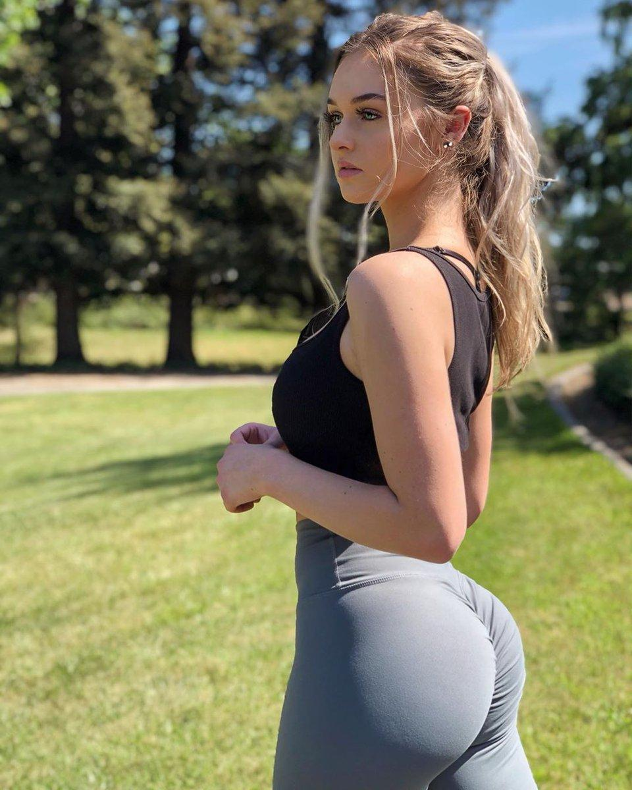

Allison wanted to die. The stink was so bad! With her nose pressed right to the thin fabric, she could feel the burning gas pushing through! It forced its way down her nose submerging her in the odor, the terrible stink of rotten eggs, the burning stink of swiss cheese! Her eyes watered as she started to choke, inhaling and gasping, sucking in the gas and making the situation even worse! The fart was still blowing out, burning the tip of her nose and upper lip as it bubbled and splattered! Allison cried as she felt damp wetness run over her nose! Katniss had just shit her pants!

Allison was frozen in fear and disgust, the gas was cooking in her lungs, burning her from the inside! Suddenly she felt Katniss grab the back of her head and push hard as she rubbed her face and up and down her crack! Allison cried as her nose scraped over the damp dirty spot over her asshole! It had such a foul cheese stink that she puked in her mouth a tiny bit!

“My ass is dripping with sweat!” Katniss complained as she pushed off of Allison and hoisted herself up onto the thick tree branch. As soon as she was up there, she looked down to see Allison below, choking, crying, her face was beet red!

“Are you coming?” Katniss asked as she reached down with one hand to pull the small girl up!

Katniss watched as she debated for a moment. She could see Allison was debating climbing into the tree with her, was death worse than her farts? Katniss began to giggle and laugh at the thought just as Allison took her hand!

Katniss pulled her up easily as they began climbing higher and higher and higher to the top! The branches were very thick and there were so many near the top that they could sit comfortably across a few of them! Allison was panting for air and dripping with sweat as they reached the top.

“Are you okay?” Katniss asked…

“Ahh, ahh, ahh yes, just, ahh out of, ahh breathe” Allison panted and wiped her forehead from the sweat.

“I’m so thirsty!” Allison complained while leaning against the tree and looking down, they were so far up

“Why didn’t you say anything! I have something you can drink” Katniss smiled seeing Allison’s eyes light up! They got so wide and big, practically sparkling!

**“REALLY?!”** Allison shouted!

“Hey! Keep your voice down!” Katniss warned her again.

“Sorry!” Allison apologized, again!

“Katniss stood up on the tree branch and began working down her leggings, using her thumbs to grab the waistband. Her leggings were so sweaty making it hard to peel off her skin. Allison’s smile turned to one of horror as she turned her head and covered her eyes!

“What are you doing?!?!” Allison asked in shock.

“Taking off my pants, you said you were thirsty right?” Katniss asked.

“Well yeah, but…” Allison tried to object.

“Well I’m gonna piss in your mouth, people do it to survive all the time! It’s perfectly normal, and I’m healthy, so you should consider yourself lucky!” Katniss said with a smile as she pulled her leggings down to her knees! They were drenched in sweat and there was a big smear of brown over the area that covered her anus.

“Lucky?” Allison asked very naively…

“Yea! Lucky that you don’t have some crusty ass bitch pissing in your mouth! I’m hot! Now lay down, I’m about to burst!” Katniss ordered!

“But, I” Allison whimpered, she didn’t want to do this…

“But what? You wanna both climb **ALL THE WAY DOWN,** just so I can go pee? Give away our position? Risk our lives? Are you serious?” Katniss asked with a head shake of disappointment.

“But, but, can’t you just pee down from here?” Allison suggested, trying anything to back out of this…

“Yea, that’s a good idea, drench the ground below our hiding place in my urine! That won’t give away where we are! Gawd you’re stupid! Lay down! **NOW**!” Katniss ordered as she pointed at three branches close together!

Allison’s heart was racing, she felt so trapped! She was whimpering, trying not to cry as she moved over the three branches and laid down! She had one branch under her knees, one under her lower spine, and one under her neck, it was incredibly uncomfortable, also knowing there was a hundred-foot drop below here made it even worse!

Allison watched as Katniss stepped on the branch over her neck, she could see up her thick thighs to her fat jiggling ass cheeks! She began squatting, her ass bubbling out and coming towards her face as the cheeks spread slightly!

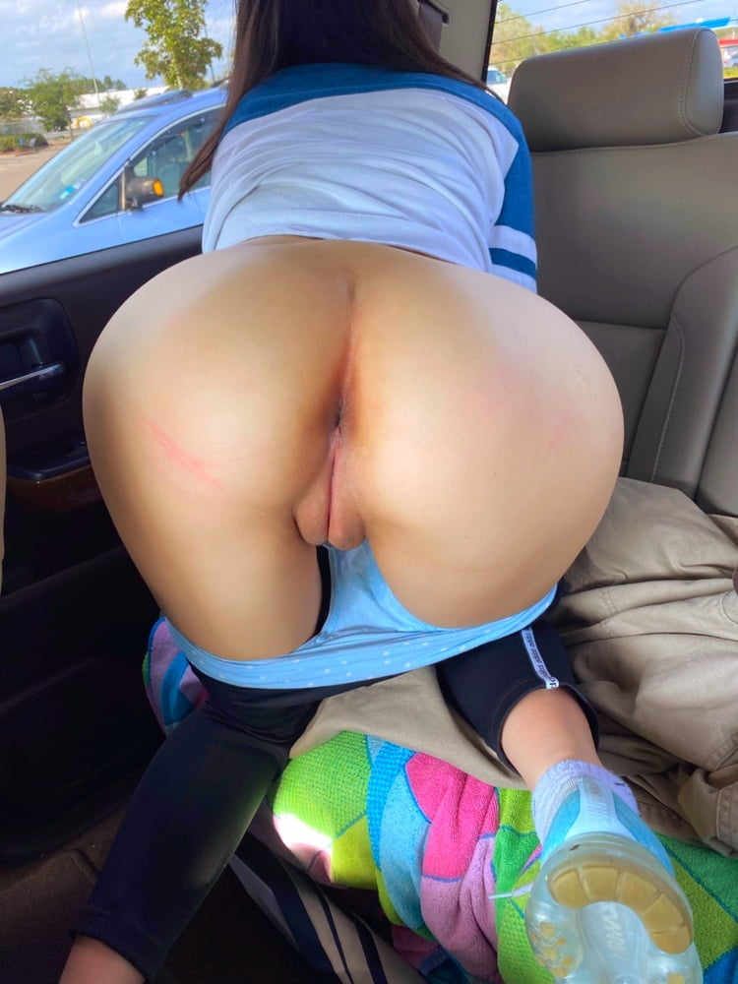

Allison was frozen in fear, She had never been this close to another woman’s privates and had never planned to be! Katniss’ asshole was covered in a dried layer of very light brown shit! It had tiny bits of green in it with tiny seeds that had traveled right through her digestive system! The foul stink of cheese and eggs returned as Allison let out a whimper and began to cry! Katniss slammed down though, silencing her! The tree branch under her neck shook from the impact.

Allison wanted to scream! Her nose was pushed right into katniss’ asshole! It was so damp and wet, it was pulsing on the tip of her nose, moving like it was alive! Her pussy lips were so wet and sour, almost vinegary tasting as they filled her mouth, pushing inside! Her fat ass cheeks spread wider as Katniss grabbed them and leaned back forcing Allison’s face into her privates!

“Open your mouth wider!” Katniss demanded as Allison cried, trying to comply!

She stretched her mouth open, Katniss’ pussy lips filled her mouth instantly. Allison lay there, waiting, her heart racing! The smell was so bad she thought she was gonna pass out, the best she could do was to try not to breathe through her nose. What would it taste like? Maybe it wouldn’t be so bad? Allison thought to herself trying to calm down.

**BBBBBBFFFFFFFRRRRRRRTTTTTTTTTTTTT**

Allison felt her nose vibrate as a harsh fart blew straight down her nostrils! It reeked of burning swiss cheese and made her eyes water instantly! Not breathing in was no longer an option as the fumes streamed directly into her bdy! Allison wanted to die, anything was worse than this, truly anything! The fat sweaty cheeks pressed down to her face hard as she felt the tip of her nose enter the dirty rectum, it slid in with a horrifying squish!

“Gawd, my stomach has been on fire all day” Katniss complained as she grunted.

Allison was choking on the gas, gagging on the cheesy fumes when the stream began! Her piss was like a firehose spraying down onto her tongue! It was so warm, almost burning like tea, and filled her mouth within seconds! The flavor was like sour vinegar, it was so foul! Her cheeks began to puff out from how much urine had accumulated!

“Swallow it!” Katniss demanded, Allison held the urine in her mouth, crying, praying Katniss would reconsider!

**“SWALLOW IT!”** Katniss yelled, Allison felt a shiver of fear run down her spine from the tone and anger in her voice!

Allison used all her strength and willpower to take a gulp! The urine was burning her cheeks as she let it move down past her tongue! She began choking as soon as it touched her tonsil and gag reflex, the flavor was so bitter, it was almost impossible to drink! She could feel the foul piss move down her throat into her belly but she had no time to choke, Katniss immediately filled her mouth again followed by a terrible fart!

**BBBFRRTTT BFRRTTTTTTTTTT**

**Pppppsrttpprttttttttttrtt**

Allison was in hell! Katniss’ asshole vibrated on her nose, she could feel wet tiny bits of shit spray down her nostrils, it built up in the back of her throat adding a terribly bitter cheesy flavor to the urine! Katniss moaned and pushed, her piss flowing out so heavily that Allison could do nothing to stop the flow! Once she had opened her throat, Katniss began pushing, physically pumping her full of piss! Her thick thighs held onto Allison’s head keeping her sealed in her ass, there was truly no escape!

The stream of urine finally ended after more than three minutes, Allison felt like she was about to explode! Katniss sat on top of her head heavily, not making any motion to move. Allison had the bitter harsh vinegary flavor of urine staining her mouth and throat, her entire body flinching every few seconds from how terrible it was. Suddenly, something slimy and gooey dripped from Katniss’ pussy into Allison’s mouth, Katniss moaned and rubbed her stomach, pushing as more began seeping out! Allison's eyes went wide, she could taste blood!

**BFRRTTTTTTTTTT**

**Pppppsrttpprttttttttttrtt**

Another sharp cheesy fart blasted Allison's face as Katniss slowly got up and stood above her. Allison lay there, her body felt like it was covered in cement, she was frozen with fear and shock! Her lungs were burning, pulsing from the gas as she began choking wildly. Katniss gathered a bunch of leaves and began wiping her ass and pussy before letting them loose into the wind as they scattered away in the distance. Slowly she pulled up her pants and stepped away from Allison.

“There, has your thirst been quenched?” Katniss asked with a giggle. Allison didn’t respond, she just whimpered softly.

Katniss could feel her pussy beginning to drip, this was too much fun!

“By the way, just in case you were wondering, I’m planning on finishing and winning this competition quickly. I won’t need anything to drink, so you’re just gonna have to hold yours in!” Katniss said with a smile.

“Oh fuck!” Katniss said as she leaned forward a bit and wrapped one hand around her stomach! She felt a terrible urge of pain rush through her lower intestines as the pressure at her rectum began increasing.

“What?!” Allison asked in fear as she looked down from the tree expecting to see someone below.

“Are you hungry?” Katniss asked…

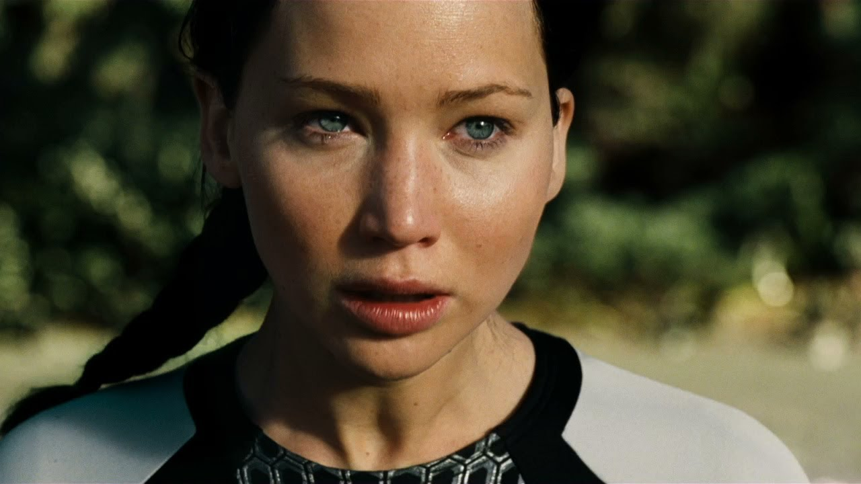

Allison looked to Katniss with horror, she could see she was sweating, she had tears in her eyes. Without waiting for an answer, Katniss began quickly taking off her pants…

**“PLEASE! OH GOD, NO! DON’T PLEASE DON’T! I’LL DO ANYTHING!”** Allison begged!

**STAY TUNED FOR PART 2**