LATE FEES
MAY 2022 REQUEST STORY
BY CHALDEACHANGE
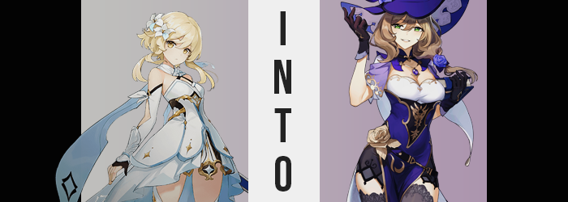

Words could not express just how bad this was.

The Traveler, Lumine, had braved all manners of danger over the course of her journey in Teyvat, all for the sake of being reunited with her missing brother. Ancient dragons, terrifying Fatui, and even the gods themselves – she had come face to face with monster after monster, and she ultimately came out victorious against every foe she faced. It almost left the young woman to be seemingly unshakable, and yet this situation? It was enough to leave her shaking in her boots as she ran.

Now what could rattle a woman of this skill set to her very core? What could leave her fearing for her very life despite the adversaries she had overcome in the past? There was only one thing in all of Teyvat that could leave her feeling like this, and anyone who had been in a similar situation could attest to just how terrifying it truly was.

She had forgotten to return a library book on time.

While this might have sounded like the most mundane thing in the world to worry about, truthfully there was a more than valid reason for the fear that Lumine felt. After all, the librarian of the Knights of Favonius could be an incredibly terrifying individual when she was upset, and nothing upset her more than her precious books not being returned in a timely manner. Library books had due dates for a reason, and she expected that they be upheld regardless of one’s own personal situation.

Her only hope of escaping the ire of this librarian, Lisa, was by sneaking the book in without being seen. It wouldn’t be easy, but it was possible. To those ends, she had even asked Paimon to stay behind because, well… There was no way she could trust Paimon to be covert enough for this most life-threatening of scenarios. She was risking it all…!

And yet, the moment she had slipped through one of the library windows with her book in hand? “My, my. Were you going to try and slip that in without me noticing, Miss Traveler? You should know that I always know what’s going on in my library.” The very woman she had been trying to avoid was sitting in a wooden chair beside the window, a smirk playing upon her face and a bottle of something swirling about in her right hand.

Lumine’s expression was almost one of comic shock. How had she been so thoroughly foiled? She had just checked to make sure Lisa was on the upper floor! She’d come down that quickly? Well, it served her right for not doing the honorable thing and just returning it late like normal. “O-Oh… Lisa…” How was she going to get out of this one? Lisa was going to shock the heck out of her with her Electro, or something terrifying…!

Actually, come to think of it? She had heard horror stories about Lisa’s punishments, but she had never heard what those punishments were? Surely they weren’t actually violent, but there had to be something to them. “I’ll do anything to make up for it! Just don’t shock me!” That still didn’t stop Lumine from blurting out the punishment she had expected to receive based on those stories.

The accusation left Lisa blinking with surprise a moment, before a sensual chuckle escaped from her lips. “Shock you, dear? Do you truly believe I would do that as a knight?” Hearing it from Lisa’s own lips, it did sound a little farfetched. If the knights were physically abusing people for not returning library books on time, then there was no way that such a reputation wouldn’t have spread throughout the kingdom and caused complications. “No, I just typically ask you do a little volunteer work, and since you seem to be so gung-ho…”

Lisa had been concealing the contents with her arm up until that moment, but she finally produced the glass bottle she was holding. Within was a liquid dyed a dark purply blue, almost the same color as Lisa’s dress. “Just a little community service. Here, drink up.” Lumine narrowed her eyes at the bottle, naturally, but took it and scarfed it down. It tasted like blueberries, but there was something of a snap to it. Or a shock.

“What was—”

The Traveler was naturally wondering what she had just consumed, but Lisa stood from her chair and waved her hand as if to brush off the question. “You’ll see, dear. I’m sure you’ll see it as a suitable punishment once the strangeness subsides. You might not even want to undo the punishment if you like it enough~!” She disappeared into the library’s depths, leaving Lumine with this cryptic explanation of what she had just done. Had she been forced to consume some sort of drug? The idea left her anxious, and so she thought to pursue Lisa to ask again.

But her feet wouldn’t move. She was rooted firmly in place. All while a strange tingling began to radiate out from her tummy and into the rest of her body. “I feel… strange…” Whatever she had consumed, there was some sort of unusual quality to it. One that was affecting her body, and it would begin to do so rather quickly.

Lumine fumbled in her standing position as a weakness temporarily took her, and before long she found herself holding a nearby table with her left hand to keep herself from falling over. In the process she knocked several books over, which honestly should have been the least of her concerns. But the concern that tugged at the back of her mind believed otherwise.

I really should clean those up.

Sure, the swordswoman hadn’t wanted to piss Lisa off anymore than she already had, but wasn’t that a strange thing to worry about when she was fairly certain she had just been drugged? Her vision was blurry and she thought she might be on the verge of passing out, for crying out loud! Yet this concern of hers won out, and using all of her concentration she bent down to pick up the books while continuing to use the table to keep her balance. “Why am I doing this…?” She couldn’t help but groan a complaint as she rose back up and set the books back down. At least the voice in the back of her mind had finally shut up.

While the girl had been in the process of picking up those books, mind you, some strange things had begun to happen to her physically. The earliest signs could be seen the most easily in the young woman’s hair, for strands of a chestnut brown had begun to spring up midst the blonde she coveted so much because it was the same blonde as her brother’s. What began with only a strand or two quickly multiplied, and then it did so again and again, until not only the hair atop her head was dyed that color, but also her brows and pubes.

Even the style of the hair atop her head was compromised, for color alone hadn’t exactly been the only thing changing regarding it. Her hair had become thicker in the meantime, as well as longer in the sides and back so that it all tickled her shoulders evenly aside from being longer on the left side. This new style bore a natural curliness to it that appeared fluffy, soft, and enticing, and a more floral fragrance danced off of her hair.

Lumine, on the other hand, was too knocked on her ass figuratively to really understand that her hair had changed, even though her bangs were brushed slightly across her right eye. “What did the original do to me…?” She groaned, but there were several things that sounded off with that groan. Her choice of words was among them, because who was ‘the original’ supposed to be? But her voice now sounded almost identical to that of the woman who had asked her to drink that concoction in the first place.

And it had been communicated with lips that appeared just as thick and glossy. In fact, the girl’s face demonstrated an increasing departure from its usual appearance in every possible aspect. Her more pronounced mouth was part of it, but it was just a small part. After all, her skull’s entire shape had seemingly changed so that she had a sharper chin and higher cheekbones. Whereas her nose was slightly longer, and her eyes? Not only had they narrowed to give off a more mature air, but their colors had shifted to a shimmering emerald with carefully cared for eyelashes lengthened across them. She hardly resembled the girl in her late teens that she had been, and instead, when looking at her face, had an air of maturity like a woman in her late twenties or early thirties.

Her body just didn’t reflect the same thing. At least not yet, but there were signs that this would be a very temporary affair. After all, Lumine’s fingers had not only grown a little longer, but the nails upon them were longer too. A similar phenomenon had affected her feet, leaving them slightly longer than they had been prior. Bigger hands and feet typically belonged to a taller individual.

It was just… her height wasn’t the area that grew next. “Ohh… I feel so warm.” She had practically moaned there, with her tongue playing with her lips as the physical fog that plagued her gradually began to loosen, and in doing so revealed that the girl wasn’t quite acting like herself. She felt warm around her loins and breasts, and she was never the type to lean into feelings like those. Paimon was usually with her, for one, and that would have caused an awkward conversation. That said, it wasn’t really in Lumine’s nature to support any carnal desires.

But now? She couldn’t keep her hands off of herself. Led to her breasts where the warmth was strongest, she had begun to massage her bosom through her dress. Each tit felt more sensitive than normal, and almost like they were fuller. Wait, no, that was exactly what was happening. Her breasts were growing larger and larger beneath her touch, promptly overwhelming the cups of her dress and peaking out over the top of her neckline as the straps struggled to keep her dress in place. It didn’t take long for them to peak at a pair of perky DDs, and Lumine? Well, while she most certainly should have questioned their growth, she was too enamored by touching them.

“Mmn…” The warmth in her loins grew – in part because she was legitimately horny now, but also because it was stretching to the surrounding area. Her thighs had begun to rub together as she fondled her tits, but the friction between them grew more and more with their surface area. That is to say: her thighs were swelling, with thick tissue pulling skin tight around them, leaving a soft and tender sheen. Not only that, but it also spread to her ass – with cheeks perking up to a size that complimented the new girth of her thighs beneath her dress’ skirt.

Naturally this left her hips to pull wider, and her panties eventually could be felt flossing in between her swollen cheeks. It was uncomfortable, but it also made her hornier. Eventually the band of her underwear snapped, but they didn’t fall. They were much too rooted into her ass and pussy from the earlier stretching.

The woman exhaled. The library isn’t a place to be doing something like this. Think of our reputation. The library had become very important to her, which was unsurprising now that she looked like a very short Lisa. She lifted her hands from her tits, and no sooner than she had, her height finally settled into place. Over a matter of seconds she blew up from 5’2” to 5’7”, lifting her dress up from her hips and exposing her lower regions to the world. “Speaking of things that just won’t do…”

She was still wearing Lumine – her own – dress? Her mind was a sloppy mess of understanding that she was Lumine, but also seeing herself as Lisa. That wouldn’t change. It was wholly intentional. Fortunately she did have a solution for the clothing situation, after all. Because an Electro Vision soon appeared on a necklace around her neck, and that gave her the ability to snap her fingers, and…

In a blast of electricity with herself as the lightning rod, her outfit was repurposed to be identical to Lisa’s. From the witch’s hat to the dress that highlighted her cleavage and thighs, to all of the rose decorations, it was one-hundred percent identical. She was one-hundred percent identical.
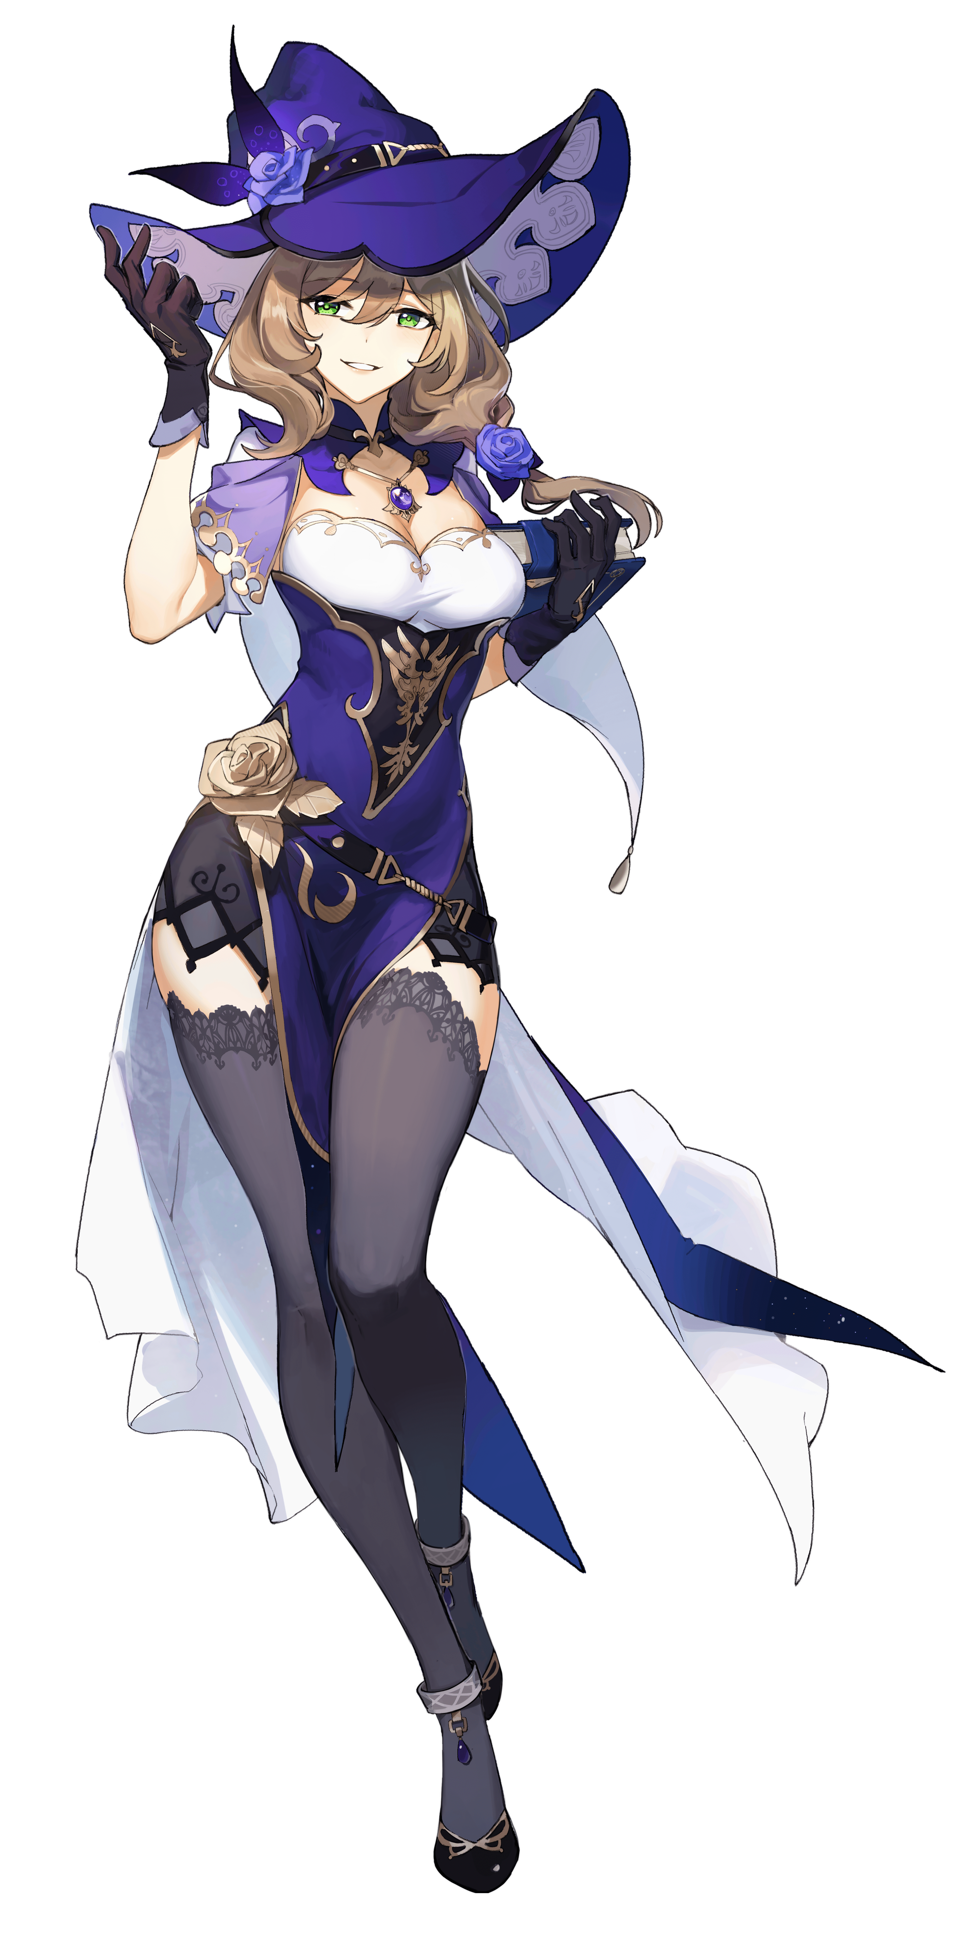
When all was said and done, the woman standing where Lumine had been frozen for that entire duration could only be seen as a second Lisa Minci. “My, my. Is that what the original meant? I do feel quite good.” From the way she spoke to the nonchalant wave of her hand, she was mirroring the real Lisa’s behaviors perfectly. That said, she was still herself when it came to her memories – but everything else about her had become fashioned so that she made a convincing, second Lisa.

The original Lisa’s comment about not wanting to undo the punishment rang through her mind as she ran gloved fingers down her ample curvature. She felt quite nice. Frisky, even, undoubtedly thanks to the feelings that came about from her body transforming like it had. Her body was taller and thicker than it had been before, and Lisa’s playful personality had left her rather invested in it.

“It seems you turned out perfectly, Lisa.” Speaking of the genuine article, the real Lisa had returned from the library’s depths to examine her handiwork. She leaned forward, placing a finger on her own lips as she took in every nook and cranny. “I was looking for an excuse to take a month off, but who could I trust to run the library in the meantime? I had been wondering, but doesn’t this make more sense? If I leave the library in my own care, then I should have nothing to worry about!”

So that had been her goal? To have Lumine fill her heels for a month so that she could go away? Were she herself, the Traveler would have taken issue with it. But as she was now? “My, what a smart and clever idea, Lisa. I would love to watch over the library for you for a month!” With Lisa’s personality and values imbued into her, how could she do anything other than agree? It even seemed as if she had been given the knowledge needed to run Lisa’s daily life without anyone becoming suspicious. Not even Jean. “But before you depart, I was thinking…”

The Lisa-ified Lumine strut towards the woman she mirrored, hips swaying sensually with each step. “Wouldn’t you like to see what it’s like to lay with yourself? I’m you, so I know you’re curious as well.” She licked her lips as she reached out to pull down Lisa’s neckline, exposing her bare breasts for the fondling.

“Oh, you know me so well! But let’s retire to our office.”

