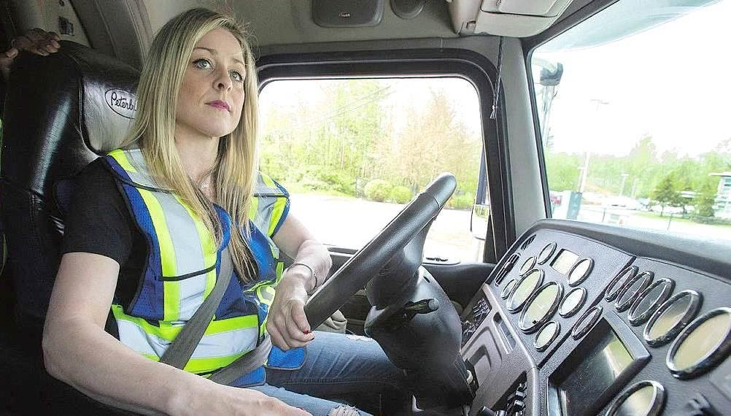
On My Back
A Short Story as requested by Taxidermist
By Maryanne Peters

I used to think that driving a big rig was the ultimate in freedom. The road is stretched out in front of you – this great country – where the road seems to go one forever. Hell – it does. It never stops.

The only enemy is fatigue, and debt on the truck if you have that. Mine is now paid off. I sold my house to live in my cab. No place to tie me down. Wife and family long behind me, long with any woman that I knew for more than a few hours in the dark, or minutes in the cot. Behind me and I don’t look in the rear vision mirror much at all. No attachments and no responsibilities is true freedom.

Sure, there is load, and a delivery time to meet, but that has never been a problem for me. When it comes to long haul, I can’t be beat. I just drive. Other folk have ideas in their heads slowing them down. Monkeys on their backs they call them.

Monkeys on their backs.

I don’t know where it came from. Some people say it is in my head. That’s why I don’t talk about it any more. That would make me nuts.

But you can see the hand on my headrest in the image from my driver-watch-cam – right? There it is. My monkey. The monster in the back seat.

Yes, that’s me. I am now what that monster made me. Female, or damn close to it.

It leaves you to wonder why the monster would visit me this way. Am I really a bad person for wanting to be free? Sure there are plenty who don’t care for me or my lifestyle. I can thin of a few roadhouses where I used to drive past hungry. I don’t do that now because I don’t look the same.

The girl pouring the coffee might say: “Girl, that rig of your looks like the one that no-good Hank Jarman criss-crossed the country in. Do you know him?”

I would clear throat up high at the back so I could warble the words like the woman I seemed to be, and say: “No Honey, I don’t know him. My name is Jane, by the way.”

I didn’t choose the name. He did. I suppose that makes him Tarzan, my ape man.

Did I fight this? Like the Devil I did. But the Devil is stronger than any man. I even thought that I could be rid of him by blowing up my own rig. Imagine that? Nothing happened. I must have done it wrong. And then I spent hours before I could get back in the cab and defuse it. I thought I was going to die.

“Trucker Blows Himself Up”. Imagine that headlines. Worse still: “Crossdressing Trucker Blows Himself Up”

The day after Halloween 2017 was when he first appeared. Scared the living shit out of me. He had boxes of stuff that had gone missing from a shipment weeks before. A load of pharmaceuticals. Suppositories, if you know what they are. He would shove them up my ass every night, with those hairy horn-nailed fingers of his. You can see it in the picture. Disgusting.

Up the ass like that, they act fast and strong. They suck the man right out of you. That is what he wanted. He wanted me to be his soft little plaything. A Faye Wray to his King Kong.

“Don’t cut hair. Shave your body neck to toe.” I can’t remember his saying the words exactly, but he grunts his demands and I hear them good. I shout at him sometimes. When it’s just him and me, in the cab, just the road and fields or the woods or the desert, stretching out from all three windows. Nobody can hear you shout. Nobody can hear him grunting and screeching through his clenched teeth. It might as well never have happened. Who could say it did? It was just him and me.

After I dropped a load in Saint Louis he had me pull over and visit an electrolysist. Have you ever heard of that? Somebody who permanently removes the hair from your face. Takes the last sign of you appearing to be truly male.

“We normally do it over a series of visits,” she said. “It will take hours. There will be inflammation”.

But I told her that it all had to go. He was going to choke me to death if I didn’t do it. He has his hands around my throat half the time – making me squeak instead of shout. He has me singing to all the girls songs playing as I drive, as high as I can go. Even higher.

He had me stop at a place in North Texas. A beauty salon. He had me tell them what he wanted. Dye my hair blonde, so that I have to keep it that way. Pluck my eyebrows, colour my eyelashes, tattoo a line around my lips so that I need to keep them painted all the time.

I got back into the cab and saw his ugly face in the rear vision mirror, grinning with all those teeth.

“Look at what you have done to me!” Or something like that, I shouted as we pulled onto the straight. He just grunted as he does.

After that, I went by Jane all the time. It was just easier. A different name on the dockets, and after a while a new name on the licence. No dispatcher cares if you do your job. No cop cares if your hair is shiny and you give him a little smile.

Why did he make me this way? What does he want from me? I thought that it might be to rape me like the bitch he was turning me into. But he had a penis like a gorilla. If that sounds threatening, it ain’t. A gorilla’s penis is tiny.

He can have my ass anytime he wants and he knows it. Hell, every day those pessaries go up and I just whimper like the girl I am now. He says that if you are looking for sex you want a bonobo. I had never even heard of that thing. He says bonobos are like chimpanzees with huge balls. A male bonobo meets another bonobo and just has sex, female or male. They just go to it instead of saying “Hello”.

At least I say “Hello, my name is Jane”.

Now it’s not the monkey on my back – it’s me.

The End

© Maryanne Peters 202

Author’s Note:
This story comes from comments on my story “Making Changes” filed earlier this week. In comments Taxidermist wrote: “Hairy hand. Anyone else notice the hairy hand on the back of the drivers seat in the photo at the front of the story? Too early fo Halloween! Keep on trucking, but watch out...... Behind you! :-)!”
I looked closely at the top right of the image (reproduced here) and I responded: “Spooky. OMG I completely missed that! She seems unaware of it. This is crazy but I feel another story filling up my head with words...”.
So Taxidermist said: “Excellent. I was wondering/hoping that might have given your muse a nudge (on the assumption that you had missed the hairy hand of course). Looking forward to the resulting tale, I don’t know how long it takes to write a good story, but as I mentioned previously, Halloween is only a few weeks away!!!!! Wooo hooo! Stay safe, everyone.”
I could not wait for Halloween. I hope it qualifies as a good (short) story.
Maryanne

