LIGHT INTO SHADE
MAY 2021 REQUEST STORY
BY CHALDEACHANGE
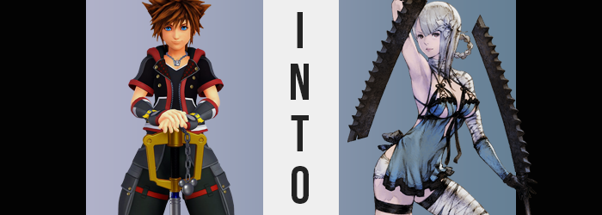

From Sora’s perspective, there was nothing but a blinding light.

The darkness had been defeated, Xehanort had been felled, and all of his friends had been saved. But in order to do so, what had it costed? His very self. But as he floated through the void, Sora didn’t really have any regrets. If it meant Kairi could survive, if Riku could have peace, then he was honestly okay with this outcome. Were there a way to have saved Kairi without giving himself up, that would have been preferable, but this was fine.

This void of light didn’t seem to have any indicator of time. The boy didn’t know how long he’d been there, but did it matter in the end? Forever was forever regardless of how much time might pass. Things couldn’t get worse, but they also couldn’t get any better. Just an eternity spent basking in light, hopeful for the future his friends now had.

Or, at least, this was how it should have been.

RISE AND SHINE, SWEETCHEEKS!

Through the void a man’s voice boomed, his manner of speech crude and his tone overtly casual. Sora was left bewildered. Was there someone else here? That was impossible, after all—

“Ah!?” Blue eyes shot wide and were left staring at the underside of what looked to be a flimsy, wooden roof. Sora’s chest was heaving and turning his head on its side upon the pillow, he found himself looking out at a grassy clearing. “What…? How am I…?” How was he existing? This didn’t seem right at all. Although, things appeared even less so when he pulled away the bed cover to step out, only to find he was in his birthday suit. “WHERE ARE MY CLOTHES!?”

Wasn’t this really bad? It seemed he was under little more than a half-shack without any privacy. What if someone walked down the path that ran by the clearing and saw him nude!? But he couldn’t sit in this cot forever, either! Was there anything he could cover up with? There was a worn box in the back corner, perhaps there…?

Deciding to brave it, Sora jumped out of the cot and scurried over, passing what looked to be a decoration made out of a rather pretty, white flower in the process. But within the box? There was only what could be best described as a woman’s underwear? No other clothes? Seriously!?

Little did he know that they wouldn’t be all that unappealing in just a few moments’ time.

“Why I’m here aside, just what am I supposed to do now?” Try as he might, Sora couldn’t seem to summon his Keyblade to his side nor use the magic he was familiar with. What if there was danger here? No… Something deep down was telling him that he’d never been to a more dangerous place in his life. He couldn’t quite place why he felt that way, it was like his body seemed to know something he didn’t.

Was there anything else in this shack he could use to figure anything out? On the wall there were a number of documents that appeared to be hung up, including a map. Thinking it might be useful to know his way around, Sora reached a bare hand out to grab it – only to stop once his eyes went wide. “Huh?”

Looking at the right hand he had reached out, he couldn’t help but note that something very noticeable was awry. His fingers appeared longer than he recalled, and that was without commenting on the length of his fingernails. They better resembled a young woman’s than the fingers he was used to, and a narrowed palm only added to that aesthetic. “What the fu—heck!?” Almost as disconcerting was the fact that Sora had just about sworn, and those words shouldn’t have been popping up regardless of how shocked he might be.

His left hand resembled the right, and were his wrists smaller as well? Unsure, he raised the two in front of him to compare, only to realize his point of view was elevated? The map had been a little above his point of view at first, and now? It was directly in front of him. “Wait, did I get taller? That’s not possible, is it?” Still doubting his own eyes, Sora eventually looked down. But the ground? It was definitely farther away. “Oh shi—shoot!” Again!?

Not only was he taller, but was the color of his skin a little paler? His skin appeared incredibly soft and smooth, much more so than he was used to, and feminine fingers touching the skin upon his thigh more or less confirmed that it felt how it looked. It also seemed to confirm a little more than that, because had his thighs always been so soft?

They hadn’t, and he could see before his very eyes that they were growing softer still. Lengthened upper legs were growing thicker in the most unnatural looking way possible, with alabaster skin stretching around the building contents until he came to possess the shapeliest pair of legs imaginable – so much so that his hips had been drawn wider in the process to make room for them. “Holy sh-!?” Sora mentally kicked himself again. Why did he keep gravitating towards curse words!?

Then again, he almost did so just seconds later as a pulling from his rear knocked him off balance. A hand reached back to find the cause, and in doing so he discovered that his rear was going the same route his thighs had. Cheeks blossomed at an alarming rate, skin jiggling as it struggled to contain a firm and sensual booty. Any doubts the boy had possessed before? He didn’t doubt it now.

“I’m becoming a… a woman!?” He’d even had to pause mid-sentence to avoid throwing a ‘fucking’ in there. But his ass and thighs supported it just as well as his hands and feet – which had grown smaller and daintier as well.

Shifting his weight to his right leg, he could feel his dick uncomfortably wedged between thickened thighs, forcing him to adjust his stance again – but that moment of freedom brought change to his groin. His dick shrunk to a smaller, much more manageable size, and he both squirmed and gasped sensually at the feeling of something opening up beneath his balls. A pussy. Yet, he didn’t lose his dick either.

The Keyblade wielder didn’t have time to grapple with the implications of this phenomenon though, not as his torso grew slender as if to contrast the thickness of his lower half. His waistline dipper inward to give his body a more pronounced arch, while his bellybutton deepened midst a tummy that was both soft while still revealing strong muscles through his skin.

“Oh no…” As his belly finished remolding, he could feel a pressure just slightly higher up that culminated in roughly what he expected. After all, his nipples appeared incredibly pronounced in both shape and size, practically double the size he was used to in just a matter of moments. He’d never seen a woman without a shirt on, was it normal for their nips to be so huge? Either way, they were merely the cherries on top of what built beneath – a perky and rather sizable bosom.

Fleshy tissue accumulated within a chest that had once been flat other than some subtle muscle definition, but while that definition was retained it was what built overtop of it that was of note. Soft and tender, a pair of orbs took shape that looked almost like a pair of lackluster pads at first before evolving into a duo of bouncing, beautiful breasts. Good natured as he was, Sora didn’t deign to touch them.

“I can’t believe this shi—stuff!” Sora couldn’t really justify the aggression he’d begun to feel, but anger did little to deter the final stages of his physical reformation. A tingly possessed his face, softening cheeks and bringing his nose to a stronger point. But what was more prominently different was the plumpness to his lips, which inflated to a sensual proportion while eyes both softened and carried a resting expression that suggested hostility. Those eyes also carried a silver color, one much duller than his usual blue.

As if to rub in the fact that he no longer resembled his old self, a silver possessed his spiky hair, which then lengthened and flattened, dangling over the sides and back of his head, drifting past his womanly shoulders. “This doesn’t make any dam—darn sense! Why am I here? What happened to my body? What—AAAAAAGH!?”

HOLD ON THERE, JUST GOTTA MAKE ONE MORE ADJUSTMENT! DON’T THINK YOU’RE GETTING OFF WITHOUT ME!

It had finally returned: the voice that Sora had heard in the void. And the moment it surfaced? His left arm and leg were wracked in a terrible pain despite his transformation having been painless thus far. He could do little more than scream as black ran across the skin of these limbs, a similarly colored smoke rising from them before thick, yellow lines scrawled themselves against the black. “Who… ARE YOU!? What… ARE YOU DOING!?”

Through grit teeth she spat out these questions. She could feel it rooting around in her mind, touching things he shouldn’t. It was through his influence that she began to think of herself with feminine pronouns, began to see herself as a woman and being avid about being seen as such by others.

He implanted memories – or perhaps those memories had always been there – of a youth Sora had never experienced. Of being ostracized for being different, of a hatred aimed towards everyone and everything. And feelings of revenge directed at a monster that had stolen her most important treasure from her. “THIS… ISN’T… ME…!”

MAYBE IT WASN’T, BUT NOT LIKE YOU’RE GONNA REMEMBER THAT IN A HOT SECOND! DON’T KNOW WHAT KINDA REGRETS YOU HAD, BUT YOU SHOULDN’T’VE HAD ‘EM! BECAUSE NOW YOU’LL MAKE THE PERFECT REPLACEMENT!

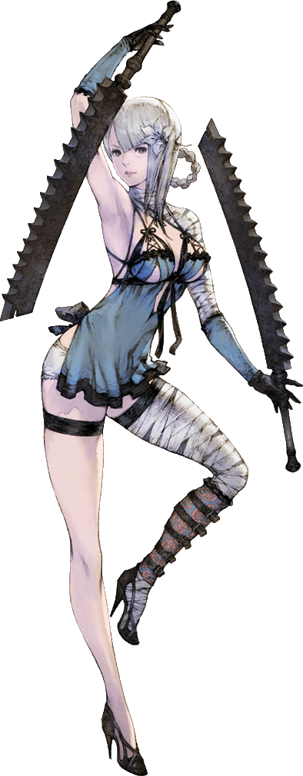
“I don’t understand what you mean! Remember what?” Voice shot into the feminine as the pain in her arm and leg intensified a moment before it finally began to dwindle. The woman’s mind was like a tossed salad that was only now being pieced back together, and in a way that she couldn’t even recall who she’d been moments ago. In tandem with the pain finally subsiding, bandaged suddenly appeared, tightly wrapping around the blackened arm and leg of a Shade.

She shook her head and rolled her eyes. “What the fuck? I feel like I was hit by fucking boat.” Kainé wasn’t able to repress her desire to spout obscenities any longer, and her perky breasts gave a mighty bounce as she stomped the heel of her foot into the dirt ground beneath her. It certainly wasn’t unusual for her to wake up on the wrong side of the bed, but this felt a little different somehow. Almost like she was forgetting something really important?

DOUBT IT, SUNSHINE! WHAT DO YOU HAVE THAT COULD BE SEEN AS REALLY IMPORTANT? GAHAHA!

The voice of the half of her that was a Shade boomed from within, but the young woman did not grace him with any response to speak of. There was no point in it if he were just going to say shit that would piss her off. So, keeping that in mind, Kainé proceeded to dress herself up in a way that drew attention away from the bandages on the left side of her body, not to mention the point of insecurity that existed between her legs.

She wanted to exemplify her femininity, that was why she dressed in what could be considered lingerie. So there wouldn’t be any doubts about how she identified regardless of her biology. It was a pain in the ass, but whatever. Not like anyone really got close to her these days anyways.

After tying up her hair, the woman grumbled under her breath. “Whatever. We need to go hunting. See if that damn Shade shows up. Maybe today will be the day I kill her.”

Little did she know that she’d have a fated meeting with a certain boy later that very day.

