Misty’s aphrodisiac potion.

Mia opens the front door letting in a small, cold gust of wind before quickly closing the door behind her. She takes her coat off and walks into the living room, clutching and rubbing herself, trying to generate some heat. Mia rushes over to the kitchen, walking right past the skunkgirl, lazily lying on her stomach, covering almost the entire couch.

“Hey! I told you to do the dishes! You really need to pull your weight around, we pay equal rent after all, kind of rude to let me do everything.”

She checks the pantry for something to eat and notices all the protein bars are gone.

“Ugh… can you at least go turn on the heater, I’m freezing.”

Mia opens the fridge and scans it for something quick to down, she grabs a chocolate milk with added protein, but before pulling it out she notices something suspicious inside the fridge, next to her hand: A heart shaped glass bottle with a cork seal. It has clearly been in use, because the cork seemed only loosely pushed in. Mia shrugs it off before chugging her chocolate milk.

Misty grins as Mia takes a sip from her drink before saying:

“Heh, no worries, I’ll turn up the heat.”

She lifts her butt up slightly and leans it to the side before…

\*PPhhrrsssptpptt\*

You can see the tight fabric of her shorts bubble up as her fart ripples out of her butthole, quickly greeting them both with the gentle stench of rotten, earthy vegetables and skunky sulphur. Even from her distance, Mia could feel the air get warmer as the gas enveloped her senses. She starts coughing before reflexively making a gasp for air, only to have her breath filled with more thick, potent, skunky air.

“Mmmphh, phew! Those protein bars sure make my farts fucking *stink!*”

Relieved, Misty swings her tail, soothing through the trail of yellow haze leaking from her butt.

Mia cringes, wafting the air with her hand.

“Oh my god, Misty! I fucking told you that if you need to fart, go elsewhere! Ugh, that reeks! At least I got to finish my drink before you turned the air unbreathable.”

Mia walks over to the window, about to open it before Misty speaks;

“Well, i don’t think that will be an issue anymore, at least for today.”

“H-huh? W-what are you talking about.”

Mia clutches at the window, trying to open it before her heartbeat starts rising.

“Oh, I’m sure you understand what’s going on, hahaha.”

Misty wiggles her butt in Mia’s direction.

“You sure you don’t get it yet? Don’t cha think my fart smelled a little more… *intoxicating* than usual?”

Mia’s eyes widen.

“Wait, how did you? … Oh no, Misty what the fuck did you- “

She falls to her knees, clutching her heart as it starts pounding deeper. She thinks to herself.

“No no no no, I can’t be feeling this way!”

Mia clutches her chest, and in an embarrassed fit of rage, she shouts:

“Y-you made your toots aphroditic! Are you for real?! I can’t believe you d-did that, mmmph fuck. Why?!”

Misty scrolls her phone before pausing and looking back at Mia and winks, swaying her tail in a mischievous manner.

“Oh, you know, I just thought this would be a really funny way to humiliate you. Turn what you hate the most into something you crave for more than anything else in this word! Something you’re even willing to throw your dignity away for~”

Mia’s heart pounds even more wildly as she starts lusting for Misty’s scent.

“N-no way! I don’t want to go anywhere near that horrid butt of hers…”

She starts panting.

“Her large, plump butt, and irresistible gas…”

Mia clutches her legs together, feeling her panties dampen.

Misty speaks with mischief in her voice.

“Oh no, I feel one coming- Hnnnnngh”

\*PPHHBBRRRMMPT\*

She releases another short, violent burst of a fart, vibrating her cheeks before it explodes out into the room, filling it with an even worse smell. Gas scented with Misty’s swampy ass, rotten vegetables and skunk spray. The air gets so thick, warm and moist, that when Mia breathed through her mouth, panting, she could taste Misty’s gas as it condenses on her tongue, filling her mouth with the most repulsive scent.

“Aaah! Hey, stop wasting them, come sniffy sniff~”

Misty wobbles her ass invitingly.

Twenty minutes pass. The room is lightly fogged up with a rotten smelling yellow haze. Some of it leaking outside the window to the porch, melting the snow gathered on the outside-rim of the window.

Misty is still lying on the couch, browsing her phone. However, this time she has company. Mia lies faceplanted right into Misty’s rear, sniffing the backside of her shorts. Though not as potent, it still has some remnants of her farts from earlier.

Misty turns her eyes, trying to get a look at Mia, buried in her massive backside.

“It’s been brewing for a while now, you want it?”

Mia lights up.

“Mmnnphh, y-yes please give it to me, I need it!!”

She buries her nose deeper into Misty’s ass, desperate for a fart, and getting wetter from the skunk’s teasing.

Misty grins with malice and pulls out a voice recorder app.

“Alright bitch, then tell me how much you just love to sniff my nasty farts. I’m recording…”

Mia comes to her senses for a second.

“I-I,”

She cringes at what she’s about to say, but desperate for Misty’s ‘warm embrace’ she scrunches up her face and speaks, her face red as a tomato. Mia knew Misty would use this against her sometime in the future, but she was just too desperate. Every time she would think of the consequences, her thought was instantly interrupted by the lust for a skunky fart, right up against her nose, warming it up and letting her huff it from point blank range.

“I-I love to s-sniff your nasty f-farts.”

Misty smiles.

“Good girl, now say it like you mean it! Say that you love to inhale mistress Misty’s nasty farts right out of her beautiful butthole!”

Misty’s stomach roars like a lion.

“Hmmmph, you hear that? It could be all yours~”

With her soft, striped tail, she pats Mia on the head.

“F-fine…”

Mia gives in to Misty’s demands.

“I love inhaling Misty’s nasty farts right out of her beautiful, butt!!”

Misty gets slightly annoyed.

“Mistress! Misty. Say it again, NOW!”

Mia closes her eyes and shouts, though muffled a little by the skunk’s ass;

“I Love inhaling mistress Misty’s nasty fart right out of her beautiful, perfect asshole!”

As she shouts, Misty peels off her shorts before her grin sharpens. She pulls her legs up, locking Mia in place.

“Good girl.”

Mia opens her mouth and presses her nose as deep as she can in Misty’s damp crevice in anticipation of a fart, making sure her nose is snuggling right against the sweaty skid mark on Misty’s panties. It reeks. Misty’s panties smelled like someone shoved your face in a bucket of manure and skunk spray, but it was about to get much worse. Misty moans, pushing to let loose her fetid storm.

\*PHHHhhhfFFHHRRMMPTPTPTT\*

Her fart vibrates Mia’s face,

The sheer stench of her fart wilts the nearby pottery, the food on the kitchen counter turning sour, and the paint starting to lightly peel from the nearby walls. Mia pulls back for a second out of shock because of how bad it smelled, but Misty pulls her back in with the back of her legs. Mia closes her eyes and leans back into her ass, nuzzling her nose right up against the rancid panties.

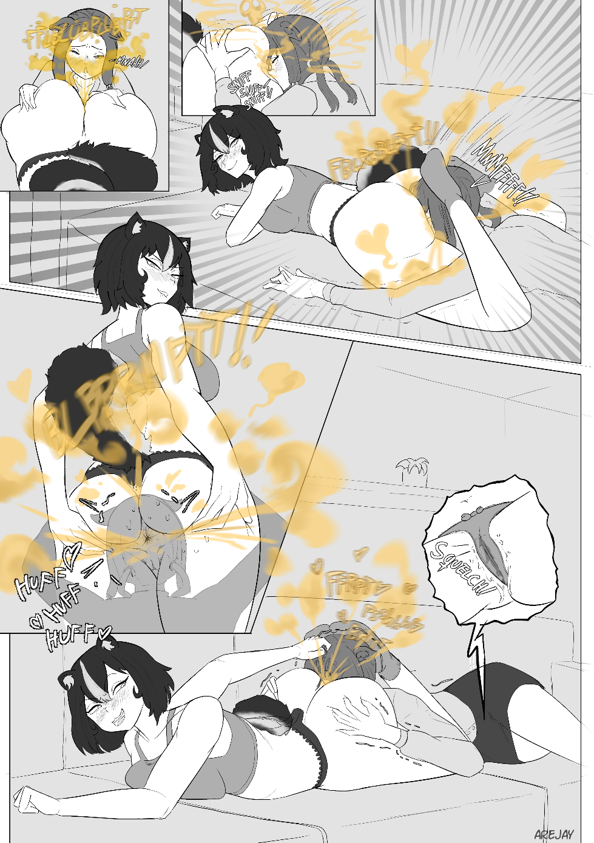

“Ah, that one was naaasty~ Haha, oh my fuck, it seared a hole through my panties! God, I bet it felt nice on your face!”

Misty teases as she bites her lips and prepares for another one.

\*BllBbBBBLLPRRTPLOPRLPTOPRPRMOPTMTPTPTT\*

Mia, making sure she inhales during the entirety of the fetid spray of disgusting gas. Inhaling in and out quickly. Having an orgasm as she pants.

\*bBBBbBBBBBRRRRMMMMMPOPROPPTOPOTTUTSSHHHTT\*

“That one was so fucking wet! Bwahahaha! Sniff it, bitch~”

Mia blushes

“Y-yes mistress.”

\*pPpHhwwSsSSSHSHHHHPRPT\*

“Fuck! That one reeked! Ugh, are you still alive? Because it sure smells like something died back there!”

Misty laughs, grabbing the back of Mia’s head and holding it down as she shakes her ass, letting out another barrage of farts, all stinking of rotten eggs.

“I can tell you’ve been craving something more, so what are you waiting for, kiss my asshole~”

Mia does as she commands, giving her asshole a little peck, the stench of her asshole now sticking to Mia’s lips.

“Wow, you really went for it! Dirty girl. Now stick your tongue out, really make out with my asshole! Swirl it around my shithole and lick me clean~ My farts do tend to stick, so make sure you really get in there and give me a good tongue bath!”

\*PHHRRBRPPRPTTT\*

“Aaahh~”

Smelling of an old, unattended cow farm and sulphur, she keeps gassing out her poor roommate. Each fart more potent than the last, the room fogging up even more, the opaque haze is now more like a dense fog. The fetid air leaking outside the house, making the nearby street think its manure spreading season for the farmers.

Hours pass and Mia wakes up, sitting in the left corner of the couch, with Misty on the right. Mia squints her eyes open and notices a piece of fabric strapped to her face.

“E-EWWWW ARE THESE YOUR PANTIES?! GET IT OFF!!”

Mia gags before trying to throw the panties off her face. Misty acting fast and holding them tightly in place.

“Bwahahaha! What’s wrong, I thought you loved the smell of my panties! You strapped them around your own face yourself, bitch! Oh, and don’t forget my recordings of you telling me how much you love my farts.”

Mia opens her mouth.

“A-aaaa my tongue, what’s that taste? … Oh my god I’m going to vomit.”

She tries rushing out to the bathroom to brush her teeth, but misty keeps her restrained before taking the panties off her face and stuffing it Mia’s mouth.

“MMMMPHH MPMMMHHPP!!!”

“Phew, that ought to shut you up, hahaha. Next time you tell me it’s my turn to clean the house and berate me for not doing it, remember this. As if you’ll even be able to ever clean that smell off you, haha!”

Mia whimpers as her struggle turns weaker. Misty content as ever.

Lolite walks in from the front door.

“Hiiii!!- Ugh! Hahaha misty did you eat those protein bars again? Man, that’s stinky! Hihihi!”

Lolite skips over to the open kitchen across the living room and opens the fridge.

“Who took my chocolate milk…”