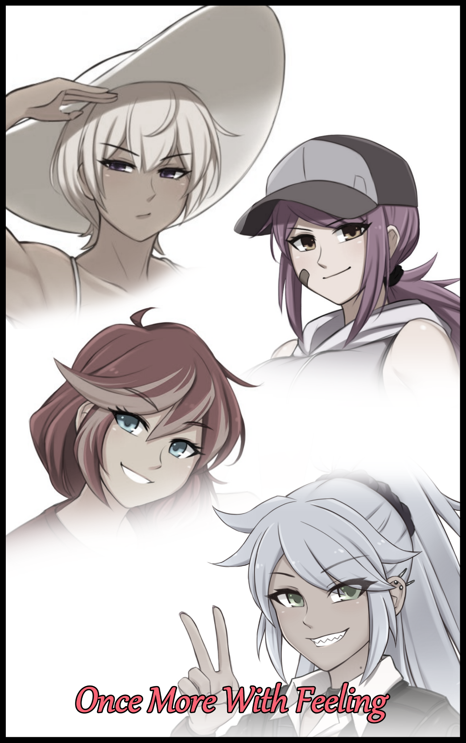

With the year gradually coming to a close after the passing of Halloween in October. Students from all over the world were excited to finally be done with their studies, hanging up their hats after major exams and tests were over.

But it was also during periods like these where restless youngsters would get themselves tangled up in all sorts of trouble, whether they were the adventurous sort who intentionally went out of their way to involve themselves or simple minded souls unwittingly ending up in the wrong place at the wrong time, everyone, at some point or another, could at least recount a tale or two from their youth, be it uneventful or otherwise.

And for a certain group of senior highschool students, they would fall into the latter group; young men and women oblivious to the hidden face of the boring world they lived in. Moving along the street as a tight knit group of four consisting of three boys and a quiet girl who seemed right at home in the group despite being the only female, ignorant to the unshakable gaze of invisible eyes keeping watch over their every move.

Thankfully for them however, the unknowable forces that treated the world like their playground shared human traits, like a sense of morals and a code they followed strictly. Some strove to uphold what the collective consciousness of man had come to agree on as the law while others were aimless spirits, doing as they pleased without rhyme or reason. United by a shared ideal that kept them from overrunning the human world, something they could easily achieve with their mind bending, psychic abilities and reality warping magics. Choosing not to in preference for maintaining the natural balance between both sides…and some twisted form of affection for the humans who they interacted with.

Where they come from and what ulterior motive they share however, will forever remain a mystery…

The group had laid down their pens and books and the time for studying was over. With the end of their final exam just hours earlier, the four weary souls weren't too eager to put their minds toward anything besides letting their hair down and partying till nightfall. Especially since these next few months would probably be the final moments they would ever get to cherish each other's company before they went their separate ways on the road to further their individual aspirations.

Even though it was easier than ever before to maintain contact with someone else through the use of modern technology, each one of them had a little spark in their hearts; a desire that things as they currently stood could never change.

Even with what little it understood about the way humans lived their lives, the immaterial being knew that uniting all four through college was going to be a tough job without drastic alterations done to the fabric of reality, nor did it have the capability to do so no matter how much it's alien heart bled at the strong bonds between them. Resolute and unwilling to give up however, it peers through the minds of the group, parsing through memories and personality weaves like a scholar would a book. Looking for something, anything it could use to ease the inner turmoil they felt.

Amongst its peers, the being was considered too 'human'. Driven by emotion instead of instinct like the rest of them were. And in a stroke of luck, it was this ability to reason and empathize that would ultimately save the group from worse fates if they had caught the attention of one of the more base entities who would most likely ignore their plight in favor of satiating themselves before moving on to others. As rare as they were, the changes they inflicted upon the world were untraceable and undetectable, even the most spiritually attuned individuals wouldn't realize they had fallen victim to the influence of otherworldly forces.

Even though it would've liked to tell the humans what it had in mind as it continues to peruse their minds. There was no way for them to communicate. Leaving their mark upon the world through the people they touched thanks to their intangibility. And with the last few metaphorical pages skimmed and done with, the being had at least some measure of a plan ready for the group as they made their way into a karaoke lounge, following closely after them while it's sensory organs winced and flexed in curiosity, taking in the bevy of human voices singing with gusto. Some were ear gratingly atrocious while others sung with a beautiful melody, shifting the being's plans somewhat as it's easily influenced mind begins to latch onto the concept of change through song. Thinking of it as a brilliant way to give each of the four a semblance of choice for what it was about to do to them as it patiently follows after them, moving single file right behind the last man until they were all huddled inside one of the rooms where they would presumably have all the privacy in the world to sing to their heart's content.

**"C'mon guys! Order up! Drinks are on me!"**

**"Really man? Only drink we're ever gonna get out of this place is fruit punch!"**

**"Hey, what gives? I for one agree with Max. Give it a few years, maybe then you'll be old enough for *milk!*"**

**"I'm fine with tea thank you very much…"**

Watching the four exchange friendly quips and jokes from its corner of the room only made the being question itself as its gaze turned from the humans down to itself, holding up wispy arms that couldn't maintain their shape for more than a few seconds before wavering like plumes of blue tinted smoke, rousing existential thoughts within its head while the sounds of the world around it fade into a muffled drawl.

So deep in thought about who or what had led to their existence upon this earth and the eventual symbiotic relationship they would share with the humans, the being barely manages to register the sight of the loudmouthed boy rushing to answer the door, taking a tray loaded with refreshment back towards the low standing table for his companions to enjoy and liven themselves up with before the main event.

After all, one didn't go to a karaoke lounge with friends to share idle chatter. They came to sing and relax, and very soon, each one would put themselves up on stage in a rare display of their singing talents.

*'Wonder if…I can sing too…'*

As hopeful as the concept of wishful thinking was, the being knew its place as a simple bystander, here to affect change as its primary function lest it fade away…for now at least. Maybe things would change in the future and they wouldn't need to live solitary lives away from humans and each other, but for now, it had work to do, snapping back to focus once the first of the group rises from their comfy seat on the posh leather couch towards the spacious center of the room where a wide-screen monitor hung nailed to the wall facing the remaining trio, flanked by an array of speakers tuned specifically to accommodate the singer as long as they made sure their singing voices were loud and clear.

Unsurprisingly, it had been the aforementioned *Max* who would be the first to step up to the challenge. Scrolling through the list of authorized songs the lounge featured in their line up before he clicks away, clearly dissatisfied by the choices as he leans forward with phone in hand, attaching a cable jutting out from a curious black box linked up to the display, a nifty attachment that allowed for guests to play their own tracks if they weren't happy with what was provided.

**"What's wrong with the song selection Max? Nothing up to your standard?"**

**"It's not about standards Dan, it's about the meaning! Not to sound rude but the lineup ain't cutting it…flair and story's part of the charm behind good music! You'll see!"**

Sidling over behind Max while he finishes inputting his desired music, the invisible fifth participant readies it's magic, channeling it into a fine cocoon that slowly coils and slides around the oblivious human busying himself with some last minute prep work; clearing his throat in dramatic fashion, fluffing the collar of his uniform while kicking the floor like a bull preparing to charge.

*'Curious…intimidation tactic maybe…'*

The entity knew all there was to know about Max after that cursory glance over the group's shared memories and experiences. Everything, from how he hid a soft heart behind the boisterous exterior his family and friends knew him for to how he loved the bass, rhythmic beats in psychedelic rock that was the true reason behind his musical selection. It knew it all.

And for such a choice of song that even the inhuman creature shuddered at once the opening guitar riffs accompanied by a strange echoing 'shadow' reaches its ears, the changes soon begin once the clueless boy begins to sing a song with a rather cliche meaning behind it. Wrought by the entranced being whose attention was now focused solely on the music, thinking of ways to improve the singer's synchronization with the instruments while taking the lyrics that flowed forth from Max's softening lips as inspiration with which it would use to reshape him as the invisible veil around him begins to compress inward, forcing the rigid human form to comply with its silhouette.

Beginning with an overall reduction in height and mass, Max's average height of 6 feet would drop by an unnoticeable margin while his broad, rectangular frame would start to mellow and bend, gaining noticeable curvature especially prominent in the hips as a result of pelvis bones snapping outward to accommodate for the rapid growth of new organs vital to the function of his new self. All while musculature that had been steadily growing from months of short trips to the gym vanished altogether, replaced by lean, supple layers of baby fat and tender flesh, coiled right around lengthened bones that gave long arms and slender legs the formation with which they would grow around. Replacing Max's former bulk with pleasing mounds of rolling hills and gentle dips, turning the former jock's budding herculean physique into that of flowering femininity; of a girl who was taking her first steps into the real world of adulthood after faking it for so long, mirroring the story hidden behind the song *Maxine* sung with that husky voice of hers, captivating her friends with her passion, lean brows furrowed in concentration while fiery eyes began to cool into pale green irises.

While graying strands of brown hair cascaded down the nape of her slender neck alongside the beginnings of petite breasts jutting out from under the cotton shirt she now wore, the trio's memories of their friend were slowly being altered to fit the new ones currently rolling around inside the newborn girl's mind. Forgetting the Mister Universe wannabe chatterbox she once was for a bully…a skank…and then eventually, a dear friend.

Maxine had misunderstood the concept of a woman's worth, thinking of it through the superficial lies and teachings the wrong crowd she mixed with had fed her. Fancy clothing, accessories, gorgeous hair. These were the ideals she chased after in her late years as a middle schooler all the way till highschool, where she would come to meet the trio she was currently pouring her heart out to. The gang she was with at the time had taught her that they weren't worth her time, and so she had bullied them and a handful of other students. Relishing in the praise her underlings and fellows showered her with. Until they invited her to a shady gathering that opened her eyes to the truth behind who she thought were her besties…

She would've almost certainly been harmed in more ways than one back then, but somehow, the people she bullied in her short time as a first year highschool student, specifically these three, had found her in the nick of time to get her out and report the would-be rapists to the school. She had expected to be mocked and made fun of with her beliefs shattered and those she once believed to be her friends expelled, leaving her alone and without anyone to turn to. But Daniels, Susan and Jim, the 'Three Stooges'. They had welcomed her with relatively open arms considering the fact that she had been bullying them not too long ago.

Over the course of the next three years, Maxine would slowly crawl out of the dark pit she'd dug for herself, changing from introverted outcast to fast friends with the Stooges. Becoming a staple part of the group while balancing out the gender ratio disparity. And her appearance had changed to reflect that…but not without some scars to remind her of what she had done. Completing her mental readjustment just in time for her wild mane of ashen gray hair to tie itself into a fiery ponytail, flinging beads of sweat from her forehead as she enters the climax of the song, uncaring of the warbling between her firm legs once the last bits of her former pecker are crushed by the skin tight shorts that slap themselves around her hips, showcasing a clear slant leading down from her toned belly to a void where a bulge should've been.

Because in her mind, Maxine remembered being born a red blooded girl. And although her choice of attire and appearance had been far more 'callous' thanks to her misgivings, she felt right at home in her current getup; a style taken from the land of the rising sun perfect for her skin tone as it darkens into chocolate tinted beige. Completing Max's physical transformation into Maxine; reformed bully with a secret crush on Jim nurtured during all the times she'd spent with him in an effort to tutor her. For as sharp as she was in the field of music composition and the playing of the guitar, her studies were on the poor side of things. Glancing at him out of the corner of her eyes as she finishes the escalating finale with a triumphant foot coming down hard on top of the thankfully sturdy table, ending off with a round of applause that snaps the entity out of its stupor.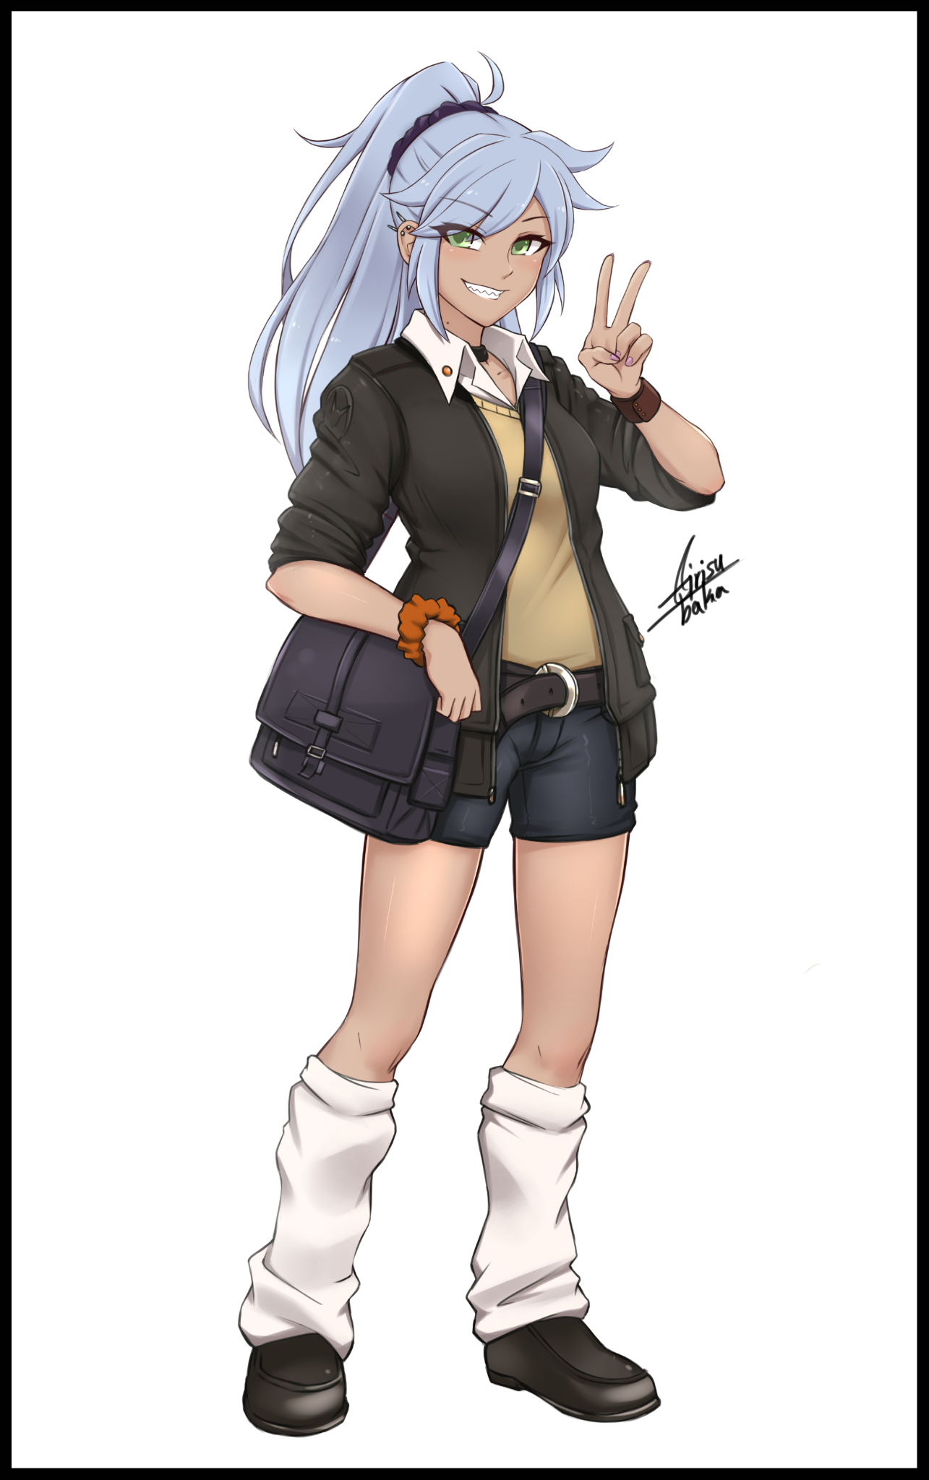

At some point or another, it had gotten caught up with Maxine's singing voice, entranced by how beautifully low of an alto her unsuspectingly husky voice was capable of taking on that likewise had her friends roaring with excitement.

**"That was amazing Maxine!"**

**"Encore! You never told us you could sing that we'll Max!"**

**"Hah! What did I say? It's all in the heart! Once ya get it, all that's left is to follow it as best ya can!"**

**"I concur…certainly did good in amplifying the delivery of the message you spoke of as well Maxine…"**

**"O-Oh…ya caught that huh…t-thanks for that Jim…*ahem* anyway…who's up next?"**

Releasing its hold over the newly formatted girl, the entity melts down a little to catch its breath while it watches the rest bicker over who would end up going next. While it wasn't a stranger to the manipulation of reality's threads, the strain it placed upon its body was still immense despite the rejuvenation it acquired from the resulting burst of emotions brought forth from the transformation.

Although it wouldn't have much time left to recuperate when it would suddenly see a pair of shoes and the rough hewn hem of trouser legs invade its field of view. Looking up just in time to see Jim struggling to stay standing while being pushed around by Maxine, laughing heartily to herself after having gone ahead and picked the next talent after growing impatient from no one volunteering…masking her secret motive to get Jim to sing a song of her choosing behind it.

**"Like I said Max, I'm perfectly capable of picking a song on my own…"**

**"C'mon, indulge a gal would'ja? If no one's gonna sing then I'm gonna pick…besides, I'm interested to see if ya really got that bit about 'sending a message'..."**

Nudging Jim's awkward footing in an effort to get him to slip and fall face first toward Maxine's flush lips, the restless entity sorely wanted them to just get together and confess. But with its incorporeal form, it could do nothing but sit and winge, although it's chance to affect change would come very soon once Maxine sets her phone down on the table with the next song keyed in, ready to play over the speakers while she scurries back over toward the couch, taking Jim's spot next to Susan with a gleeful look on her face, piquing the interest of the quiet girl who prods her on the shoulder.

**"What did you get Jim to sing?"**

**"Eheh! Personal fave of mine~ Hush now dearie, songs boutta start!"**

Shooting Jim a wink of good luck from where she sat while the flustered man sighs in exasperation, the room falls silent once again before the slow beats of a somber melody begin to fill the air. Making the entity bob its head along to the catchy rhythm. Although it sounded dreary, there still remained enough of a lively tune for anyone to follow after like a dwindling light in unfathomable darkness. Humming unheard to itself until remembering it had a job to do once Jim himself starts to sing in a nasally voice that had Maxine snickering.

*'Girl…won't be laughing…long…'*

Producing another veil that casts itself over Jim, focus forces it into immovable silence once again as its mind zeroes in on the slow beating of the drums alongside the steady, emotional riffs of a toned down electric guitar providing ample reinforcement for Jim's steadily focused voice. The man had started off not knowing a thing about the lyrics thanks to Maxine forcing it upon him, obliging simply because of his weakness to the fairer sex.

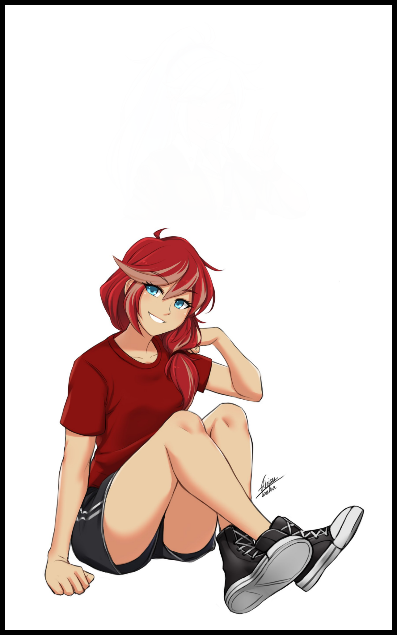

But with each passing second, coherent sentences would be string together from shaky words delivered with a mild sign of uncertainty that eventually fades for an unheard level of confidence that silences Maxine's laughter, leaning forward in her seat with a crease in her brow caused by a lapse in memory…or rather, two sets of similar yet vastly different lifetimes crashing into each other akin to tectonic plates, and just like the aforementioned plates, one side would eventually win out over the other, dwarfing the other into obscurity, altering Maxine's thoughts and feelings as her eyes widened upon the recognition of the song her girlfriend had decided to sing, forgetting everything she knew up until now regarding her relationship with Jim in favor for a new set filling her in on all the fond memories she shared with *Jane*; Rocker girl, soulmate and the first one out of the Stooges who stuck to her like glue when she first joined them. Not minding her permanently pale head of hair as a result of the damaging dyes her former ‘friends’ had given to her.

And with each new memory gleaned from her new past, Jim's drastically altered form changes in tune to match Maxine's perception of her; an inward curling bob of scarlet tinged spice tapering off into a low hanging ponytail, framing a handsome visage she more than remembered clearly thanks to the many intimate moments they shared together, and while she didn't quite match up to her in terms of figure, the one place Jane won out over Maxine in was her bust. As evidenced by their vigorous swaying as she moved her body to the slow, pulsing beat that made this her favorite romance song in the genre of rock. Something only the smug redhead would know as her steely eyed gaze focuses in on her, vapid gray eyes flashing for a moment before vivid aquamarine overtakes them entirely, filling them with a fire that spurs Jane forward, swaying petite hips while growling the closing lyrics to the song in a manner that had Susan blushing while Daniels simply shakes his head, looking away with a mild blush on his face at the sight of Jane acting on her lesbian urges so brazenly, cozying up to a shivering Maxine, whispering the final words into her ears before locking lips with her, filling the air with soft smacking from their lips coming together, biting tongues as they exchanged oral fluids without a hint of shame.

**"J-Jane…! T-Thats…"**

**"God, get a room you two…"**

The Jim of old would never stoop so low as to kiss another so immodestly in the public. But Jane was brave, and she didn't care much what others thought about her. Making her the de facto leader of the Stooges during their three years together. But the changes had also come at a cost in the form of a hefty chunk of IQ being deducted from her tingling brain as years of fascination with heavy metal, alt rock and synth metal flooded the empty pockets in her mind. So instead of teaching Maxine, the pair now weathered through studies together. And with their shared interest in rock, the two were now planning to enter the treacherous world of music as a two-girl act with Maxine's talent in lyrical composition and guitars combined with Jane's talented vocal range that enabled her to perform a great many songs ranging from emotionally charged bangers to solemn hymns.

And with the hundred thousand or so views they had already amassed across various social media channels, they already had the traction and proof necessary for potential record labels to sign with them.

Tearing herself away from a thoroughly stunned Maxine before reclining comfortably by her side as if nothing had happened, Jane shoots Daniels another of her smug smiles with a dismissive wave of her hand. While she understood Daniels wasn't the type to favor making out in public. Jane knew it was high time for the loners in the Stooges to get hitched. She'd known for a long time now that Susan had a bit of a thing for the dunderhead, and while he might not look eager to reciprocate her love, Jane had caught him stealing sidelong glances at Susan whenever he thought no one was looking.

And if experience taught her anything, Jane knew that the sooner one acted on that 'connection' they had with someone else, the better their chances were lest they lose interest altogether…or worse yet; whisked away by someone else. If there was a better time to seal the deal, it was now, when they were all riding high off final year exam adrenaline.

**"Talk about yourself! C'mon Dan, admit it; you've got the hots for Suse don't you?"**

**"J-Jane! But thats-"**

**"Woah! What's that got to do with you two lovebirds?!"**

**"It's got *everything* to do with it…don't you get what I'm saying? It's time for you two to stop acting as if you aren't interested! Suse! That goes for you too!"**

*'Uh oh…girl…not mad is she?'*

The entity had lost consciousness for a moment, missing the moment when its veil had slipped off of Jane and the proceeding steamy moment she shared with Maxine. Awakening to the sudden shout the irate tomboy's voice had risen to, jolting her love-addled wife awake from her stupor as she too turned to face the redhead with shock. But now that the entire room was focused on her, Jane had no intention of stopping, gently taking Susan by the sleeve while pulling Daniels roughly by the collar, ushering her two uncertain friends over toward the middle of the room before stepping away while dusting off her hands, slamming her butt down on the couch next to a still silent Maxine who had no idea what was happening after blanking out from that mind blowing kiss, her mind still stuck in the past with a hand tracing the sore bump on her lip left behind by Jane’s aggressive biting.

And now it was Daniels and Susan’s turn, standing close enough for both to feel how nervous the other was. Both had simply been expecting a fun time singing till their throats were hoarse and their limbs were drained from dancing till the wee hours of midnight. And now here they were; forced into an awkward position, unsure of what to say or do. And right before Daniels looked about ready to say something, a sudden scratch of static cuts into him before a gentle serenade begins to play, silencing the opening words he was about to say as he whips his head around, glaring daggers at Jane, who didn't seem the least bit deterred. Returning it with a nonchalant shrug of her shoulders.

While their fifth participant remains unmoving right under their noses, hearing yet another song go seconds by, yet neither one of the humans sung, they just stood there. One frowning indecisively while the other fidgeted awkwardly, shifting her weight from foot to foot, glancing all around the place with a look that suggested she wanted to run as far away as possible. While it agreed with Jane's reasoning, she had still put her friends on the spot while hoping for the best. Even it knew there was no possibility of a confession in stressful conditions like these.

*'Strength…gone…but need to help!'*

Clenching it's fist before shuffling over as fast as it could toward the faltering duo, the entity summons a larger veil that envelops both Daniels and Susan, sending a shudder running down their spines as it takes things into its own hand, keeping their future at the forefront of its mind while spurring the two on through the last transformation it could muster.

Except this time, something strange was happening to the duo as they began to move, grabbing hold of each other's hands before swaying slowly, moving their legs step by step, until eventually a rhythm was established despite Jane's audible mutterings about what they were up to.

Unlike the others, a contrasting metamorphosis would take hold of Susan and Daniels as they danced together in the narrow space in the middle of the room. While Daniels' tall, gaunt figure begins to fatten and shrink, Susan would go in the complete opposite direction; gaining musculature and tone to her physique all while growing a head or two taller than her love interest. It was as if they were trading traits with one another. And like their forebears, neither one seemed to question their changing bodies even when B cup breasts tested the limits of Daniels’ top while Susan’s pale hide started to tan into alluring sepia. Instead, Daniels opened fattened lips not to ask questions but to sing along to the cool soothing lullaby in a melodious voice far girlier than Jane and Maxine's combined, accompanied by Susan's deepening baritone with the dwindling man now needing to crane his neck up a little to gaze into Susan's crystal clear, ochre pearls. The same shade of brown she sported as well, bringing her lean waist to bear before *Suzanne's* rock hard abs, rosy cheeks flaring upon the feeling of the Amazonian woman's hands tracing the slender arch of her spine, involuntarily letting out a soft gasp of excitement that interrupts their song and dance.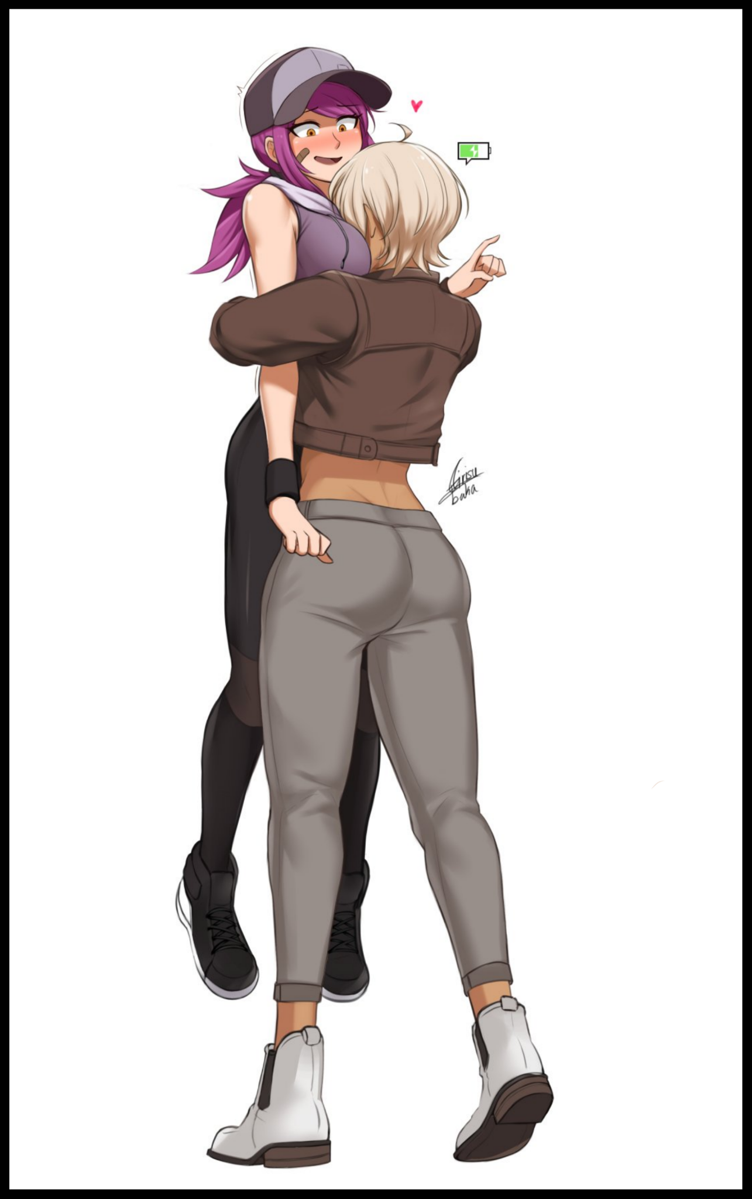

**"O-Oh my god…I'm so sorry Suz, that just came out of no-whaaaat are you doing?!"**

**"Shhh…just let me hold you for a sec…"**

Not giving *Daniella* a chance to protest any further, Suzanne easily hefts the slender young lady in her jackhammer arms, taking the blushing girl into a bearhug that seemed to last forever, leaving her feet hanging a good distance above the floor enough for her to feel threatened by the glaring lamp above, shielded from its searing glow by the leather cap she wore atop her violet colored head of hair done up into a sharp, low hanging ponytail. Muttering incoherently at the sight of the blonde haired musclehead stuffing her face straight into her cleavage, blushing at the alien bolts of euphoria sparking all over her body just by knowing her closest friend in the group was borderline motorboating her chest. Her face was so deep in there she could literally feel her melons being sucked into Suzanne’s nostrils with each deep breath she was purposely drawing in.

***“Fhani?”***

**“W-What? I can’t…hear you…”**

Pulling her head free from Daniella’s chest cushions, Suzanne’s beady eyes zero in on her friend, unwavering, unabashed, burning with a confidence to make her feelings known.

**“Dani…I love you! I want to spend the rest of my life with you! I won't take no for an answer!"**

**“S-Suz! You can’t just…that doesn't…hahhh~! Fine! I…I love you too~!”**

Collapsing into a heap on the floor with a sharp whistle of air escaping its body, the drained entity could only watch from the floor as the second and final pair of lovebirds continue to mutter and exchange their vows with one another, all while Jane and Maxine rocked with laughter where they sat, likewise having missed the fact that their nerdy friend had been turned into an eye catching lady with the beginnings of an hourglass figure while the meek damsel had become an oddly endearing scatterbrain who was too straightforward for her own good, rambling on about all the things she and Daniella would do from now on besides their daily training sessions. All while the rest of the unfinished song draws to a close, forgotten in the background.

**"Hah! See? Wasn't that hard now was it? Now you two are officially on board the love train~"**

**"You are correct June…Dani will not be getting off my love train anytime soon!"**

**"Suze…you probably misunderstood her…right? You didn't actually think-"**

**"That we would make love? But you promised you'd be on board!"**

**"I…that's…goddamnit Jane…"**

It was as if nothing had changed at all despite the four souls who'd stepped inside the karaoke box over half an hour ago turning out entirely different. And even though they had lost as much as they gained without their knowing, the being responsible for it all was more than satisfied with what it had done as it retreats to the far corner of the room, listening in to what they each had to say about the future that awaited them accompanied on occasion by pleasant singing from the four newborn ladies.

Instead of going their separate ways, this outcome had allowed for the four to split into two groups that would constantly share their bonds with each other. Never wavering even through the time they would inevitably have to spend away from one another once graduation came to take them on to the next step of their respective careers. For Maxine and Jane, their passion and skill would take them far ahead in their planned path toward fame as a rock band duo. While Daniella and Suzanne claimed preference for a far more easy going approach, drawing up plans to enter the same college together with promises to cheer on their girlfriends from the side.

It all served to lend a profound effect on the entity as its thoughts drift back to itself and what to do from now on. Wondering when it would ever be able to converse with someone other than itself; an oddity amongst oddities considering the cold outlook the rest of its kind had for humanity as a whole; a people they could not understand. Maybe someday it would be able to chat up someone as easily as these four spoke with each other. Potentially even the chance to feel the euphoria and joy it could only ‘taste’ on occasion whenever it had to sustain itself.

But for now, it was content with observing, learning what it could from the few humans that would inevitably draw its attention from time to time. And with an entire planet’s worth of them, there was still so much to learn…

THE END