*Beating The Heat*

With temperatures reaching exorbitant new highs all over the world, the summer of 2022 was proving to be the harshest season yet; scorching land, sparking wildfires, and putting millions at risk as people collapsed from heat exhaustion and dehydration.

While it might've been a great way for people to earn themselves a tan in no time at all. Others looking to enjoy a good time out on the sands in places affected by the unrelenting heat of the summer blaze might be out of luck.

And for a certain few suffering from a unique, non transmissible fever stemming from a genetic disorder that reared its head every now and then across the world, the next few weeks if not months, would prove to be a test of their endurance

Take Ethan for instance, a young man in his early twenties. Fresh out of high school and eager to start college, things seemed bright for the brilliant mind with his future secured for the moment. Moving into the college dorms alongside his childhood bestie; Donovan.

Until the TS genome lying dormant within him had decided to kick into gear on the cusp of summer season, falling terribly I'll with an incredible and highly dangerous 40 degree fever that few could walk away from.

Sweating profusely with a medical professional and Donovan by his side at all times to make sure he pulled through, Ethan would begin his transformation into a chrysalid; with his pores exuding a thick slime that eventually layers over into a warm, smooth shell that encapsulates the entirety of Ethan's body.

By the time Donovan was ushered out of the room under the assurance of the doctor that everything would be alright, there was a featureless mass pulsating on the bed where a fit Caucasian male once laid. The middle stage that came after the fever every bearer of the TS gene would develop.

Over time however, the mass would soon begin to grow translucent, offering the trio of concerned individuals a glimpse of the metamorphosis occurring beneath, with Ethan now curled into a ball much like a developing fetus, already drastically altered from when they'd last seen him; sporting a sleek, androgynous build that bore no trace of his time as the ace of the football team. With soft supple flesh layered over the spots where bulging biceps and hardened abs should've been. At Donovan's own insistence, he had spent several sleepless nights listening to the beeps of the medical machinery hooked up to the cocoon alongside the gentle slushing of the meat soup beneath.

And everytime he looked upon the cocoon, Donovan would remain transfixed by the sight of Ethan's effeminate face sleeping soundly beneath his fleshy home, placing a hand over the eerie skin like surface and feeling its warmth, Ethan's warmth, run through his palm.

Being one of, if not the only close friend Ethan ever had, Donovan was unsure of his feelings for his friend. While he wasn't homosexual and preferred women, the fact that Ethan, someone he saw as a blood brother, was turning into a woman had him torn apart. Happy at the fact and disgusted at himself for even feeling not at the fact without considering Ethan's feelings on the matter.

Over the next few days. The embryo within would begin to develop breasts, naturally grown and capable of producing milk alongside a body blessed by Aphrodite herself; sporting shapely limbs connected to a curvaceous torso with a cinched in waistline and a petite neck connected to a face that was the spitting image of a feminized Ethan.

By the time the machinery started to go haywire and blare noisily, Donovan was wide awake to witness the sight of the mass bursting open with a flood of orange goop staining the sheets and pooling on the floor with the limp figure of a voluptuous maiden lying still, until her lanky lashes flutter open with brilliant cyan blue pearls catching the moonlight to gaze upon Donovan in a mix of curiosity and confusion.

It took a while for the newly christened Elizabeth to get used to her new body. Receiving hand-me -downs from her elder sister and a loving message of encouragement from her parents, Liz, as Donovan had come to call her, would struggle for awhile with the idea of putting on a suffocating bra and soft silk panties that only rubbed home the fact that she was no longer a man. And Donovan, unsure of what to do, could only stand by and try not to ogle his friend who didn't seem aware of the fact that she was alone in a room with a man…a very hormonal young man.

But with the summer now in full spring and the sweltering heat outside taking its toll on the college campus, Liz's risque choice of attire whenever she wasn't in her casual study wear for lessons was beginning to wear on Donovan's psyche, struggling to literally stay cool when there was a hot spanking piece of ass just inches away from him at all hours of the day. Many times now he'd caught sight of Liz's privates, whether her closet malfunctions were accidental or entirely on purpose, Donovan didn't have the capacity to think straight anymore.

When taken in tandem with Liz's sweet airy voice grunting and breathing in erotic fashion during her intense exercise sessions that was her way of regaining the bulk she had lost from her former self, Donovan was at his wits end; driven close to the edge from the summer blaze and his very hot friend.

Until things took an unexpected turn when Donovan had returned well into the wee hours of the dawn after a round at the bar for some stress relief, coming back to hear soft moaning coming from behind the door before pushing it open to catch Liz with her panties slung halfway up her thighs and a trembling hand with dainty fingers plugged firmly into her dripping pussy, surrounded by sweat stained sheets and workout tools. Yelping in surprise with her hands swiftly making an exit with a wet pop before staring him right in the eyes with those same blue pearls he had seen a few weeks ago, only this time with shame and embarrassment as her heaving bosom rises and falls erratically with erect nipples tenting the sweat stained singlet.

**"D-Don?! I…this isn't what…what're…you…"**

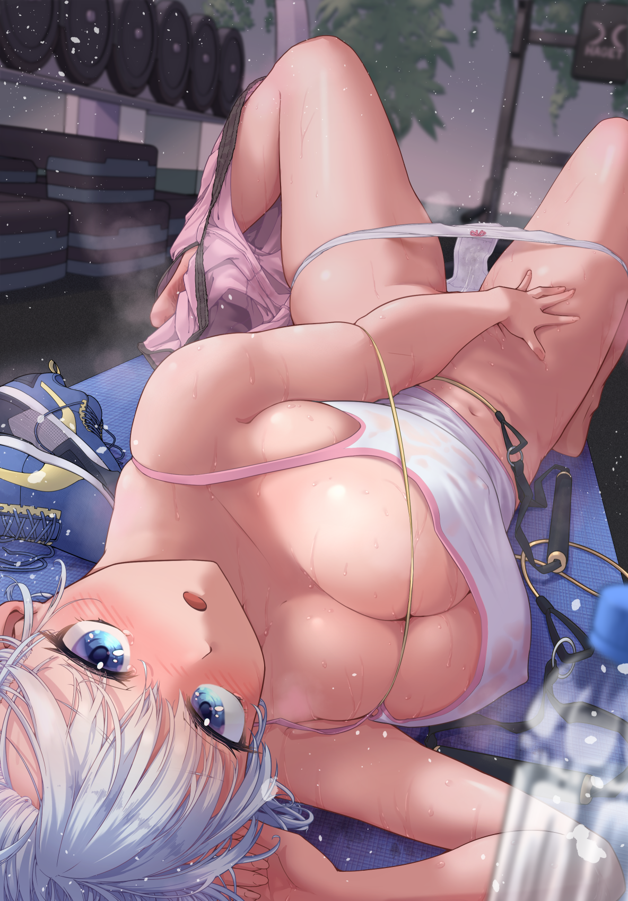

Seeing the white haired maiden lying in a steaming mess of her own making had broken the metaphorical dam in Donovan's mind, slowly approaching Liz before pouncing on her, joining her in bed with her excuses falling silent the instant she spots the raging boner in her friends pants with visible excitement in her eyes.

Because much like Donovan, Liz was beginning to grow frustrated with her new body and everything that came attached with it. From how small, frail and sensitive it was to the budding feelings she was beginning to harbor for her best friend. Finding her gaze lingering on Donovan's visage with a yearning she had never felt for him before.

It wasn't just her emotions she had to deal with either. Because everytime he came close, Liz's body would enter into a state of oestrus; hardening her nipples, clouding her judgment and forcing her new reproductive system to cramp with an unbearable urge, growing damp and itching for something long and hard to fill the void within. Something her small fingers could barely hope to achieve whenever she found some alone time to herself, feeling terrible and alienated when she had assumed Donovan had left her after all her attempts at getting him to notice her had gone unnoticed.

And it didn't help that the summer warmth was getting her riled up at the continued failure to satisfy herself and come to terms with her undeniable love for Donovan, fearing he'd see her as gay, or even a freak.

But it was a yearning finally fulfilled with Donovan's meaty member currently pumping in and out of her tight snatch, knocking hard against the entrance to her fertile womb. Moaning in ecstasy with her face twisted into a look of shame and joy, cradling Donovan's hardened body in an attempt to steady herself from how good it all felt despite the mind numbing warmth of the summer atmosphere pressing down around them both. Soon filling the tiny dorm room with steam clouds emanating from the two sweaty bodies locked in coitus with each other.

After the initial excitement had died down however, the couple would soon find themselves sitting next to each other entirely naked in bed. Unsure of what to say next with the irrefutable, and very smelly evidence of their romantic tryst all around them.

But as a large comforting hand rubs her shoulders assuringly, Liz could only turn hesitantly toward Donovan's likewise flushed face.

**"S-So uhh…I know it's...too late to say this after…y'know…but Liz? Will you go out with me?"**

**"Oh..w-wow…I…dunno really…I mean…gosh I'm so stupid!"**



Swallowing her hesitation as a warm, fluttery feeling radiates from beneath her chest, Liz leans closer toward her friend before retreating, nodding shyly and at a loss for words before her newly crowned boyfriend takes the initiative, closing the distance between them and landing a kiss on her soft plump lips, gasping in surprise before closing her eyes to bask in the moment. Overjoyed and excited for what the future held for her and Donovan.

*THE END*