**Patreon Pin-Up Commission Prompt Helper**

*Fill this out to help give our artist and me a clear idea of what you want!*

1. **How many people are in the pin-up? (Max of two except for special exceptions)**
2. **What are they doing/what is the pose?**
3. **What type(s) of growth takes place? (Predominately BE please)**
4. **How is she growing? (i.e., regular growth, milk, hoses, cum, water, air, etc…)**
5. **How big does she get? (please attach size references if unable to describe)**
6. **What is her reaction? (scared, excited, confused, angry, curious, etc…)**
7. **What is she wearing?**
8. **Is there any nudity? (No limit to this)**
9. **Pick an art/shading style!  
     
   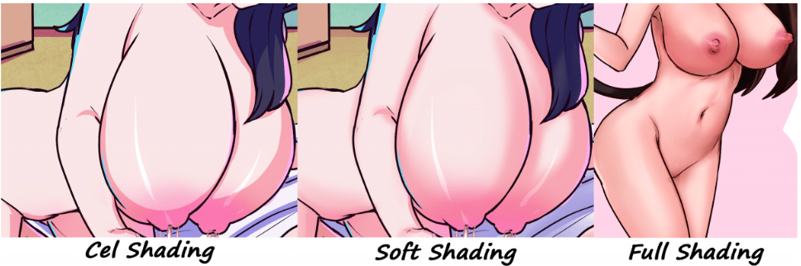**
10. **Please attach any references for the pose, clothing, sizes, other details, or real people if you would like them modeled after someone.**