GOLDMARY ENVY
COMMISSION STORY
BY CHALDEACHANGE
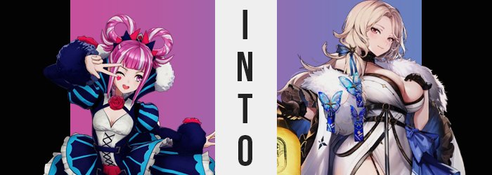

Hortensia wasn’t exactly sure about this trip.

Not that the circumstances were bad or anything. It was quite the opposite in that regard. The war had finally ended between the kingdoms upon the continent of Elyos and the Fell Dragon would be an issue for them no longer. It had been some months since that climactic final battle, and in that time the continent and its people had begun to heal. The need for soldiers had diminished to protecting the people against monsters and bandits alone and slowly but surely the buildings that had been felled were being rebuilt.

But this rejuvenation process would take time. Not only for the structural design of the land, but for the people. The war had been won in the end but how much had been lost? How many people had died? Family members killed, corrupted, or sacrificed? There was no easy way to rebuild the hearts of the masses after suffering for so long but all they could do was move forward one step at a time.

It was in the service of this that princesses Hortensia and Ivy of the kingdom of Elusia had set out into the forests of their country, traversing them to reach a small town on the outskirts on the invitation of one of their retainers. Hortensia’s retainer, in fact. Goldmary came from a small village with a world famous hot spring run by her family, and Goldmary had invited the two princesses up for the weekend. But wait! Didn’t that sound like they were just heading up there to relax!?

Well that was part of it. But part of the recovery efforts of their kingdom involved visiting the villages and offering help personally. They would be spending time at the hot springs, but at the same time the two sisters would be offering relief where they could to the village’s people. Fortunately from what Goldmary had written in her letters, it didn’t seem as if things were too bad though. “What do you think about— Huh? Ivy?”

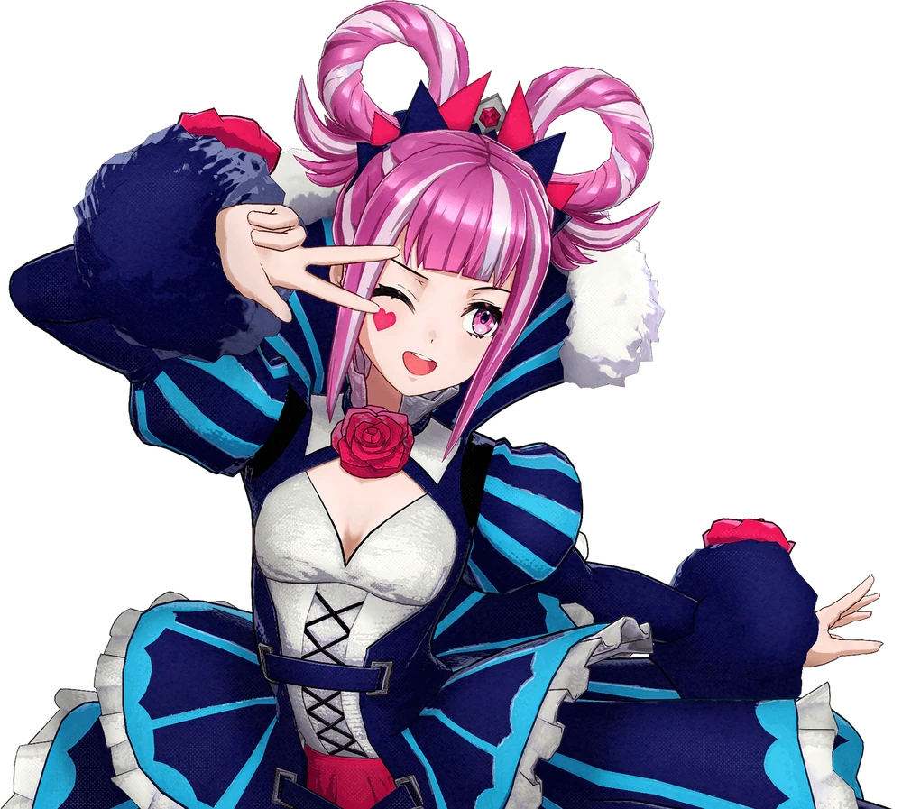
The forest path had been poorly marked, but had it been so poorly defined that the younger sister would find herself separated from the older one so easily? “Uh… IVY!? YOU’VE GOTTA BE OUT THERE, RIGHT?” Maybe it was Hortensia’s fault for walking ahead, but Ivy had been behind her literal moments ago. Walking at a normal pace there shouldn’t have been any scenario where she had pulled so far ahead that her big sis couldn’t hear her, right? And yet there was no response to her calling whatsoever.

It made Hortensia a little nervous, but… “If I keep following the path I’ll reach the village, right? I’m sure Ivy will meeeeet me there!” And if not perhaps she could find some manner of mount and get Goldmary’s assistance. But she wasn’t worried about Ivy’s safety. If monsters or bandits attacked her then she felt sorry for them for even trying. “We weren’t that far out from the village anyways, right?” She could recall her sis saying that it would only be another ten or twenty minutes.

In truth? She had taken a wrong turn. The path had split into two and Hortensia had gone the wrong way when Ivy hadn’t been looking. And so even after following the path she was on for another ten minutes she didn’t arrive at the village. However she did arrive at a clearing with something interesting inside. “Wait, are these hot springs? This isn’t Goldmary’s place? Is it new?” It was attached to a rather fancy looking inn, too.

Wondering if they might be able to guide her to the village, or if they might have perhaps seen her sister, the young princess stepped inside. It was a fancy building with clean looking springs behind it. And once she finally did get inside she could ascertain the fact that it was being maintained by someone. “Uh… hello?” But there was no one inside. No one was behind the counter at all, even though they definitely looked like they were open for business?

“Huh?” Well maybe it wasn’t completely vacant. She caught sight of something fluttering above her. A brilliant, blue butterfly. It was hard to miss seeing as it was dropping a sparkling substance. A pollen of some sort? Or maybe dust from its wings? Some had fallen on her head but she didn’t assume it was harmful or anything like that and carried on. “I wonder if whoever runs this place is in the back?”

The counter had a door behind it. Hopefully they weren’t hurt or something and were stuck back there!? Getting caught up in her own nonsense she bolted behind said counter, but immediately found her desire to move much father dwindling. It was almost like, of all things, she felt like…

…I’m supposed to be behind this counter?

“Wait a sec, no I’m not! Why was I just thinking that? That’s weird…” She didn’t know what it took to work behind the counter of an inn! There were a ton of papers with words and numbers scattered on and around the counter to begin with – there was no way she could realistically make any sense of that! Well that one is the customer log, isn’t it? And that is our expenditures for the month… H-Huh? Do I really know all that information!?

Hortensia furrowed her brow, utterly ignorant to the disappearance of her heart. Not the heart beating in her chest, because she’d die if that was the case, but the heart on her face. A bright red heart she always had tattooed beneath her right eye! It was a tattoo that was removable and appliable with magic in the first place, but it wasn’t supposed to just fade away all on its own. And yet it had! This was the first but it wouldn’t be the last change to her face. Yet it was the only one for now.

No, the butterfly’s magic targeted much more strikingly different areas before her identity was wholly compromised. The next change was much more pronounced and was actually one that the girl could see plainly. After all, standing before a counter that she was just over the eye level of, how could she ignore that counter dipping farther and farther away from her perspective?

Or the sensation of her arms pushing out of her sleeves? Or the sound and sensation of her sleeves tearing from her dress at the shoulders as those shoulders stretched wide? Or how her striped tights had been yanked right off her ass? Or how her boots now felt a little too snug? These were all differences that could be explained with a singular observation and Hortensia did not miss it. She couldn’t miss it. “HOLY COW, I’M HUGE!”

The princess wasn’t wrong. She had been a meager 4’11” at first, but now she had to be around 5’8”? She had practically burst out of her dress, with the skirt raised above her navel to show her belly widening… because her hips had swung outward a handful of inches. Her panties were really digging into those hips because of it. “This is… what!?” How could she have grown so tall so quickly? Even her face reflected that of an adult even if she was still plainly Hortensia. She had grown older on top of taller. But have I not always been so… huge?

Hortensia had used the word ‘huge’ to describe her height boost, hadn’t she? Little did she know just how applicable it would be to other aspects of her body very soon. Like immediately so. “WHA—!?” Still gawking at how much smaller the world seemed with her elevated stature, her body lurching forward so that her arms slapped into the counter had taken her by surprise. A surprise she expressed in a voice that was low and sultry.

So what had caused this collapse? Observing her from the front and slowing things down made it clear. Her small breasts had perked up, jiggling violently from what was a clear pump of weight to their sizes. It was slight in the opening milliseconds, but she fell forward because much more poured on just as quickly. Engorged, enlarged nipples slipped out of the cups of her dress and swelling tits bounced free. Soft, supple and perky, these F-cups and their weight had taken Hortensia off guard and had slapped against the counter with her arms.

She corrected her posture but was left speechless. What she didn’t say with her words she expressed with her hands, mind you, lengthened fingers cupping, pressing into, and eventually jiggling her big tits. “There’s no way my bosom could be so…” And by the time she did remark aloud she didn’t really sound like herself. She sounded too composed, her words far too proper. While ogling her breasts, it didn’t even strike her that similar change had been wrought below.

At least until the waistband of her panties finally snapped. “Oh!?” She found it difficult to observe past her large breasts with her eyes and once against had to resort to her hands. And those hands grabbed onto an impeccably swollen ass. Cheeks must have been expanding, taking advantage of her wider hips to muffin out into an excessively ripened peach. That explained why her panties were wedged into her ass crack. And why her tights had torn in places around her thighs. Those thighs had inherited her ass’ weight overflow, thickening until each thigh was comparable to her waist in width.

“My body, it’s so… lewd?” Saying it aloud, was that really so strange? Somehow Hortensia felt like this body of hers was something she was used to. In a cinch it could be used to coerce or calm down customers if she showed off a little skin. “N-No, I shouldn’t be thinking of using my body like that… But I’ve grown even larger than my… sister?” How strange. Did I have a sister? How was that even a question considering how close she had been to Ivy?

The pinkish purple of the woman’s gaze had lightened a touch, the pink now more reddish than purple. But when it came to her eyes it wasn’t only a subtle change in color that could be observed. Their shapes stretched and lashes lengthened beneath brows that were somehow thinner than ever. Those eyes were certainly striking, but were they as striking as the sight of her lips swelling up like they had been stung like bees? Or a nose that grew a little longer? The maturity her new face showed had been stretched so that her cheekbones were better defined, completely erasing any sign of her previous identity in her appearance.

From there? All that really remained of her old body was her purple-pink hair with white highlights. Yet those locks evened in color so that they were a singular, platinum blonde. A platinum blonde that was a little curly and, if not bound in those strange loops, would halve unfolded to reach a few inches past her broadened shoulders. Fortunately for that hair those loops did come undone.

Because Hortensia’s old, ill-fit outfit faded into the same glittering substance that the butterfly had scattered onto her head. When that glitter blew away, however? Her body wasn’t naked underneath. She was seductively dressed in a white kimono with her cleavage entirely exposed, along with black, thigh high tights, white heels, black gloves, and a fluffy scarf that almost seemed to merge with the detached, ornate blue and white sleeves of her kimono. Oddly, blue butterfly ornaments decorated her scarf – and a butterfly bow tied her golden locks into a side ponytail draped over her left shoulder.

The woman gingerly shook her head. Her body began to move according to her instincts, like being in this inn was completely natural. Like being behind the counter was entirely normal. Like she did it every day and had done so for a long time. As far back as when her late mother had taught her how to run this family business of theirs. What remained of her old personality and memories, well… Did anything truly remain in the end?

“Hm… I wonder if that Goldmary girl is planning anything now that she’s back from the war.” Now rustling through paperwork behind her counter as if it was the most natural thing in the world, the owner of the combined inn and hot springs found herself murmuring about Goldmary for different reasons than she might have when she had first walked in. From her perspective that girl and her family were business rivals.

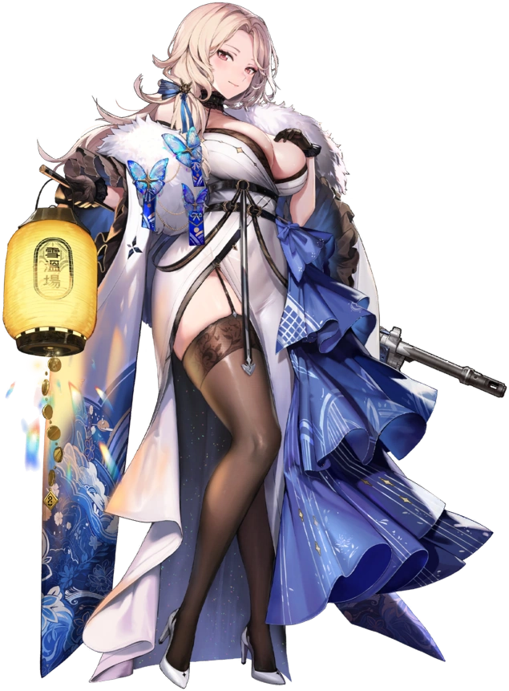
Which made sense realistically. If Ludmilla saw herself as the owner and manager of the Snowfield Hot Springs & Resort, which she very much was, it was only natural she would see the daughter of a competing inn as an enemy. Even though both springs had been active for a very long time, Ludmilla often found herself losing to Goldmary’s on account of the fact that it was closer to town. “Even though my location is much cleaner and better maintained…”

Not that it didn’t have its problems. Being farther from the village meant that it could be unreasonable at times to fetch supplies – especially when the weather was poor. Her springs were of higher quality, but there were also fewer of them compared to her competitor as well. All in all there wasn’t much she could do about it than she hadn’t already tried. And in the end she tabled those thoughts for the time being, because an important guest suddenly walked in.

“P-Princess Ivy!?” Ludmilla may have been a different woman now but she was still a resident of Elusia. Of course she knew what their singular princess looked like, and the dark purple-haired woman was dressed in all the trimmings of an Elusian noble. “What… brings you here!?” A foul thought crossed her mind though. Didn’t Goldmary serve the princess? Was she only here on Goldmary’s invitation? But if she could snatch her up as a customer first, then…

That idea was immediately rejected. “Excuse me, have you seen my little sister by chance?” Hearing these words from Ivy caused some sort of glitch. Did Princess Ivy have a younger sister? Who was Princess Ivy? No, this woman standing in front of her was no noble of Elusia, was she? Ludmilla’s left eye twitched as she attempted to process changing information. But why was it changing? For what reason? Then again it wasn’t even just changing for her but for all residents of this world. Much like her own existence, everyone’s minds were being rewritten to accept Princess Ivy as someone else.

When things settled, Ludmilla finally offered a reply. “Little sister? Whatever are you talking about Mica? You don’t have a little sister that I recall?” Whatever was happening it was clear that the well endowed woman did not see the princess as a princess any longer, but instead someone else entirely.

