NEW YEAR, NEW VIEW
JANUARY 2022 REQUEST STORY
BY CHALDEACHANGE
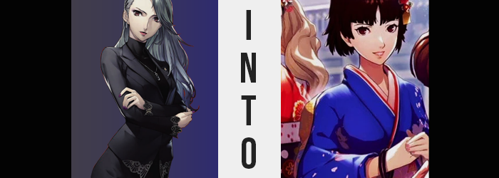

It had been a late night for Sae Nijima, but what else was new?

A prosecutor of her renown in a crime-riddled city might as well have been bound to never sleep a wink. Whether she was preoccupied with new reports, or just simple lost sleep over the weight of the work she was committed to, Sae often struggled with the physical and emotional complications that her job brought about. At times she lamented her decisions and thought back to when she was just a young girl with a plethora of free time at her fingertips, but at the same time she wouldn’t trade her present job for anything.

Collapsing into her desk in the office she’d put together in the apartment she shared with her younger sister, Makoto, Sae pressed the button necessary to boot her computer up. She had paperwork she needed to finish before she turned in. When it did, however, and she noticed the date in the corner? “…I messed up.” It was after midnight on January 1st. She had completely forgotten about New Year’s Eve and how she had promised to spend it with Makoto and her friends.

“I wish I could go back in time and be there.” It was a desire she’d expressed idly, because she was loathed to have upset her younger sister like she likely had. But unbeknownst to her, her sister’s phone was sitting on the counter in the adjoined kitchen with the Metaverse app open – and responding to her wish, it suddenly came alight to demonstrate an ability that it never had before.

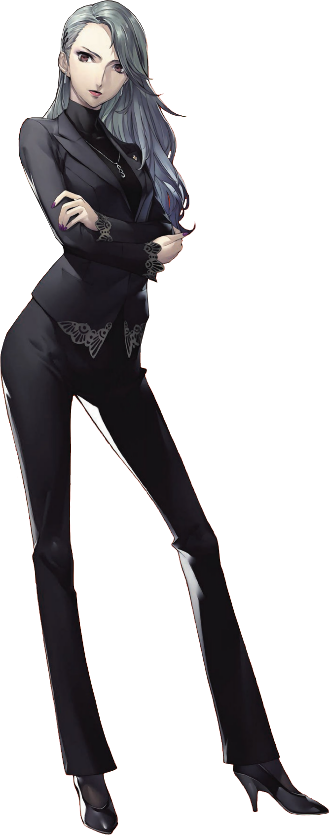
Sae had to wonder if she was dreaming briefly. She was suddenly in their living room, standing, and outside the window it looked like the sun would soon set; which at this time of year was very early evening. On their couch a kimono had been put out against its back. The blue one that Makoto had planned on wearing to the fireworks before coming back to the apartment to party with everyone. “What? How? Is it because of what I said? Maybe I just passed out at my desk…?” From what she could tell it seemed like she had somehow gone back in time, but not even the Phantom Thieves had ever managed to accomplish such a feat.

Not to mention one little thing: Makoto was nowhere to be seen. Had she stepped out for a moment? Since she had been at work all day, Sae wasn’t exactly aware of what her sister’s day had been like either. She could have very well stepped out to fetch groceries for the party. But if she really had gone back in time, then what of herself? Was she presently not at work?

No. There was still a Sae living out the day she had already lived it out. Which posed a very major problem from a timeline perspective, which was actually why Makoto appeared to be absent. Or, well, she wouldn’t be absent for very much longer…

The woman dismissed it as little more than just a shudder brought about by the cooler condition the winter afforded their apartment, but it was actually a telling sign that something had begun to happen. Something that could immediately be seen in Sae’s face prior to the escalation that would soon follow without pause. But despite being a woman in her late twenties?

Well, if you were only looking at a mugshot of her, you might not have gotten that impression a few moments after the entire debacle had begun. Because she had begun to look a little more youthful, with cheeks rounder, eyes wider, and her lips? They appeared to be a little thinner. Not only that but the makeup that she wore had all been erased, leaving her looking quite plain and very much like a teen – perhaps around the age of her younger sister?

“Hm?” With a smooth transition, Sae soon after found herself rather perplexed by something – making it the first point she noted because, without a mirror, how exactly was she supposed to confirm that her face had changed? This, on the other hand, was much more comprehensible. Because she almost felt like she was falling.

There was no way that this could be the case, of course. She was fully aware that her feet, still in heels, were planted firmly on the floor beneath her. “I’m not…? But how?” She wasn’t falling, and yet the couch she saw every day looked closer to her eye level. And closer. And closer still. Until it finally struck the prosecutor. “Am I shrinking?”

It certainly sounded and felt like an impossibility, yet she could not deny both what she was seeing and feeling. Clothing becoming looser and bunching up or dangling far beyond where intended – as shown in her pant legs and sleeves respectively – provided the additional proof to show her that she wasn’t delusion. Limbs were becoming shorter, as was her torso.

But the phenomenon did not stop with her body’s height. As her fact had already revealed, it wasn’t a matter of Sae just becoming a shorter woman. No, no. Her very age was at stake, her body slipping back into her late teens, and with a reversal of age came a reversal of her figure’s evolution as well.

Sae’s breasts diminished a pair of sizes. When her growth had peaked in her early twenties she had been surprised to find that her bosom had reached the fathomed D-cups, and even then they were easily disguised by her tight and snappy sense of style. But before long they had unraveled so that they were perky B-cups, the end result being the front of a turtleneck that seemed to be a little loose.

“This… This is…?” The victim in question had begun to have difficulty comprehending just what was happening to her, and not through any fault of her own. From her perspective, what had once seemed unusual felt normal. She couldn’t imagine being taller or having a bigger bust, though a small part of her wondered if it might grow to the size of her older sister’s eventually… Wait! She was supposed to be the older sibling, wasn’t she!? “No… Wait… I…?” Her voice higher now, it was becoming clear just what had been put into motion by the Metaverse app.

While Sae had never been much of a thigh girl, she did have a nice and perky ass. Or, well, had possessed one up until the moment it had begun to deflate. Her well-fit black dress pants remained hitched to her waistline, but with narrower hips and a smaller butt, there was certainly some more bagginess to be had where it didn’t belong. And with hands and feet having shrunk? She idly stepped out of oversized heels without thinking all that much about it.

She now looked like a young woman around the age of seventeen or eighteen dressed up in clothes that she wouldn’t fit into for a few years, but that wasn’t quite the case and Sae wasn’t simply becoming a younger version of herself. But it once again fell upon her face to speak to what was to come, for she wasn’t much looking like herself in that regard.

While there were some similarities between what her face had come to look like and what it had once been, suffice to say she almost looked plainer somehow? Her overall facial structure appeared to have become a little shorter, and her eyes somehow wider. It all presented her with an aesthetic that appeared to be rather tomboyish, beautiful but not in the typical sense.

Widened eyes certainly highlighted a prompt change in color, silvers igniting into a brown that certainly stood out more keenly than their prior, subdued color. It stretched even to her hair, igniting it with a brown that should have been familiar, for it was a color that she saw basically every day. My hair has always been brown, though? No, it hadn’t. That was supposed to be her sister’s hair color.

“I always get drowsy around this time of day, but isn’t this a little much?” Sae was having a hard time remembering what she had been doing. She felt a little anxious, and yet could not piece together what had caused that in the first place. It just left her more confused than it ever had before, and distracted her from the final bouts of change that wracked her form.

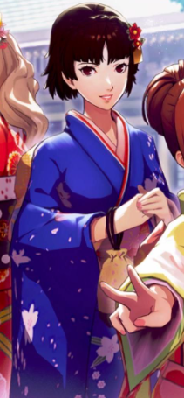
Such as a shortening of her hair. Or, well it was more like everything from just above her shoulders had been chopped off, fluttering towards the floor but disappearing before it touched the carpet. Bangs were pulled so they completely covered her forehead like curtains, parted subtly in the middle in a style that was all too familiar to her. But, again, she would rationalize it as her own, when she should have rationalized it as her sister’s.

But her sister had long, flowing, silver hair!

“Was I just thinking like my sister? I really need to stop staying up so late…” Makoto Nijima bemoaned a peculiar thought that had crossed her mind, that she had somehow been Sae. Making matters even more confusing? “Uh… When did I put on her clothes?” The suit set that Sae wore with her turtleneck was snappy and cool, but it certainly didn’t look right upon the frame of the younger sibling. She couldn’t really remember putting it on or why. Truthfully, if Sae realized that she had then she no doubt imagined that she would be scolded.

Quickly, small fingers worked at undoing the buttons. She wasn’t expecting any company for another hour, so she didn’t have any qualms with stripping down until she was naked in her living room, folding up Sae’s suit as neatly as she could. Returning them to her sister’s room, she fetched undergarments that fit her from her own room and put them on, before sliding into her kimono. It was a little disheveled, but Haru would help her straighten it out when she arrived.

In doing so though, she left her cellphone on the counter.

Creating the perfect cycle.

