*Unmasking Ones True Self*

When Kevin had agreed to go to a real life gathering consisting of a tight knit group of friends who had met in an online game including himself. The young man was excited to finally see the faces behind the incredible personalities he had bonded with over the years in a long running MMORPG he thanked his lucky stars for playing. If he hadn't picked it up, then he would've missed the opportunity to meet these amazing people.

But when the time came to fess up their true identities, Kevin would soon grow nervous and afraid upon realizing he was the only male in the group. From past experiences talking with the group during down time when they weren't out raiding or running parties, he had assumed them to be fellow geeks and slightly older men masquerading behind their female avatars. What he wasn't expecting was a group of trendy girls and outgoing gals behind the mouse and keyboard, the true driving force behind the light-hearted banter and modern day internet slang the inexperienced Kevin had mistakenly assumed to be a thing used exclusively by immature boys who hadn't grown up yet. Not like he was 'immature' by any means when he was already midway through a year in college.

So when the time came for Kevin to turn on his monitor camera, some quick thinking and dress work had resulted in a moderately concealing getup that masked his face and torso from his sudden audience of curious women, replying meekly when they prodded him about why he was so camera shy, unaware of the trap in their midst. If it weren't for his androgynous figure, then there would be no way for a man of Kevin's age to conceal their true identity from a gaggle of girls with keen eyes in fashion. Although they commented about his pasty skin with skeptical looks, ultimately the veil worked, and Kevin's 'true face' had been accepted amongst his friends as they teased the shy girl about wanting to see her dress her best this coming Saturday, unaware of the flustered young man wondering what the hell he was doing throwing himself into a pitfall.

But would they really still be friends once they figured out he had essentially lied? What if he didn't turn up even after giving his word to them all on video call? On one hand he was cursing himself for even pretending to be a girl, but on the other he didn't want to be alienated from the group once they found out he wasn't truly 'one of them'.

And so, calling upon skills long buried in a past he felt slightly ashamed of. Kevin sets his mind to the task of preparing a suitable outfit for himself, heading out to purchase skin toner, makeup, accessories and a fitting dress with which he would become someone else entirely. It was what drew him toward cross dressing in the past since it made him feel liberated from the trappings of a body he didn't quite vibe with. And doing it again after so long and to mask his identity even, only served to draw out the demons he had thought suppressed and forgotten.

Once the pieces of the puzzle were ready, all that remained was to slot them into the correct slots on the empty playing board that was Kevin's body…except the dress seemed a little bit too…extravagant. Would he really need this? He had bought it for the express purpose of filling in his friend groups idyllic image of his female persona since they did like to talk a lot about gothic lolita fashion and all its associating subtypes. But after giving the raven black frilly dress a once over before looking at himself in the mirror, it was a bad idea to do so, even with the pads he had bought to give his girlish frame just a little bit more curvature. He needed something that could mask it all yet show it off just as well instead of a fancy dress, and with his eyes scouring his wardrobe until they settle upon a baggy dark sweater that could go well with a matching skirt, it was enough for Kevin to envision the new identity he would be taking on this coming weekend, swallowing a lump in his throat in a mix of excitement and dread.

As the days march on toward the much anticipated outing, Kevin would begin making the preliminary changes before ultimately donning his female self; waxing his body clean of hair, applying moisturizer that would lend his skin a feminine glow, doing dark brooding makeup, manicuring his nails before painting them obsidian black, doing up his hair so it would take on the same lustrous consistency as the wig that would be strapped around his head and accustoming himself to the suffocating squeeze of a corset so he could spend an entire day in them without breaking a sweat. By the time Saturday arrived, Kevin was more than prepared for a routine that took only a few days to get himself back into, a routine he had been a former expert at before the troubles of overbearing parents and highschool life came into play.

Making sure the all natural, gelatinous pads sunk in well on his chest before slipping a dark lace bra around them, the crossdresser takes a seat on his bed for an easier time getting the equally suggestive yet comfy embroidered panties up slim legs oiled, creamed and powdered into the same complexion the rest of his body now sported. With a navy blue pleated skirt that came up short just above his thighs and the aforementioned jacket now snugly encompassing the waifish Kevin. All that remained was the long flowing wig that, while stiff, had been done up into twintails and dyed an eye catching neon orange beforehand by the masterful hands of Kevin himself, tucking his head of chestnut brown hair inside a wig cap before putting it on properly and doing a once over in the mirror, blushing a little at the passable goth girl staring back at him in the reflection. It had been so long since he last did something like this but the thrill of seeing someone totally different in the mirror where he knew the ordinary, drab reflection an American boy should've been was still there to strike him in the heart as he spends a few minutes adoring the 'girl' staring back at him. If it weren for the barely noticeable bulge between long lanky legs strapped up in stockings and boots, then Kevin's disguise could very well pass him for a flesh and blood female. With a jingle from his phone however, he knew he didn't have much time left to ogle himself. Picking up his wallet before stuffing it in the backpocket of his jacket alongside a string of lollipop candy, Kevin heads out the door, holding high hopes for the amazing time he was going to have with his friends, confident that they wouldn't figure him out.

Unbeknownst to the innocent yet naive young man however, something unseen to the naked eye scoffed at his blind optimism. Clearly this man knew nothing of what entailed a girl's outing, it thought to itself. While it could leave the doomed crossdresser to his fate…it could also lend him a helping hand, not without some caveats however. Having the power to bend reality and alter perception, the supreme being's aid came rarely, and sometimes unwanted. But when it did see fit to help a wayward soul, some…trickery…would be needed to spice things up a little.

With a flick of its hand and a simple thought made, the world conforms to the invisible entity, causing heavy distortions and tears into other realities that offer a glimpse into what could've been; from an ordinary 20th century suburb to a futuristic hub, a loving couple into gal pals, a homeless grandpa into a rich tycoon. But these were only windows, gashes forming around the main anomaly centered entirely around Kevin as he continues to make his way downtown oblivious to the transmogrifying energies slowly creeping their way around his body, not so much changing but fusing the inanimate with flesh, making them one and the same.

Where Kevin's original hide was one of coarse feel and an ill pasty white in appearance, the magic worked to rectify that, targeting the makeup and toning used to mask it all until it became one with his skin, taking on the youthful radiance and porcelain smoothness of it all while ridding itself of hair follicles to ensure no further waxing in the future. And with the hard flesh beneath mellowing out in warm flowing layers of supple fat and toned muscle that offered as much flexibility as they did allure and sex appeal? It was a definitive improvement over the old, especially when the plastic mesh of the corset gives in to the change, providing a nice framework for Kevin's torso to follow suit, barely noticing the stress on his waist and hips lifting away entirely when his crushed in figure expands and lengthens to fill the gap left by the corset as it fades. And with broad hips and a tight waist always having been staple assets, there was no need for such trivial support when Kevin's effeminate physique was already bordering that of a young model's. All it needed was just a little bit more oomph, and soon enough, he would have heads turning his way from a mile off.

With a noticeable sway to his step and a bob to his behind as it inflates from a firm pair of cheeks into a hearty bubble butt, the spirit gleefully moves in close to inspect his latest work doing a roundabout around Kevin as he boards a train. And as the passenger seated in front of a standing Kevin looks up, the mischievous being decides to take a personal hand in the shaping of Kevin's femininity, putting its cold hands on the tiny sacs holding the crossdressers testes before pushing gently, pumping Kevin's groin with its energies that make his flesh malleable and numb to the changes occurring right under his nose as it smoothes out wrinkled balls into pristine, pudgy flaps while tucking in a flaccid dick that throbs ever so slightly under its manipulation, refusing to be put away between the wet pink folds of a blooming vagina as plump labia form around Kevin's inverted member, dampening the fabric of the newly made girls panties as her tight innards connect to a steaming baby chamber right under a sexy navel lined with gentle peaks and smooth dips of supple flesh and warm muscle.

With a cute little clitoris left twitching below a neatly trimmed crown of smooth pubes, Kevin's status as crossdresser is officially abolished as the middle aged businessman's eyes look up in time to grace the sensual window offered by the flutter of the goth girl's skirt; teasing a fat camel toe between thighs squeezed thighs by her lace underwear and see through stockings, their dark coloration contrasting well with snow white skin and a subtle red flush beneath. Remembering his marital vows however, the man looks away just in time for Kevin to turn and exit the train car, none the wiser to the show she had unconsciously put on and the loss of her manhood. But as she moves toward the mall at a steady pace, a slight bounce to her chest begins to make itself known alongside the pronounced curvature shown off whenever the baggy clothes lay down over her drastically altered form. With her false boobs vanished leaving the cups of her bra momentarily vacant, Kevin's barren chest begins to surge forward to fill the empty space her imitation pads had left behind, led by fat pink nipples rejuvenated from dull brown inverted nubs, a hefty pair of milkers that far outweighed her disguise soon sags and weighs down on her shoulders while putting immense strain on her poor bra before it jumps up from a dainty B to an impressive DD, supporting the gelatinous mass of Kevin's new, all natural tits as they push against her jacket and white undershirt, sending an electric shock of pleasure running through her sensitive nipples and spine that almost alerts her to the changes as the underside of her wig creeps forth in a disturbing mass of swaying tendrils, bonding with her scalp and subsuming the role of her old mop of hair, eliminating the janky shake of her twintails as they now flow and sway naturally to the rhythm of the wind with stray strands sticking naturally to her gorgeous face as wide eyes slant to the sides just a little in tune to her nose cracking into a petite bridge atop pert lips that plump up into kissable cushions.

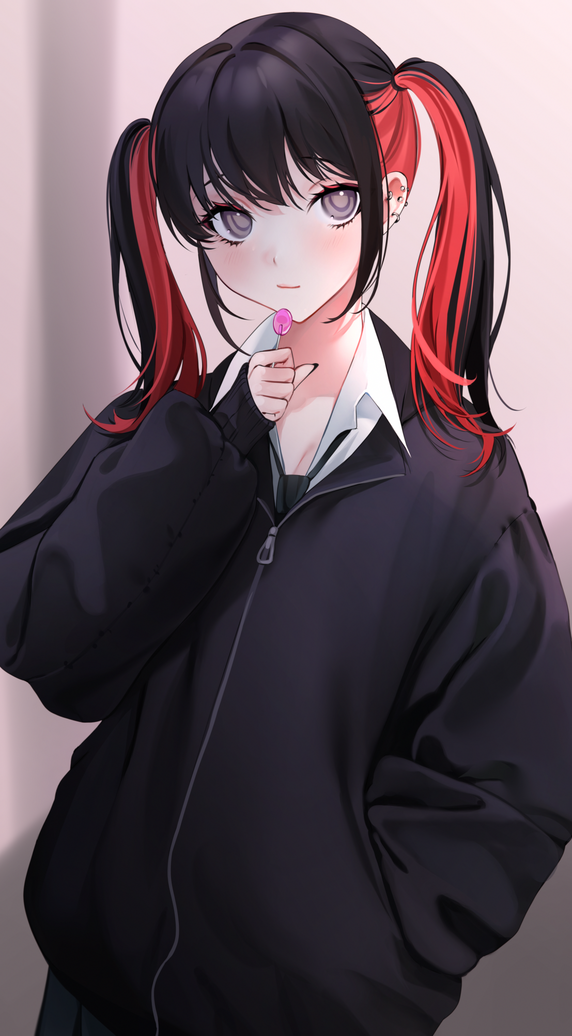

By the time Kevin had reached her destination just a few minutes before the appointed time and popped upon a pink lollipop to busy her idle tongue with while she awaited the rest of her companions, unintrusive studs plaster themselves to the soft flesh of her ears to complete the gothic ensemble that Kevin had quite literally grown into. Leaving the spirit impressed as it makes one final change to the unwary boy-turned-girl before taking its leave, off to mess with other lives on its own discretion. From a crossdresser to fill fledged girl, Kevin remained oblivious right until a sudden pair of hands pull up from her rear, locking her arms in place while they give her new boobs a playful squeeze, forcing a girlish cry of panic out of her as she spins to face her assailant in shock at the foreign sound she had vocalized alongside the familiar face of the blonde girl she remembered to be the face behind Fergus the Dwarf, aka Linda, leading a small group of faces she had seen a few days ago on a blurry computer monitor. All of them eyeing her up in adoration and a little bit of friendly envy as their keen vision peers through thick clothes at their online mate's voluptuous figure and doll-like face. To think that such a beauty was hiding her looks on that video call because she didn't feel confident enough…

**"Kelly right? Nice to meetcha! C'mon over and say hi to the others, we met along the walk here but I guess you took the train here huh? Uhh…Kelly? Earth to Kelly?"**

Linda's words fall on deaf ears as 'Kelly', still stunned from the alien pleasures of having her new foreign protrusions squeezed, remains staring down at her body. Lollipop lying forgotten on the floor as trembling hands move to poke at her engorged chest in morbid curiosity, only to recoil once her fingers graze the sensitive mounds. This was no dream, she really did have boobs, and from the lack of something between her legs and the faintest sense of moist, steamy air escaping down below, Kevin had no choice but to accept the truth; that she had somehow, maybe even along the way here, become a girl.

But she wouldn't have much time left to explore herself when Linda leans in close with a skeptical eye, painting a blush on Kelly's rosy cheeks at having a woman pressed up so close to herself, close enough to feel her body heat and the scent of lavender perfume. It was enough to hasten the dampening of her loins and the tenting of her shirt as her nips go erect upon the triggering of her hormonal lust for other girls that had survived her transition from male to female.

**"Are you alright Kelly? You're looking pretty red there…unless…hmm nevermind, come, come! The girl's have been waiting long enough, to Wysteria's first live meetup!"**

Hearing the name of their guild was enough to stifle Kelly's feeble protests as she lets herself be taken wordlessly towards the others, reminding her that this was supposed to be an outing with friends that had been with her for many years, even if it had been from behind glass and code. And since she wasn't crossdressing anymore…then that meant she could fully devote herself to the rest of the day with her girlfriends without worrying about her disguise being seen through.

*'And if I'm a girl now…then that means I can wear whatever I want now without anyone thinking I'm some freak…oh wow, this is amazing!'*

Holding in her excitement as Linda draws her into the middle of the other Wysteria members who immediately drag her in for some small talk as they set off to begin their first outing together, Kelly slowly mellows out if her shell as they go around the newly opened mall, taking in the sights and perusing shops. But in the brief moments of downtime afforded to her, the changed man would soon realize it wasn't just her body that had been altered, but reality itself. Everything, from her social media accounts to the message logs in her phone had been changed according to the mask she had hastily come up with that night in front of the monitor, displaying the personal details and images of Kelly; A happy college student living her best life studying in a fashion design course.

While Linda leaves her with a special dress she had selected just for her to tend to the others as they explore the boutique they had stopped to ransack, Kelly stands idle in the changing room as she pulls out her ID to look upon the face of the woman she now was, it all felt a little surreal to her. As if the withdrawn Kevin, whose life she still remembered living, had been nothing but a long, terrible dream she had just woken up from. A suffocating experience that left her yearning to return to her original self, to being Kelly.

And as long slender hands move to unzip her jacket, slide off her shirt and unbutton her skirt, the raven haired woman was left standing naked in her lingerie, staring down her virile young body with vapid eyes and a flushed face, panting softly under her breath. Eager arms moving in lackadaisical fashion over her stomach and towards her itching groin…she didn't know why she felt this way, but from the way her polished nails slide over her warm skin to the very air itself embracing her nubile form…all she knew was that she loved it.

**"Heya! How're things…oh my…Kelly! You naughty little thing~"**

**"W-Whuh?! Linda? No! T-This isn-*mpff!* W-Wait! What are you…what-*oh god~*"**

It was all so sudden that Kelly didn't have much of a chance to reject the advances of Linda who had suddenly pulled apart the curtains to catch her midway through a masturbatory session. And even if her hands hadn't yet found their way under her scant underwear, the lustful look on her face was all Linda needed to know about her friends intentions in addition to confirming her earlier suspicions about the seemingly frail and meek Kelly.

**"Shh~ We don't want the others to hear now do we? Kelly, Kelly, Kelly~ When I first saw you behind the monitor I knew you were hiding something…don't worry~ I know what it's like, so let big sis Linda take care of you alright?"**

**"Mmm?! Nngggg!!!"**

With her weakened body held tight in Linda's grip and her mouth gagged by dexterous fingers playing with her tongue, Kelly could do nothing but flail weakly as her bra, then her panties come loose, leaving her lustful body naked and vulnerable in the arms of her sudden lesbian lover.

Originally, Linda was supposed to have been a straight laced girl who already had a boyfriend of her own, but with the being's antics, all that had been flipped around, changing Linda into a raging lesbian and her loving soulmate into her submissive girlfriend. And with her inhibitions unbound in this altered reality, the confident blonde was already looking to find another girl to make her nightly tryst into a romantic threesome. And Kelly, being a quiet, peppy goth girl who got all excited after just a little coaxing, was just her type.

It was safe to say that by the time Linda was done toying with Kelly as she exits the stall with a smile and her big breasted partner in hand, the shivering goth hanging on to her friend's shoulders was more than convinced that the life of a girl was going to be far more exciting and thrilling than she ever could have hoped for…

*THE END*