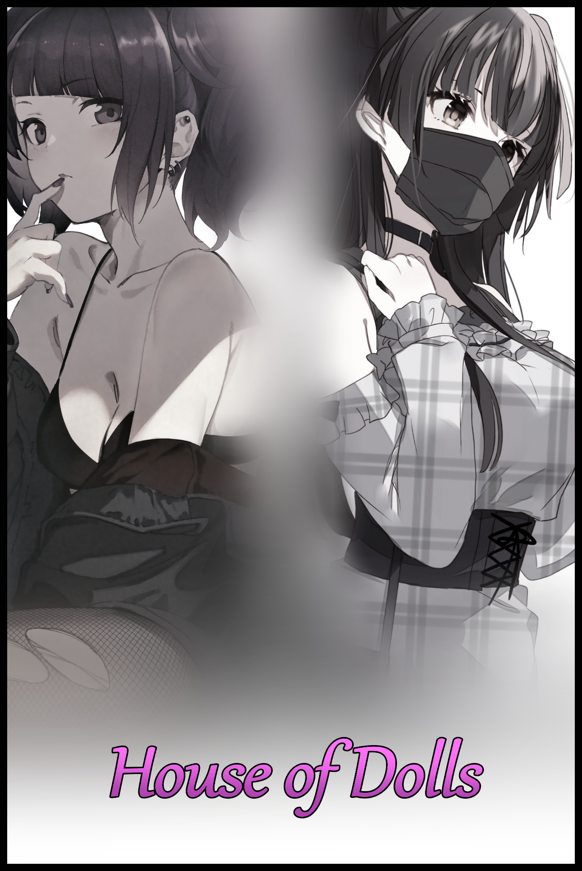

“Is this really the place? Man…it’s really messed up…woods crawling with bugs…and this is supposed to be a…what did Susan call this place again?”

“It’s called a ‘Mansion’…do you really not know what a M A N S I O N is?”

“Yeah! yeah! No need to be a dick about it…smartass…”

Standing outside the withered foundations of an old home settled near the edge of an untamed forest on the farthest outskirts of a borderline abandoned suburban district, two youngsters continue to bicker amongst themselves, the mundane contents of their argument echoing down the vast empty street with not a soul around to overhear a single word.

Avid thrill seekers living the peak of their youth at the tender age threading the line between adolescence and adulthood, the two highschool students had traveled a not so terribly long distance towards the borders of their hometown with the intent of exploring the rundown abode they currently stood outside of. A supposedly unique oddity they hadn't been told of until recently, when a friend of theirs had casually dropped a bombshell on their heads, the memory of which remained fresh in their minds.

A humid Wednesday afternoon, lessons were over, students from different classes flooded in and out of the room, mingling with their friends while the air buzzed with the raucous rambling of a dozen or so people all at once. And amidst the noise, the sentence spoken by a young lady sporting a bob trim hairstyle rang loud and clear to the two men as they prepared themselves for a 'serious' confession from her they had mistakenly assumed to be a declaration of love.

"I'm…actually a boy…well, I was one at least…I know it might be hard to believe but I swear, I'm not lying."

Richard, being the realist he was, couldn't quite believe what he was hearing. For years now, he'd known Susan. And in all that time, he certainly remembered her to be a girl. Hell, he'd been there to witness her growth alongside her as childhood friends; all the way from a rough kid in preschool to a mellow girl in middle school till she became the soft spoken maiden she was now.

True, she had been a tomboy at one point in time, but Richard couldn't recall a moment where she had been a he to justify her claims of being born a boy…

Nathan on the other hand didn't seem to be taking things as seriously as his friend was. In fact, he seemed enthused by the idea of playing along. Jokingly asking Susan how 'he' had turned into a girl, unexpectedly earning a reply that seemed to strike a flame of interest in their hearts as they listened closely once Susan begins to describe an abandoned house sitting right on the edge of town. A deceptive construct flanked by the forest with an interior far removed from whatever its exterior might suggest.

But before she could continue, a snicker from Nathan sours her mood upon realizing her friends 'interest' had been a mockery, huffing as she swings her bag around her shoulders before stomping off with a huff. Leaving the two with a subtle warning before moving out of sight…

“You think this is all some joke huh? Why don’t you two buddy up and go down there? See it all for yourselves! Just don’t come crying to me if you guys end up the same way!”

Maybe she was lying, maybe she wasn’t. But the anger in her tone had been enough to convince Richard to check things out for themselves, with Nathan in eager agreement just so he could come gloating to Susan after coming out on in this game of hers, the two of them in equal agreement that they just couldn’t believe their childhood friend had ever been a boy. Except his rude interruption of her tale had left them on their own, taking the time off their remaining weekday afternoon to search for this fabled ruin at the edge of town without much sincerity put into the search with the thought that their friend might just be playing them for fools and that this ‘gender swapping’ house didn’t exist.

But after a lengthy bit of searching everyday, they would finally find the house that best fits Susan’s brief description. And she certainly hadn’t exaggerated just how ‘run down’ the place was, with creeping vines and obscuring clumps of shrub and foliage concealing rotting wood beneath, shattered in certain places where nothing but empty void remained, an unnatural darkness that did not allow exterior sources of light to illuminate the interior beyond a few inches. The duo weren’t even sure if the door would open, considering how the hinges had either rusted into place or were missing entirely while the handle; an old fashioned knob that looked out of place on a front entrance of all places had lost all its color and luster, left as a rusted orb covered in insect remains and whatever else the elements had decided to smear over it like a natural repellent to ward off the curios.

Making a mental note of the place and its position, Richard and Nathan would part ways that Friday afternoon, eager to return the following day when the weekends finally rolled around. And thanks to their lack of homework and tests to study for, it was safe to say that they’d have all the time in the world to explore this unnerving place they hadn’t known about till now.

Sharing a passion for urban exploration and the thrills oftentimes associated with it, the two friends would almost always set off in search of adventure. Thanks to their humble little town being a bit of a sequestered locale, the most they could do on weekends was to walk the road out of town before exploring the forest that surrounded the area, searching out and exploring the abandoned structures that dotted the region like donut sprinkles; each one offering an unknown experience that could range from uneventful and boring to thrilling, chill-inducing trawls through dark urban interiors left to rot in the annals of time. There was a time when they had discovered an old building they could only assume to be a water treatment plant of sorts considering how close it was to a body of water, pondering the reason for it’s abandonment before stumbling upon a basement that had been converted into a lair for alligators, startling but wondrous once their initial fears were settled as they took in the glory of the powerful reptiles from a safe distance. And now as they stood outside yet another potential hotspot for fun and unforgettable memories to be made so close to home, the two friends could only hope it was as exciting as the basement gators were.

Unbeknownst to them however, there were certainly going to be many unforgettable experiences lying in wait for them within the ruined home. Curated by unknowable entities as invisible eyes tracked every movement from beyond the darkness fogged up windows kept hidden from the men as they finished up the last of the goading words they had to send each other’s way as Richard reaches out for the crusty door knob before being stopped by Nathan, wearing an incredulous look on his face as he holds his friend back as if he was about to interact with a fatal hazard.

“Hold up…you wanna touch that? With your bare hands?!”

“What’s the problem? It’s just some dirt and vines-”

“Dirt and vines…nice…if I were you, I'd wanna try playing it…safe!”

Interrupting Richard, Nathan takes the lead as he raises a leg high into the air, soles aimed right at the door knob where he knew the lock (or lack thereof) would be before thrusting it forward like a high powered jackhammer, instantly smashing a hole through the softened wood before it slides open with a faint squeal.

“Did you really have to do that? We’re gonna have to pay for the damage if they catch us y’know?”

“If they catch us…whoever ‘they’ are…c’mon dude! Chill! You did hear what Suze said right? The place has no owners, it's been abandoned for…god knows how long already! Besides, it beats having to touch that rusted ball, who knows what you’re gonna get if you did~ Now let’s go already, I wanna see what’s in there!”

Flicking on his torch before nonchalantly strolling past the threshold into the darkness within, Nathan leaves Richard behind as the flustered man lets out a heavy sigh. Unlike his aloof buddy, something about this place had been giving him the chills ever since he laid eyes on it the day before. It was strange enough how no one else seemed to have heard of it when he had asked around the neighborhood for advice on the building’s whereabouts, but laying his eyes on the real thing was something else entirely.

What Nathan had said about it barely resembling a mansion despite Susan’s prior description of it was one thing, but the pervasive darkness within was the first sign that told Richard to back away and to go in with someone else if there was no other choice. Unlike their other visits to abandoned locales, he had never felt scared. Creeped out, sure. Feeling an odd sense of homesickness as if he was stranded in another land altogether, certainly. But never outright fear like the feeling that weighed heavily on his heart as he watches his friend take his first step inside, wondering too late if this really was a good idea as he clicks his tongue in frustration before following hastily after Nathan before something happened to his ignorant buddy.

“T-Took you long enough dude…do you see this shit?”

And the moment he passed into the front hall, Richard’s eyes widened in disbelief at the expansive surroundings that didn't seem to match the exterior, made clear to him once the unnatural darkness recedes upon his entry. It wasn’t a small room, or a lengthy corridor, but rather a two story high lobby area complete with banisters, a dusty old chandelier hanging high above and even a mottled painting hanging on display high on the desiccated walls where anyone walking in would instantly be able to see. It was stepping through a portal leading into another location.

“This…just can’t be possible…can it? It doesn't fit the outside at all…even the aesthetic is different…”

“Possible or not…holy hell, we gotta give Suze some credit for telling us about this place!”

“Credit? But what if-h-hey! Don’t just go running off! We need to take this thing seriously!”

Dashing off after Nathan as he scurries up the flight of stairs toward a second set of doors leading deeper into the mansion-like interior Susan had described in her story, Richard would barely be able to make it a step past the last flight before a slamming sound from behind him grabs his attention, causing him to whip around in fear and disbelief at the sight of the front doors; miraculously restored now closed and sealed tight as the dreaded sound of a lock being turned sends a chill down his spine.

'The hell? You've gotta be joking…we can't seriously be trapped in here!'

There was just too much going on all at once for the young man to process as he struggles to choose between going back and trying to unlock their only way out or to follow after his friend who would no doubt only get himself in deeper trouble if left to his own devices in a place such as this.

"Aghhh! Richard! Help meee!"

And as the echoing traces of Nathan's panicked screaming reaches his ears alongside a flurry of noises that suggest a physical scuffle taking place beyond the dimly lit room he'd stepped inside of, Richard clenches his teeth while turning his back on the front door despite the added risk of more occurrences blocking their exit popping up if he went deeper, swearing to make him pay back double once this was over and they somehow managed to get out of this alive.

"N-Nathan?! What's going on? Where are you?!"

No matter how loud he yelled however, an extended period of silence would follow after as he reached up toward his neck to flick on the portable torch attached to his shoulder, holding back a startled yell as the brilliant yellow beam illuminates a cracked visage staring back at him from the nearby wall he had almost run into…except it was a wall…it was far too organic in shape to be one…

"Shit…what the hell is all this…"

It was a mannequin, a fully articulated one complete with ball joints and thin threads of lining that kept it and all it’s inert buddies hanging limp in the air, suspended on some invisible contraption concealed by more of the thick darkness that holds strong against Richard’s torch, revealing only the slightest glimpse of more wires up above the armada of ‘sleeping’ dolls, a coin termed by the smart aleck after noticing how quite a few of them were adorned in clothes. Some hovering inches off the ground while others knelt, lay or sat where they had presumably fallen after aged string could no longer bear their weight as whoever (or whatever…) owned these dolls had dressed them up so they better matched the people they were probably molded after.

The room was full of them, so much so that the only way for Richard and presumably Nathan before him to move was a pre-existing path cut clear through the swathes of wooden human replicas. Inanimate and silent save for the subtle creaking of wood as the sudden introduction of wind from the outside causes the string and in turn, the constructs to sway, giving Nathan another scare ashe curses with a hesitant look behind him at the doors slamming shut, leaving him devoted to the cause of saving Nathan wherever he might be in this alien and very much hostile environment.

Navigating the labyrinth of silent dolls, Richard takes his time to ensure he didn’t set off anything that looked remotely like a trap; bypassing strange protrusions in the floor, avoiding particular dolls that had an eerily aggressive look to them while his head remained on a swivel, looking all over for signs of impending danger or Nathan after his initial call for help had gone silent…that is, until a soft murmur too high in pitch to be his reaches Richard’s ear, barely able to glimpse the silhouette of two people standing in a clearing amidst the wooden bodies just around the corner he was about to turn.

“N-Nathan? Is that you buddy?!”

No reply, but neither was there any movement or sounds to suggest that anyone had heard his panicked whisper. Adrenaline was burning strong in Richard’s body as beads of sweat formed from anticipation and anxiety pours down his brow, slow moving legs trembling in fear, white hot knuckles shivering as hands balled into fists readied themselves for a fight at any moment. All while the urge to run had to be quelled lest he abandon his friend and in turn; all the moral goodness he stood for because of a little spook…

After narrowly avoiding a wayward limb sticking out from the side of the path, Richard’s torch does it’s best to illuminate the last stretch ahead, revealing a startling sight as he observed what looks to be Nathan…holding a frail, young lady he’d never seen before in a highly insinuating position, revealed to him only because the glare from his friend’s torch hanging off his shoulder served to light the other end of the path; slender arms bound behind her back, trembling legs immobilized by her captor’s own placed between them, mouth gagged and bound with a heavy hand to prevent her from calling out for help…what the hell was going on here?

“N-Nathan? Is that…why are you doing that to her? Let her go!”

Nathan would not reply, standing his ground while the damsel in his arms makes known her distress through a muffled cry loud enough for Richard to hear from where he stands on the other end of the path, steadily approaching as he keeps an eye locked straight ahead while bending over to scoop up a discarded limb to use like a weapon if the need arose. Something was definitely wrong here. Nathan wasn't the type to assault a girl, but even the most pure minded of folk could turn rabid in stressful situations. But this wasn't normal, so the best approach Richard could think of was to simply treat everything he saw like an illusion. After all the weird occurrences he'd experienced ever since setting foot inside the unsuspecting house, this was the safest thing to do.

Or so he figures until the shortened distance between them reveals another startling revelation once the image of Nathan in his blurry eyes starts to become clearer; matte smooth 'skin' sporting a wavy brown texture of khaki stripes and cocoa splotches. Ball joints and spacious gaps just beneath the hem of his sleeves. An unmoving face with the same facial carvings and indents present in all the other dolls he'd seen up to this point complete with a wig that serves as an exact replica of Nathan's wild mop of auburn hair…it wasn't his friend…it was an animated doll, moving at the behest of an unseen puppeteer controlling the mimic through string as its wooden head cranes to the side, almost as if in mockery while the girl it holds prisoner manages to let out another muffled scream, glimmering amber eyes not directed at Richard, but rather, somewhere further down…at his arm, specifically the one holding onto the detached arm that now looked alot more bulkier than it had been a moment ago.

"W-WHAT THE FUCK IS THIS?!"

Tossing the mannequin limb aside with a shrill yell accompanied by more muffled cries from the imperiled girl and a clatter of wood and creaking joints from her inanimate captor in the form of his friend as it's shoulders jitter almost as if it was engulfed in a fit of laughter. Richard swipes at the arm that had been holding on to the makeshift weapon as if he was trying to rub away an unseemly stain. But no matter how much he tried to convince himself that the sight before him was all just a lie, it only served to irritate hairless hide coating the feminine limb as distraught eyes scan over supple flesh, ghostly pale skin and the petite fingers that tips a waifish hand, polished nails painted over in moody midnight purple…the same color the mannequin arm had sported instead when he first picked it up as his eyes move over toward the discarded limb as it begins to writhe in a repulsive manner, crawling over towards the wall of dolls in zombie-like fashion before another hand emerges to take ahold of it, bringing up the trashing thing until its socket was firmly attached to the main body of a female doll adorned in the girl's uniform of their highschool with a stuffy jacket colored to match a fitting hairstyle displaying heavy goth inspiration, the first one Richard had seen amongst the army of faux men.

And as ‘she’ emerges from the darkness to join her wooden companion wearing his friend’s appearance, Richard could see the features he had lost in his right arm reflected clearly in the recently attached limb, juxtaposed clearly with the doll’s other arm to paint a clear picture of what was going on here as the would be savior turns to meet the eyes of the wide eyed girl whose true identity seeds itself in his mind despite her appearance; she was Nathan, feminized and transformed into a girl after encountering the dolls…

And as he watches the female doll begin to close the distance between them at a rapid pace, Richard knew he was next up on the list as he looked around while backpedaling, trying to search for something he could use to beat back the incoming entity without making physical contact. But the decoy had been the only loose thing he had been able to pick up, and the knowledge of their metamorphic touch left Richard too afraid to touch anything else, left with no other choice but to attempt a swing with his dominant arm, the same one that had been left weak and frail, far too short to connect properly before the doll intercepts it with its renewed arm, moving faster than the eye could see to overpower and stun with shock and awe.

Richard could barely register the fact that the doll's other arm had already grabbed ahold of his neck until his feet were already inches above the floor, choking him out before the unseen transformation that had stolen his right arm begins to affect his unchanged limb, all while the grip strength of the doll intensifies in turn as he feels his own girthy fingers begin to dig into his own neck, rapidly trading traits until his left arm matched the other with the curvature and smoothness to match.

Unlike before however, the transformation would continue, creeping up past both shoulders and even going so far as to affect the clothes on his body, unwinding the singlet he wore while the pale wave of delicate skin creeps on beneath, spreading its feminine touch without slowing down despite Richard's efforts to break free as he continues to squirm around, kicking however he best he could to no avail even when his broad neck snaps into a petite pillar, stifling his choked groans before they resume in a much higher pitch than before with a husky wisp he didn't have before now.

‘W-What the hell are these things m-made of…my legs…starting to hurt! Can’t let them…N-Nathan…damn it!’

The unfeeling doll didn’t care about Richard’s protestations and inner conflict as his resistance begins to weaken and fade, especially once the bulk of his body’s musculature was robbed from him, making it a smoother transition as more and more traits were swapped out to fit a weak, tender body with undulating waves of soft, sensitive flesh that had more curves than it did lean lines from before. Leaving the young highschooler looking far more pleasing to look at once the skin tight shirt that had replaced his singlet begins to bulge, writhing with internal activity once the doll's impressive bust begins to deflate, gaining solid pectorals while a girly squeak exits Richard's soft spoken lips upon the feeling of his chest beginning to pump up with fat and flesh that causes it to sag, testing the limits of his new clothes while sensitive areola swell to capacity before crusty nipples invert themselves into swollen nubs atop an impressive pair of rapidly grown breasts that waste no time in popping buttons and shredding cloth in their bid for freedom as the jiggly teats flop free of their prison before coming to rest atop Richard's dainty torso, giving Nathan a good show as her eyes grew wider at the sight of milk filled boobs teetering toward the DD range hanging off her feminized friend's chest…signed off with the emergence of a puffy ribbon alongside a choker that tightens itself around her neck, forcing a titillating 'Ugh!' to leak out of bloated lips just as Richard's nose snaps inward to form a cute button inlaid between foxy lashes that had long since replaced the narrow, beady eyes present on the doll's unmoving and very Richard-ly visage…just like the rest of ‘his’ body was in comparison to the nameless, twintail totting girl he held in one hand…

A lean belly becomes toned and plump, pushing up against sweat soaked fabric that did little to hide snow white skin. A gaunt rear had been filled in with heft and mass until twin cheeks came together to form a cushioned, pliable ass. Scars from prior urban exploration trips vanish, leaving rounded knees and warm thighs without blemish as they hung limp in the air out of a pleated skirt signature to the girl’s uniform of the local highschool, too exhausted to move any further as the last bits of callused feet shrink and compact into waifish pads ending off in equally cute toes hidden away beneath polished sneakers.

And from where Nathan remained standing, the height at which her fully transformed friend was displayed had given her a good view of Richard’s manhood being forcibly remolded and shaped into a young lady’s untouched flower; unable to look away from the oddly mesmerizing sight of boxers unfurling before wrinkled skin peels away, receding like a banana to reveal a shrinking penis, pulled by muscle acting against their will while the doll’s groin bulges and expands. Forming wooden testicles while pale pink folds of sopping wet flesh takes their place beneath smooth, fattened lips snuggled up tight between warm thighs. Gaining heft and mass as sensitive nerves flare up, linking to a brain that couldn’t quite believe what it was experiencing as the first taste of the sensations experienced by a sultry young woman’s hypersensitive loins explode in Richard’s head, forcing a wet tongue to loll in the air with a gurgled cry of disbelief and subtle ecstasy to accompany it, forcing her newly grown head of moody purple hair to sway wildly to the tune of her rabid neck’s movement, revealing studded ears and heavy makeup on her cheeks as she continues to struggle against the feeling of a vagina being etched into her body alongside a womb settling into place within her heated tummy, leading down nicely to the moist gash between her legs where a tiny clitoris, crowned by smooth pubes, twitches in the cold. A sad remnant of her manhood before some much needed modesty would arrive in the form of silken panties slinging tight around fleshy hips and digging into her buttcheeks, soaking in grool to form a cameltoe before clicking her tongue in frustration at the utter defeat experienced at the hands of the cursed doll bearing the appearance and clothes of her former self, having perfectly swapped their traits around without much of a struggle…leaving the two men trapped as girls, uncertain of what else their captors had in mind for them as the two swap gazes of worry and fear…
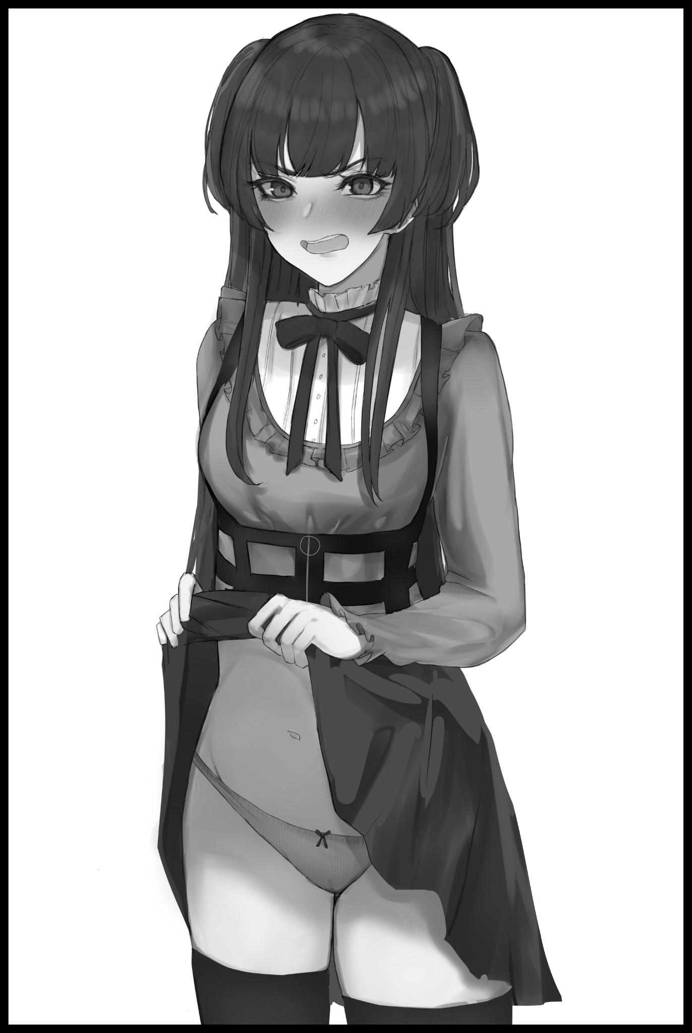
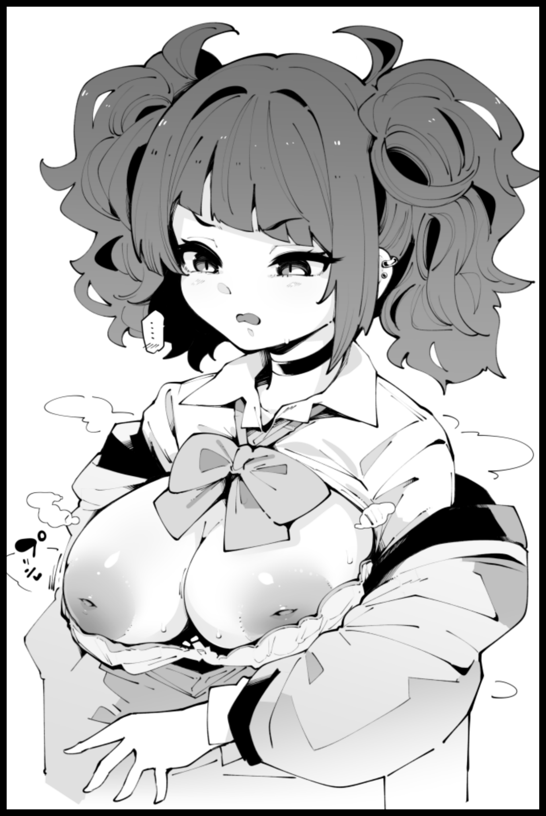
“W-Whaat the hellll~?!”

“N-Nathan?! W-Where’d you-ow!”

Before the sudden sensation of freefalling at what felt like an estimated speed of a hundred miles an hour overtakes the two distressed girls alongside a pale void, sending them hurtling through the featureless funnel until the two of them are deposited right outside the front door of the abandoned home?

The sun was shining high in the sky now, pointing to the onset of a humid afternoon weekend, the wind was as fine as it always was and the distant hubbub of vehicles roaring down the more populated streets of the town were comforting, now more than ever as Nathan and Richard scramble in the grass, overcome by panic and adrenaline as they look around with wide eyes for spooky, body snatching dolls and the innards of a creepy mansion they were no longer trapped inside of as they winced at the bright rays of sunlight beating down on them. Oblivious to a third individual standing right behind them as the two women rubbed at their aching bodies and stinging heads, feeling as if they'd been sent through a blender after that nauseating experience in the blinding tunnel.

"So? How'd it go? Judging by your…wait…what're you doing with your boobs hanging out like that Rika?! Cover up before someone sees you! You too Natalie! Skirts exist for a reason!"

Irate and more aware of the situation than Richard was in her currently dazed state, Nathan clambers to her feet before crossing the short distance over toward Susan who had suddenly appeared without notice, obviously thinking to lay the blame squarely on her judging from the bitter look on her cute face, struggling to make herself look intimidating despite the oddly feminine way Nathan now conducted herself with; as broad hips swayed to and fro beneath her waist high skirt before knees buckle inward as trembling hands lifted her the bottom high up into the air, exposing childish panties that, like her friend, no longer sported any noticeable 'protrusions' save for the lean indentation of her womanly folds, flanked on both sides by curvy legs that were far more rotund in comparison to Richard's.

"You think this is all some big joke Susan? I'm wearing a skirt! Panties!!! I was a man before stepping in there, we were men!"

"W-What's gotten into you? You and Rika…were men? Do you even hear yourself right now? Where'd you even get that from?"

“I-I’m sorry Suze…l-lemme take it from here…i’m afraid Nath-I mean Natalie…might’ve smoked something bad in there…c-could you help cover me? Gotta fix my lil wardrobe malfunction, soz!"

Before Susan could say another word, 'Rika' grabs ahold of 'Natalie', tugging on her cheeks to force her along toward the side of the house where they would have the privacy of discussing things between themselves, all while she found herself showing the same worrying signs she had observed in her friend; her breasts were flopping around, and yet she didn't feel the least bit embarrassed. Her hips gyrated from side to side and any attempt at walking 'normally' either failed or made her stumble, unable to arch her back or walk without either her ass or her bust being accentuated. All while her hand remains balled in an obnoxiously girly fashion with the thumb and index finger squeezing Natalie's cheeks did so with the other three fingers erect and craned…just like a girl's…

"W-What did you do that for? Susan obviously-"

"This isn't Suze's fault…at least, not like, totally? It's those damn dolls…and whatever they threw us in afterwards…"

"But she's the one who…wait…you said 'Suze'...and you're starting to talk like a ditz!"

"While you're…totes girly? The way ya…we move and talk…are ya startin' to get all these weird memories too? I can…I can sorta do my bra now I think…"

"Weird…memories…what do you-kyah! D-Don't…w-wait…why did I scream like that?"

Patting down her skirt before freezing upon the realization of what her friend had meant by the use of ‘memories’, Natalie wouldn't have much time left to ponder what Rika had said before the two girls panic upon hearing the sound of the front door opening, breaking into a sprint as best they could now that they couldn't deviate from the innate, waifish gait their bodies seemed to be locked into.

Thankfully, Susan hadn't entered the house, but as they come around the bend, the two of them stop cold in their tracks as their eyes glimpsed the interior that awaited beyond the open door, it's handle mysteriously restored to the same mottled condition it had been previously before it's perceived destruction.

Instead of an unnatural cloak of darkness, light was free to shine in without an anomalous effect. Gone was the two story high mansion hall, replaced by a decrepit hallway of broken floorboards and flaking wallpaper…it was…just an ordinary home that had been left to decay…turning their attention back towards Susan as she lets out a sigh at the sight of them, particularly Rika and her still exposed chest, an error the goth girl quickly corrects much to her own dismay upon the proof of her ability to hook a bra properly without aid…

"There's a reason why I thought you two would like this spot y'know? Not a danger for a beginner, but It's supposedly cursed with a hex that doesn't affect girls. Only men…I don't know what it is exactly but-"

"And you didn't tell us that?!"

"Well I'm sorry Miss Rika over there was being such a spoilsport! How should I tell you when someone's making a big fu-"

"W-Wait…what did I do to piss ya off? Could you like…tell us what happened on Wednesday?"

"You mean you two forgot? You were going on about wanting to try urban exploration so I told you about this cursed home…and then you started getting all-"

"B-But what about the stuff you said before? About you being a man?"

"A-A man? Seriously, I think I'd know what side of the spectrum I'm on best…I'm a girl dummy! Always have been ever since I was born~"

EPILOGUE

A few days after the incident at the outskirts of town. Life would slowly crawl back to an acceptable level of normalcy for the changed friends as they struggled to adapt to new lives as women now that there didn’t seem to be any way for them to return to their former selves as Nathan and Richard respectively.

Susan on the other hand, had completely forgotten the story she had attempted to tell them, the story that had kickstarted this entire debacle in the first place. Which only served to remind the two of how she must’ve felt if what she was saying was in fact true now that everyone in the world seemed to remember them as girls and nothing else; who could she turn to with a ‘tall tale’ that only she herself knew to be the truth? But that also led to a whole string of questions that could never be answered, not when Susan, or whoever she was before all this had been liberated of her memories as a man…if she really had been telling the truth of course.

Who or what she had heard about the curse from. Whether she knew her memories (if legitimate) would be erased upon their own existences being overwritten into those of local bred girls. If she had simply been trying to prank the two of them into visiting the ruins…unknowns that would forever remain a mystery as Natalie and Rika soon settle into their new lives together, especially now that the end of their final year of highschool was fast approaching.
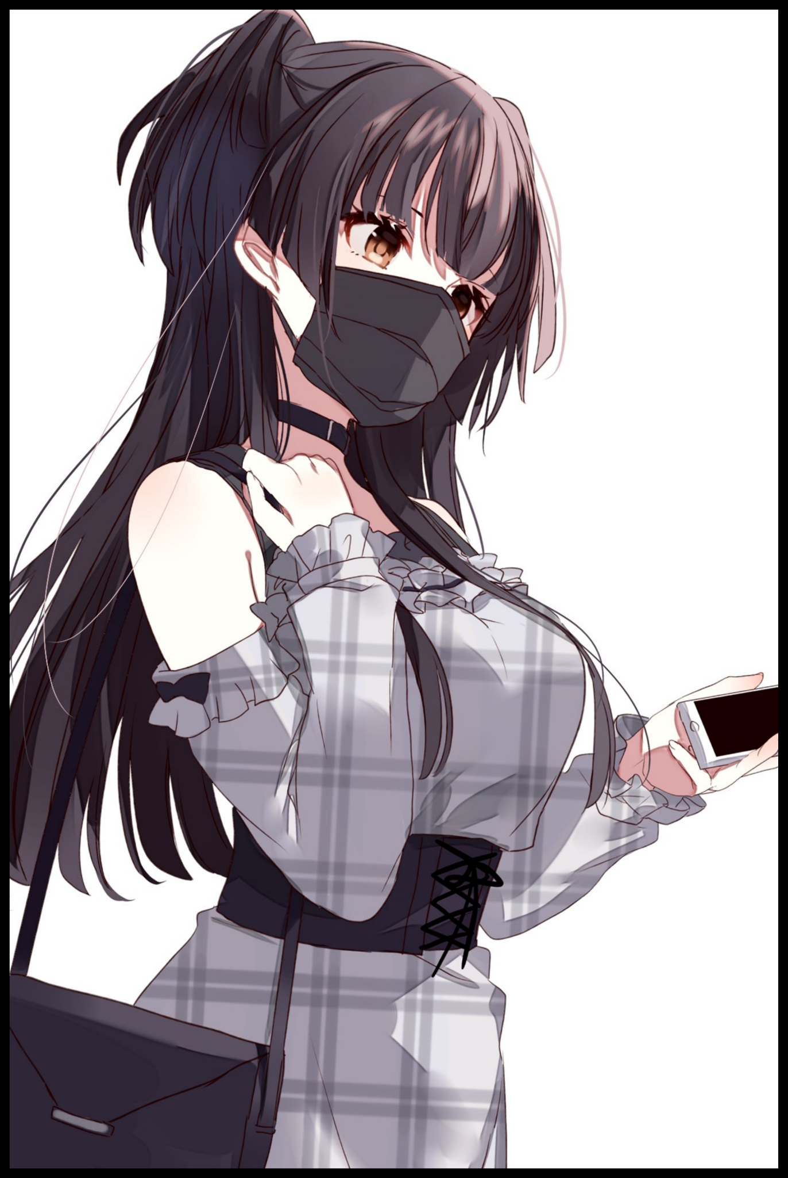
In Natalie’s case, it seemed her former reputation as Nathan the notorious prankster and thrill seeker had been drastically toned down as her ‘bourgeois’ appearance seemed to suggest.

Instead of hailing from a family with a stable income, Natalie’s parents were now a middle-to-high class couple after her mother had won a raffle, using the money to invest in influential businesses while kick starting her own, specializing in designer bags and other fashionable accessories. Most of which her new daughter had taken to wearing all the time despite her initial discomfort to live life as a modern day princess, slowly being lured in by the newly instilled mannerisms and compulsions roiling inside her head.

Temptations that would ultimately prove superior to her former wanderlust, engaging in activities most girls her age with glee after the first few days or so…
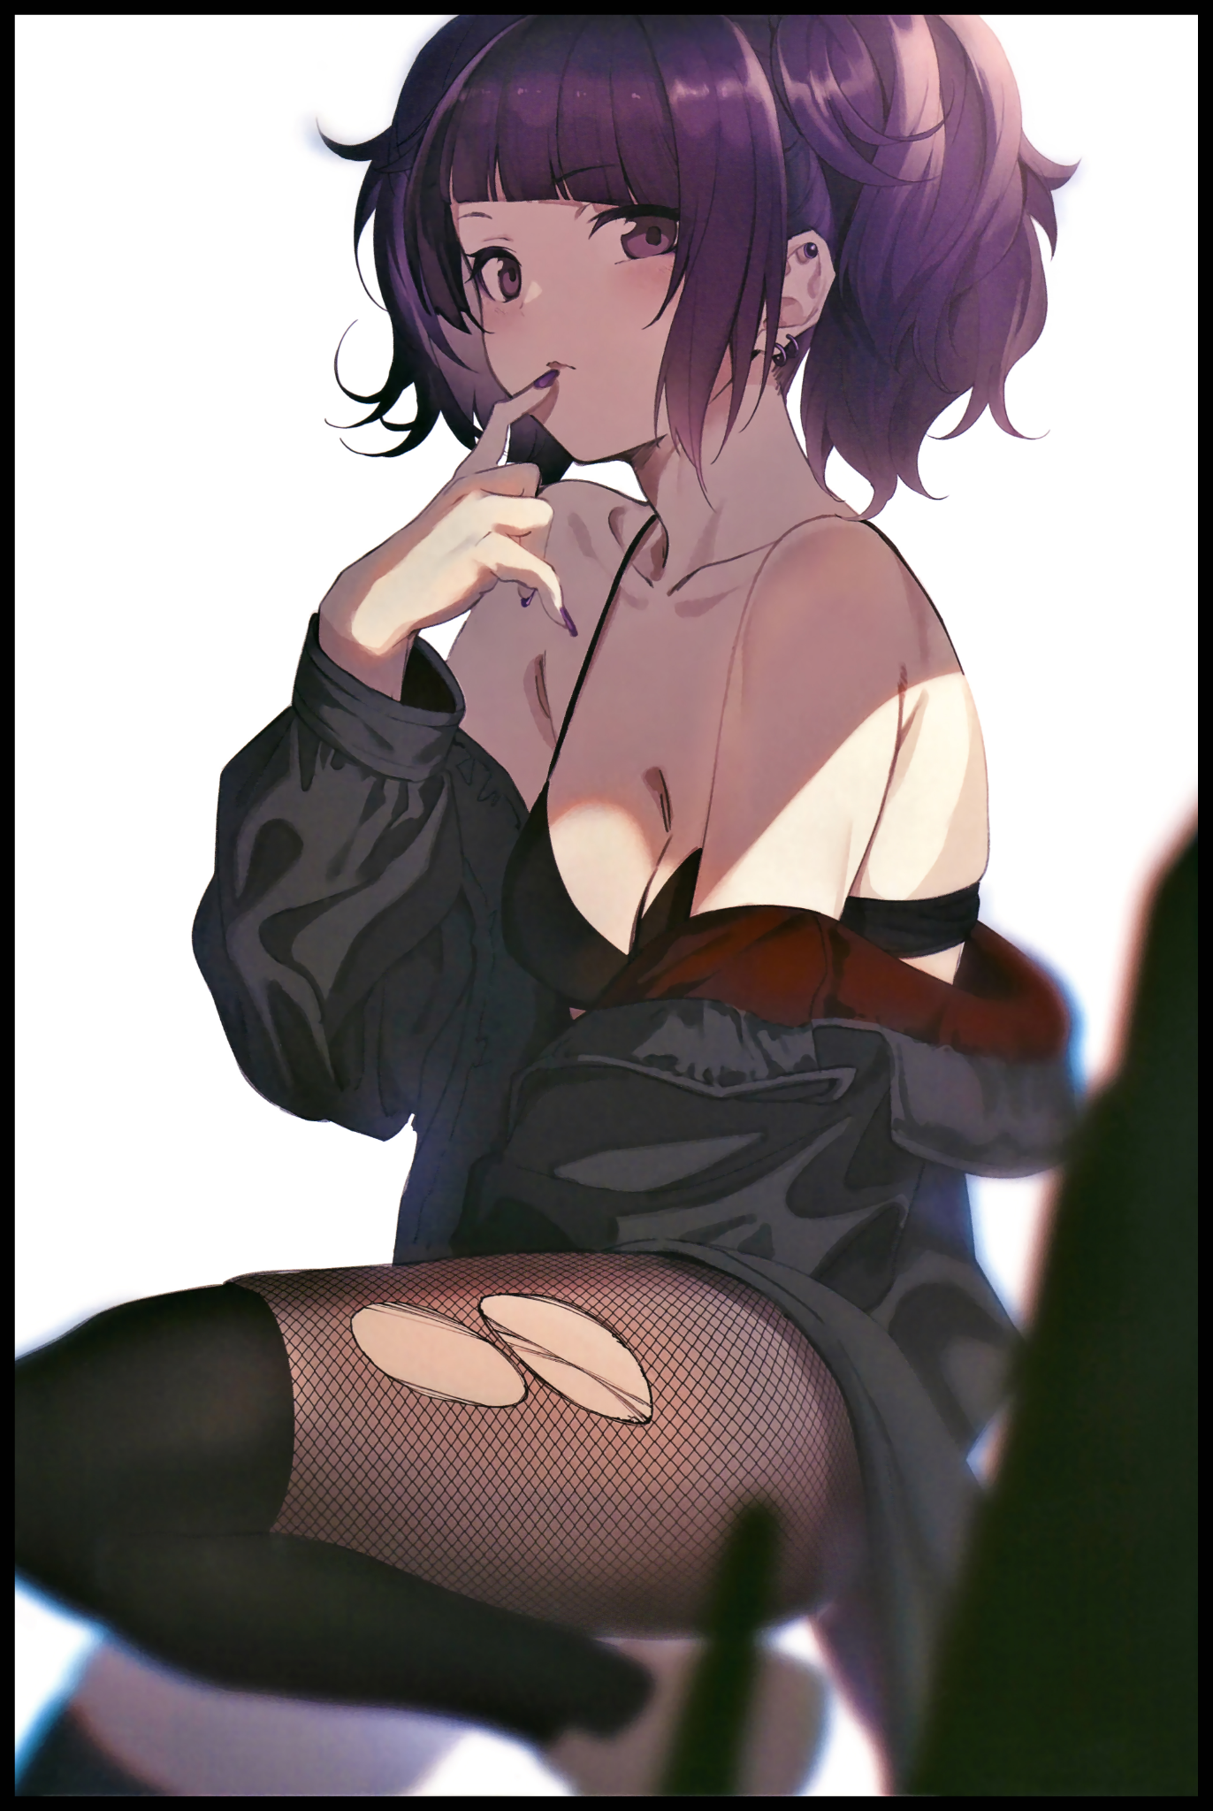
As for Rika? Hers was a slightly humbling experience to say the least. Finding her former, snarky self being cut down dramatically with the introduction of a more laid persona she couldn’t help but lean into once it’s influence had begun to seed her mind, taking root just like Natalie had to a point where even she herself found her old habits to be…’irritating’ if there was a kind way to describe it…

Despite her vapid speech mannerisms and lascivious approach to dressing (hence her carefree attitude to walking around with her privates exposed), a modicum of Richard’s smarts remained strong with only a marginal cut to even things out with how capable Rika could be, finding herself depending on Natalie for her studies, not like there was any shame in it of course. In fact, it pleased her to some extent after remembering how hopeless Nathan was in the field of studies…having to rely on her now felt like a little bit of well deserved tit for tat~

With everything a girl would need to know with topics ranging from personal care to the do's-and-don'ts instilled within their minds, both Natalie and Rika had little issue with their lives going forward with Susan in the middle to support them both, gradually starting to forget about that little known house at the edge of town once more important events came to mind. Like end of year exams…and where they would go moving forward…in addition to something else the two friends had abstained from telling an oblivious Susan about…something to do with Rika’s developing promiscuity and raunchy tendencies leaking over to Natalie as they began to spend more and more time at each other’s houses…strictly for educational purposes of course.

It would only be until a month or so when the two girls would be reminded of their former plight as they come across an adventurous group from the grade below them. A group Natalie was familiar with after influencing their ‘leader’ with tales of her former self’s adventures through abandoned hobbles and ruined factories, no doubt planning to get themselves knee deep into that sort of thing as they overheard the boys talking about where to go…

And with a shared look and a warm smile on their faces, Rika shrugs her shoulders in a sign of willful ignorance while Natalie rubs her shoulders for warmth, fighting back the urge to tell their juniors about the little known wreck on the derelict edge of town…maybe they’d find their own way there, but even if they didn’t, the couple were certain of the fact that they wouldn’t need a ‘hard reset’ so to speak to enjoy their lives together.

But on the off-chance that the unsuspecting group would eventually stumble upon that life changing house of dolls, Natalie and Rika could only hope the unknowable entities of wood and string within would be just as kind to them as they had been for them…

“Hey…you ever wonder if Susan would be…y’know? Interested in what we’ve got going on? I don’t wanna leave her hanging…”

“Nah, she totes wouldn’t wanna get in on our little gig…besides, I hear she’s got a boyfriend…unless she’s up for a foursome, I wouldn’t exactly be too quick to say her two besties are like, fuckin’ each other behind her bac-owch…”

“Language Rika…”

“Got it mom…”

THE END

Image Sources

Image 1 Dera Self : https://www.pixiv.net/en/users/31709099

Image 2 by Tanaka Mamimi : https://www.pixiv.net/en/users/596129

Image 3 by Sola : https://www.pixiv.net/en/users/8764301

Image 4 by Misumi : https://www.pixiv.net/en/users/1122006

