DIETARY CHANGES
BIWEEKLY STORY #132
BY CHALDEACHANGE
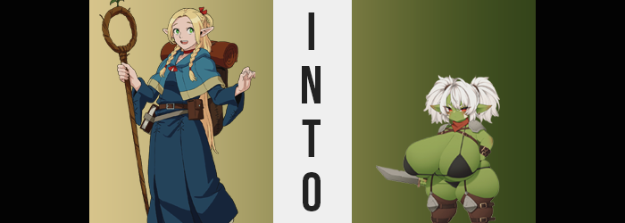

“I TOLD YOU I’M NOT EATING THAT!”

It had become a tragically common occurrence for Marcille to find a plate of food that she absolutely did not want to eat sitting in front of her. Unfortunately, it had been a necessity ever since she had entered the dungeon around with the rest of Laios’ party to save Falin because they absolutely hadn’t had the funds to purchase proper supplies to bring with them. And a lot of it had tasted really good even though she would always deny it if asked in retrospect. But that wasn’t the point!

Even then, this was actually a tamer meal than usual. Having forged a temporary alliance with the orcs, the group had been permitted to take supplies from their camps when necessary, so long as they restocked them after the fact. That meant that a lot of the ingredients were normal. And at first the elf had felt confident knowing that she would eat a relatively normal meal for the first time in a while.

“Eugh…” But in the end? Senshi had found a pretty strange ingredient in the shed. A green vegetable that he referred to as ‘Goblin Greens’. Apparently, goblins in the dungeon, while rare, tended to raise it as a crop. He guaranteed her that it was safe for consumption and that he himself had consumed it plenty of times in the past. But why did it look like a pair of goblin ears!?

Senshi had prepared it in a salad and those ear-shaped vegetables were just poking out of it. But she was so hungry. “Fine Senshi, if you say it’s safe…” Mustering all of her courage she eventually took a bite and… “WHY DOES THIS STUFF ALL ACTUALLY TASTE GOOD!?” And she didn’t really get the vibe that it would cause any health problems, which was certainly an added bonus.

But time would tell if that would remain to be true.

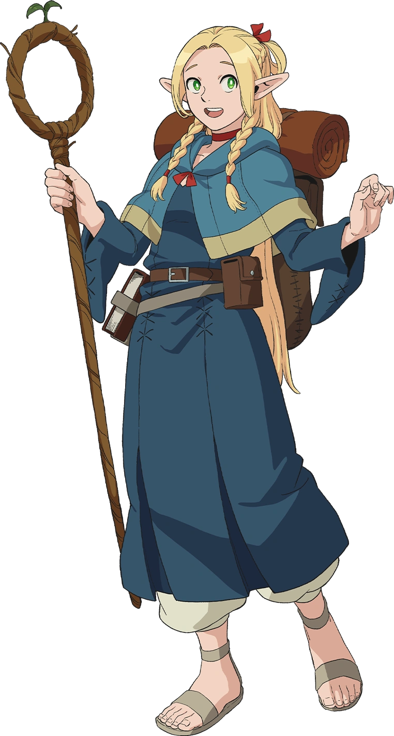
“Guuuh… I don’t feel so good…” While it was difficult to tell in the dungeon of all places, it had to have been the dead of night when the elf awoke with a start. It felt like her stomach was doing loops, she was flushed, and dehydration had set in. Knowing there was a bathroom and fresh water in the room beside the one the party was using to sleep in, Marcille tiptoed around the men and slipped into said room.

She greedily took a large drink of water and gasped with relief when she was finished. “I knew it… Senshi must’ve been wrong about those greens…” The only thing she could really think of that would have made her feel so sick was the dinner they’d had. And nothing else in the salad she had eaten had been unusual… that she knew of, anyways. “But why didn’t the others get sick too? Didn’t they eat them? Ugh… Just my luck!”

There was a reason for it. Just as there was a specific reason that goblins grew those special greens in the first place. Senshi hadn’t lied about eating them without having any ill effects and that was the truth – only because their ‘special purpose’? Well, the activate it they had to be consumed by a woman. It didn’t matter which race did so, so long as they were female.

“Huh? Was dizziness one of the earlier symptoms? I hope things aren’t getting worse…” For a brief moment she believed she had started to feel healthier after having something to drink, but then a new problem emerged. Her balance was unsteady, and she naturally interpreted it as a bout of dizziness on her part. But that interpretation of the situation that she was suffering was quickly disproven. After all, the elf couldn’t really ignore the truth in this case. “Eh? Am I getting smaller? Eh!? EEEEEEEH!?”

She hadn’t been certain at first, but the room was bigger. Her clothing had begun to feel baggier too. And since the only thing that these two problems had in common were her body and perspective, well, it was obvious to a mind as bright as hers that her body was shrinking. And now that she was aware of it? Things became even more so. She’d already dipped beneath the five foot mark and was quickly nearing four feet. “Wait, I’m going to be shorter than a half-foot at this rate!”

But why was she shrinking? It wasn’t like she was becoming a child. Her body was becoming smaller in a very even manner. For example? Her adult breasts did not fade away and remained just as perky beneath those robes of hers and her ass maintained its weight – it was just all relative to how short she was becoming. While it was better likened to the body of a half-foot? Once her clothing swallowed her whole and she dipped even closer to three feet? That possibility had to be taken off the table because her height and figure didn’t match up with an adult woman of Chilchuck’s race either.

“I don’t sense any magic, so the only possible trigger could be… Wait! Was it the Goblin Greens after all!?” Now bottomed out at three feet, she practically had to claw her way out of the pile of clothing that had once fit her elf body. By the time she managed to get it all off she had to accept the reality that she was naked, but if her screams from before hadn’t attracted anyone’s attention by now then it was probably safe to say that no one would be coming to check on her. What could she have even worn anyways? “But why did it make me smaller? Come to think of it this height is roughly around the height of a— Urgh…”

A terrible thought had crossed her mind and yet there wasn’t enough evidence for her to say for sure just yet. Marcille likely would have been singing a different turn had she been able to notice her ears, mind you. They were shortening a touch and curving in shape, although they retained their points. What was actually the most concerning about them wasn’t their shapes but their colors though. They had been dyed a dark green, and that same green was beginning to arise elsewhere across her body.

Along with a strong odor. “Ugh! And me just bathed this morning!” It was a concerningly pungent scent. Body odor was certainly part of it, but there was something else mixed in. Pale skin became greener and greener, and that green skin began to excrete a pheromone. One meant to attract goblin males. Marcille began to flail about naked, and with arms bouncing about she finally noticed through eyes that had turned a bright red. “M-M-Me skin!? Marci’s skin!?”

It was green! Green and she could make out her pores – typical of the skin of a goblin. Not only was her skin green in general, but her nipples and pussy were an even darker shade and were, for some reason, erect. Why was she horny all of a sudden? “What kind of magic could… could… Huh? Me know magic, right? But magic… hard to know…?”

“GYAAAAAH!” The woman cried out in a much shriller tone this time after it dawned on her that she couldn’t remember a thing about magic anymore. When she tried to think about any useful skills she might have had? Hunting, cooking, nursing… All areas where she hadn’t excelled in before. Even if she had there was something off about this knowledge. The methods she now recalled were far too crude to be used by one of the civilized races.

They were more akin to what you might expect from a monster.

Streaks of white appeared amidst Marcille’s beautiful golden hair. Anything dyed shortened, which with time became a problem as all of her hair succumbed to this color shift. It only reached her shoulders before long and became coarse and dirty. Like the woman hadn’t bathed properly in a very long time. Specks of dirt had have appeared on her skin and her odor had worsened because of it, but… “Sniff sniff! Me guess me smell okay?” It didn’t really bother her anymore. She actually smelled quite nice?

This wasn’t true, of course. It spoke to how the woman’s mind was being changed and corrupted. Her sensibilities were shifting to reflect those of the creature she was becoming, and things like social understanding and even speech were becoming more difficult for her. The fangs within Marcille’s mouth sharpened to reflect a change in evolution, and a bush of white pubes above her pussy grew until the resembled a tangled, unkempt jungle.

“Marci really becoming gobo? No good! Gobo can’t find Falin! Gobo get… bred…” The very thought provoked her to lick her lips. Lips that were filthy and full, perfect for seducing a goblin male. She was plainly fully a goblin in terms of species now, but what she was enduring wasn’t through just yet. She didn’t have the traits necessary to make her the breeder the greens had been fashioned to construct. And she was still much too thin for a goblin in general. “BURP!?”

No effort had been made on her part to stifle the uncouth belch that bubbled up from her tummy. Her breath stank like she had been eating uncooked food, but to a goblin that didn’t matter at all. They were simple, dirty little monsters that only cared about eating, pillaging, and breeding, and Marcille’s body was merely reflecting that. The belch had arisen in the first place because her small tummy had become a little distended. She’d grown chubby and now had a soft belly bump.

It was at this stage that the changes she was suffering took a very dramatic turn. Her mind was wandering against her will towards the idea of being bred and fucked in the filthiest way imaginable. But a filthy breeding goblin would need an even filthier body, right? That was why she began to swell further, but no longer in her stomach. It was plain to see that Marcille’s tits had begun to engorge, added weight sloshing around inside of them as the containers were stretched to D-cups compared to her new height.

If only things had stopped there then perhaps it wouldn’t have mattered that much. But it didn’t. “Ooooh! Big! Melons big! Hehehe!” The woman herself didn’t seem to mind one bit, reaching short arms around them and twerking her own dark green nipples as they grew bigger atop tits that swelled to unrealistic sized for such a short body. As big as they became she never struggled to hold up their weight, perhaps because her small body was becoming stronger – or perhaps because her lower half was also reaching an abundance otherwise thought impossible.

The green skin around her thighs stretched just as it did around her breasts, an indecent amount of heft pooling within her short legs so that those thighs filled larger and larger. Each leg pushed past her chubbier waistline in swell, bulging like a water balloon that was ready to burst and jiggling just the same. With how short she was it was truly unbelievable that her thighs could become so abundant, but then again…

Thick as they were they still didn’t hold a candle to her tits. “Hehehe!” Marcille’s mind was so simple now. She was slapping her own boobs around almost like a kid even though she absolutely was not one. Within time they were so huge that she couldn’t even reach her nipples with her arms. 75% or more of her body mass had to have been made up by a combination of her boobs, thighs, and the jiggling ass she received in kind. It looked inconvenient and it technically was. But not for the type of life she was meant to live as a breedable goblin slut.

One with some major dietary changes.

She’d been lost in the sauce for so long and she was utterly unaware that her transformation had completed. But after accidentally slapping herself in the face with her own breast just once? She was suddenly hit with a brief moment of clarity as her old self attempted to break through just one final time.

“Marci… weird! Gobo Marci? Marci naked!?” Tens of years of magical knowledge had been sapped away from her, but simultaneously? So had her general knowledge as well. Even speech proved difficult for the curvy goblin, who struggled to put sentences together as she flailed about. Of course, every little movement brought her huge tits to bounce and her thick green thighs to jiggle. “What do!?”

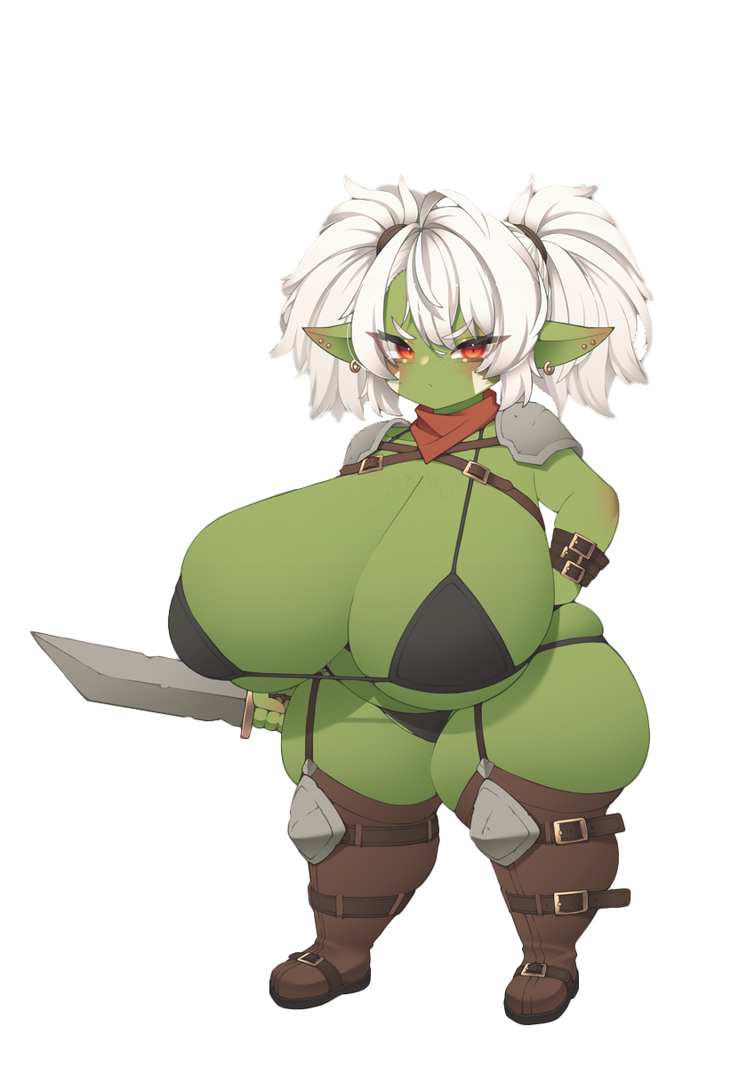
Strangely? She didn’t feel repulsed by her new form or anything like that. Maybe it was because she was too stupid, or because she was now no more than a monster that acted on instinct, but she couldn’t even imagine anything being wrong with it. She was a good goblin female. She had been born to be bred, as all goblin women were. How could she complain about a fate that would be so pleasurable?

But then she noticed it in the corner of the room. A chest. She pitter-pattered over to it and just barely managed to open it with her current height a factor. And within? “Yeah! Find good!” Trying to grab what she had found inside with tiny hands involved leaning over the edge of the chest. But with her breasts so big and heavy? She fell in and the lid of the chest closed over top of her, locking her inside. “GAH!?”

“What are we supposed to do with her? She keeps calling herself ‘Marci’ but can’t seem to remember us.” Later that morning Laios and the others had found the chest rattling around. Upon opening it? They’d found Marci dressed in a bikini and boots while holding a sword – the items she had found in the chest before falling in. Laios wasn’t even sure what to do.

Chilchuck rolled his eyes. “How do we even know she’s actually Marcille then? I’m not suggesting we kill her, but we shouldn’t take her with us. If the orcs found those greens nearby then there must be goblins on this floor, right? Let’s just let her go free. With that body she’d just be in the way anyways.” It was unfortunately a sound idea. And the one that the group eventually went with.

Leaving Marcille to breed a new generation of goblin young.

