Projectile Motion Formula Sheet:
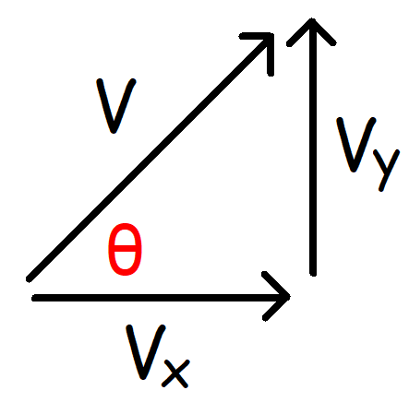 | Vector Formulas:  $$v_{x}=v\cos{θ} v_{y}=v\sin{θ}$$  $$v=\sqrt{{v_{x}}^{2}+{v_{y}}^{2}} θ=\tan^{-1}\left(\frac{v_{y}}{v_{x}}\right)$$
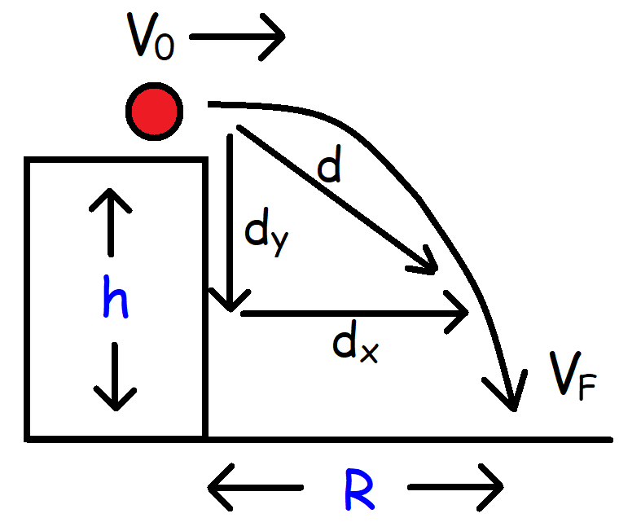  Facts to Know  - $v_{o}=v_{x}=constant$  - $v_{yo}=0$  - $a_{y}=-g=-9.8 m/s^{2}$  - $g=+9.8 m/s^{2}$  - $θ=0° and\cos{0°=1}$  Derived Equations:  _______________________________  Initial Velocity:  $$v_{o}=R\sqrt{\frac{g}{2h}}$$  _____________________________  Range Vs Time:  $$\frac{R_{1}}{t_{1}}=\frac{R_{2}}{t_{2}}$$ | Height of the Cliff/Building:  $$h=\frac{1}{2}gt^{2} h=\frac{R^{2}g}{2{v_{o}}^{2}}$$
Range: $\cos{0°=1} and v_{o}=v_{x}$

$$R= v_{x}t R=v_{o}\cos{θ}t R=v_{o}\sqrt{\frac{2h}{g}}$$
Displacement:
$$d_{x}=x_{F}-x_{o} d_{y}=y_{F}-y_{o}$$

$$d_{x}=v_{o}\cos{θ}t d_{y}=v_{o}\sin{θ}t-\frac{1}{2}gt^{2}$$

$$d= v_{o}t\sqrt{1+{\left(\frac{gt}{2v_{o}}\right)}^{2}} d=\sqrt{{d_{x}}^{2}+{d_{y}}^{2}}$$
Final Vertical Velocity:

$$v_{yF}=-gt$$

Final Velocity:
$$v_{F}=\sqrt{{v_{o}}^{2}+{\left(gt\right)}^{2}} v_{F}=\sqrt{{v_{o}}^{2}-2gd_{y}} θ_{F}=\cos^{-1}\left(\frac{v_{o}}{v_{f}}\right)$$
Note: dy is negative when the projectile is falling. (g = +9.8)
Time to Reach the Ground:

$$t=\sqrt{\frac{2h}{g}}=\frac{R}{v_{o}}=\frac{v_{yF}}{-g}=\frac{\sqrt{{v_{F}}^{2}-{v_{o}}^{2}}}{g}$$

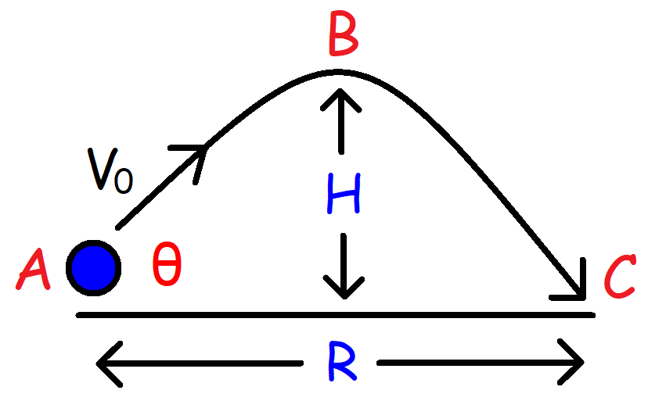 | Point A:  $$v_{x}=v_{o}\cos{θ} v_{yo}=v_{o}\sin{θ}$$  $$v_{y} decreases by 9.8 m/s every second.$$  $$v_{x} is constant.$$  Point B:  $$v_{y}=0 v=v_{x}$$  All Points:  $$a_{y}=-g= -9.8 m/s^{2}$$  $$g=+9.8 m/s^{2}$$
Height:  $$H= \frac{{v_{o}}^{2}\sin^{2}\left(θ\right)}{2g}=\frac{R\tan{θ}}{4}=\frac{{v_{yo}}^{2}}{2g}$$  $$H_{Max}=\frac{{v_{o}}^{2}}{2g} when θ=90°$$ | Range:  $$R=\frac{{v_{o}}^{2}\sin\left(2θ\right)}{g}=\frac{2v_{x}v_{yo}}{g}=\frac{4H}{\tan{θ}}$$  $$R_{Max}=\frac{{v_{o}}^{2}}{g} when θ=45°$$
Time of Flight:  $$t_{A→B}=\frac{v_{o}\sin{θ}}{g} t_{A→C}= \frac{2v_{o}\sin{θ}}{g}$$ | Initial Angle:  $$θ_{o}=\tan^{-1}\left(\frac{4H}{R}\right)=\sin^{-1}\left(\sqrt{\frac{2gH}{{v_{o}}^{2}}}\right)=\frac{1}{2}\sin^{-1}\left(\frac{Rg}{{v_{o}}^{2}}\right)$$
Velocity Components:  $$v_{x}=v_{o}\cos{θ} v_{y}=v_{o}\sin{θ}-gt$$ | Equation of Trajectory:  $$y=x\tan{θ}-\frac{gx^{2}}{2{v_{o}}^{2}\cos^{2}(θ)}$$  Note: $x=dx and y=dy if \left(x_{o},y_{o}\right) is \left(0, 0\right).$
Initial Velocity:  $$v_{o}=\sqrt{\frac{Rg}{\sin{(2θ)}}}=\frac{\sqrt{2gH}}{\sin{θ}}=\frac{gt_{A→C}}{2\sin{θ}}$$ | Final Velocity:  $$v_{F}=\sqrt{{v_{xF}}^{2}+{v_{yF}}^{2}}$$  $$v_{F}=\sqrt{{v_{o}}^{2}-2gtv_{o}\sin{θ}+{(gt)}^{2}}$$
Position:  $$x_{F}=x_{o}+v_{o}\cos{θ}t$$  $$y_{F}=y_{0}+v_{o}\sin{θ}t-\frac{1}{2}gt^{2}$$  Position Vector: $\left(x_{o},y_{o}\right)→\left(0, 0\right)$  $$\vec{r}=\left[v_{o}\cos{θ}t\right]i+\left[v_{o}\sin{θ}t-1/2gt^{2}\right]j$$  $$\vec{r}=r_{x}i+r_{y}j \left|\vec{r}\right|=\sqrt{{r_{x}}^{2}+{r_{y}}^{2}}$$ | Displacement:  $$d_{x}=v_{o}\cos{θ}t d_{y}=v_{o}\sin{θ}t-\frac{1}{2}gt^{2}$$  $$d=\sqrt{{d_{x}}^{2}+{d_{y}}^{2}}$$  $$d= v_{o}t\sqrt{1-\frac{gt\sin{θ}}{v_{o}}+{\left(\frac{gt}{2v_{o}}\right)}^{2}}=|\vec{r}|$$

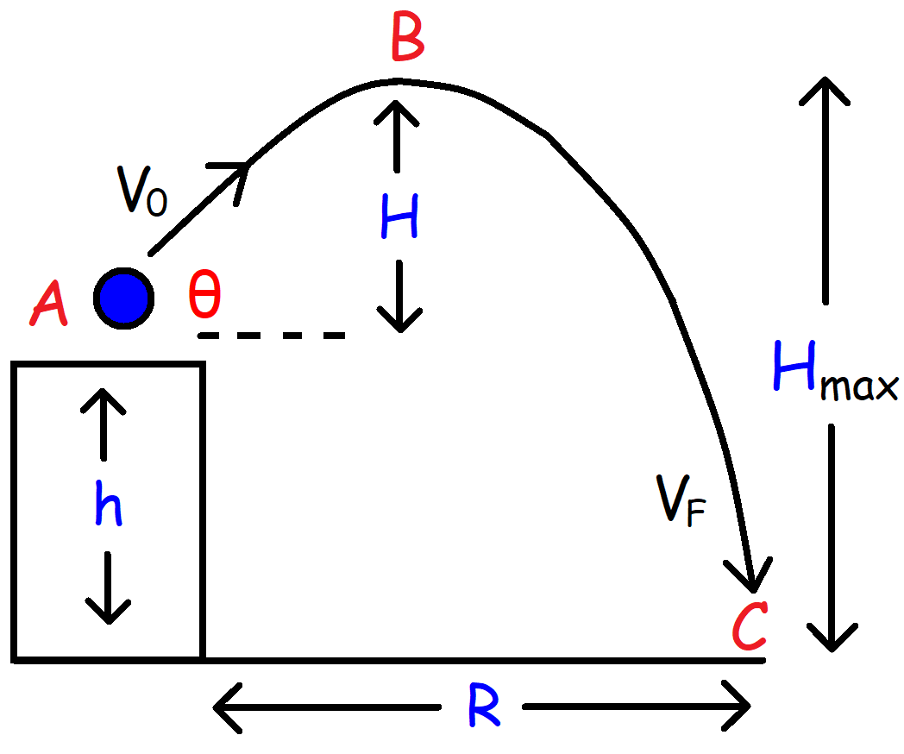 | Point A:  $$v_{x}=v_{o}\cos{θ} v_{yo}=v_{o}\sin{θ}$$  $$v_{y} decreases by 9.8 m/s every second.$$  $$v_{x} is constant.$$  Point B:  $$v_{y}=0 v=v_{x}$$  All Points:  $$a_{y}=-g= -9.8 m/s^{2}$$  $$g=+9.8 m/s^{2} and h=y_{o}$$
Height:  $$H_{max}=h+H= y_{o}+\frac{{v_{o}}^{2}\sin^{2}(θ)}{2g}$$ | Range:  $$R= v_{o}\cos{θ t}$$
Time of Flight:  $$t_{A→B}=\frac{v_{o}\sin{θ}}{g} t_{B→C}=\sqrt{\frac{2H_{max}}{g}}$$  $$t_{A→C}= \frac{v_{o}\sin{θ}}{g}+\sqrt{\frac{2H_{max}}{g}}$$  $$t_{A→C}=\frac{v_{o}\sin{θ+\sqrt{{v_{o}}^{2}\sin^{2}\left(θ\right)+2gy_{o}}}}{g}$$  _________________________________________________  Equation of Trajectory:  $$y=x\tan{θ}-\frac{gx^{2}}{2{v_{o}}^{2}\cos^{2}\left(θ\right)}$$  Note: $x=dx and y=dy if \left(x_{o},y_{o}\right) is \left(0, 0\right).$ | Displacement:  $$d_{x}=v_{o}\cos{θ}t d_{y}=v_{o}\sin{θ}t-\frac{1}{2}gt^{2}$$  $$d=\sqrt{{d_{x}}^{2}+{d_{y}}^{2}}$$  $$d= v_{o}t\sqrt{1-\frac{gt\sin{θ}}{v_{o}}+{\left(\frac{gt}{2v_{o}}\right)}^{2}}=|\vec{r}|$$  $$d_{x}=x_{F}-x_{o} d_{y}=y_{F}-y_{o}$$  ____________________________________________  Position:  $$x_{F}=x_{o}+v_{o}\cos{θ}t$$  $$y_{F}=y_{0}+v_{o}\sin{θ}t-\frac{1}{2}gt^{2}$$
Velocity Components:  $$v_{x}=v_{o}\cos{θ} v_{y}=v_{o}\sin{θ}-gt$$ | Position Vector:  $$\vec{r}=\left[v_{o}\cos{θ}t\right]i+\left[v_{o}\sin{θ}t-1/2gt^{2}\right]j$$
Initial Velocity:  $$v_{o}=\frac{R}{t\cos{θ}}=\frac{\sqrt{2g(H_{max}-h)}}{\sin{θ}}=\frac{1/2gt^{2}-y_{o}}{t\sin{θ}}$$  Final Velocity:  $$v_{F}=\sqrt{{v_{xF}}^{2}+{v_{yF}}^{2}} θ_{F}=\cos^{-1}\left(\frac{v_{o}\cos{θ_{o}}}{v_{f}}\right)$$  $$v_{F}=\sqrt{{v_{o}}^{2}-2gtv_{o}\sin{θ}+{(gt)}^{2}} θ_{F}=\tan^{-1}\left(\frac{v_{y}}{v_{x}}\right)$$ | Initial Angle:  $$θ_{o}=\cos^{-1}\left(\frac{R}{v_{o}t}\right)=\sin^{-1}\left(\frac{\sqrt{2g(H_{max}-y_{o)}}}{v_{o}}\right)$$  $$θ_{o}=\sin^{-1}\left(\frac{1/2gt^{2}-y_{o}}{v_{o}t}\right)=\tan^{-1}\left(\frac{1/2gt^{2}-y_{o}}{R}\right)$$  ____________________________________________  Height of the Building:  $$h=\left|d_{y}\right|=\left|v_{o}\sin{θ}t-\frac{1}{2}gt^{2}\right|$$

