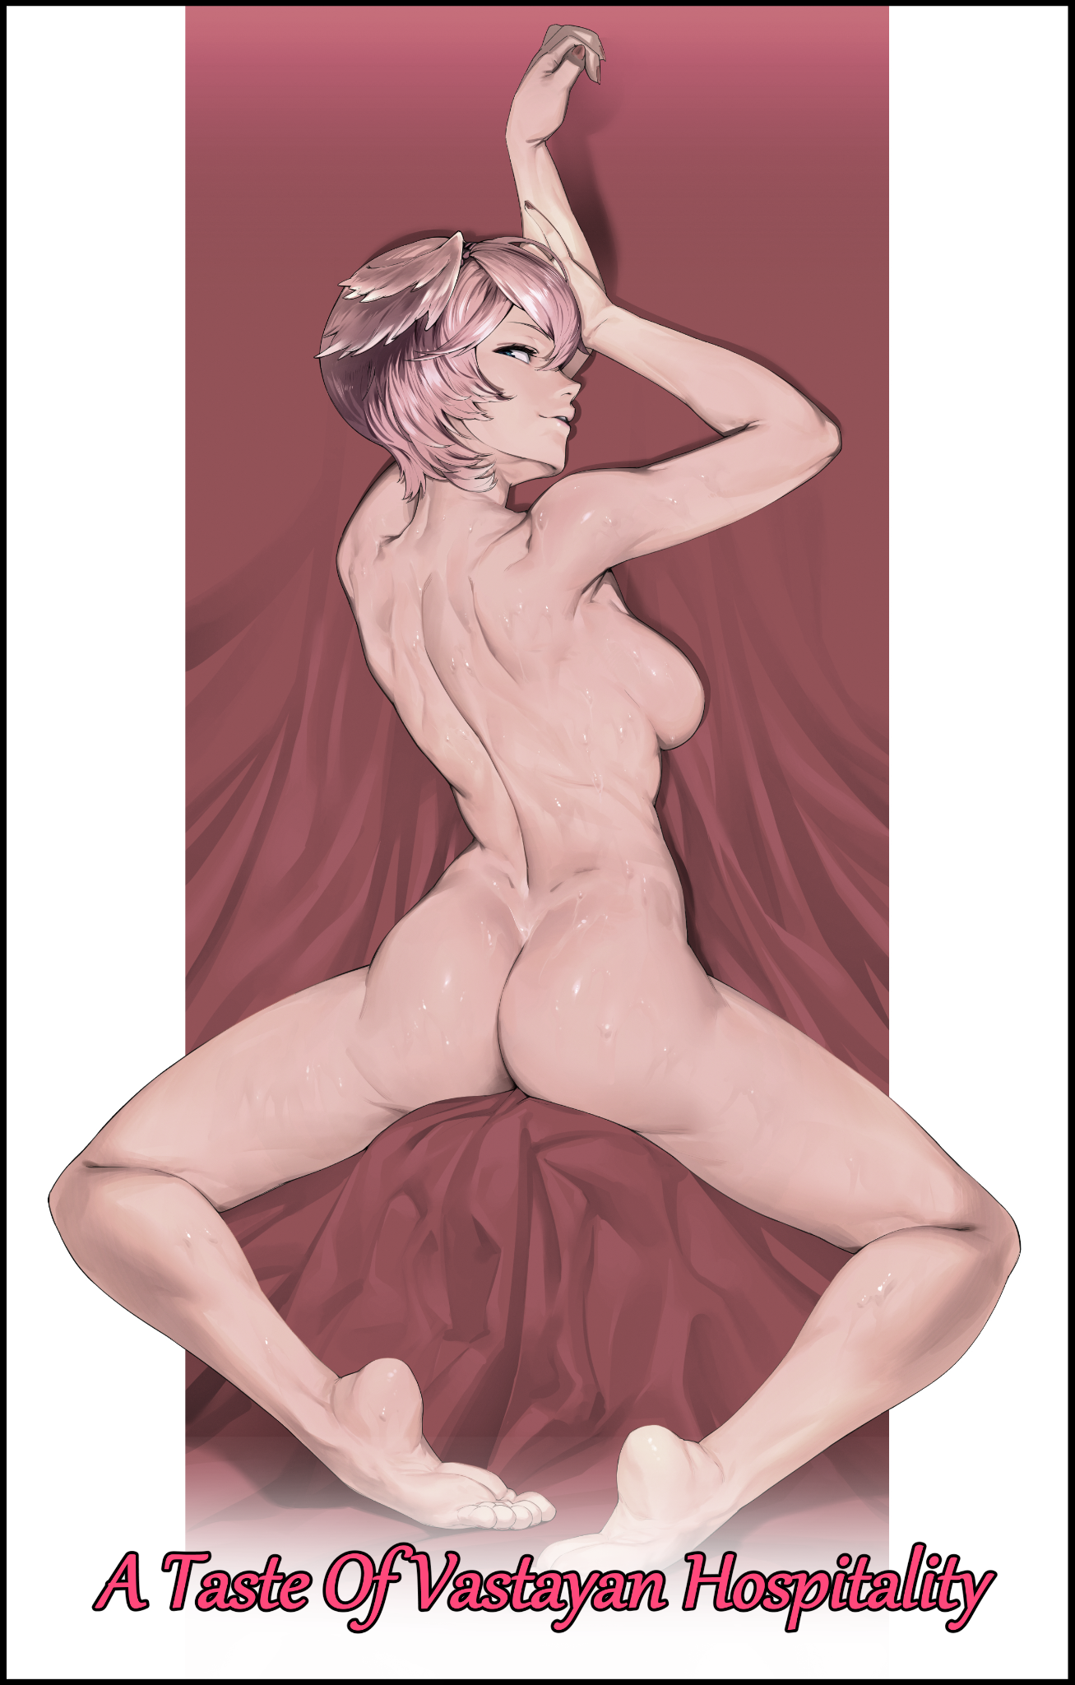

A homely little apartment flat fit for one, bathed in warm orange lights, chilled by a cool evening sir supplied by an ongoing downpour outside and a strong internet connection ensuring the comforts of a modern society were close at hand and easily accessible. A stroke of luck for the tenant currently nestled comfortably in a swivel chair, arms resting on the edges of a wooden desk, fingers rapping away at a keyboard and mouse, eyes laser focused on the wide-screen monitor in front of him.

All he needed was focus, and with sound dulling headphones blasting the sounds of faux combat into his ears, he was in his element, directing the tiny 3D model across the screen, making strategic plays, luring overeager opponents, drawing attention for troubled teammates and pushing whenever an opening presented itself. All while muttering incoherent words at a rapid fire pace into the microphone jutting out the side of his headset.

A true gamer general commandeering his battlestation with a firm hand…

With a slightly plump build and a cool head of chestnut brown neatly trimmed and brushed back, Charlie was a man who preferred to spend most of his time reclined and gaming when he wasn't out working, seated in the embrace of his comfortable chair at home without the worries of the world constantly weighing down on his shoulders.

There was always a time and place for everything. That was a saying Charlie loved to adhere to. Work and Play were never meant to intertwine, and for Charlie, work was reserved for the office. When he was at home, gaming was king, and he wouldn't have had it any other way. And as for the games he favored, ones that focused primarily on strategy and teamplay were his bread and butter. Which came as no surprise when he soon kept returning to a certain game with a conflicted reputation after discovering it for the first time when he was still in university toiling for a degree.

Depending on who gave their opinion, the franchise and its various forms of media (besides a recent animation project that had the world fawning over it) drew comments ranging from derisive drivel to unwavering praise for both the game itself and the very people who played it, citing an unbridled level of toxicity one would have to wade through in order to enjoy it.

But none of that mattered to Charlie. He simply adored the game for what it was and the bevy of supplementary lore he could immerse himself in during his free time. Books, music videos, short stories, fan theories. There was so much to be had involving his favorite characters so in theory, the only way he was going to become bored of it was when he finally exhausted himself of it all. An unlikely occurrence considering how he liked to take things slow, drip feeding himself with small smidgens of content every day while having fun with the game. Wondering how these maps he viewed everyday through an isometric top-down view would look like in a real world setting.

And considering how many games there were in circulation today, there was no way he could ever grow bored, simply hopping from one to the other in case he ever felt the inevitable pang of burnout plaguing his mind. Moderation was an important factor to a well lived life after all, even moreso than achieving a good work-life balance, for that would be no fun to be had if playing games became a burden.

While Charlie was a level-headed individual, others in the community were not as mature or level headed as he was. And that usually meant he had to go out of his way to mute and block the never ending flow of easily offended kids playing the game he loved much to his dismay, like the one currently spamming the global chat with expletives and accusatory remarks just because his team was on the losing end. He was all in for some friendly banter, but vitriolic exchanges like these was the sort of stuff he preferred to sit out on.

Unbeknownst to Charlie however, there existed certain people in the world, people with extraordinary abilities living mundane lives amongst their ordinary brethren in an effort to keep themselves hidden away from each other and the public eye.

Despite their status as superhumans among men, they were ultimately human beings at the end of the day. Right down to their fickle hearts and naive mindsets, they still lived lives of boredom, some feeling more restricted and oppressed than others by the fact that they had to keep their 'gifts' a secret…all except a certain few who felt that they shouldn't need to keep their abilities a secret, using it as they saw fit. And whether it was a stroke of bad luck or simple coincidence, a member on the opposing team was one of these special individuals.

And he wasn't too happy with the fact that who he saw as a 'normie' had beaten him at the game. Furrowing unseen brows in frustration by the loss, anger directed at Charlie's username hovering over the player who kept hindering their attempts to turn the tide until it was too late to do anything, ending with the first defeat in the unknown man's evening while Charlie simply removes the stuffy headset off his ears without much fanfare besides a celebratory fist pump, popping the cap off his water bottle to take a nice hefty swig to quench his parched throat, ignorant to the great enemy he had made miles away from where he sat in the safety of his home.

Distance was no issue for the stranger, not when he had complete mastery over manipulating the weave between dimensions, possessing the ability to pluck things from one end before dropping them off wherever he pleased, whether it was the bottom of the Mariana Trench, the frigid peaks of Mount Everest, the other end of the Moon, or even places far removed from existence as most people knew it. And as he rubs his forehead with a crooked finger, eyes fixated on the results screen, a punishment like no other floats by in his mind.

'If he's so good at the game, why not just send him in there forever?'

All Charlie could do was gulp down his last mouthful of refreshing water before suddenly falling over onto his bum with a grunt. Only instead of hardwood and his legs knocking against the table, the startled man would find himself sitting on a soft cushion of mildly damp glades of verdant grass, feeling the chill of the open air gracing him like an invisible hand was a sudden change that immediately had him shivering in fright. Within a second, the familiar orange of his room light was gone and an auditory assault on his senses had him reeling.

The comforting barriers afforded to him through the walls and ceiling of the room had been taken away, leaving Charlie confused and alone in the middle of what looked to be a forest clearing, flanked on all sides by trees…but not just any ordinary trees like the ones he'd seen on the way to work, or in wildlife documentaries. These ones seemed to burn with an ethereal energy, pale blue like phantom fire, natural lights that blended in nicely with the moonlight shining down from high above clear skies. Offering the stunned human a mesmerizing glimpse into a world clearly divorced from the likes of Earth, sighting earthen formations far too immense and grand to have gone unnoticed for so long if this really was some hidden paradise he'd been teleported to…had he even been teleported?

"C'mon Charlie…it's just a dream…just gotta…pinch myself! And I'll be back home…"

But still he remained in the enchanting forest even after delivering a surprisingly hard pinch to the flab beneath his left wrist, leaving an angry red mark where his index finger and thumb had bitten down on.

No matter where he looked, it was the same all around; an endless row of trees that seemingly went on forever into the unseeable horizon, reared by the imposing mountains beyond them. More concerningly however, was the fact that it was starting to get colder and colder with each passing second. Even though it didn't look like winter had set in, anyone caught out in the wilderness at night dressed in a simple t-shirt and boxers was asking for trouble…and if they were to fall asleep in such conditions…

It would be a nap they would never wake from.

He didn't have a second to waste wondering how he had ended up…wherever the hell this place was. If he wanted to outlive the night, he needed to get a fire going before his body temperature fell even further than it already had, cursing under his breath as he rose to his feet before making a wavering beeline toward the foliage. It didn't help that he'd spent the last two or three hours basking in the natural air conditioning while gaming. The memory of which causes a sudden, impossible thought to run through Charlie's mind as he scans the auburn leaves making up the swaying canopy above him, wincing against the glaring moon hanging in unspoilt skies…beneath which laid the distinct rise and falls of familiar mountain tops that reminded him of a Chinese painting.

"No way…am I really? T-This can't be true, can it? I'm actually in I-"

"Ionia? Right you are…but what I wanna know is, where are you from?"

Turning his head sharply toward the source of the husky and very familiar voice of a woman whose sleek silhouette blended in perfectly between the pockets of darkness within the woods, Charlie's eyes widened at the sight of a scarlet fringe and an additional tuft akin to the tip of a shoulder slung ponytail peeking out from under a hood. Double jointed legs barely made a sound as they flew through the thick carpet of fallen leaves with practiced steps.

Sharp avian ears that jutted out the back of her head with a curving skyward slant, raven feathers sheathed around what was clearly a wing hanging down over her left arm. The man didn't even need to spy the bird skull pauldron or the signature ebony red clothes to know who she was. After all, he'd been 'controlling' a low polygon representation of her not too long ago, bringing victory to his team because of it.

"X-Xayah?"

No sooner had he uttered her name when a feather trailing phantom exhaust embedded itself into the ground near his right flank, disintegrating his water bottle along the way until nothing remained of his plastic drinking implement. Shot so fast and without a sound that Charlie had barely noticed the bird lady's winged arm was now raised high in the sky, palms spread open, scrambling backward before the sizzling plume dissipates with a fizzle.

And as he turned his gaze back toward the playable character turned living breathing aggressor, he had forgotten the qualities that drew him toward Xayah's character also made for a terrible person to talk to in real life…if this was real, how could he even know?

"You . Don't . Get . To . Say . My . Name!"

The venom which laced every word the brooding Vastayan rebel hissed at him was bone chilling, forcing him to choose his next words very carefully, especially after catching a glimpse of the feathers in her wing vibrating, primed and ready to raze him off the face of Runeterra…either that or he would find himself awakening back inside his room if Xayah's patience ran out, relieved to have lived through a very lucid dream.

And so, deciding to chance it all on luck, Charlie decides to resort to the tried and true method of communicating with video game characters he had seen in movies and novels featuring ordinary humans much like himself being flung into their world. If he was playing League not too long ago, and the first character he ran into upon arriving here was the one he'd been playing as…then maybe the game was actually more than just a simple online match. Maybe she really had been fighting a battle and was just on edge!

Charlie figured that if he could communicate through that link, successfully convey the message that he came from another world, then maybe he could get somewhere with the normally hostile rebel.

"I-I helped you! You were f-fighting not too long ago right?! I was the-"

"Really? You? Help me? You'd do better as an errand boy than a fighter! You lie!"

"B-But it's true! I saw…no, I helped…p-plan your attack! You fought Sett didn't you? A-And Swain? I-hrk!"

The panicking man would not get to finish his sentence once another zip of purple splits the air between Xayah and her target, except this one wasn't a projectile meant to harm, lifting Charlie easily into the air with a flick of the wrist, choking the life out of him as an invisible vice grip clenched down hard around his neck, flailing arms unable to grab ahold of the immaterial bonds that held him up.

All that talk had failed to budge the Vastayan woman, in fact, it only served to deepen the furrow in her brow upon the mention of the two men's names.

"Think you can fool me, is that it? Normally, I'd have shot you the moment I saw you sniveling like a whelp, but you seemed…different…I gave you a chance Human, and you have the cheek to lie…funny you mention them y'know? Half-breeds and Noxian bastards…it's reminded me of a little something I've been meaning to test out on outsiders like you; a reminder of how magic isn't something any hand can control, an untameable force that does as it pleases, goes where it wishes…"

Closing the distance between herself and a weakened Charlie with a light kick that puts her within arm's reach of the human, Xayah plucks a feather from her plume before bringing it up towards her mouth, uttering an indecipherable prayer that he knew to be some sort of incantation, enchanting the plume with whatever she had planned for Charlie; an unwitting test subject for The Violet Raven herself, waving the magically charged feather in his face, a taunt that had the man shaking his head weakly from side to side.

"P-Please…believe…"

Xayah was done with talking, vehemently believing him to be a Noxian spy, a foul human that couldn't be trusted. If their name wasn't Rakan, then any hope in a non-hostile confrontation was lost. A fact cemented too late in Charlie's mind the moment his captor plants the cursed feather in his hair, triggering a sudden release of energy that liberates the stranglehold around his neck, sending him tumbling down onto the forest floor, albeit in a state of severe pain strobing through his innards like a really bad muscle cramp, except it felt like his entire body was trying to fold in on itself.

Paralyzed and unable to move an inch, Xayah saunters backward a few steps before coming to rest on top of a recently chopped tree trunk, cozying herself up to watch the results of the spell play out before her eyes, watching as Charlie's fattened form begins to lose its solidity as skin bubbles while flesh undulates like the surface of a disturbed river, all while pained grunts, subtle cracking of bones and the cringe inducing snap of tendons fill the air. It was a strangely enchanting sight despite the horrific noises, but once a few seconds passed, all that remained amidst the ambient whistle of the night was Charlie's voice…a voice that was starting to gain a secondary undertone in the form of a soft, feminine trill. Something that had Xayah's ears perking up while she leaned forward, clearly intrigued by the implication of it.

Unlike his Vastayan spectator however, Charlie was in a world of hurt, trying his darndest to remove the magic imbued feather he could feel pulsating in his hair through his agonized trashing, oblivious to the fact that it was no longer simply slotted into his frazzled mop but rather permanently affixed to his scalp, causing more feathers to take root until a noticeable growth was beginning to take shape beneath Charlie's cranium, gaining pulsing pustules that bloat and gain in mass, until they quickly tighten themselves into a recognizable shape that had Xayah's mouth forming into an 'oohhh' of wonder.

Wings, they were tiny, and they were adorned in adorably small tufts of faded pink feathers that were bleeding over into Charlie's originally brunette hair color, but they were unmistakably wings, flapping weakly atop his head while the rest of his body continued to change, and even though only a minute or two had passed, the formerly obese man had changed drastically besides his brand, spanking new head of pink hair that had lost its gel coating, allowing it to fall down in fluffy tufts of lustrous silk that could almost rival Xayah's scarlet mane in quality and texture. But with now baggy clothes hindering her view of what was going on with Charlie's body, the amused woman sends another energy charged quill zipping through the air, instantly deleting the man's sweat stained clothes, and the sight was definitely something to behold.

Where Charlie's figure once widened the further down it went, there was now a noticeable increase in curvature, presented by how the silhouette of his torso quickly dips inward, cinching at the waistline before widening outwards into a broad pair of killer hips that contained the bulk of the changing man's appeal; a toned navel layered over in supple flesh with a firm quality to it. Sloping down the middle towards a shrinking dick centered between smoothened lips repurposed from deflated ball sacks, releasing a soft wet noise both were privy to thanks to Charlie's new ears providing him with superb hearing. Allowing the fading man to hear everything that was once denied to him; like the gurgling of flesh and flab forming twin mounds beneath a bloating chest that rises and falls with a gradually climbing level of jiggles after each haggard exhale through pert lips or even the feminine lisp his voice was beginning to sport everytime a reforming bone or a rewired nerve forces him to cry out in an effort to distract himself from the mind breaking agony of such an experience.

But the masculine form of address would no longer suit Charlie, not after his precious number two finally gives up the fight, retreating back inside a moist blanket of pink, leaving a puckered hole behind before re-emerging at the top as nothing more than a tiny clitoris no bigger than a pencil nib, twitching in the cold air while a blot of semen begins to drip forth from the tiny hole squeezed out by undulating muscle, then a trickle until eventually a spastic spray of bitter spunk and transparent fluids that shrinks Charlie's green irises into dilated dots, tossing her head back before letting loose an involuntary scream that sounded very different in terms of tone and underlying meaning. For it wasn't another painful spasm that made her do so, but rather an unexpected burst of euphoric bliss the likes of which she had never experienced before. It had struck so fast that she didn't even realize a second blast had struck her tender brain until it was too late, shaking her head in denial while tender arms dig into the grass struggling for a proper grip, long, curvy legs wiped clean of hair follicles kicking up dirt and grime from the alien pleasures of the female orgasm.

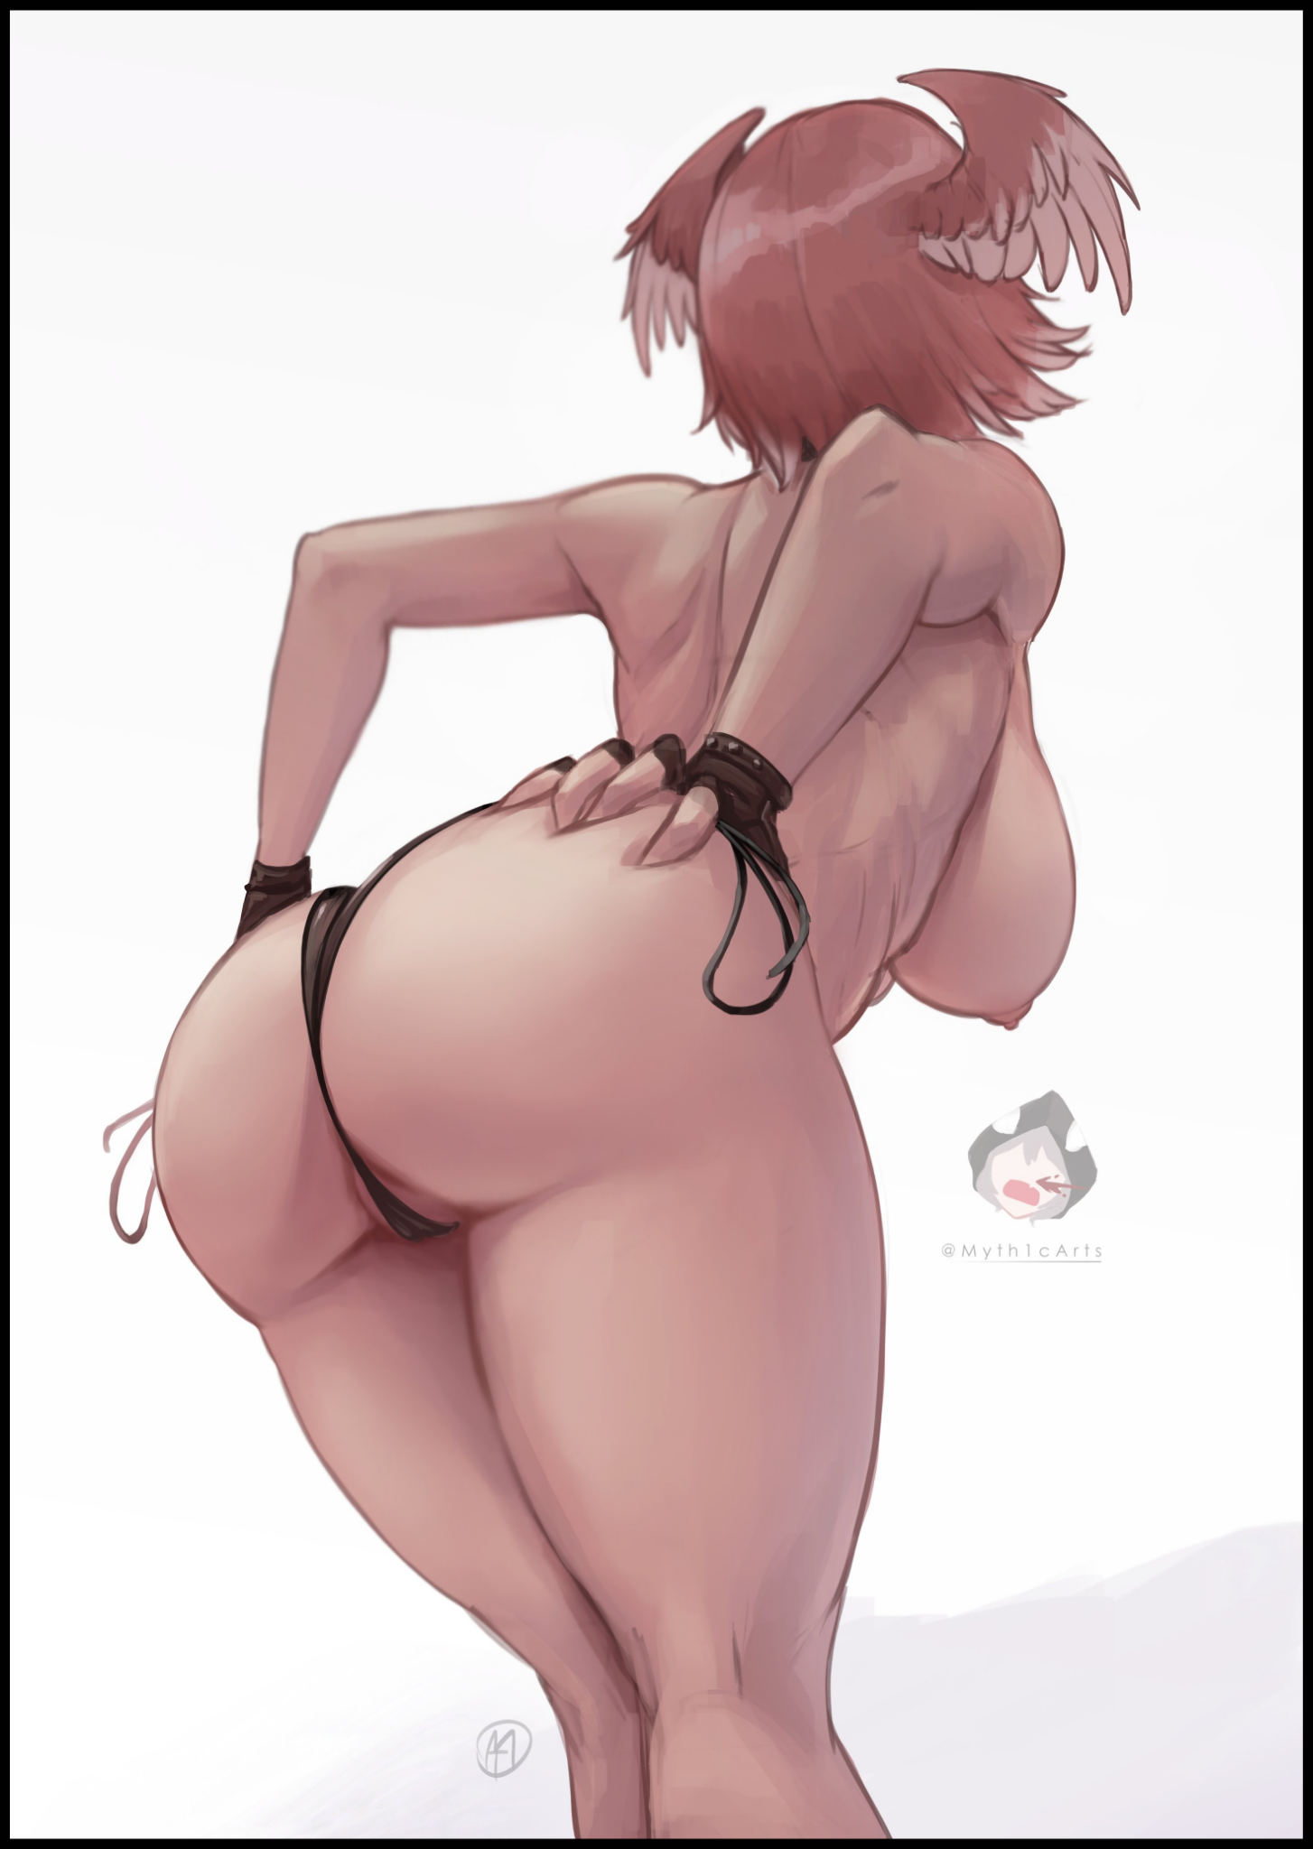
Compared to the pain from earlier, pleasure was a more preferable sensation to feel while in the throes of whatever metamorphic spell Xayah had cast over her, but that didn't mean Charlie was completely fine. Her mind was reeling with embarrassment from hearing the sounds her tight, nubile body was making, and no matter what she tried, she just couldn't seem to drop the magic from expelling her old supply of baby batter from her new ovaries, only able to let loose choked cries and guttural moans in a sonorous voice that only worsens the hyperactive state of estrus she was enraptured by while handlebar hips thrust and buck from the effort of her vaginal muscles flexing and churning to ensure her innards were thoroughly cleansed. A process that finally reaches its end once the spewing froth between her legs turns into a faint trickle. Finalizing the changes and freeing Charlie from her predicament as she collapses onto the ticklish grass beneath, massive D's wobbling like jelly from the impact, swollen nipples standing to attention.

"Tsk…why isn't she changing anymore…the spell should've worked!"

While Charlie bathed in the reprieve offered to her after the strenuous torture of her body being forcibly shifted into that of a voluptuous young lady with avian features signature to Lhotlan Vastayans like Xayah, who seemed displeased by the results as her keen senses watched her magic slowly begin to weaken, the rebel didn't share in Charlie's relief. Instead, the sight of the newborn woman only seemed to infuriate her, unfurling her legs before rising back up to full height, muttering a mix of cursed under her breath alongside a new incantation that forces Charlie to her feet despite her protests, grunting and flailing in her weakened body, staring with wide aquamarine shaded eyes first at Xayah, then at herself, shaking her head in disbelief once she realized she had breasts big enough to block out the sight of her waifish feet before yelping in an ashamedly attractive voice upon the sensation of a thong slapping itself between her heart shaped ass and the front of her still throbbing groin. Adorning the hands that rubbed her swollen peaches with leathery gloves.

She looked nothing like her old self at all. Not some nerdy man in his mid twenties but a buxom woman of unknown descent…at least, unknown to native Earth. But when paraded around Runeterra, everyone could tell she hailed from somewhere across the vast lands of Ionia, home to get fellow Vastayans as far as appearances went of course. But without special tools or magical aid, no one would realize that a human man had been cursed to take on the enchanting facade.

And as expected, Xayah would not give Charlie even a second to say anything before silencing her with a simple tap of a finger to the forehead, sending the pink haired woman tumbling forward and into her scowling captor's arms, unable to resist now that she was temporarily silenced and rendered mute.

"Now…what do I do with…hm? That sound…hmph! Talk about perfect timing~"

Pushing Charlie off of her before scrawling a quick note that she slips into the knot of her underwear, Xayah proceeds to take her leave from the crime scene, speeding off without a sound, presumably back towards wherever her boyfriend had decided to take refuge in for the night. There was still a long way to go before the magic worked as intended, but it also served to paint a wry smile on Xayah's lips as she mused over Charlie's botched conversion and what she had told her seconds before spiriting her manhood away. A just punishment for claiming he'd been responsible for her own quick thinking and tactile maneuvers in the heat of battle against two opposing forces, one of which had just stepped out onto the clearing with a heavy weight in his step. Too banged up to spot the unconscious half breed Vastayan lying a few meters away from him.

Unlike Xayah, the burly beefcake of a man couldn't be bothered for stealth, announcing his presence with each thunderous footfall bouncing across the trees with the grating sound of leaves being crushed underfoot. From his appearance and build, it was clear to see he was a brawler, outfitted with knuckles, form fitting pants and an open coat that left his bulging abs and steaming pecs on show for all to see. A display of confidence in his physical capabilities when it came down to a fight.

But there was no fight to be had here, instead, the disgruntled man would soon find himself recoiling a little once his feet brushed up against the unconscious woman lying stark naked in the grass near a patch of trees on the opposite side of the clearing. And almost immediately after sighting her, he couldn't help but grow a little 'rustled', especially when he noted her alarming lack of clothes and the distinct scent of sex wafting off of her. But that excitement would soon fade for disgust upon the sight of what she did have on her person; slave dregs made of woefully inadequate fabric meant to parade the wearer than it served to cover them up…did a passing caravan get caught up in their scuffle and this nameless girl, seeing her chance, slip free of her captors? A quick check of his surroundings told him she was alone, but a lingering scent on her porcelain smooth skin had him mildly concerned as to who could have left her in this state.

"Hrm? What do we have here…paper…woah…she can't seriously…"

By the time he was done reading the tiny thing, the red haired half Vastayan man had shrugged off his uncertainty as he crumples the note before taking to a knee, taking off his coat before scooping the still unconscious Charlie up into his arms in a bridal carry, using his clothes like a thermal shield against the elements as he stalked his way back home to the pits of Navori, consolatory prize from the victor of the previous fight held close to his chest…

The next time Charlie awoke, she would find herself sorely disappointed with the fact that everything she had experienced in the frigid wilds of an evening in Ionia had not been a dream. Sentenced to live out the rest of her days as an ostracized half breed 'working' under the employ of the greatest half breed there ever was in the troubled lands' recent history with heavy ties to the recent rise of the criminal underworld. But things weren't quite as bad as they sounded, for the Boss had a mellow heart softer than most knew beneath his rugged, battle hardened exterior. Especially for others like the young half breed woman currently learning her way through the hoops of Navori's seedy underbelly.

Apparently, the letter Xayah had left on Charlie's person told Sett everything there was to know about the former man right down to who she once was. And even though it was a slip of paper, the experienced fighter knew there had to be some truth in the words of the Violet Raven who had bested him a few minutes ago. And even though a part of him didn't want to believe it, his doubts were soon corrected after managing to get the reawakened Charlie to cooperate, wondering what the heck Xayah had done to 'her'.

"So…you're sayin' you were from some world where people like you…control us or somethin'?"

"Y-Yeah…a game…but after winning a round with Xayah…I just found myself here…before she…well…"

‘Cheh…a game, huh?’

Gesturing to her body with a shrug of the shoulders and spread arms, Sett could only rub his chin in thought while his brows furrowed even deeper together, trying to understand the concept of other worlds where all of this…his experiences alongside the others he fought with and against, their struggles, their histories…were a simple game with a script already laid out for them to follow.

And that Xayah had been the first to make contact before uncaringly transforming them into a native of this world…he felt a little bad, but not so much after realizing their 'directing' of Xayah had cost him the fight. A smear on his name that needed some fork of recompense, even if this Charlie hadn't meant to. In their world, it was a literal game after all…but here, in Ionia…

"Yeesh…that must've sucked…but still, from what ya told me…sorta sounds like the reason I lost back there…was because of your meddlin' right?"

"R-Right…w-what're you gonna d-do to me?"

"Come on, I ain't that pompous woman so you can stop lookin' so scared…for now anyways, dependin' on how ya do in your job!"

"That's a…wait…my job?"

"Yeah, can't expect I'd let you go after readin' that letter and hearin' what you said right? Oh come on, it ain't as bad as it sounds, I might run a brawling pit, but I'm not gonna force you to fight or anything…I've got…special roles in mind for ya~"

"Special? W-What do you mean?"

"That's a secret hun…but we're gonna need to work on that jitter of yours…and I know just the thing that makes a headstrong woman out of meek little ones like you."

Left with no other choice but to follow along close behind Sett like a pup, Charlie, although mildly relieved that she'd found a Champion who wasn't as blind to conversation like Xayah, dreaded what he had in store for her as he leads her through the hallowed tunnels of Navori's underground, trying not to trip on her own two feet with her still masculine mind adjusting to the strange new center of gravity her body possessed and how arousing it felt to have such a titillating figure.

Pushing open the heavy metal reinforced door that lay at the end of the corridor with a simple nudge, Sett strolls in first, leaving an awestruck Charlie at the entrance while he conversed with a bevy of women ranging from petite to curvaceous, all of them dressed in revealing silks and glittering gold much like the coffers that laid shut against the walls of this makeshift throne room. She had only seen glimpses of this place from official art back on Earth but to see it all up close and personal despite all that had happened to her recently was still a breathtaking sight to behold.

Although Charlie's sightseeing was soon cut short by the women from earlier surging forth to get a better look at her, staring with bug eyed wonder at the flustered specimen as hands ruffled her hair, played with her curious, ear wing appendages and poked at her skin, gushing all the while.

"Is she really a man?"

"What sort of magic can even do this?"

"My, her skin's incredibly smooth!"

"Come on girls, we're supposed to show her the ropes, not fawn over her!"

That had Charlie's attention focused on the tall, sultry woman who seemed to be the one in control of the group, moving forward from behind them to make herself known.

"The ropes? I-Is this that job S-Sett mentioned?"

"Yeap! And the first thing you've gotta know is that you don't mention the Boss by name unless you're either personal with or intimate with him, he tells me you're from another world but…I'm sure we can work past those barriers, you'll make a fine addition to the Boss' workforce, there's always demand for a ring girl after all, or failing that, a maid!"

"R-Ring girl?! But I can't! I'm a man!"

"I'm sorry dear, but for all intents and purposes, you're as much of a woman as I am. The sort of magic that's done this to you ain't the reversible sort I'm afraid, best to accept and live with it than to keep denying what's happened…but really, with a body like that…my, I'd say it's a definite improvement over who or what you were! Now then, enough talk, come along and we'll get you dressed in some proper clothes!"

Slumping her shoulders in defeat at the sight of Sett shooting her a wink and a mock salute before he turns his back to tend to his wounds, Charlie acquiesces to the girls as they drag her out of the room to don her in whatever they considered to be 'proper'...

From that day on, a new girl would be spotted amongst the ranks of Sett's personal harem, a curious oddity when compared to the other women for she wore an enchanted artifact specifically tailor made to reveal the curse that hung over her; a man forever changed to appear like a buxom Lhotlan wench with breasts bigger than most other women. Of course it did little to deter the ravenous hordes that composed the audience and contestants that fought within Sett's pit. They were there to see blood fly and bones being broken, a little bit of skin on the side was a bonus to them.
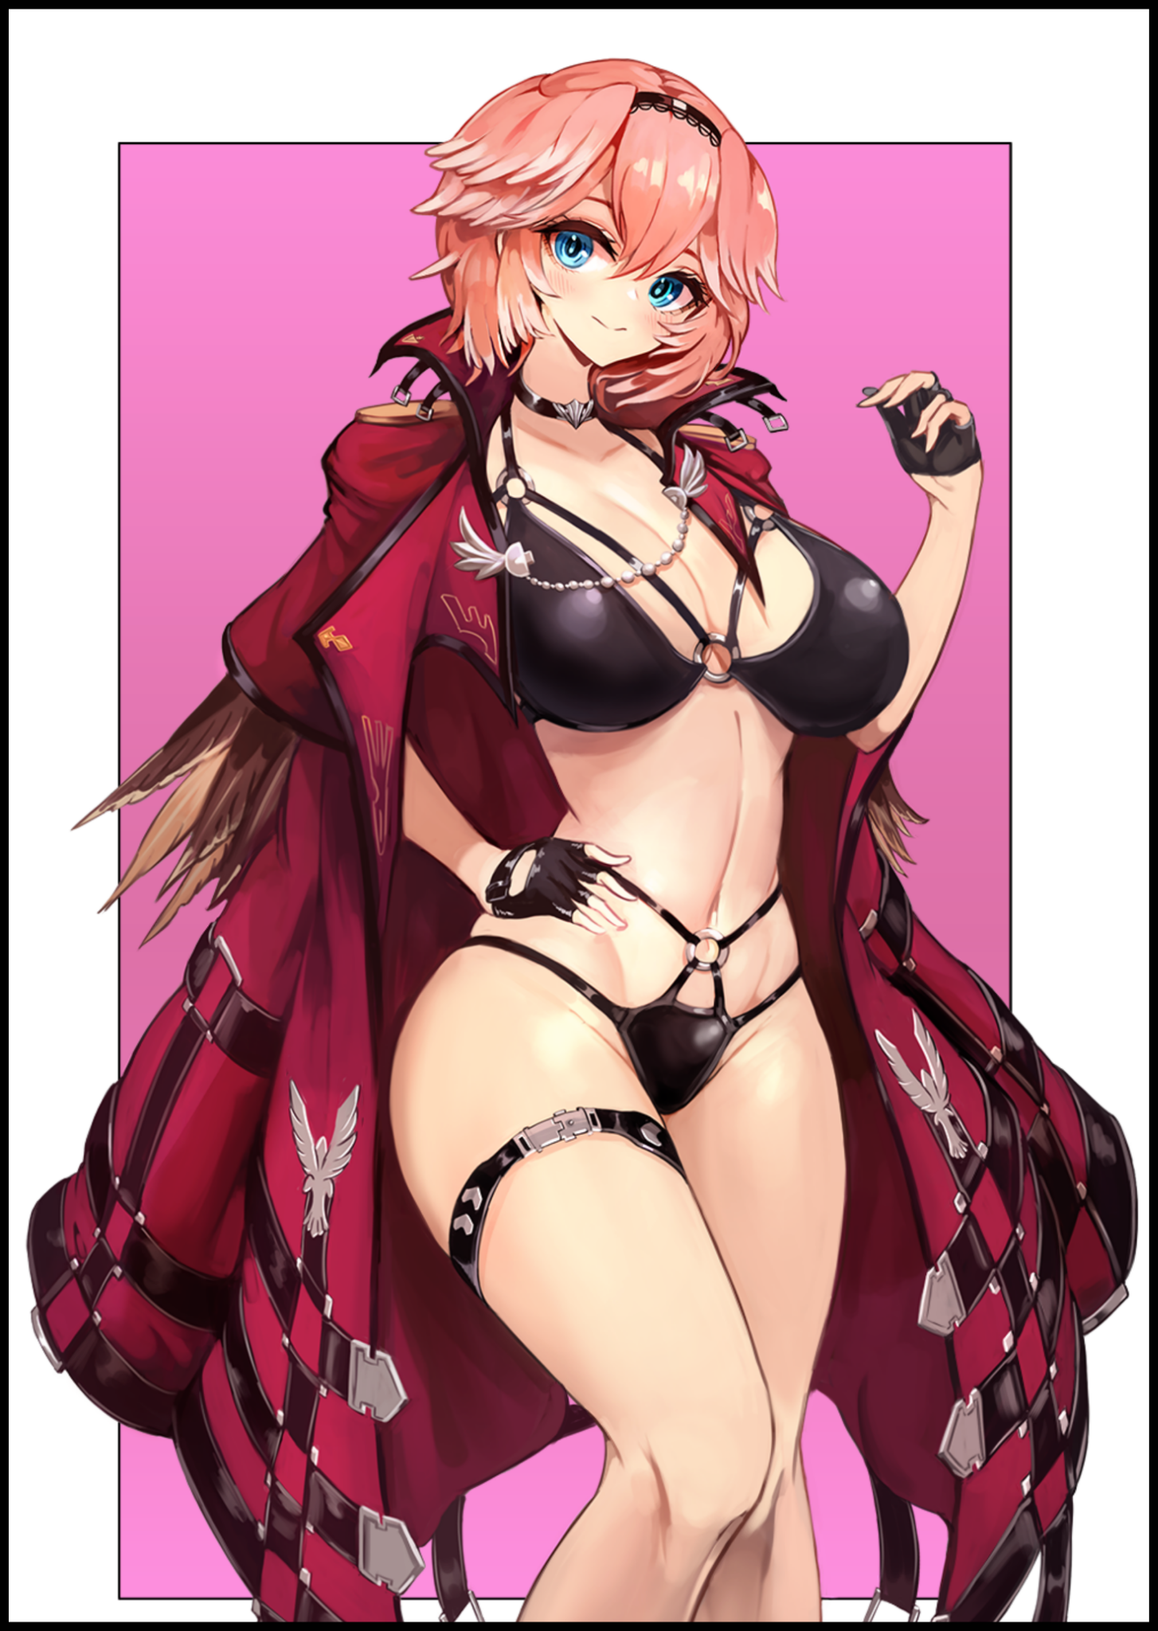
Although several keen-eyed visitors to the pit would note a gradual change in behavior displayed by the eye-catching pink haired Lhotlan woman as she did her usual rounds advertising for Sett's sport alongside some of the other familiar faces. For one, she no longer scurried to and fro like a confused mouse, nor did she struggle to match the overbearing gaze of the crowd who came to satiate their thirst for savage fighting. Her clumsy walk had turned into a confident stride, gaining a natural sway to her hips that grew more and more pronounced with each passing week. Lending credence to the fact that she wasn't always a bodacious lady, and one could see that clearly now from how she slowly grew accustomed to being inside her own flesh and blood vessel.

But the most glaring change was seen whenever she took to the pits holding up placards and boards announcing the next match and whatever messages each one had tacked on to it. Instead of trembling in her shoes while looking like she was about ready to go bolting off into the horizon, the Lhotlan basked in the eyes of the audience, parading her hourglass form around in an open coat bearing avian motifs, a brazen style paying homage to the Boss. Sweat soaked skin glistening in the limelight while pert flesh struggles to breathe from all the straps of the skimpy underwear biting into her luscious body. Very soon, attention would be drawn towards the color pink before and after a match. Some would even begin to pay entrance fees just to catch a glimpse of the rumored Sunrise Wench, a less than flattering nickname earned from her color palette matching that of the sun's rays filtering through the red leaves of Ionia's forests at the crack of dawn.

That and the fact that she was working in this line of business in the first place. Parading her body around like a work of art without shame, wearing all smiles for the adoring public. And even though there were strict no-touching rules in place, the simple minded folk who frequented the pits would simply assume she'd stoop lower if given the chance to, oblivious to her circumstances and the discreet bond she was beginning to sew with her Boss.

There was a time when being called derogatory terms would've tickled her the wrong way, even made her lash out in self defense. But after what she'd been taught down in the most unlikeliest of places to learn life lessons in, she wasn't fazed in the slightest. Not when her surprise debut had resulted in a notable rise in gold and trinkets from the mindless hordes starved for blood and women in an uncertain time where war had left its mark on both the land and its people.

Not like she could care much considering this world wasn't her own, and after settling in to her new job as a ring girl cum maid who drew in the masses with her unparalleled looks alone that earned her enough coin to buy her own house if she so wished, Charlie had more or less hung up any hopes of returning back to Earth, especially not after she had succumbed to certain vices she simply could not refuse after more than one go at it…not like she had much of a choice when the time came for her unexpected initiation at the hands of Sett himself, blushing at the memory as she stood before the very same heavy iron doors she didn't get a chance to pass through until a few moons ago, dressed in silken robes much like the one she had worn on that night…

"Boss? I'm coming in…"

Not even waiting for his word after growing accustomed to Sett's practices, Charlie strolls inside without a sound, shutting the door behind her before casting a demure glance at the busy man stuffing his face in a book laid out on his lap, a focused look on his face she never thought she'd see before on a man stereotyped to be a muscle headed brute. Another benefit of being able to interact with once lifeless game characters like real people, to feel their touch over her own body…

The rest of Sett's harem seemed to be out today, leaving her alone with her employer, musing silently to herself as a wry smile painted itself on her face. It wasn't as if she disliked the company, but having some quiet time with the Boss meant she had him all to herself…and the privacy to let loose a side of herself that had taken root during her time here.

"Still figuring out the incantation Sett?"

"Hm? Oh…yeah…this stuffs doin' a number on my head…but I think I've almost got it!"

"Hmm~ How so?"

"Well, for one, I've had one of the girls do a lil snoopin', and crossin' what they found with-"

While Sett continued to ramble on and on about his findings and progress with this new pet project of his, Charlie simply strolls aimlessly to and fro, pouting a little when her attempts to get him to pay attention to her goes unnoticed, even when her robe crumples to the floor, leaving the half breed Lhotlan woman as naked as the day she was born (quite literally). She had taken the time to oil her body up with a special lubricant to emphasize the allure of her supple body, applying libido boosting perfumes that had her raring to go, barely able to control herself as she continues her slow walk up and down the length of the room to the tune of Sett's mindless rambling about how he'd managed to extract trace residue of the magic that had transformed her to appropriate for himself. Etcetera etcetera, it was an agonizing wait that left Charlie frustrated in more ways than one, giving up her parade as she saunters over toward the pile of crates and boxes on the left side of the hall, draping rich silks over the uncomfortable wood before laying herself out atop the hastily arranged ensemble
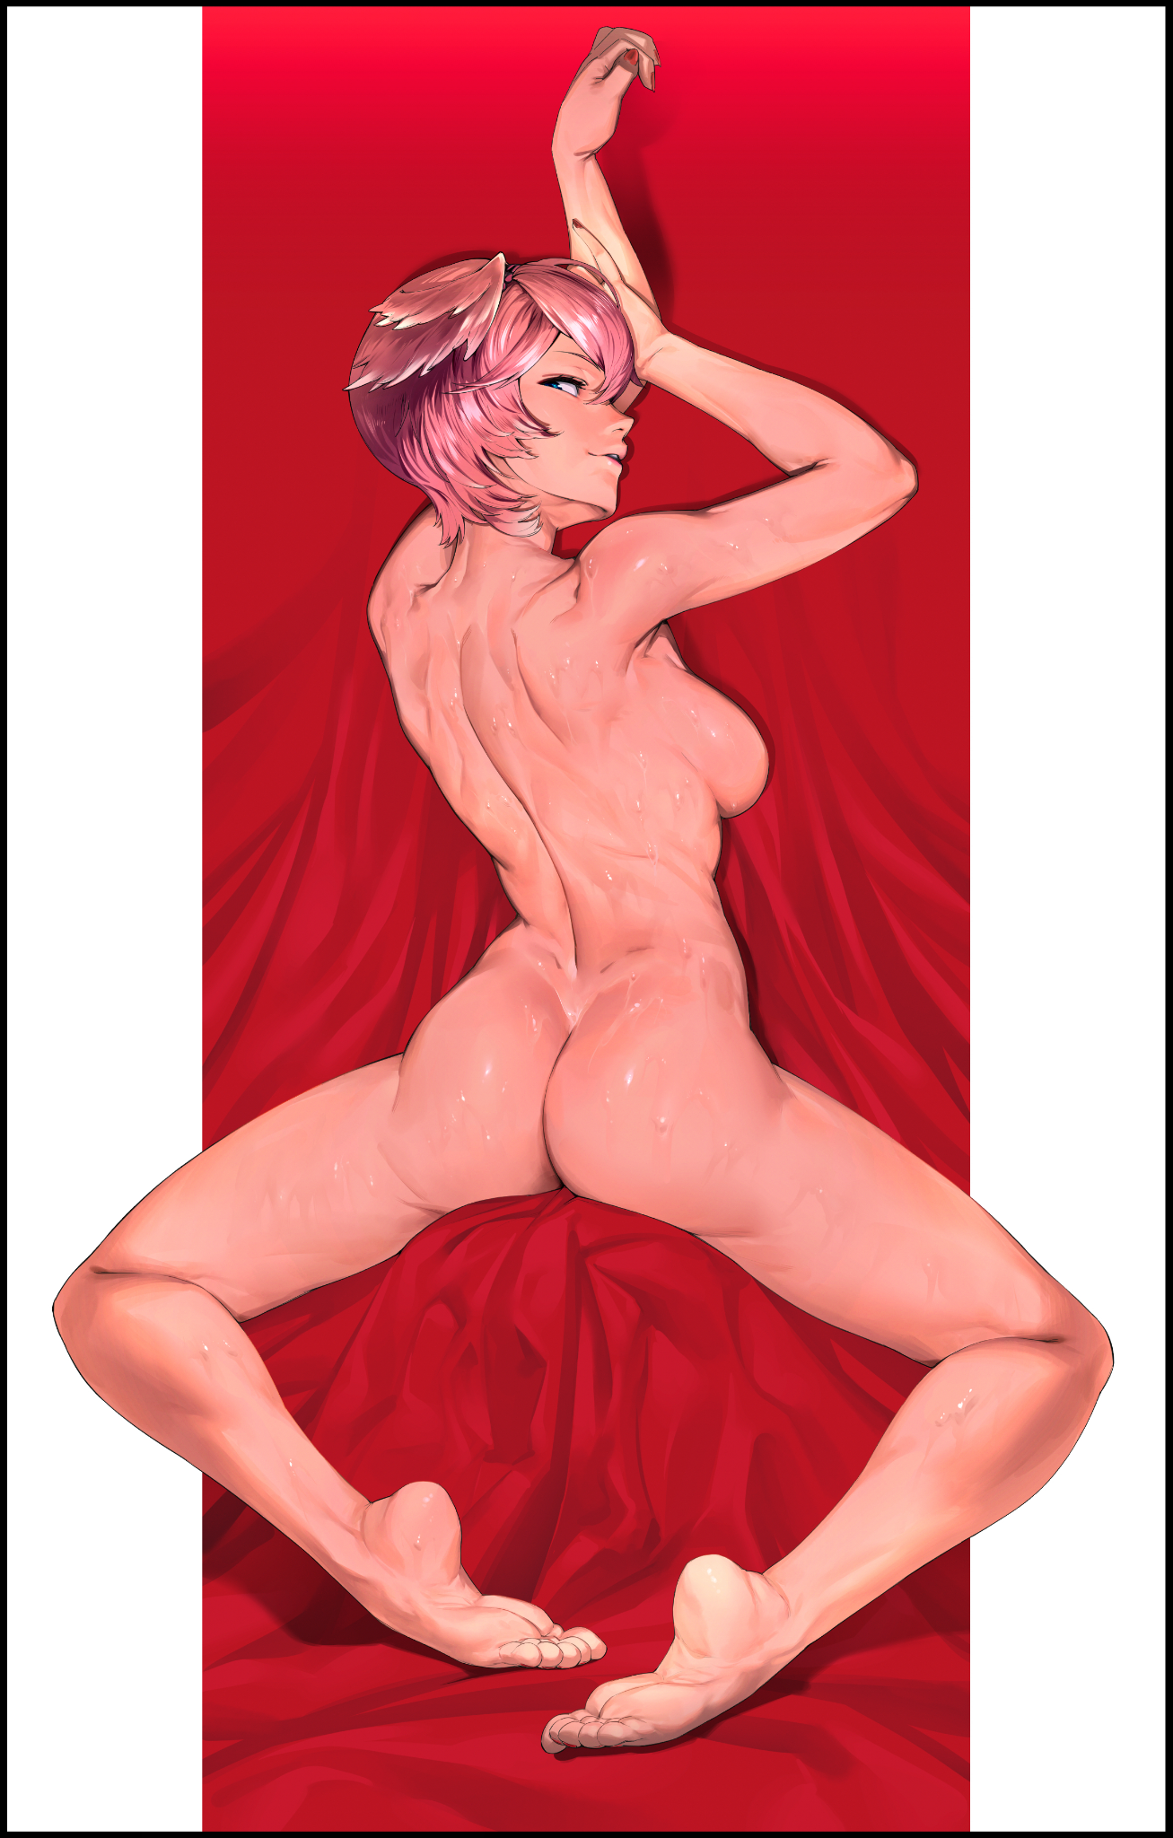
“So with a little bit more work, I think I can…woah…"

"Took you long enough dummy…never knew you to be a brainiac Sett~"

"What the what? The hecks a brainiac?"

Scoffing at his remark, Charlie simply stretches her flexible body, presenting herself before Sett in a way she had never thought possible until now; pressing her leaking snatch against the box she rested on while spreading her toned legs apart, doing the same with her arms while twisting her torso around so one side of attractive visage remained visible, as did her right breast, looking deceptively small thanks to how the majority of its heft remained tightly hidden beneath her. And the sight of a tent pitching itself in the unmoving Sett's woefully tight pants was more than enough to make Charlie wet herself, bearing a seductive grin in anticipation.

"Since when did you become so…"

"...brazen? Hot headed? I wonder~ It couldn't possibly have been the brutish musclebrain who fucked my brains out the other day, right?"

"Hooo~ Talk about on the nose there love! All right birdy, I'll bite…"

Putting aside the book he'd been pouring through so vehemently a second ago before rising off his throne, Sett disrobes himself, flinging aside his coat as if he was ready to tackle a charging beast head on, glimmering amber eyes locked with Charlie's bejeweled pearls. He could smell her arousal from where he stood, and whatever she sprayed herself with was beginning to take its toll on him. She did claim to be from a world where special individuals like him had everything about themselves known to all willing enough to look it up. And so far, she'd proven herself in those matters when it came to, surprisingly, matters of the bed. And now she'd taken advantage of his wolverine traits, turning his hypersensitive sense of smell against him.

He normally wouldn't be so gung ho about having sex so openly with one of his harem girls, but Charlie, as strange as her name was, just seemed to eat away at his convictions, pulling his strings like a puppeteer…and to think he had her put to work because she'd cost him a victory…

True, she had boosted the already impressive revenue of the pit. And so far, she was compliant with everything that had been asked of her; from taking blood samples to magical examinations in an effort to derive either a cure or a replication of whatever it was that Xayah had used to leave her in this state. If he could utilize it to his advantage, then he would have more than just brute strength and an indomitable ability to take punishment to bring to the table; intimidation, coercion, and maybe even an expansion to his underground business through the salacious red light district.

All of it was possible now thanks to Charlie being dumped into his lap…had Xayah thought he would simply kill her for being an otherworld invader? Throw her into the pits to be slaughtered without at least hearing her out? How crude…

'Ma would never forgive me if I pulled that sort of stunt…and I'd be spitting on my own name!'

He hadn't even realized his sausage had slipped into the horny Lhotlan woman's folds, barely able to hear her guttural moans while he pumps into her like a machine, pistoning in and out of Charlie's sopping wet pussy while firm hands held her broad hips for dear life. Everything about her was perfect as ashamed as he was to admit it, he couldn't even think about the fact that he was currently having sex with a former man. And although he had kept the fact that there was no longer any magic binding Charlie to her current form a secret from her, Sett was starting to think she no longer had any desire to return to her old life, not when she was making the most erotic noises to ever grace his ears while hazy, half lidded eyes burned with lustful vigor, no longer the eyes of the shy damsel he'd invited here so long ago it almost seemed like a dream now.

Maybe this was some form of comeuppance for soiling her virginity during the surprise initiation he had the girls pull on her after her first few weeks or so working the pit. He'd taken her for a meek mouse, and now? He'd accidentally turned her into a ravenous hawk craving his presence like a love starved maiden.

As for Charlie herself? She had no qualms about losing her first time to one of her favorites among the League roster. And the fact that she was now biologically female only made it that much harder to see Sett in a different light after all the time she had spent near him. Feel good hormones and chemicals flooded her body everytime she caught sight of him, the false smile she put on for the crowd turned genuine when he had his broad arms wrapped around her shoulders every time he went about his domain with a girl or two slung around his arms. Until eventually, she'd almost forgotten she hadn't always been this lucky girl faced with strange circumstances that turned out more or less alright in the end.

A sudden white hot explosion deep inside her tummy forces her head back, but before she could scream, Sett closes the distance between them, silencing her with a tongue curling french kiss that had her body quivering in unadulterated bliss from the combined euphoria of having her womb pumped full of semen. Whiting out completely as she slowly tumbles onto the floor after Sett's grip over her loosens, panting heavily as he stares down at his sweat soaked partner, winged ears flapping weakly atop her ruffled head.

"Damn it…went too far again…"

Propping Charlie's unconscious body up after cleaning her as best he could alongside wrapping her back up in the robes she had discarded, Sett returns to his throne with his fellow half breed in hand, plopping her down next to his seat with a hefty sigh of satisfaction and one final glance cast her way before devouring the rest of the book of ancient Vastayan script he'd been pouring through earlier…oblivious to the fact that Charlie had been playing with him, opening one weary eye with a satisfied smile on her face before her mind gives in for real, dozing off after a hard day of work cleaning up the fighting arena and arranging the stocks. Balance after all, was key to a life well lived.

And for Charlie, that life was just beginning in a fantastical world she could only hope to visit in her wildest dreams come true…

THE END

