Forget Silicone  A Vignette  By Maryanne Peters  I had always had a crazy crush on Gerry. I suppose it was because he was like me in many ways – quiet and home loving. I suppose that the big difference was that I was I gay, and while I hoped he was too, he wasn’t.  We met through gaming. We had an online team of three guys and the third guy suggested that we get together and look at playing at a live e-sport event. I guess that Gerry and me came across as more outgoing on line, because when he met us in person he realized that it would never work.  I just fell for Gerry that weekend, but just when I was thinking about how I might get into his pants, I borrowed his laptop and had a quick look at his porn. I guess you only need one word to describe it – bimbo.  There were just thousands of images of slim blonde girls dressed in pink in various poses – legs in the air, legs wrapped around standing poles, mouths pouting or with tongues hanging out – stroking their tits or wiggling their butts. For a gay man all of this was truly revolting.  It was a secret glance, and I tried very hard not to let my feelings show. I still enjoyed his company, online and in person. When the third member of our team drifted away, I still wanted me and Gerry to play as a pair. It was just that my dreams that we be more than a pair – a couple – were dashed.  If there was one positive thing it was that in all the images I had seen, there was no visible vulva. | 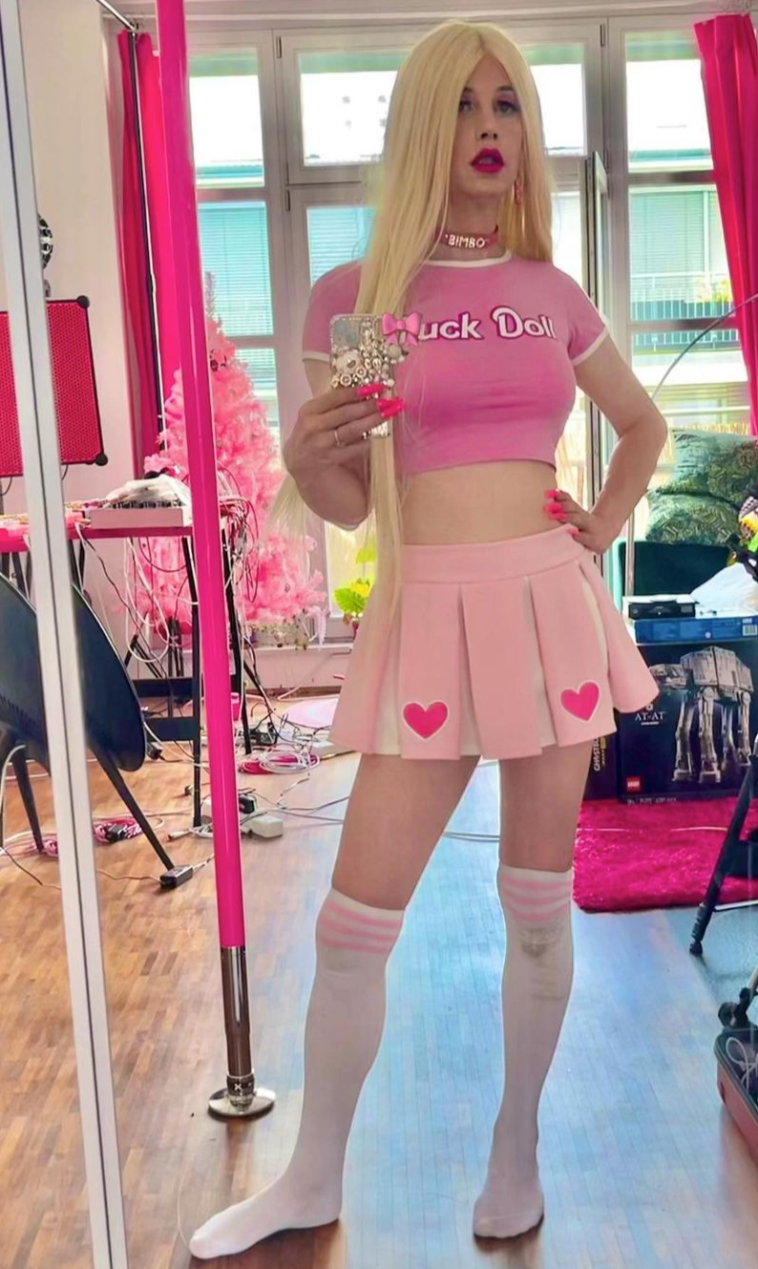

It left me wondering if I might attract Gerry if I looked more like a girl and in particular the kind of girl he appeared to like. I had the advantage that I was smallish and slim, and my face was not overly masculine. I could even be pretty if I didn’t wear my thick glasses. I played around with gender changing images, then I bought just a few items of clothing, a long blond wig and some makeup online.

But it was still a fantasy. Fantasy was the background for the games I played, so I knew where it began and where it ended. Game Over is when you have to go back to reality. I was a man and a shy one at that. It just seemed impossible to see how I could change that.

Then one day Gerry zoomed me to introduce me to his new girlfriend, Jaxie. With those opening words I swear you could hear my heart crack – Gerry had been able to find a woman to love him! But then he panned across to reveal Jaxie in all her silicone glory. Jaxie was a doll! Not one of those inflatable ones but one of those high quality expensive mock humans, with a bit of weight, and three fuckable orifices. I almost laughed, but I could see for myself just how lonely and desperate Gerry was.

“You don’t think I am a freak, do you?” he pleaded.

“Thank you for sharing her with me,” I said earnestly. “I want to tell you that I am here for you to talk to, because I am guessing that Jaxie doesn’t talk much?” It sounds funny to say it, but I said those words seriously. Gerry stared at me down my camera and I think he believed that.

I looked at Jaxie in the background and I envied her. Then I realized that she actually looked like me, when I was dressed up in my long blonde wig. She was even wearing pink. She was just the woman that I knew Jerry liked – a bimbo.

“Do you think that Jaxie some feminine company?” I asked Gerry.

“Really?” he said. “Do you have a girlfriend too? Could you bring her over? Tomorrow night maybe?”

I went and bought the outfit – the “Fuck Doll” tee-shirt and the bimbo choker, the pleated skirt and the socks. I went to the local mall to have my makeup done properly, and I got my nails sone as well. Before I headed out I took the selfie, so this is what greeted Gerry when he opened his door.

He first looked behind me looking for the person I used to be, but then he took another look and his mouth fell open.

“Hi, my name is Sissy,” I squeaked out in a super feminine voice I had been practicing to go with my airhead look. “I have come over to play with Jaxie … and maybe with you?” I gave him a well-rehearsed look. You might know it – trying very hard to look dumb and adorable at the same time.

It must have worked because Gerry could not get me inside, and then inside me, fast enough.

Jaxie lives in a cupboard these days. I may have only two fuckable orifices but Gerry prefers real flesh over silicone.

The End

© Maryanne Peters 2023

